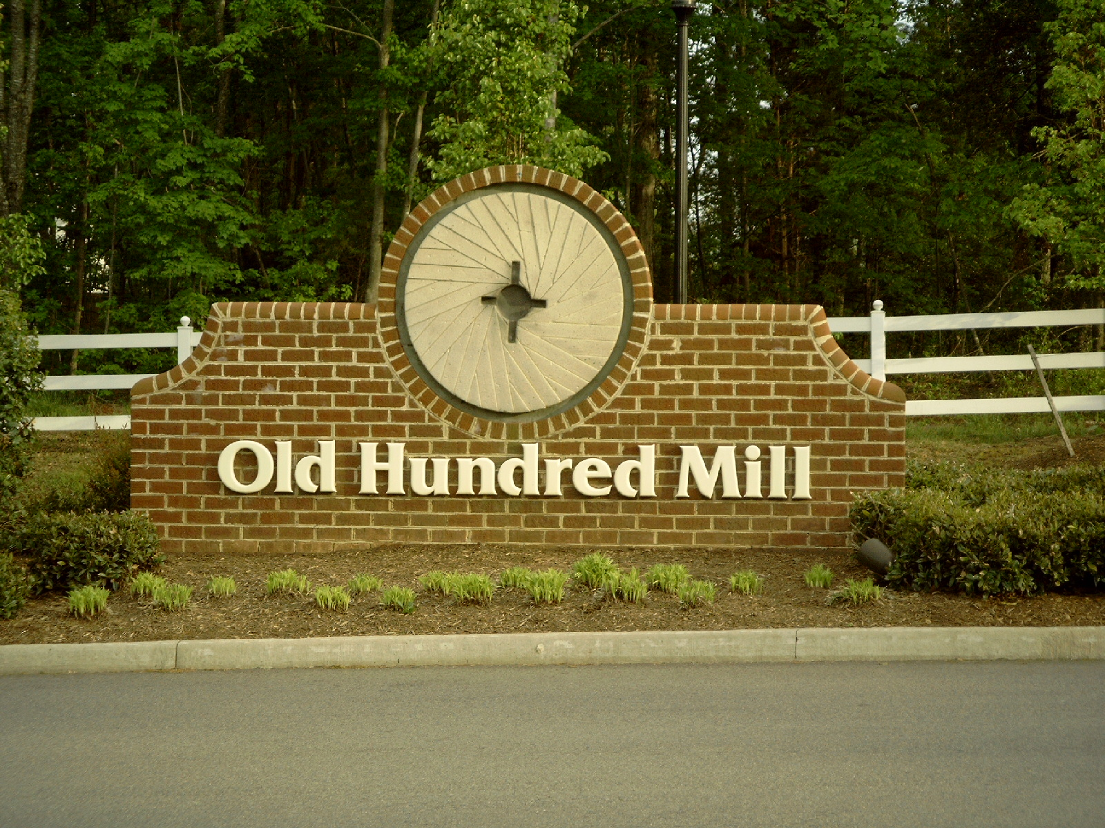
Old Hundred Mill Homeowners Association, Inc.
ARCHITECTURAL REVIEW BOARD
ACS West, Inc PO Box 11361 Richmond, VA 23230 282-7451 phone 282-9590 fax

APPLICATION FOR FENCE APPROVAL

Lot Number:

Property Address:

Property Owner:

Mailing Address:

Telephone Home: Work: Cell:

Allow up to two (2) weeks after the review to obtain a written response from the ARB. Verbal approvals will not be granted.

The following must be included with your application:

- A survey showing the proposed fence on the lot with dimensions to the property lines.
- A description of the type of fence, materials and finish.
- If a privacy fence, a scale drawing of the design is required.

Date work will be competed _________________________. Construction must be completed within six months of the approval date. A follow-up inspection will be performed at that time to determine that all work has been performed in compliance with this approval.

FOR OHA USE ONLY

APPLICATION RECEIVED:

APPLICATION: ( ) Approved as submitted
( ) Approved with Limiting Changes
( ) Not Approved
( ) Preliminary Review - additional information required

SIGNATURE: __________________________________ DATE: _______________

COPY SENT TO OWNER: ________________________________

Approval is limited to design criteria established by the Architectural Review Board and should not be interpreted as approval of any variation from restrictions or conditions imposed on the property owner by the Old Hundred Mill Covenants or Chesterfield County.
Approval of application does not imply compliance with county zoning requirements.

