**JobAcess EAF Application Guidelines**

This guide will help you navigate the process of applying for ADHD coaching services through JobAccess. Each step is outlined clearly, ensuring you understand what needs to be done and what to expect along the way. If you have any questions, feel free to reach out to me at any stage of the process.

This funding ($1640.00/ year) is available to

* Australian citizens/ permanent residents
* Employed for a minimum of 8 hrs/ week at above the minimum wage
* Over 14 yrs old

**You need:**

For Stage 1:

* MyGov account

For Stage 3: You can collect these documents right away:

* A letter from your psychiatrist, verifying your diagnosis
* Identity Documents
* Evidence of employment / employer. NOTE: it is possible to apply for JobAccess without disclosure at work

**Stage 1: Apply Online:**

*Set aside up to 30 minutes to complete the application and you need your MyGov ID.*

1. Visit the [Job Access](https://ecsn.gov.au/JOBACCESSSECURE/JAS/Security/SelfRegisterMyGovLogon) website and submit your application.
2. Select “New Registration with myGov”

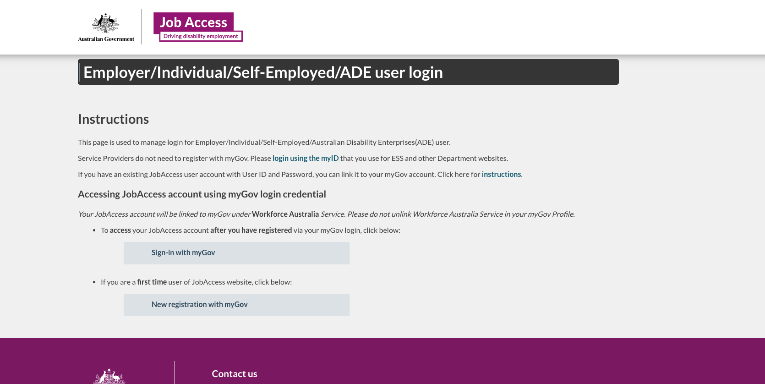

1. **Appoint a Nominee** (Optional): During the application process, you can appoint a nominee (your coach) as your main contact with JobAccess.

**Privacy notice**

* Proceed

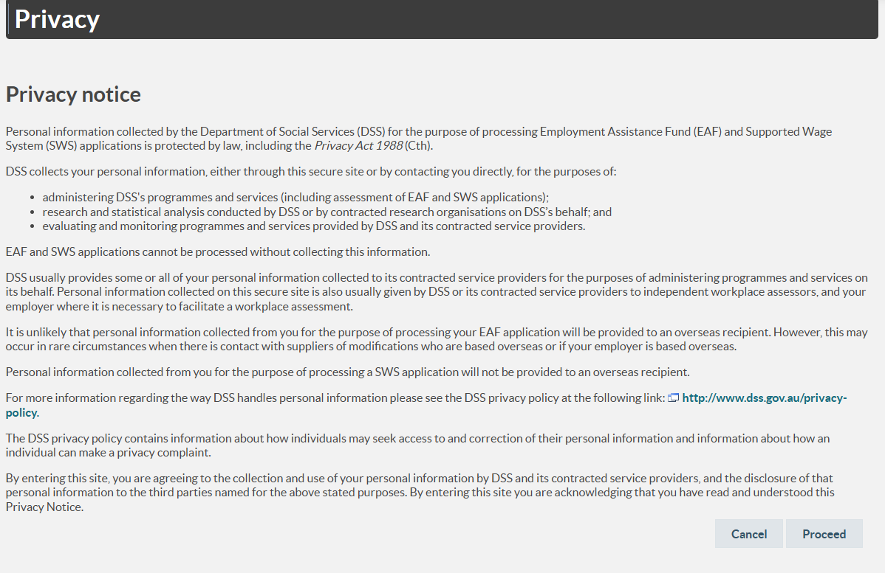

**Welcome**

* Start New EAF Application
* Note: you can return to this screen if you need to edit your application

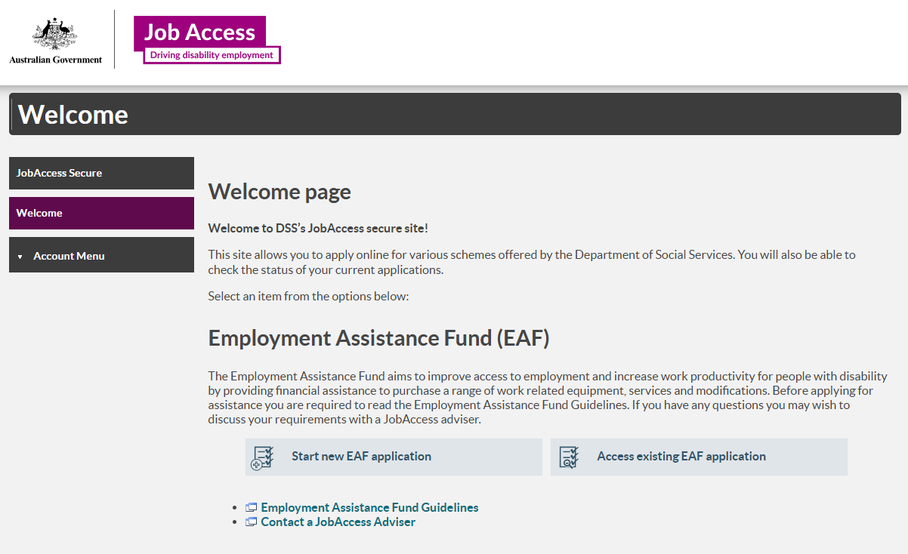

**New Application**

Options are “employer” or “self- employed”

* Select “self- employed”, (even if you are an employee, this should be named “individual”, I think)
* Next

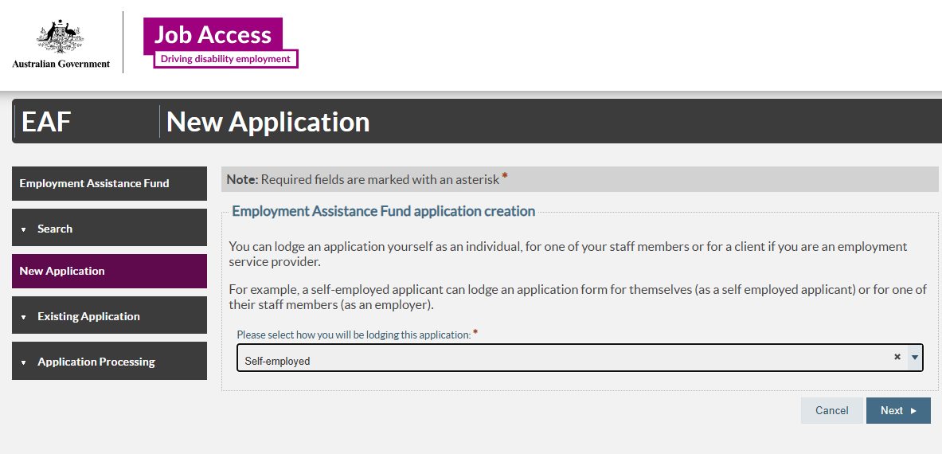

**Step 1 Individual/ Employee:**

* Fill in ***your details***
* Next

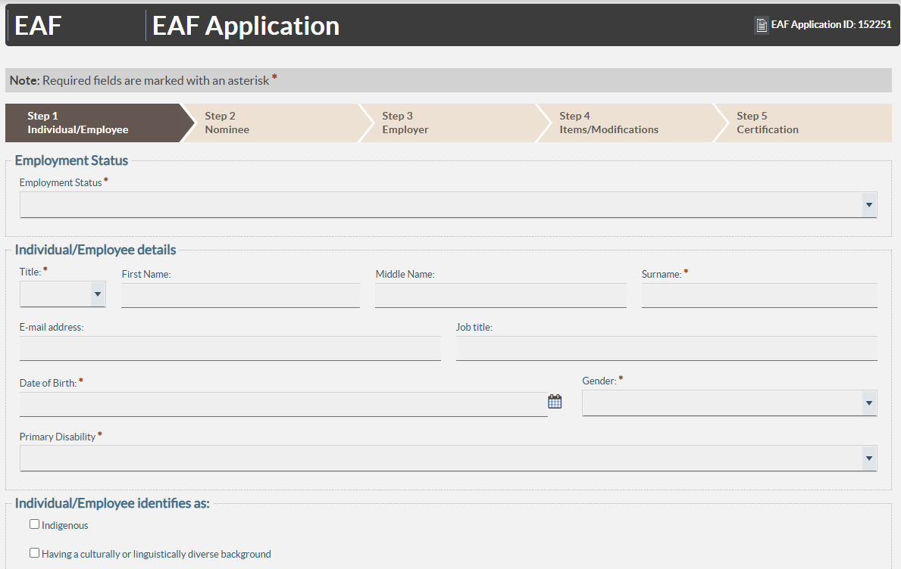

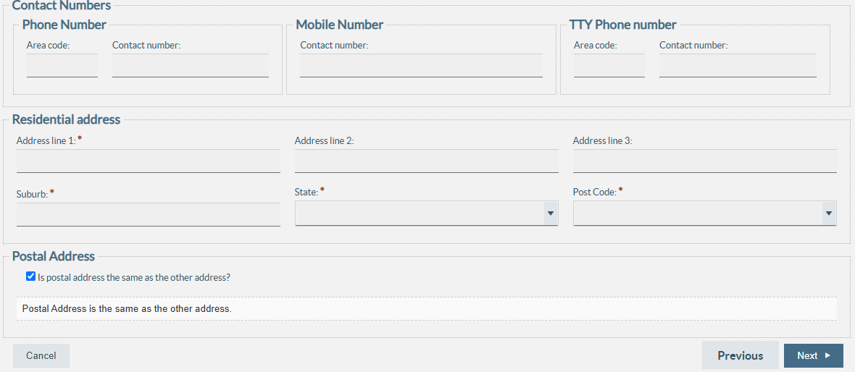

**Step 2: Nominee:**

* Select YES or NO in the drop down menu
* No – go to step 3
* Yes – fill in my details:

Doing Doing Done Ltd Pty

ABN 51 614 166 737

Swantje Lorrimer-Mohr

7 Karana Place

Chatswood 2067 NSW

0490 885 581

[coach@doingdoingdone.com.au](mailto:coach@doingdoingdone.com.au)

* Next

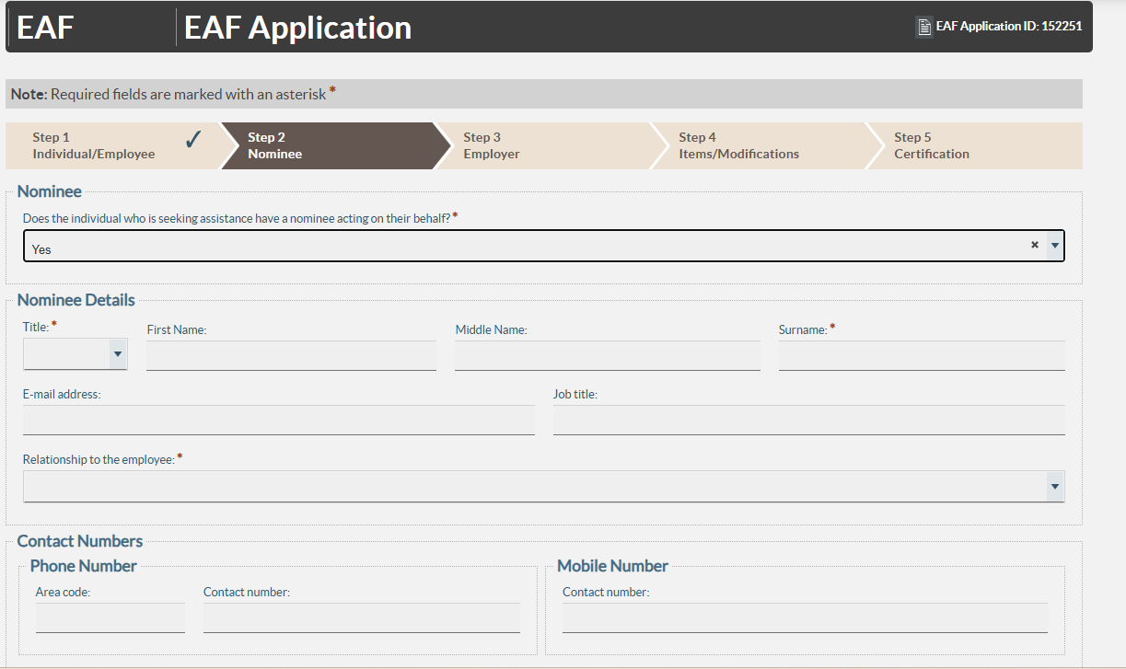

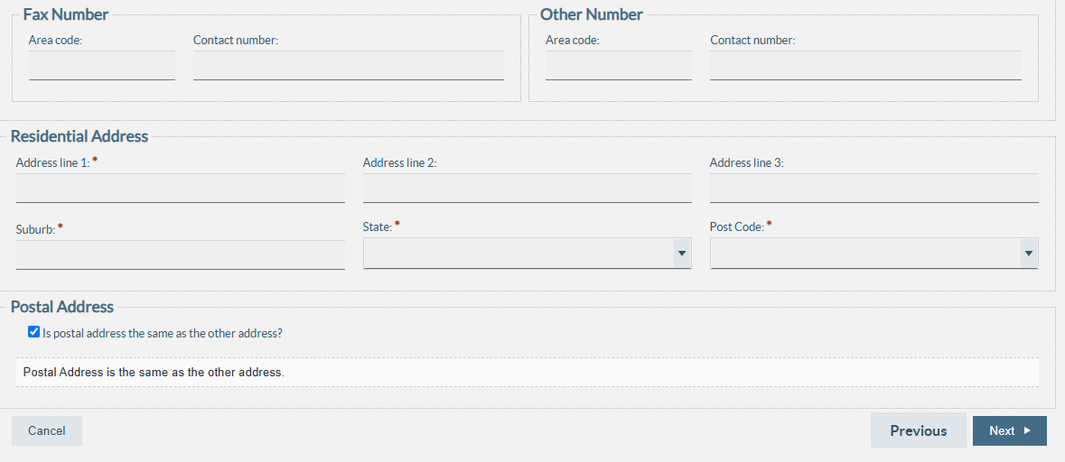

**Step 3: Employer**

* Fill in ***your employer’s details*** OR if you are self- employed, your own work details
* Next

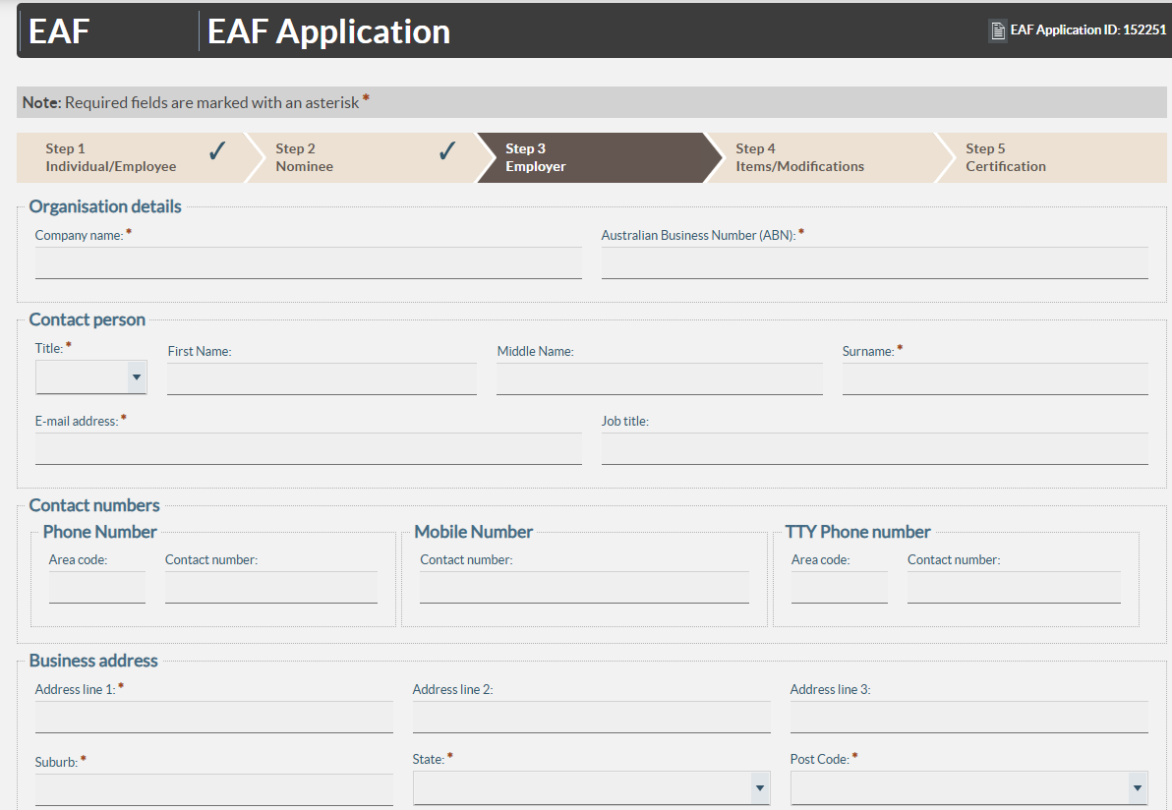

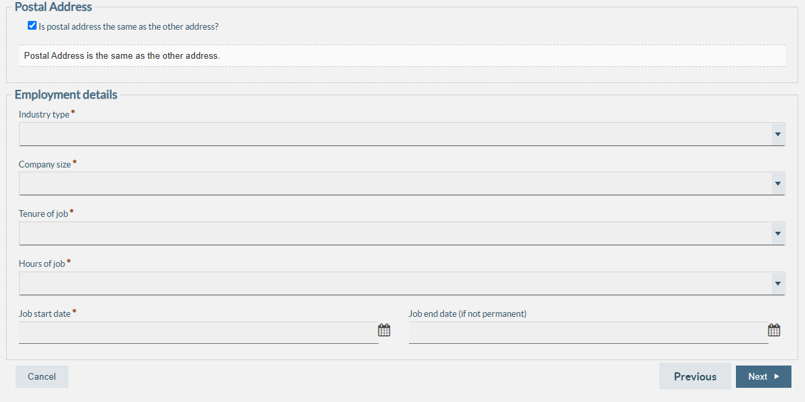

**Step 4: Items/ Modifications**

* Add item
* Item Type: Select “Specialist Mental Health Support” from the drop-down menu
* Item Cost: enter $1650 (that is $1500 + GST= $1650); note: the maximum you can claim is $1610, so you will be $40 out of pocket
* Reimbursement: select Employer (including self- employed)
* specify ADHD Coaching as the description of services you need

**Step 5: Submit the application**

After entering the required details, review everything, then submit your application. If you need to pause, you can save the application as a draft and return to it later.

**Stage 2: Approval of Nominee**

* **Email Notification:** Within 24-48 hours of submission, JobAccess will email both you and your coach after reviewing your application.
* **Authority to Contact:** They will include an "Authority to Contact" form in their email. Please complete this form and return it to jobaccessadvice@workfocus.com to confirm that your coach can liaise with them on your behalf.

**Next Action:** Complete and return the "Authority to Contact" form promptly.

**Stage 3: Sending Required Information**

* 1. **ADHD Diagnosis:** Medical evidence to verify your ADHD diagnosis.
  2. **Identification:** Certified copy of your Australian passport, Citizenship Certificate, or Permanent Resident Visa (if you were born outside of Australia).
  3. **Employment Verification:** Employment contract confirming that your role is ongoing for at least 1 day per week, for a minimum of 13 weeks.
  4. **Job Description:** A brief description of your role, including your typical responsibilities.
  5. **Disability Barriers:** An overview of the disability-specific barriers you are facing at work due to ADHD. If you want to speed up your application process, email this document to your coach so they can prepare their response (how to support your barriers)
  6. Please review the support plan your coach provided and make any necessary additions or amendments.

In the meantime, JobAccess will contact your nominated coach.

They will email your coach your Disability Barriers Document and ask the coach to write a plan with strategies they will employ with you.

Your coach will email their Support Proposal Document to JobAccess straight away.

**Please note:** Once your application is approved, you will need to pay for the services upfront and then request reimbursement from JobAccess, which will be deposited directly into your bank account.

**Stage 4: Application Approval**

* **Application Review:** JobAccess will review your application and typically send approval to both of applicant and coach within 48 hours of receiving all the necessary documentation.
* **Service Purchase:** Once you receive approval, you must purchase the approved services within 21 days.
* After making the purchase, you can apply for reimbursement.
* **Proof of Purchase:** Please refer to your approval letter for detailed instructions on how to provide proof of purchase so that you can claim reimbursement.
* **Note on Retrospective Claims:** If we've already begun the coaching process, you won’t be able to claim reimbursement retrospectively. However, you can claim for all approved services going forward.

**Next Action:** Once you receive approval, proceed with purchasing the services and follow the steps in your approval letter to claim reimbursement.

Your coach will keep you informed of all conversations with JobAccess and let you know if there is anything further required to support your application.