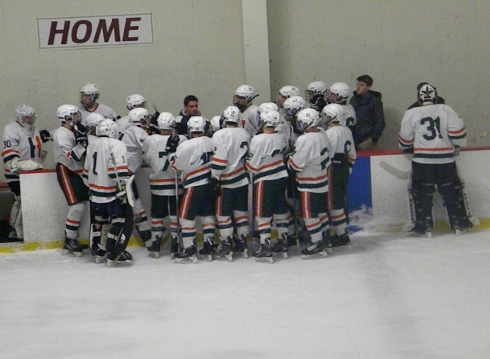

**Join us in celebrating 23 years of Hiller Hockey**

The Friends of Hillers Hockey (FOHH) organization was created in 1996 to support the launch of a High School program. FOHH hockey plays an integral part supplementing the program of things not covered by the athletic department. FOHH supports the program by funding activities to enhance the player experience and support the hockey community.

Our planned commitments for each season include:

* Assistant coach salaries
* Team program
* Team Building events
* Practice jerseys
* Player and family apparel
* Middle School night
* FOHH website
* The Pioneer Award
* Alumni game
* Additional equipment needs
* Senior night
* Captain’s practices
* JV ice and refs

After successful Varsity and JV seasons last year Varsity Coach Chris MacPherson and coaching staff are ready to start another season. Your support is crucial to the overall success of the program!

**Sponsor Levels:**

**Bronze-$20-$49 Silver-$50- $99 Gold-$100-$199 Platinum-$200-$249**

**Leadership - $250 and above (one season ticket to home games)**

Please send contributions made payable to FOHH, PO Box 331, Hopkinton, MA 01748

Name:

Address:

Amount: Recognition in Program (Y/N)