2022 Blueberry Jubilee
Arts & Crafts General Information

- Craft spaces measure approximately 12 ft. by 12 ft. If all of your items will not fit into your 12 x 12 booth, you will need to purchase additional space. ALL VENDORS WILL BE REQUIRED TO PARK IN DESIGNATED VENDOR PARKING AFTER UNLOADING. UNLOADING MUST BE COMPLETED BY 7:15 A.M., AND VEHICLES REMAINING IN THE CLOSED-OFF AREA AFTER THAT TIME WILL BE TOWED. NO PARKING ALLOWED IN JUBILEE CLOSED-OFF AREA. Transportation will be provided from vendor parking to booth spaces for those that are handicapped or disabled. Notify a council member (at the Blueberry Jubilee Office at 108 Beers Street) before parking.

- Space fee is $20 for non-profit booths, $60.00 for arts and crafts booths, $80.00 for Car Show vendors booths and $120.00 for Commercial booths (Check or Money Order) until May 15, 2022. Fees can be paid through blueberryjubilee.paypal@gmail.com
After May. 15, 2022, booth space fees must be paid with PayPal, cash, cashier’s check or money order. A $50.00 late charge will be charged for any applications received after May 15 and must be paid with PayPal, cash, cashier’s check or money order.

- Final deadlines for applying are:
March 31, 2022 - Returning vendors wanting same spot
May 15, 2022 - New Vendors

- An application is a commitment to show, with no refund for cancellation. Spaces are not transferable so you cannot sublet your space.

- This is a family-oriented Jubilee. Work and individual conduct must be in keeping with the atmosphere. The Jubilee Council has sole discretion for removal of vendors violating Jubilee rules.

- The Blueberry Jubilee Council will not be responsible in any way for damages to the work or persons participating in the show. Limited overnight parking is available.

- Photos required: Submit 3 photos showing you assembling the item(s) that you will sell.

- Entry fee, photos, and a self-addressed, stamped envelope (for your confirmation packet and returned photos) must accompany application. Make sure photos fit in the self-addressed envelope. IF YOU DO NOT ENCLOSE A SELF-ADDRESSED, STAMPED ENVELOPE, YOU WILL NOT RECEIVE CONFIRMATION BY MAIL. IF AN ENVELOPE IS NOT INCLUDED, CONFIRMATION CAN ONLY BE SENT BY EMAIL (if email is put on application). Checks will be deposited upon acceptance. Should your application be rejected, your check will be returned promptly. No postdated checks will be accepted. If your application is received by the deadline, you should receive your confirmation by June 1, 2022.

- Setup time:
Friday, June 10 (5:30 p.m. to dark) or Saturday, June 11 (6:30 to 7;15 a.m.)
Absolutely no setup before 5:30! Vendors who attempt to set up prior to 5:30 will be asked to
leave and space fee will not be refunded. Vendors who arrive prior to 5:30 on Friday will need
to report to vendor parking until time to set up.

After 7:30 a.m. vendors MUST park in vendor designated areas. (Map will be included in the
confirmation packet.) NO VEHICLES WILL BE ALLOWED TO REMAIN IN THE CLOSED-OFF
AREA. UNLOADING MUST BE COMPLETED BY 7:15 A.M. VEHICLES REMAINING IN THE
CLOSED-OFF AREA AFTER THAT TIME WILL BE TOWED AT THE OWNER’S EXPENSE, AND
THE VIOLATORS CAN BE ASSESSED A $100 FINE AND LOSE THEIR BOOTH SPACE.

The Blueberry Jubilee Council makes the final decision.
NO VEHICLES WILL BE ALLOWED IN THE CLOSED-OFF AREA UNTIL 4:00 P.M.

- Take Down Time: June 11 (4:00 to 5:00 p.m.)
No vehicles will be admitted in area before 4:00 p.m. Vendors that attempt to pack up or enter
the area before 4:00 p.m. will not be accepted in the future.

- Return tax envelope to the Blueberry Jubilee Office at 108 Beers Street.

- No wearing apparel bearing "Blueberry Jubilee" may be sold except by the Jubilee Council. No use of
the Blueberry Jubilee artwork will be allowed.

- No political information of any kind will be allowed in any booth.

Categories:
- Crafts
Painting, drawing, graphics, sculpture, pottery, dolls, weaving, quilt-making, original needlework, woodwork, handmade jewelry, metal work, basket-making, etc. Commercial items are not allowed to be mixed with crafts. If commercial items are in booth, vendors will be asked to remove them. If not removed, vendor will be asked to leave, forfeit booth space fee, and not be accepted in the future. Electricity (110 volt 15 amps) is available in areas for an additional fee. Vendors that use electrical outlets without permission will be asked to leave, forfeit booth space fee, and not be accepted in the future. Vendors are responsible for their own extension cords. No generators are allowed at the Blueberry Jubilee.

- Commercial Booth Displays
A specific limited number of commercial booths are available. These booths will be assigned on a first come, first served basis as applications are received. Items that directly compete with crafters will not be allowed as determined by the Blueberry Jubilee Council. No display will be allowed to block other vendors from being seen. Electricity is not available in commercial booths, and no generators are allowed at the Blueberry Jubilee.
Please send completed application with payment to Blueberry Jubilee Council to:
Tammy Krutzfeldt
P.O. Box 4
Poplarville, MS 39470
For further questions contact: (601) 795-7033
See us at www.blueberryjubilee.net
Payment can be made through blueberryjubilee.paypal@gmail.com

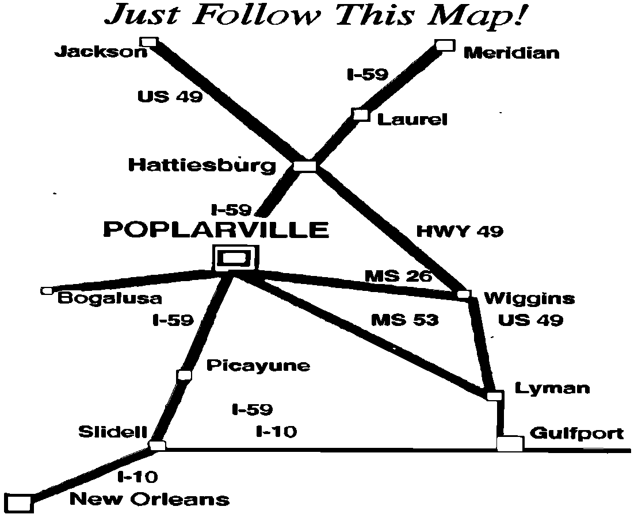
2020 Blueberry Jubilee
Application for Arts & Crafts Booths

Please Print Name:__________________________________________________________

Address:_______________________________________________________

City:______________________________ State___________________Zip Code________

Day time phone:_________________ Night time phone:___________

Cell phone:_____________________
E-mail address:_______________________

Booth space number requesting:____________

Check if you want e-mail confirmation_____ (be sure to put your e-mail above)

1. Entry Division: Check one and enclose payment to Blueberry Jubilee Council

_____ Single Non-Profit Craft Booth $ 20.00
_____ Single Craft Booth $ 60.00
_____ Double Craft Booth $ 120.00
_____ Car Show Vendor Booth $ 80.00
_____ Single Commercial Booth $ 120.00
_____ Double Commercial Booth $ 240.00
_____ 110 Electricity (limited) $ 10.00
(not available in commercial booths)

______ Late Charge after May 15, 2022 $ 50.00

*Make check payable to Blueberry Jubilee Council. After May 1, 2022 only PayPal, cash, cashier’s check or money order will be accepted.

2. List Item(s) to be sold:______________________________________________________
_____________________________________________________________________

3. Display Material Needed:
Bring own display. Please check one of the following if you are bringing a canopy:
_____Self-Standing (no anchors)
_____Needs to be on grass (needs anchors)

4. The Blueberry Jubilee Council will not be responsible in any way for damages to the work or persons participating in this show.

I certify I have read the Arts & Crafts General Information and agreed to the rules therein. (BE SURE TO READ THE GENERAL INFORMATION AND RULES ESPECIALLY CONCERNING VEHICLES PARKED IN THE CLOSED-OFF JUBILEE AREA. THIS WILL BE ENFORCED!)

Signature(s):__________________________________________________

License Plate State, County/Parish & #:
_______________________________________________________________

