An Auto rack Facility for Leeville- Jeff Lee MMR

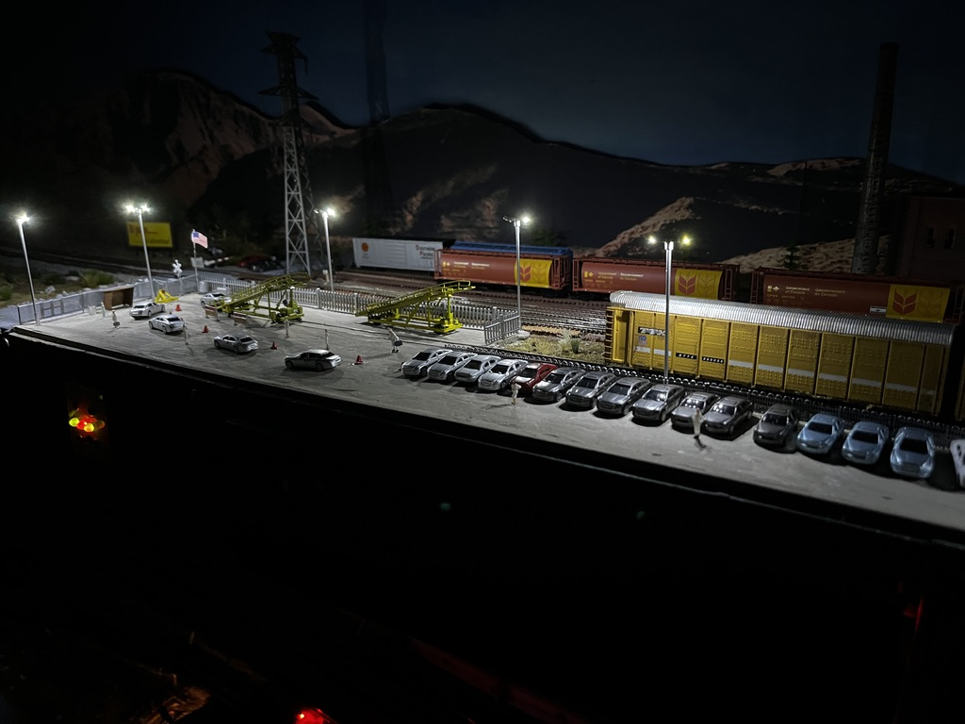

Several years ago, I was “forced” to spend a weekend in Chicago on a business trip. Of course, there are the jazz clubs and many other delights of Chicago. I also checked the NMRA and other sites for what was on and there was a major train show in Milwaukie. Well, Milwaukie is a 90 minutes’ drive, so I hired a car and off I went. As well as an outstanding event, one reseller had Atlas Autoracks in N Scale for $8 each. How many could I fit into my carry-on luggage? I think I bought 8 sets and carried them home to Australia.
Now, Leeville, a contemporary period UP / BNSF N Scale layout has had this 16-car auto rack train for years but has no loading facility. Operators complain there is no facility, so I had to build one.
There is a great auto loader facility modelled by Daryl Crews (UP Genesis Subdivision) but I did not have that available space. However, I did have a long spur that could be developed and would have enough room for 50 autos to park, plus loading facilities.
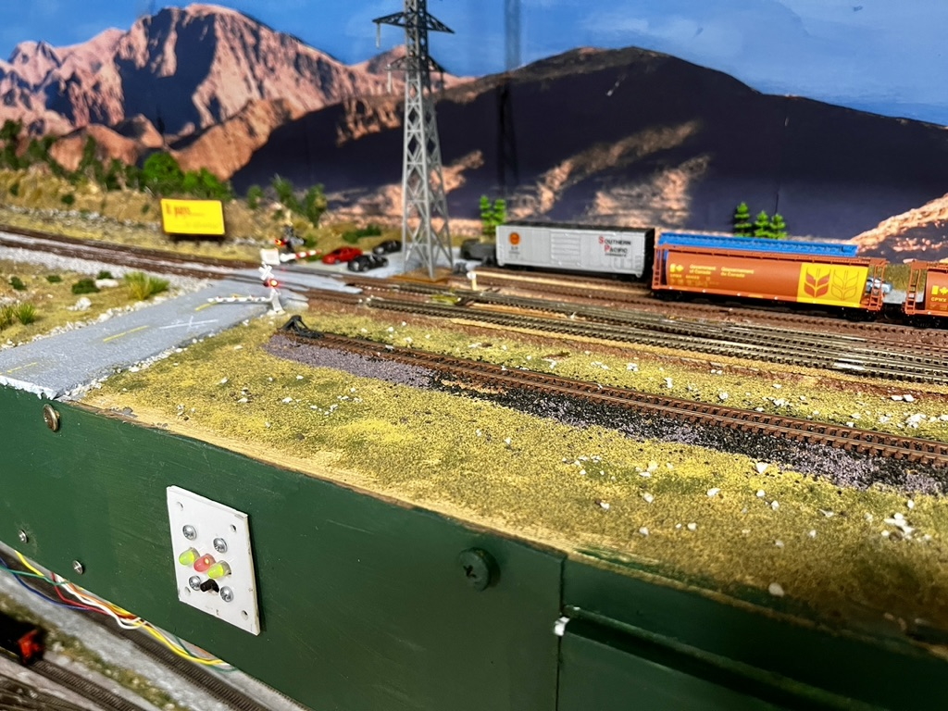
Fig. 1: The end of the spur track where I will build the car loading facility.

The site was covered in ground cover and the track was ballasted.
The first stage was to define the area.
I removed the larger pieces of landscaping and identified the area that would be concreted. Once the area was identified I used 3mm square timber as the edges for the concrete slab. This timber edge was glued and pinned down until the glue dried. I used PVA white glue, but a woodworking glue or Gorilla Glue would also work. Then I formed up the base ready to lay concrete. For concrete I used Sheetrock (Gyprock) Base Coat. You can buy it in a powder form or already mixed. Go for the ready mixed – it costs a bit more but is useful everywhere on the layout and is ready to use.

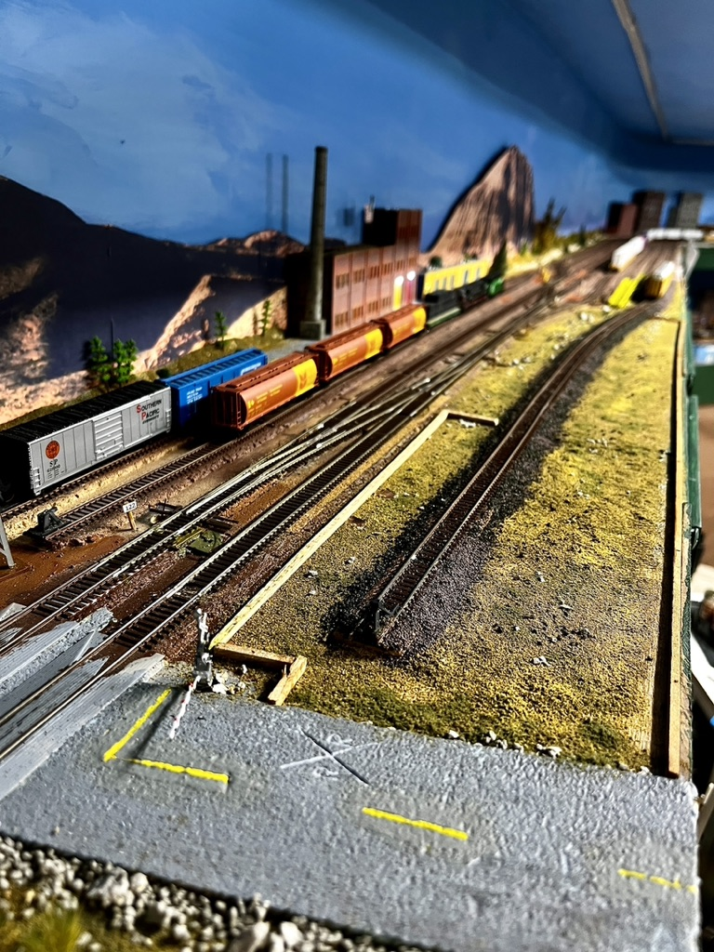
Fig 2: Area formed up ready for “concrete”

The next phase was to pour the concrete. I could have used a Woodlands Scenics product, or plaster etc, but decided to use some Sheet Rock base coat that I had.
Here is the first layer before sanding. I used a spatula to screed the plaster and get it roughly level.
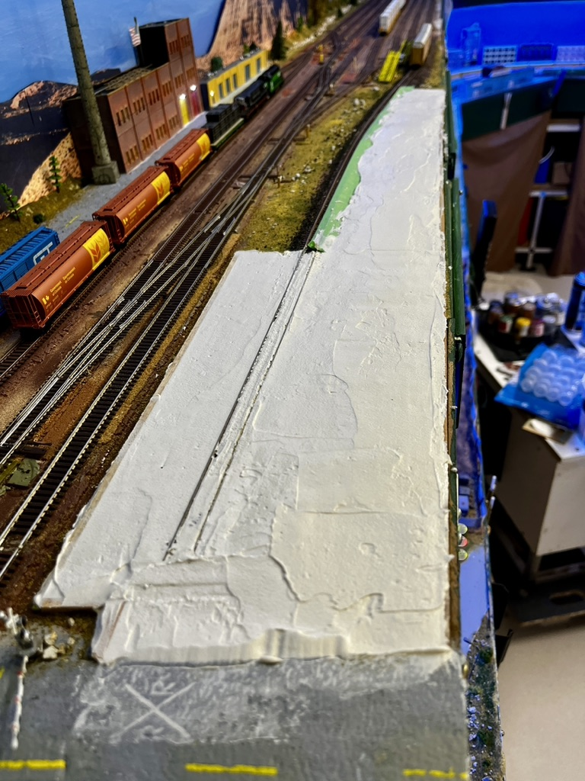
Fig 3: The area covered with the concrete base before sanding.

The green in the distance beside the track is masking tape to protect the track that has been ballasted.
It was extremely humid when I laid the base coat and several cracks developed as it dried. Drying took several days. Base coat is ideal for patching those cracks and it took several attempts to get the surface smooth and relatively crack free. Where there were still cracks, I dry brushed some black paint along the cracks to simulate patching.
Once dry I used Woodland Scenics “concrete” to paint the concrete. This required several coats as the Base Coat soaked up the paint. This worked out well as the extra coats randomly added gave the concrete a real worn appearance.
I used a set of bogies with “cookie cutter wheels” to drive a gap in the concrete along the tracks. This worked well and with a little vacuuming there was little maintenance to do after the concrete set. What maintenance that is needed is easy to do and then vacuum away.

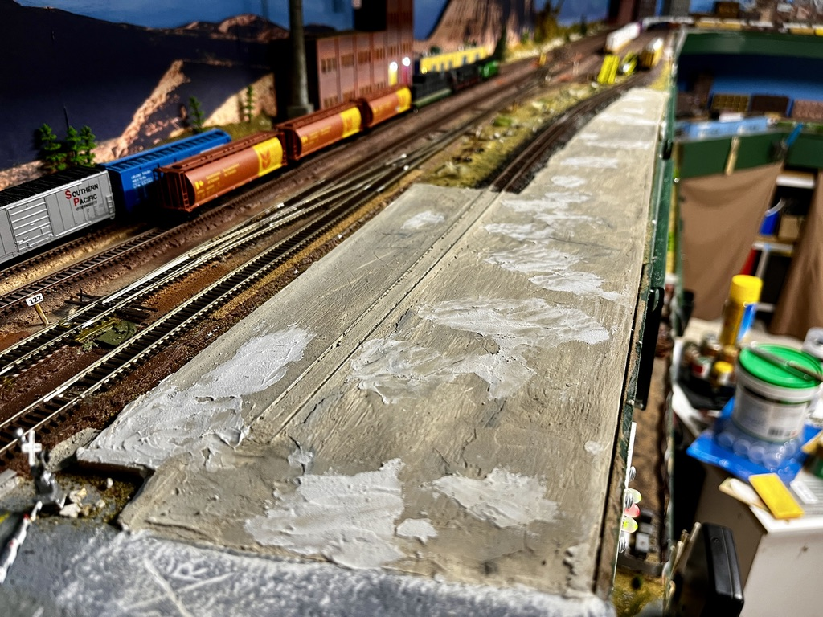
Fig 4: Patching the concrete base before more sanding.

The concrete base was lightly sanded and again brushed with Woodland scenic concrete. These multiple coatings produced a very realistic concrete finish.
Next, we needed to fence the site. I had various fences and for a large section I used some Atlas railing. This was painted black, so I spray painted it an aluminium colour. This fence comes in small sections which I needed to join. I laid out the fence on double sided tape at the workbench, and glued it together, using plastic weld.

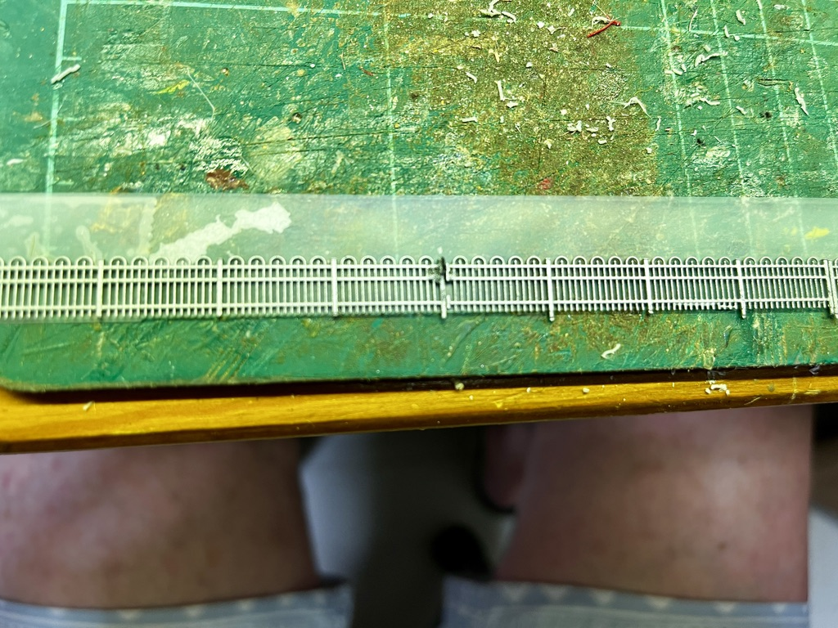
Fig 5: Atlas fences on double sided tape.

This fence is the most visible. I installed it by drilling holes for the fence posts. The fence was still held by the tape as I inserted the fence posts into their holes and used a little CA cement to hold it. Once secure the tape can be “rolled” off the fence.

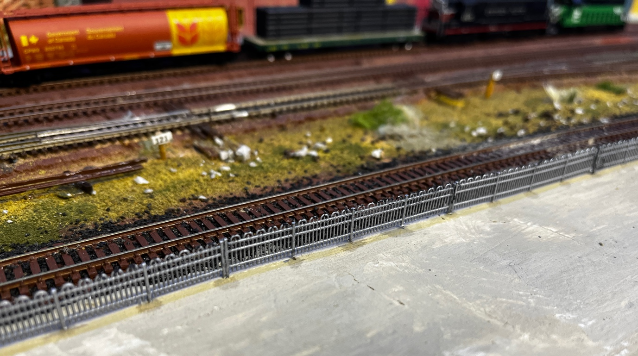
Fig 6: Fence installed besides tracks. Holes drilled and CA glue used to hold the fence.

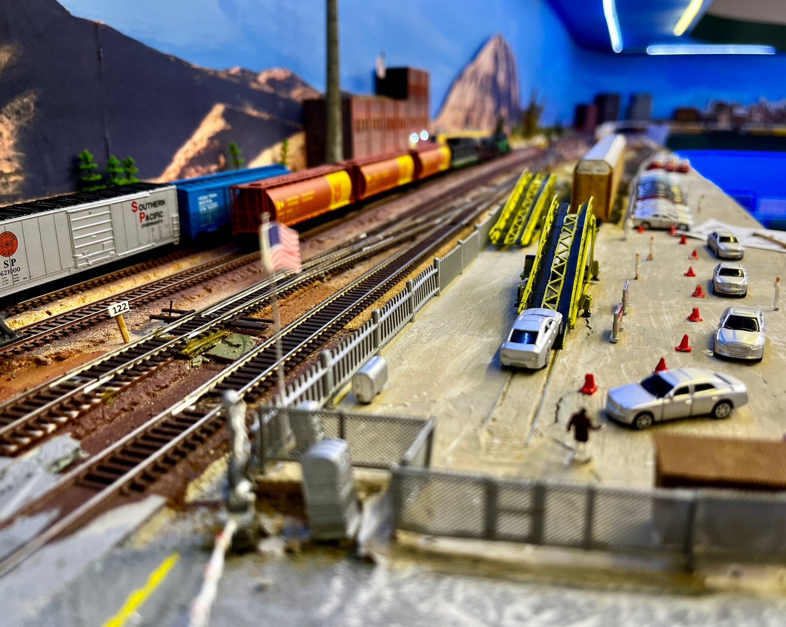
Fig 7: Woodland Scenics Industrial Fencing.

For the entrance to the site off the road I used Woodland Scenics Industrial fencing.
I purchased several bags of cars from AliExpress. Fifty (50) cars painted and delivered cost about $20.
Next, I parked the cars, trying to put similar models and colours together so they looked like batches.
I recently bought a 3D printer and found a car loader available for downloading. It took a couple of attempts to get a reasonable model built, but the investment in the 3D printer has paid for itself.
To show activity on the site I added people directing traffic to the loader, and several safety cones to direct the drivers. I glued the people and cones to the concrete with a touch of PVA white glue. The people were held in place with tweezers whilst the glue dried. Again I have people from Kato, Tomix, and several other “expensive” and quality suppliers, but when you need a lot of people AliExpress has them in large quantities for around $10 a bag.
Security at a car loading site is key and I installed several industrial lights. These LED lights are 3 volts. I added a 470 ohm resistor and attached them to my 5 volt DC bus, with an on-ff switch on the facia. I use WAGO connectors which I find very practical for connecting cables. (Fig 9). I do have many Light Up controllers and their Woodland Scenics LED lights, but in this case I either wanted the lights on or off.
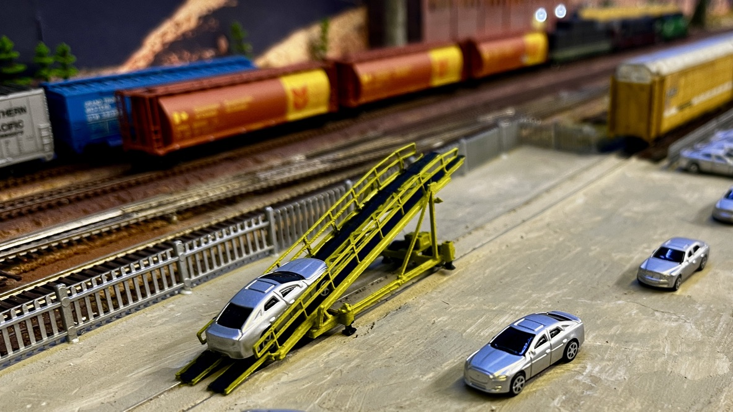
Fig 8: 3D printed car loader.

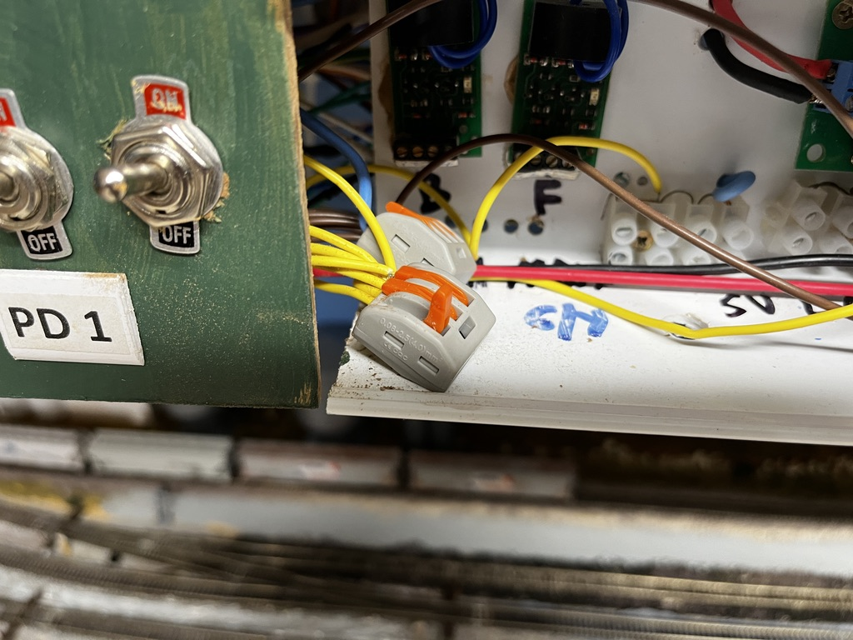
Fig 9 Connection to 5 volt bus and fascia switch via WAGO connector.
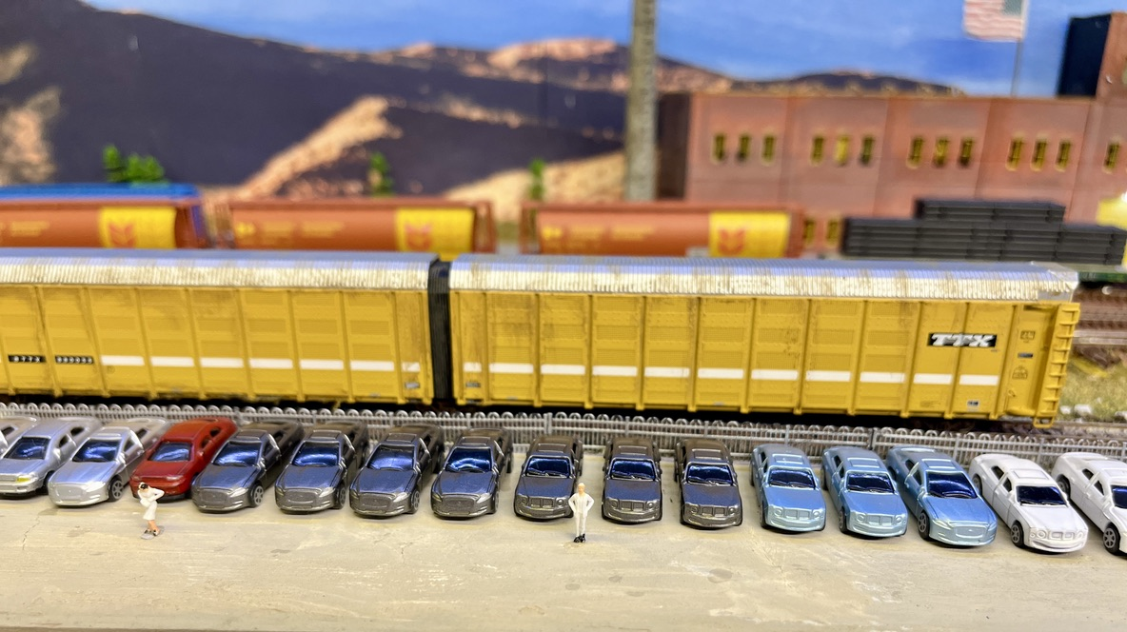
Fig10: Cars waiting for loading.

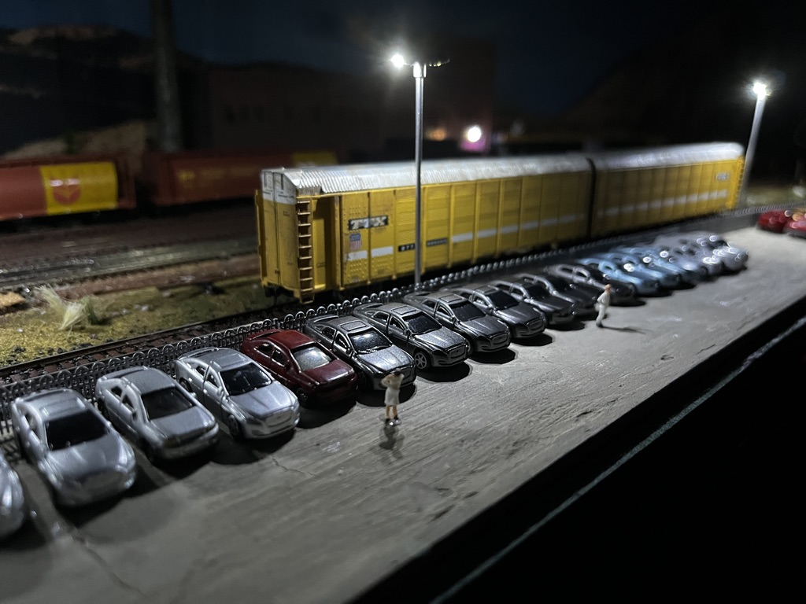1
Fig 11: Work goes on during the evening.

I am satisfied with the finished result. In terms of supplies most of the cars, people and industrial lights were bought using AliExpress. The industrial lights were less than $10 (for 10), the people and cars a similar price. The fences, although not top quality were from my spare parts bin.
In my opinion “Gold Medal Models” make the best industrial fences which I have on other dioramas on the layout. However, the overall feel and look of the loading facility works.
I hope you get some ideas from my experience.

