Building a Stub End terminal – Part 3

The Scenery:

Once the track is laid, and the electrical components are working the next phase is to complete the scene. You may remember from the first part where I debated over an industrial site or several industries. I eventually decided on a one industry terminal: - an ethanol plant.
Looking at the photo below of an ethanol plant, you can see a consistency in the style of buildings. Some silos are aluminium or steel and some are a white colour. Buildings tend to be steel framed and steel panelling clad.
The size of the terminal I am working with is 1880 x 500mm and we are working in N Scale. I googled ethanol plants and found several that gave me some ideas.

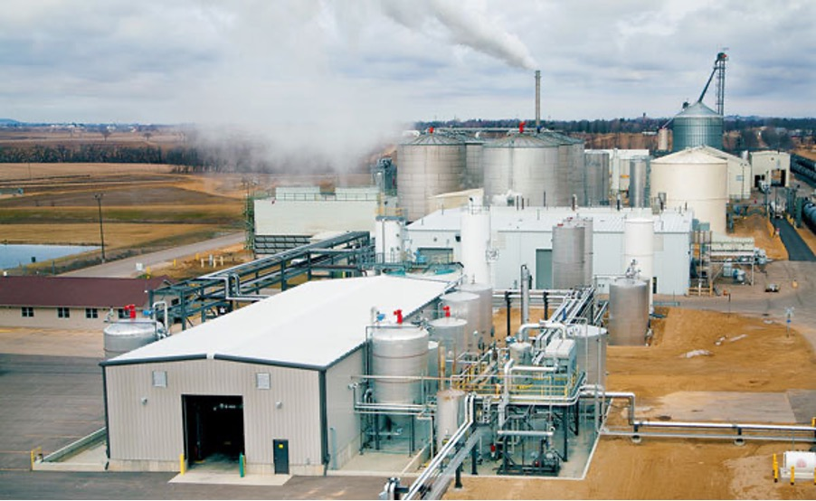
Once I had this idea, I proceeded to mock up some buildings. I used foam board to build the shapes. Some mock ups were also made with thick cardboard. Every building except the grain silos is scratch built, using photographs like the one above to get ideas.
The mock ups were glued together with PVA white glue – sometimes painter’s tape.
Often the building looked out of scale. The advantage of building mock ups is that it is easy to use a sharp knife and cut them down to size.
Once I had a rough idea of the buildings needed, I had a plan that needed execution.
I cut out sections of perplex as bases for the structures and plant equipment. These bases fitted into the allotted area between the tracks and board edge. Each is about 40 cm long.
This would allow me to make the mini scenes at the work bench. I spray painted the perplex base grey and pencilled the location of the buildings before taking the base to the work bench.
Below are two bases and “mock ups”. The tanks are water pipes and the buildings foam core at this stage. You can see the grey perplex bases in this photo. Note the painter’s tape on one of the buildings and the position for windows and doors drawn with a sharpie pen.

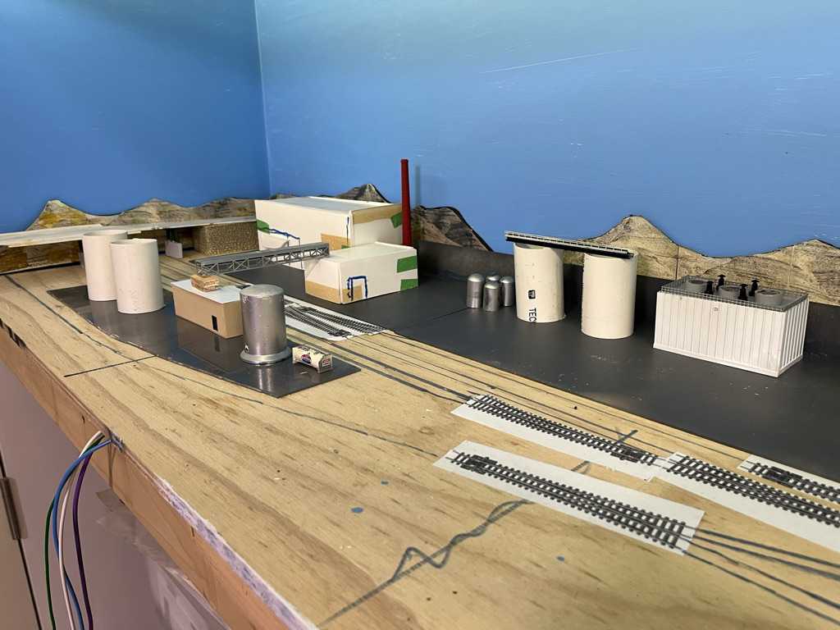

- Key Buildings:

Once the mock up buildings were done each of the perplex bases were removed to the work bench.
Having the key buildings sized and finished in cardboard, or foamboard allowed me to build the models. I used Plasticut cladding to construct the outer building. It was possible to use the cardboard or foam board mock up to support the outer cladding. This double layer also provided support to minimise any warping of the model. The lesson here is when cutting the foam board for the mock ups make the cuts square. That way the mock up can be a frame for the finished building.
Places for windows and doors were identified in the cladding and cut out with a nibbler. Once attached to the mock up the area behind a window, or door was deleted, so I could insert a window or door.
Future considerations in each building included exterior and interior lighting and detail.
Follow along and I will share how I used new cladding, old parts, and scrap to build the structures.

Here is a small storage shed. It is made with foam board to make the frame. Then I clad it with vertical steel panels. I used small 90 degree angle to mould all the corners. The roof is 2mm styrene covered with corrugated iron. I needed a large door so one was selected from the scrap box. I could have used the steel cladding glued horizontally to simulate a door. I had to cut the opening and then cut away the foam board behind. A small frame around the door completes it. The model was then sprayed with a primer. When dry, the walls were spray painted off-white and the roof painted silver. The door and frames were hand painted grey. Downpipes were added and the model weathered by dry brushing some “rust” coloured powder.
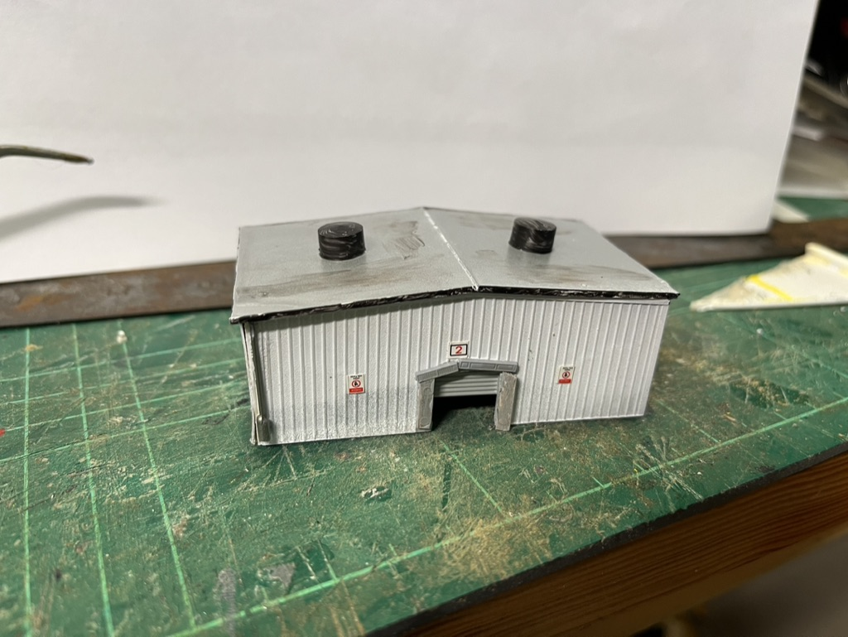
Finally, a mini-LED was inserted above the door. I used a 1mm drill in a pin vice to make the hole and fed the wires through. For HO or N scale, mini-LEDs are ideal as external lights.

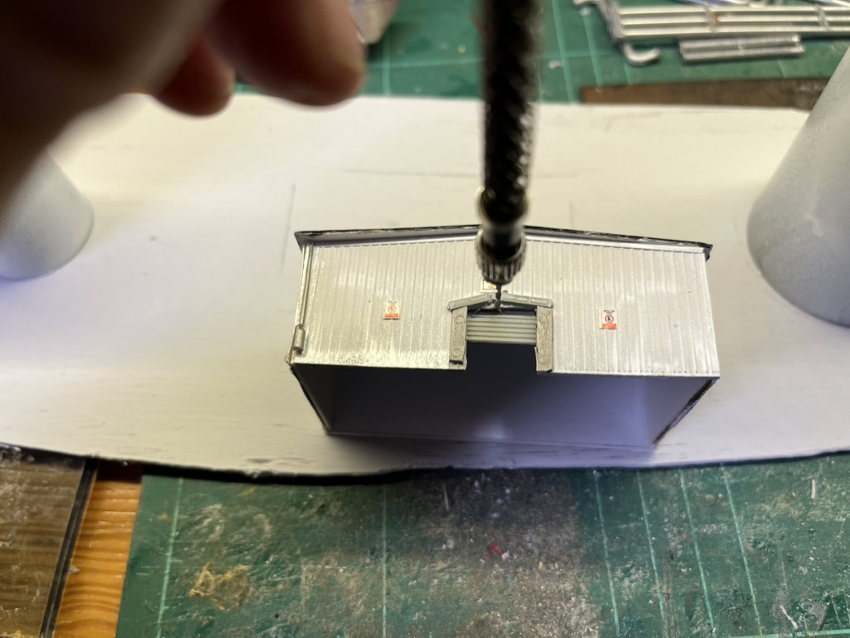

Here is a cooling tower. This also is a simple building. The frame is foam board. The cladding was added to the front and two sides. I had this cladding in my spare parts bin. The railing is a cut down plastic fence, again from the parts bin. The exhaust stacks are small pieces of 20mm conduit. I cut pieces of fiberglass screen wire to insert in the exhausts. Some left over chimneys were initially used but later replaced as they looked out of scale. The whole model was spray painted with a grey primer and then painted off white. The roof was covered with white PVA glue and ballasted with grey track ballast.
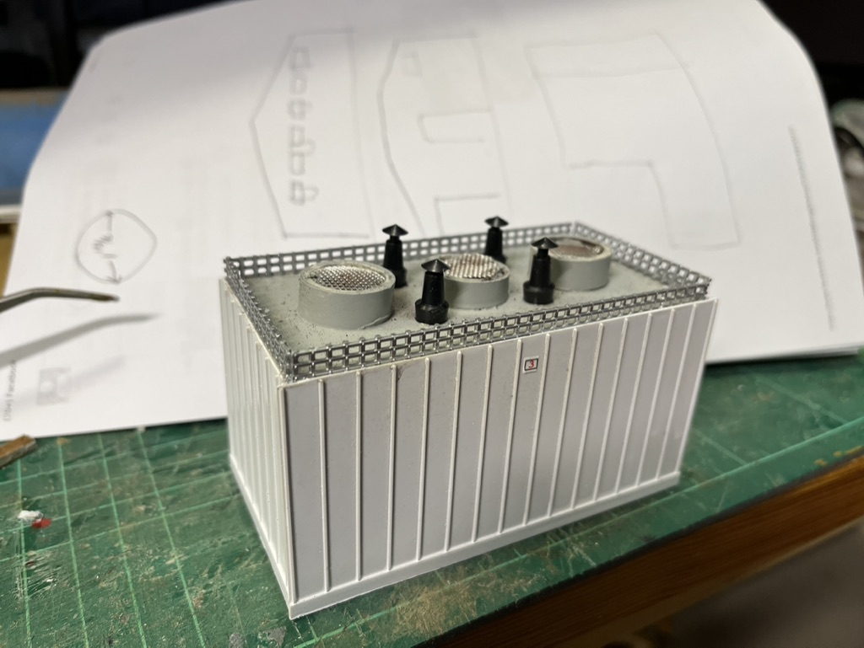

Here is a small office / storage building that is completely scratch built. All of the panelling is Plasticut cladding. The windows were inserted after nibbling the openings. Angle styrene was used on the corners. The building has a centre dividing wall which acts as strengthening, and allows one half of the interior to be lit. An external mini-LED was inserted above the door on the left-hand side of the photo. A small piece of styrene above the door provides an awning and covers the LED.
Some details like the drum and small gas cylinder complete the building.

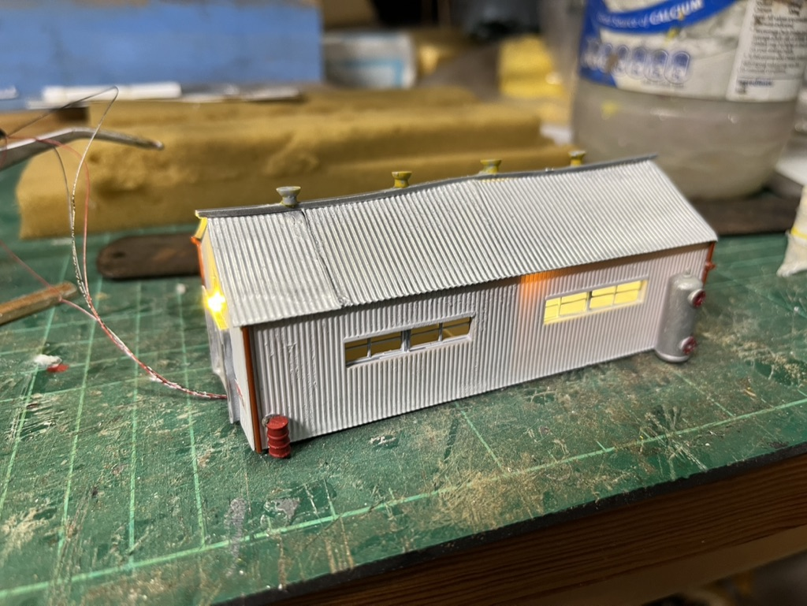

Here is a truck canopy that was left over and part of my spare parts box. I also had a petrol pump that I attached. The idea was to attach it to a storage building.

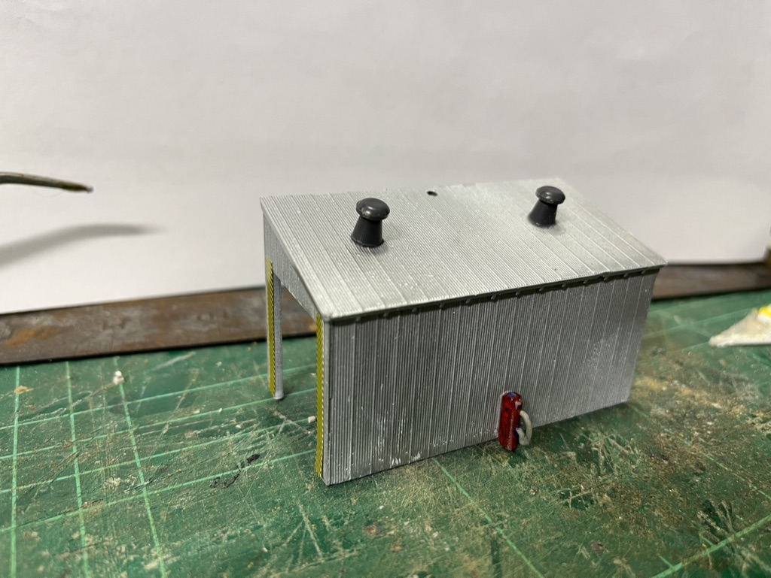

Here is the foam core frame for the storage building. I use magnetic 90-degree angles to hold the frame square whilst the PVA is drying.
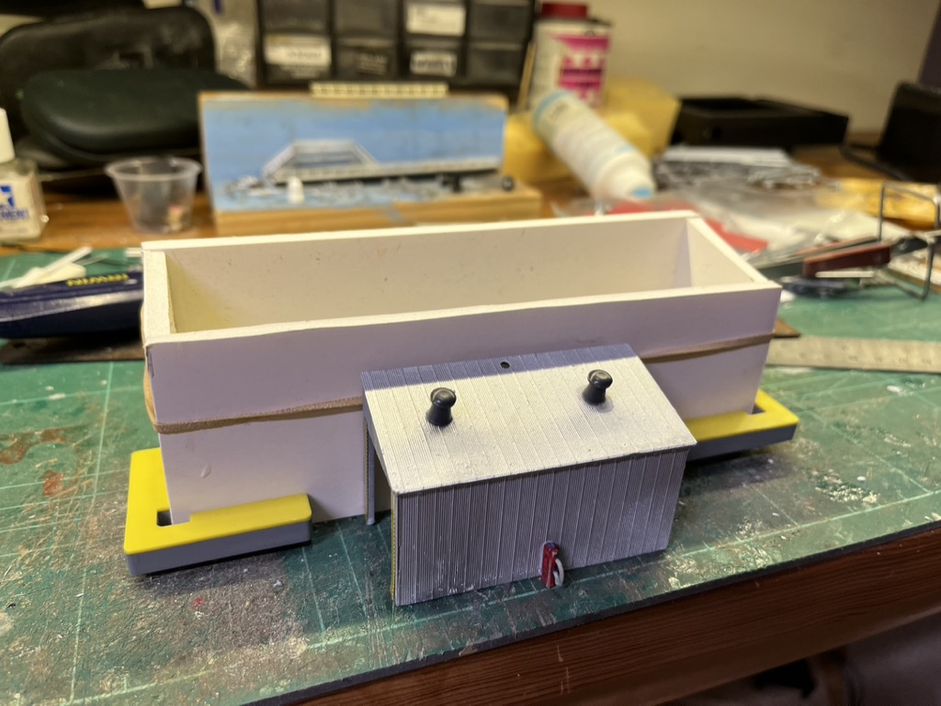

Here is the model almost finished. It is clad in Plasticut steel cladding. The windows came from the spare parts bin and the door (not visible on the side) was the cladding with the joins horizontal to represent a roller door. LED lights were inserted under the roof of the truck canopy. The wires fed into the building and out the base. I didn’t like the dark grey roof so again I ballasted the roof with light grey ballast.

In the scene below at the workbench I position the building on the perplex base (now painted a light grey) and start to install piping and other details.
The two storage tanks are 20mm water pipe. The horizontal lines on the tanks are black thread fed through holes in the rear and super glued in place. (See on for more silo details) Once the tanks are spray painted, they look realistic. The building to the left in the photo is the original mock up clad with styrene cladding.
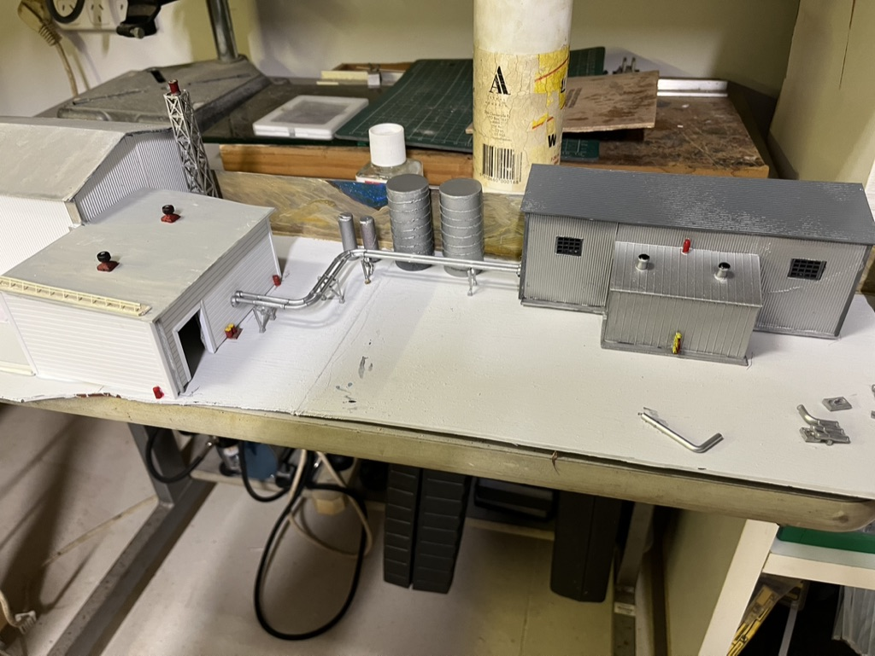

2: Assembling the scenes:

Once the basic buildings are completed for each of the bases it is time to bind them together into a scene. Here are two of the buildings in position at the workbench. Some pipes are connecting the two buildings. The road is painted onto the base and edges, representing footpaths are glued down. The area where there are tanks and piping, is ballasted to represent a gravel base. At the front of the photo the area is covered with ground cover.
My method for ground cover is:
- Paint the area with PVA white glue
- Sprinkle a base dirt cover.
- Add some burnt grass.
- Add a little yellow grass.
- Add some tallis to represent rocks.
- Spray the whole area with wet water (water with a few drops of detergent, or mentholated spirits.
- Soak the area with 50/50 PVA and water from a dropper.
- Leave to dry, then add small brushes.

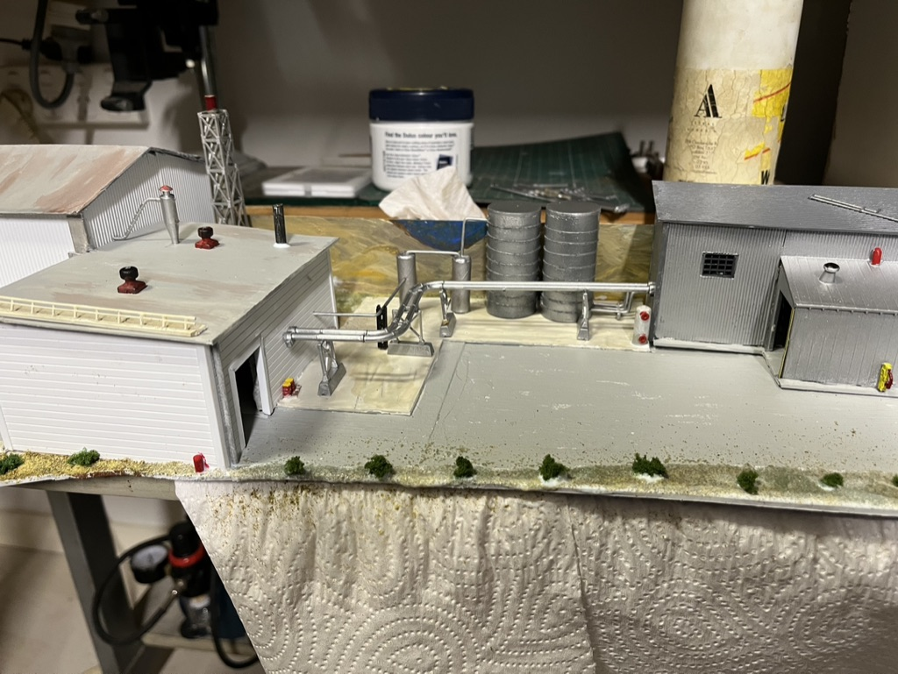

Here is that same section positioned on the layout before any details are added.
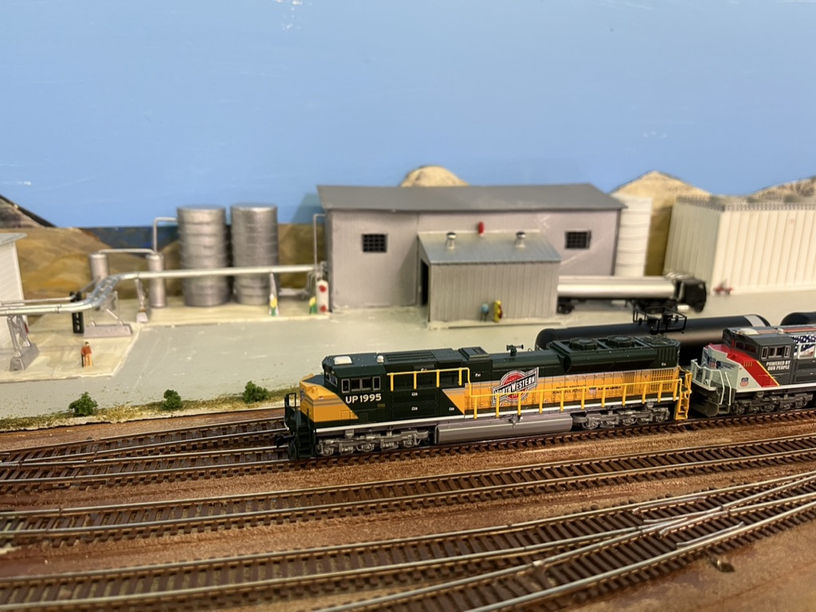

Here is another section being assembled at the workbench.
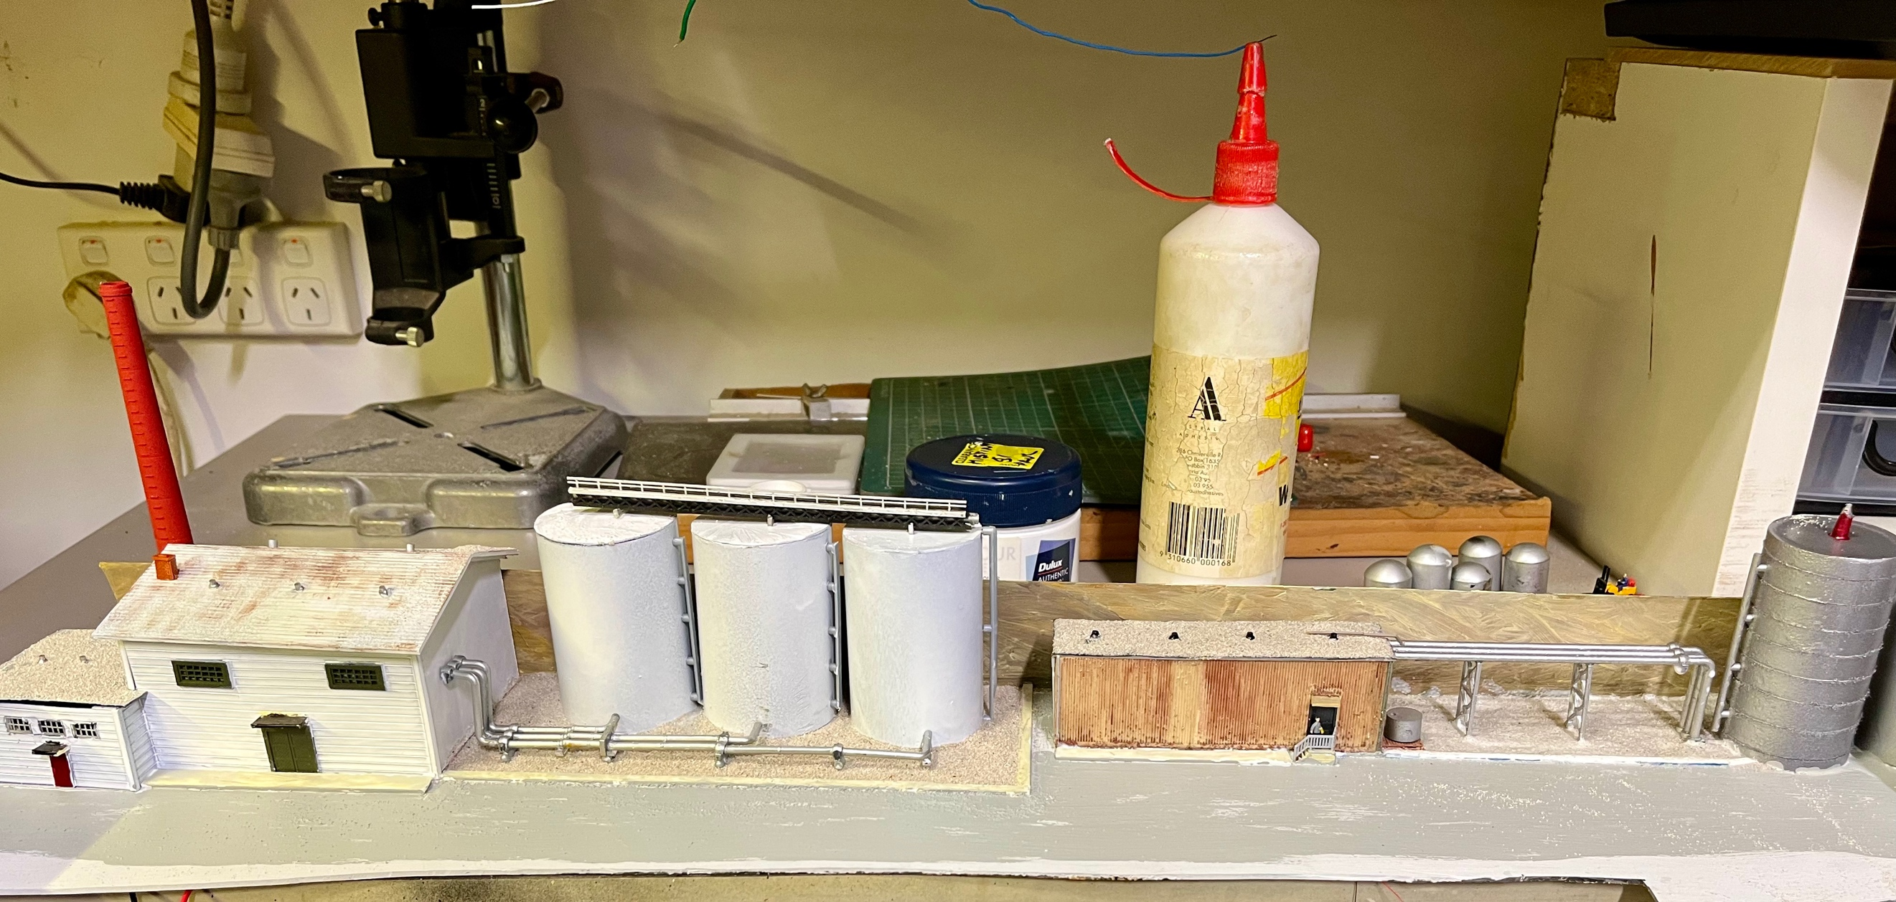

Here are the steps to provide the road base to the working areas.

- Cover the area with PVA white glue and spread with an old brush.
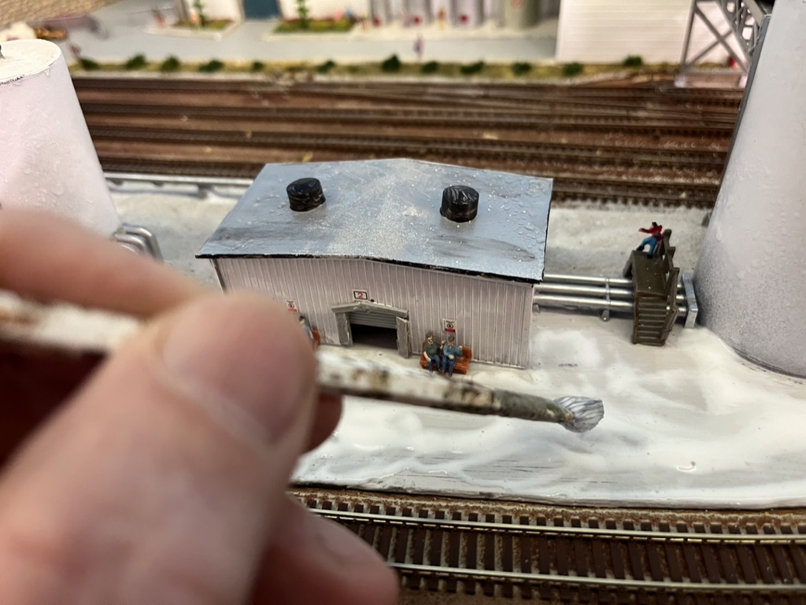

- Sprinkle on the grey ballast
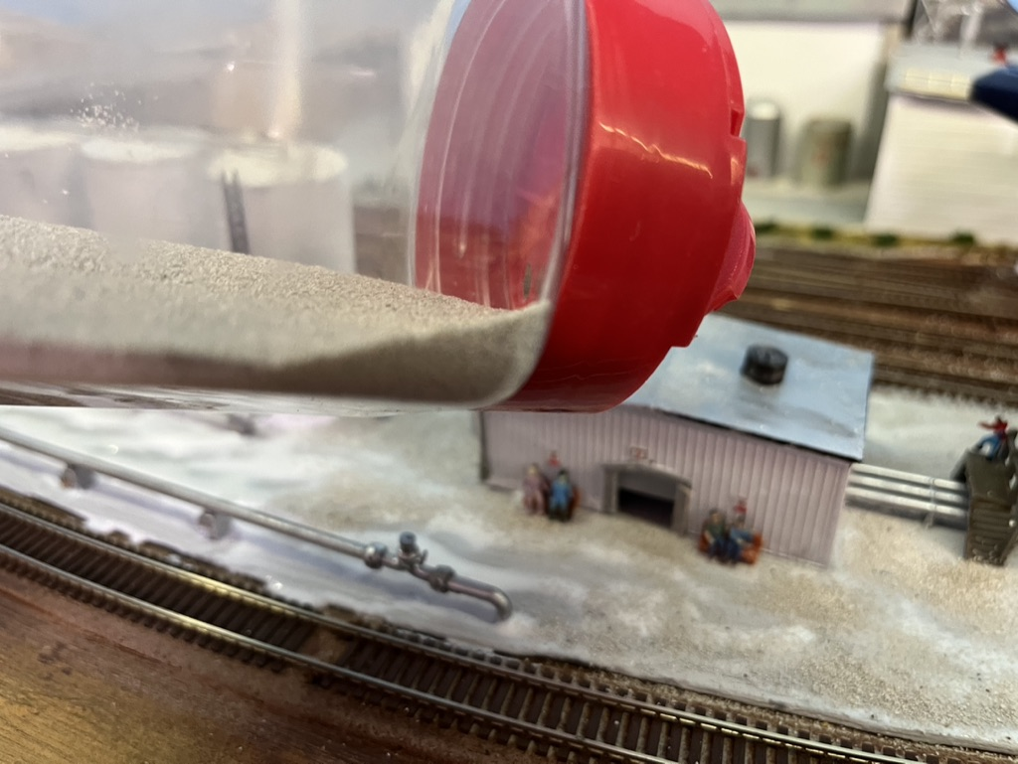

- Spray the ballast with wet water and then soak the area in 50/50 PVA and water.
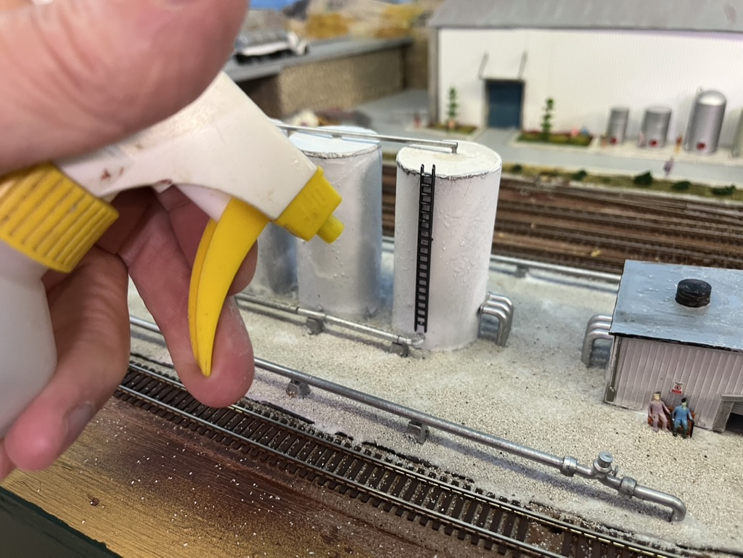

- Leave to dry.
Before placing and gluing the mini scenes on the layout I needed to drill holes in the baseboard for the wire leads for the interior and external lights.
Then once the bases are installed on the layout, they can be connected as below and glued down. In the scene below I have some piping with a girder frame across the tracks between the building in the background and the large storage tank at the front.
The pipe on the side of the tank is the throw away sprue piece from a plastic kit I sanded it to represent multiple outlets from the tank. A ladder was also added to the tank. The tank is 25mm water pipe.
The 4 tanks on the left of the photo are 15mm plastic water pipe. Other details are people sitting on benches outside the storage shed, an overhead walkway across some piping, and later I will add some other details like drums and workers.

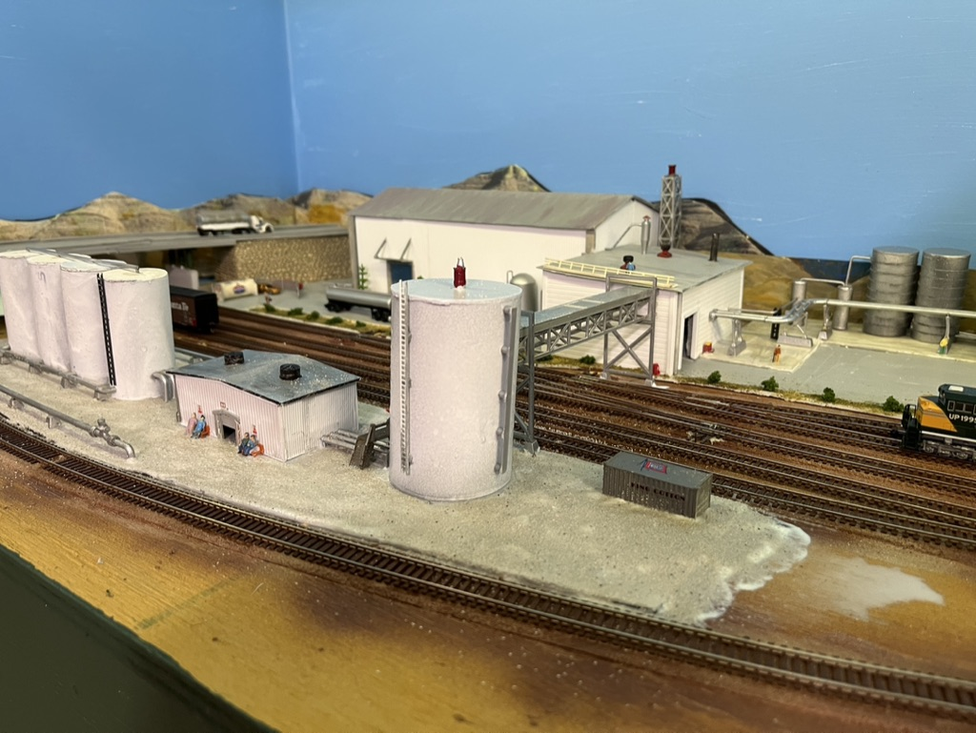

Here is a peak across the tracks of the main entrance to the ethanol plant. Details like a garden, storage tanks for oil and a tanker start to complete the scene.
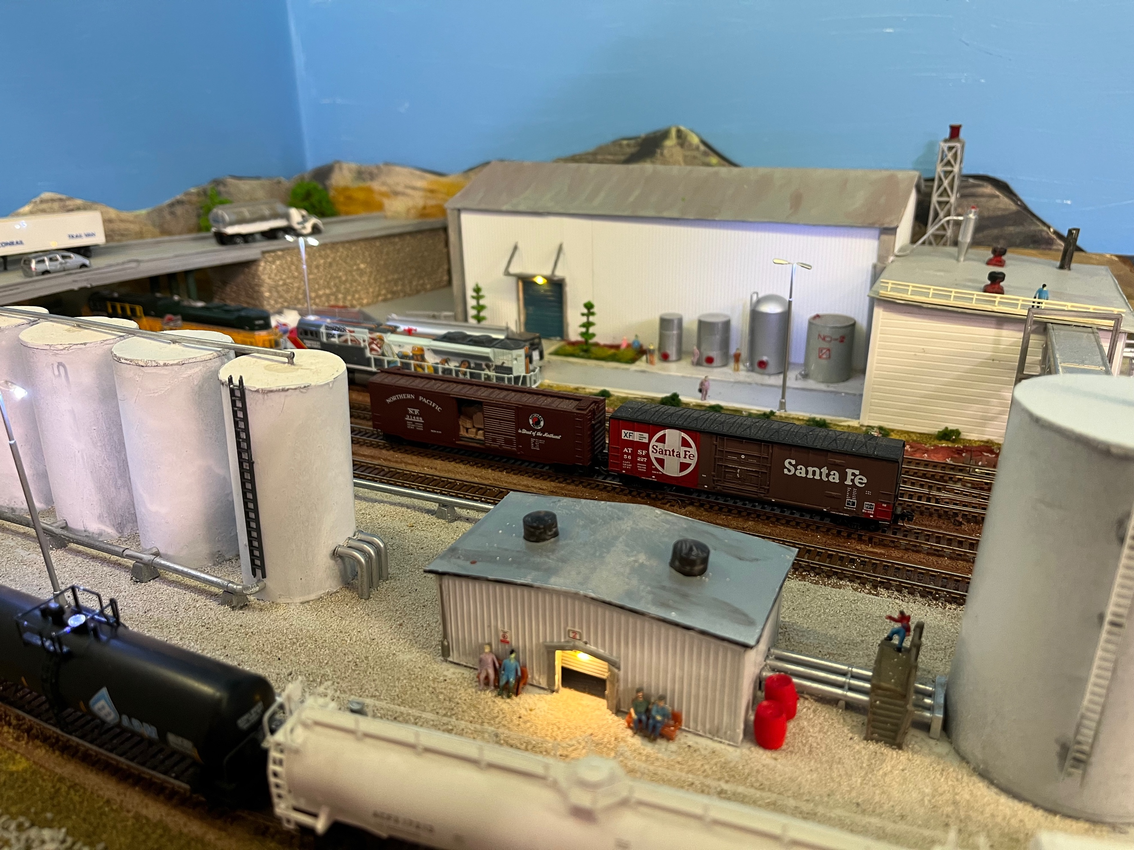

3: Track Buffers:

I have several commercial track buffers but here is an idea that may work for you.

I make the buffers from strip styrene.
See the photo below. There are two sides to the buffer.
The bottom section is 0.8mm square and 20mm long.
The vertical and sloping parts are 0.6mm styrene.
The buffer itself is a small piece of 0.8mm styrene.
The base is a small piece of styrene, 20mm long that fits between the tracks.
Glue the two sides to the base and glue the two sides together at the top buffer.
Spray paint dark grey, black or a wood colour.
There you have a very quick and cheap buffer stop.
The photo shows the two sides on a piece of tape and the lower part is a completed buffer sitting in a piece of track before painting.

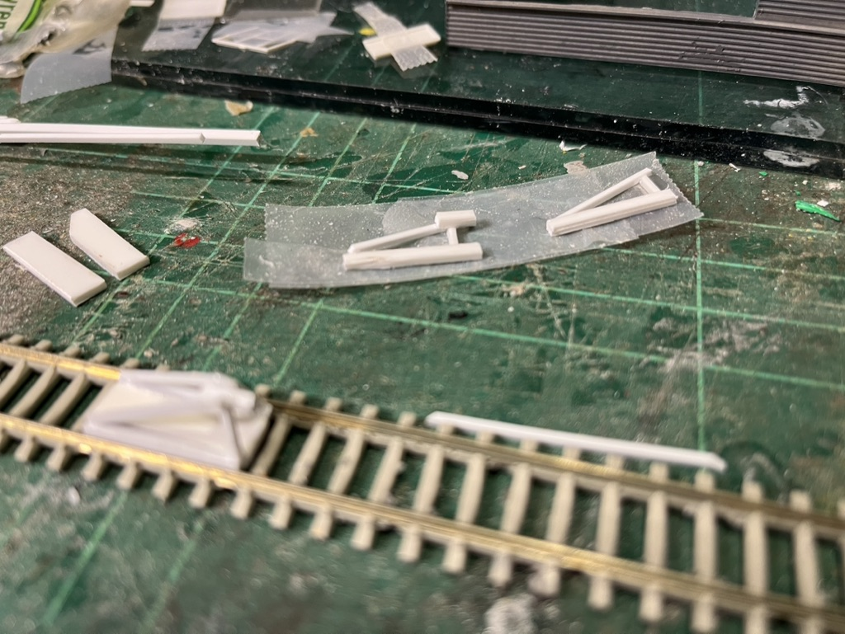

4: Special Buildings:

As mentioned all the buildings are scratch built. The walls are Plasticut panels / sidings of various detail. The roofs are a combination of aluminium foil to represent corrugated iron or are flat or slightly sloping roofs with gravel or tar paper finishes. I found fine grey ballast on a flat roof represents a realistic industrial building roof.
I use 90-degree magnetic clamps to hold the walls square whilst I glue them.
It is amazing how many spare windows I have collected over the years, and they were put to good use.
A nibbler (available from Jaycar) is a good tool to make square window and door openings for the spare doors and windows.

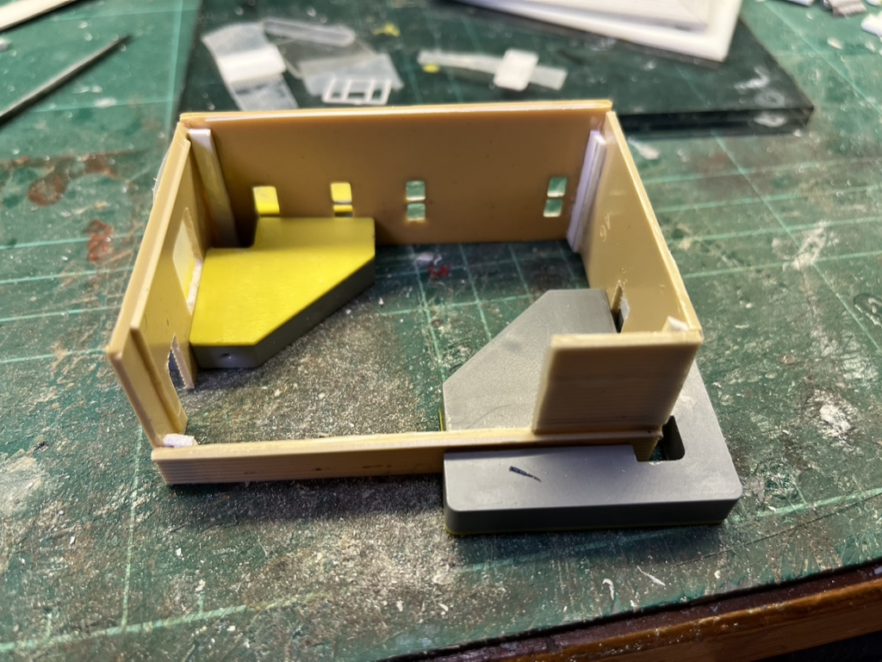
Here is the gatehouse frame. The overhead lights are wired mini LEDS inserted in a small plastic tube. You can see the three LEDS just poking out of the tube at even spacing. The tube is then glued just under the ceiling at the front to throw light on the interior details. The wires are fed down a wall out of sight.

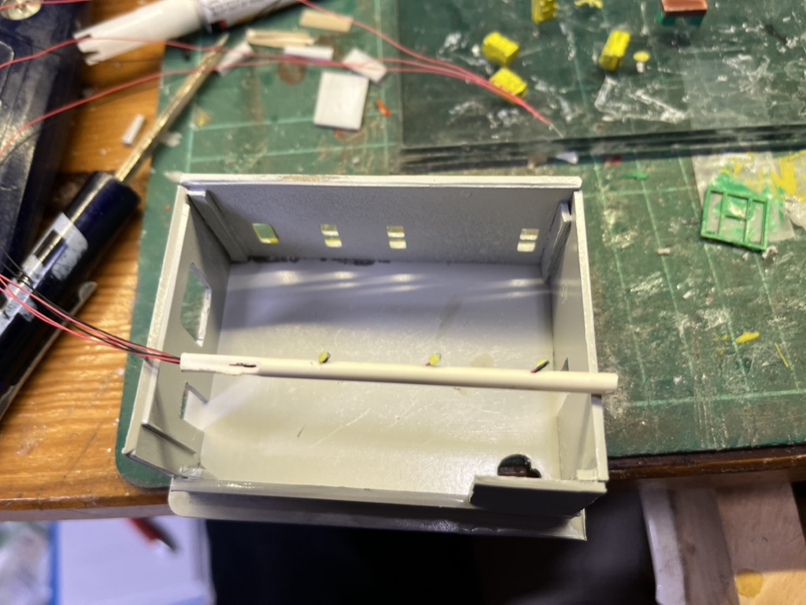

Below is the gate house module at the workbench.
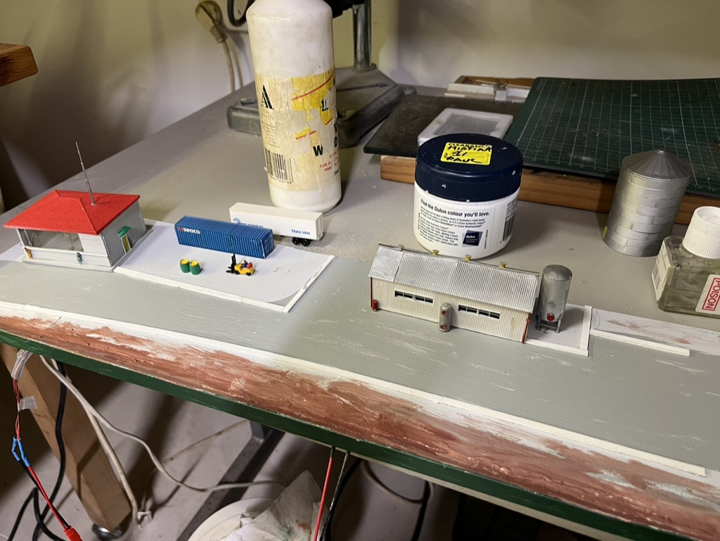

Here is the finished gate house with interior details.
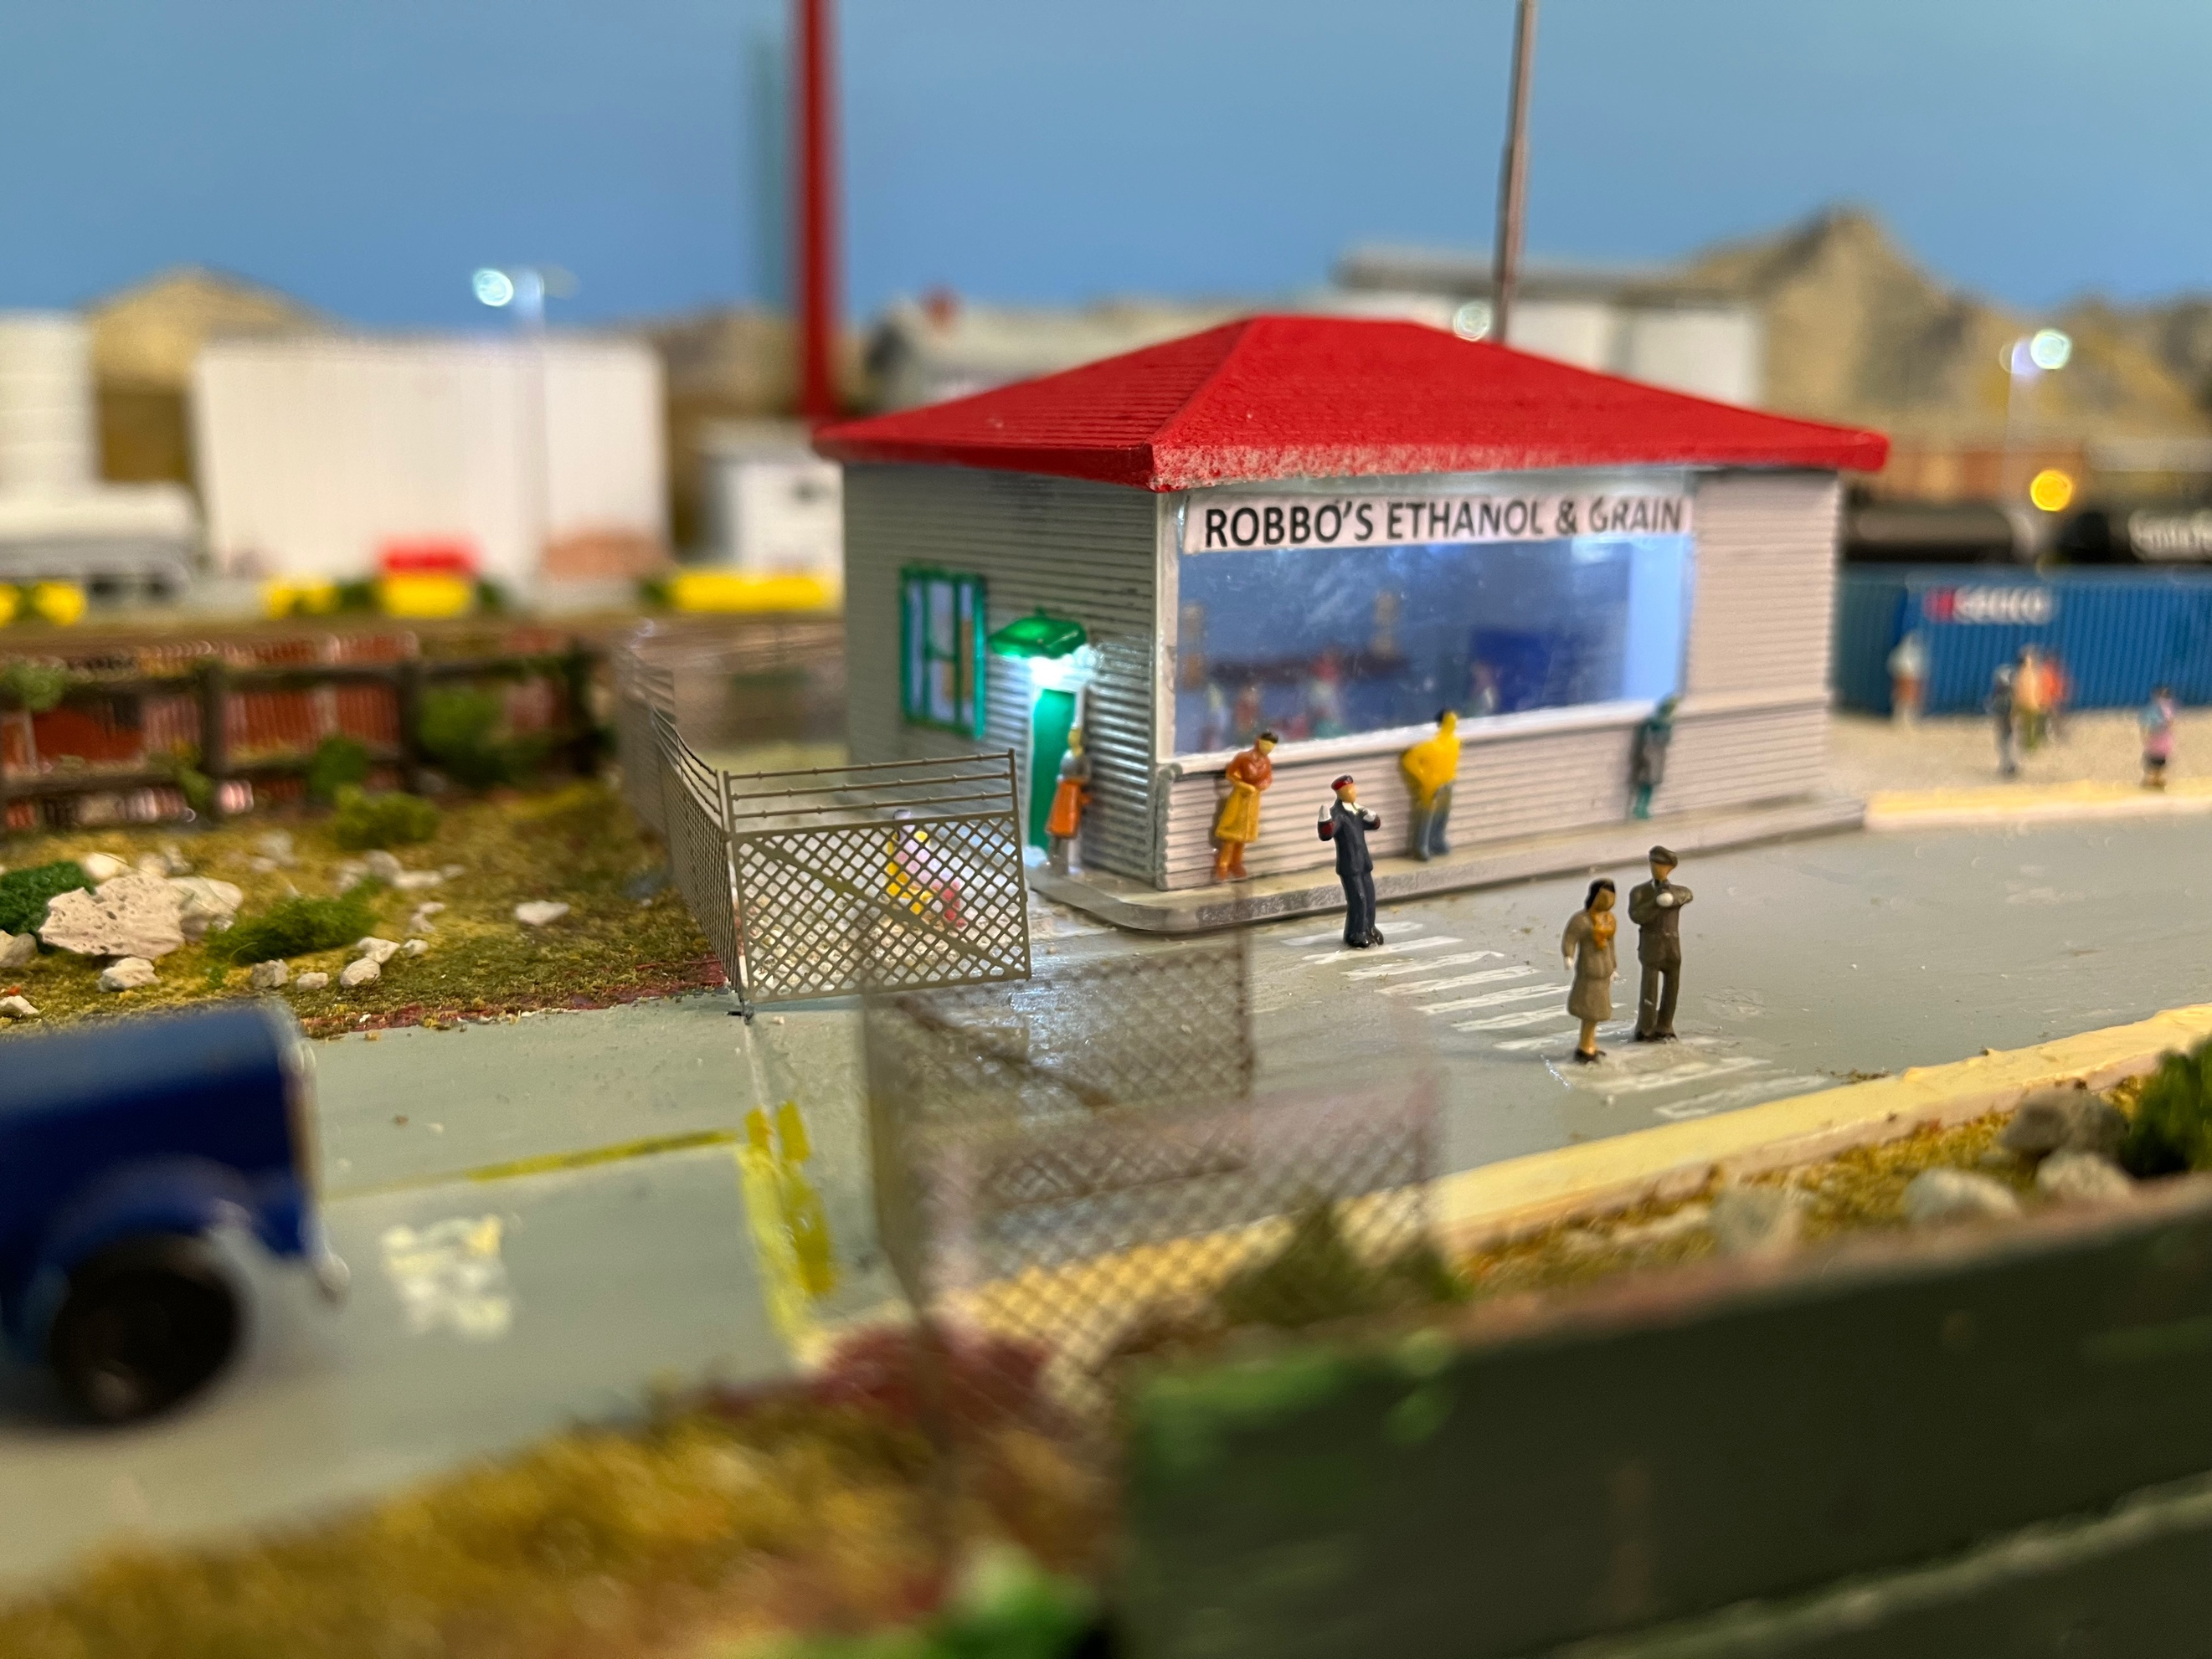

5: Silos:
The silos for the ethanol plant are all made from PVC pipe bought from the local hardware store. The top is 2mm plastic glued onto one end. After the glue dries the top is shaped to the circular shape by first cutting the plastic and finally sanding it down to even with the tube.
Most of the silos have horizontal ribs about 1cm apart. I used two methods to do the ribbing.
The first method was to drill a pair of holes at the 1cm rib mark and thread black cotton thread around the tube. As each horizontal thread was done, I held it taught and used Superglue (CA) to hold the ends. This was tedious and required a cut down sewing needle to get the thread inserted into the pre-drilled holes from the inside of the tube.
The other method was to use very fine strip styrene. I marked the 1cm positions and superglued a piece of strip styrene horizontally. Once dry I bent the styrene around the silo and cut it off where it joined. I used tape and clamps to hold it in place whilst I glued the rest of the styrene to the silo.
Once completed I gave the silo a coating of Rustoleum Grey Primer. The final coat of paint is an aluminium spray paint from a “Rattle Can”.
You will notice some of the silos have vertical feeders up the sides. These are the throw away sprues from plastic kits. A little sanding and shaping and they look realistic and add detail to the silos.
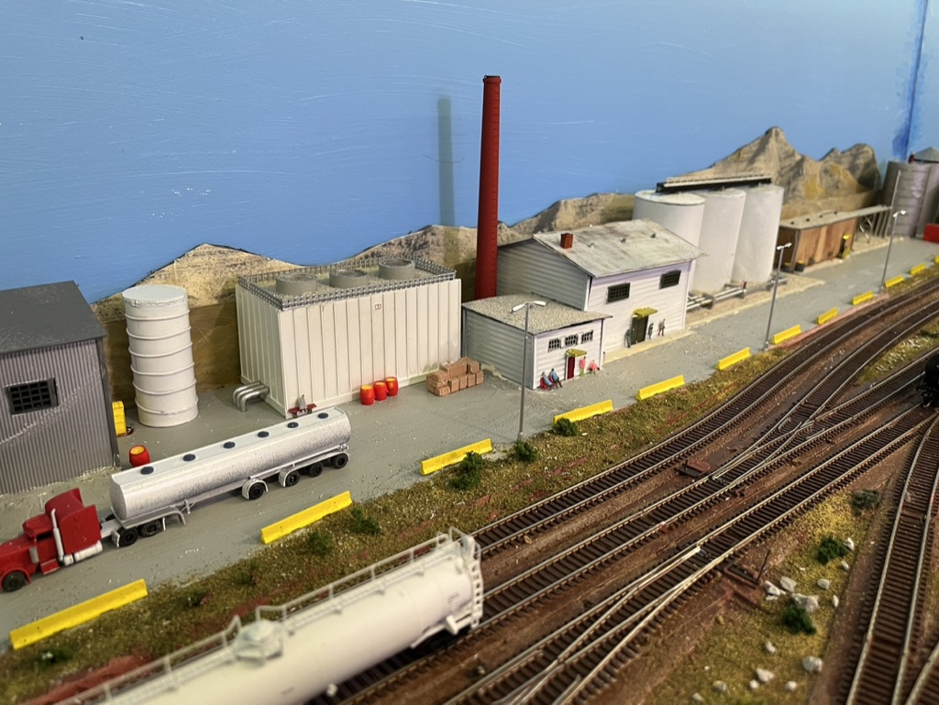

6: Lights:
Most of the building have internal or external LED lights. The external lights are mini-LEDs. I drill a small (#60) hole with a pin vice and thread the leads through. Mini LEDS have a back which should always face up. Once in position I apply a little CA glue to hold it. Many of the external lights have an awning above them which helps reflect the light downwards.
If there are interior lights, I install them, so the wiring is not visible. The wiring is “glued” in place inside the building with hot glue. A little hot glue is all that is needed to hold the wire out of sight. Also, in some buildings I blocked off a section so only a room or two was lit.
I soldered wire connectors to the LED leads so I could disconnect the wire to any building if required.
All the wires from the building go to a terminal block under the layout. This terminal block is then connected to a Woodlands Scenics Lite Hub. I find the Woodland Scenics light hubs a good method of controlling lights, as resistors are built in, and each section can be individually adjusted.
All the building lights connect to one port on the light hub.
The module also needed streetlights. Again, these were installed the same way. All leads go to a terminal strip which then connects to the Lite Hub.
The final separate light control is for the gate house with interior details.

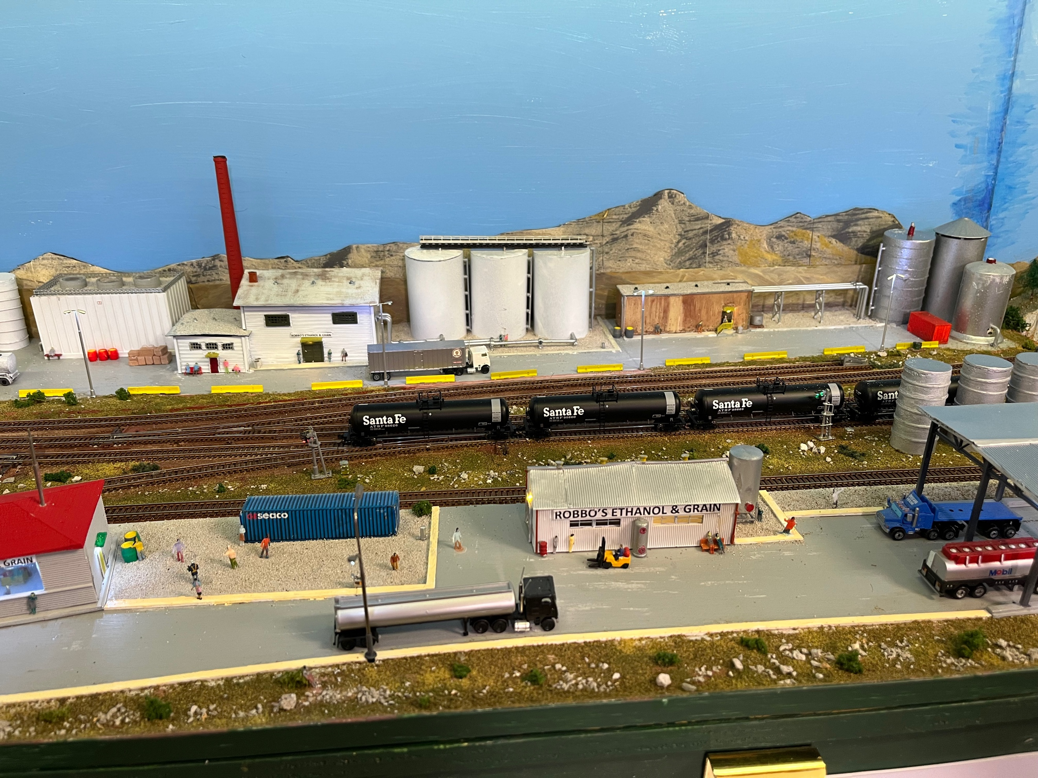

7: Final Details:

Once the ground cover was completed between the modules and the track ballasted a few little details were added. Tallis was added, and several low bushes installed to the open ground. My tallis is pumice, collected from local beaches and ground down and sifted. The various sizes from powder to small rocks are filed in separate containers.
The module has “swallowed” over 50 people. The road near the track needed concrete safety barriers. Many crates and barrels were located around the scene.
A few containers were installed at logical places.
Electricity boxes were added near each of the signals.
Cars and tankers were added.
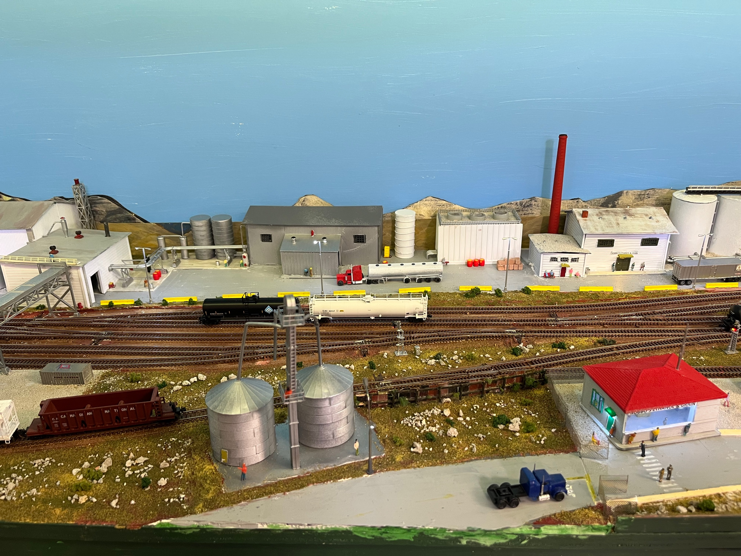

8: Summary:
I hope you enjoyed my journey and perhaps some of the ideas will help you. Some of my colleagues are now looking forward to switching operations at our next session. Certainly, having committed to our editor (Merv) forced me to keep going and complete the module quicker than I probably would have without a deadline.
Scratch building when models are not easily available is no more difficult than assembling a kit, and the rewards are better. You end up with a realistic scene that no one else has.

