Building a Stub Ended terminal

Jeff lee. – MMR

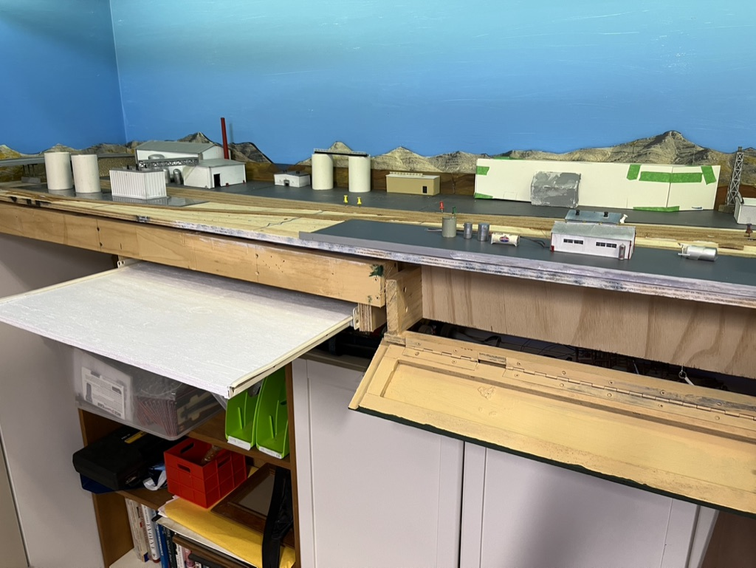
One of the last sections of my latest N Scale double deck layout to be built is a 1800 x 500mm stub end terminal.
The rest of my layout is a permanent structure, but this section gave me the opportunity to think of portability and to create a potential module.
The terminal will be accessed from the main line via a “Y”. This means trains will arrive on one part of the Y and re-join the main via the other leg of the Y.
The supporting structure is a box frame. Cantilevered off the wall. The base of the section I am building is 12mm plywood.
Eventually I drew a track plan. I photocopied the switches and used them to check sizes for trains arriving and possible switching movements. But, what of the theme? Would I model a contemporary era town, with warehouses? Would I build an oil terminal?
I had many boxes of parts left over from my many models, plus extensive DPM building parts, so either solution could work.
The layout is contemporary so I can run modern freights, like double stacks and the latest diesels. However, as a stub end terminal, double stack trains, and long freights and passenger trains are a “no-no”. Oh, I forgot to mention it is roughly based on the Pacific North West of the USA, and is N Scale.
Like any good business plan, a layout also needs a plan. The plan needs to include a vision of the end result, and key milestones on the way.
Despite all the lack of decisions over the type of town, I did conclude this section would be portable so it could possibly be used as a module, or part of another layout . Despite every layout being the “last” I have a history of rebuilding and so if I did this section well it could be re-used, rather than cut up as all previous layouts have suffered. So, I started planning the wiring and controls and type of terminal. Some of my “druthers” are: NCE DCC and Atlas Code 55 track plus Tam Valley Servos. I have found Woodland Scenics Light Hub’s to be valuable so they would be needed. I also use Tam Valley Frog Juicers. This being a switching terminal, I would have some signals – maybe a simple design based on switch direction rather than block detectors?
On the supporting base which is an open grid design, I built a fold down door in part of the opening to hide some of the controls like circuit breakers for this power district etc. I also built a 600x400mm slide out shelf which I can use to mount the servo controllers and Light Hubs and terminal blocks for the numerous wires. Most of the buildings will be lit and I will have street lights whatever the town is.
If the base board (12mm plywood) was to be modular, it needed re-enforcing, so I built a 12mm frame underneath to give it structural stength.
Eventually I decided to make the town one industry – an ethanol plant. This would suit the era I model.
In N Scale there are not many kits to model such a plant. Rix Products sell some grain elevators and Grain Bins, so I ordered them. But, what does an ethanol plant look like and how could I build it? Fortunately, a little “Googling” and you can see the real thing and models in various scales.
Here is one such plant I found on Google. The buildings and distribution pipes looked like they could be scratch built.
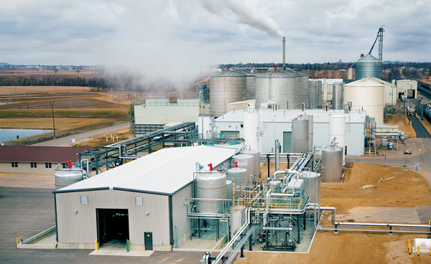

I also found a model which looked like it had many of the elements I intended to include.
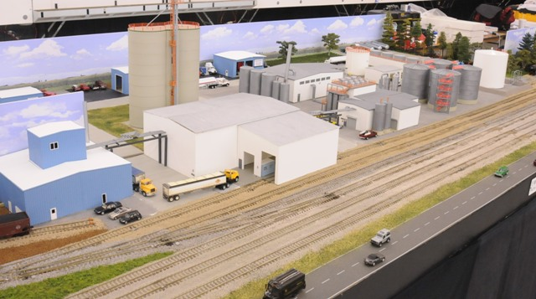

Here is the area I have to work with before any fascia or the drawers and shelf was added.
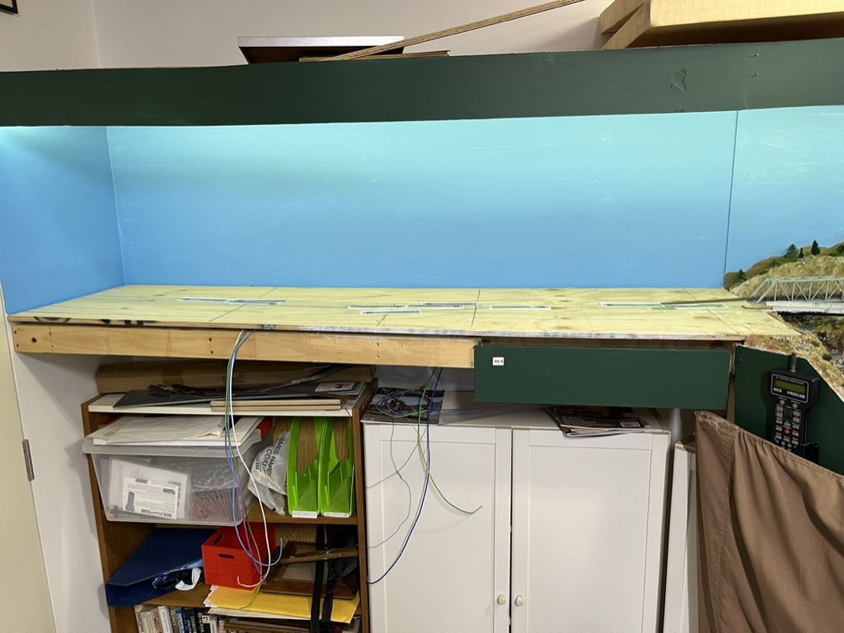

Here is an additional view showing how it connects to the permanent layout.
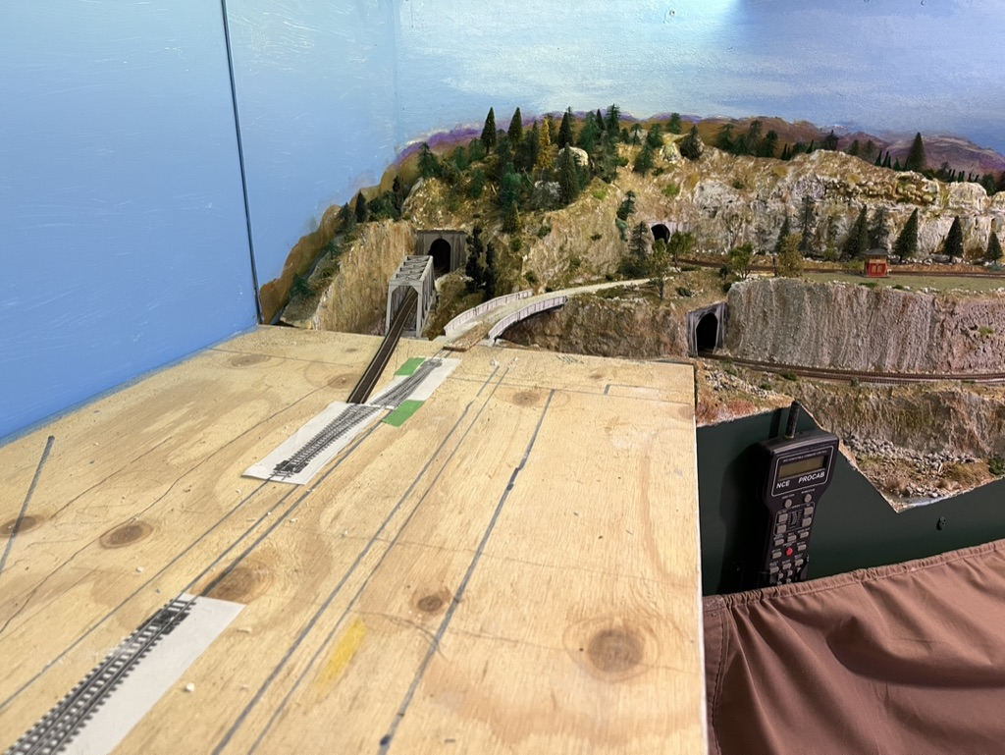
I proceeded to mock up some buildings using cardstock. I also tried to lay out the plant moving the mock up buildings around. With the track plan in place the area where we have buildings was obvious. In order to help build those buildings, I cut sections of Persplex as the base, and spray painted the underside with a grey primer. This would enable me to assemble the ethanol plant at the workbench. There are several sections. Here is one near the overpass.
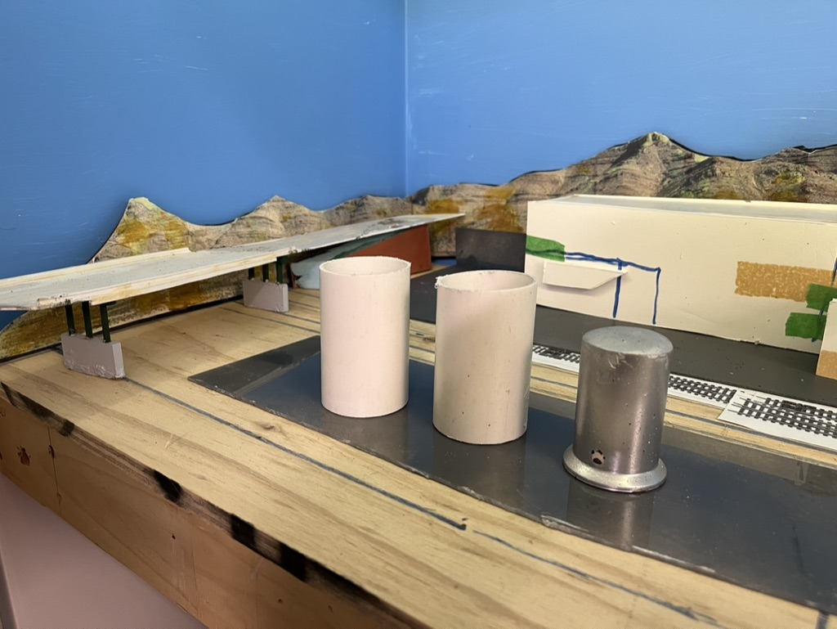

Here are a few examples to give me an idea if the plant will work. I used 50mm stormwater pipe to simulate the silos that will eventually be replaced by the kits I ordered. I will also try to make some tanks / silos from water pipe, as an ethanol plant has many tanks.
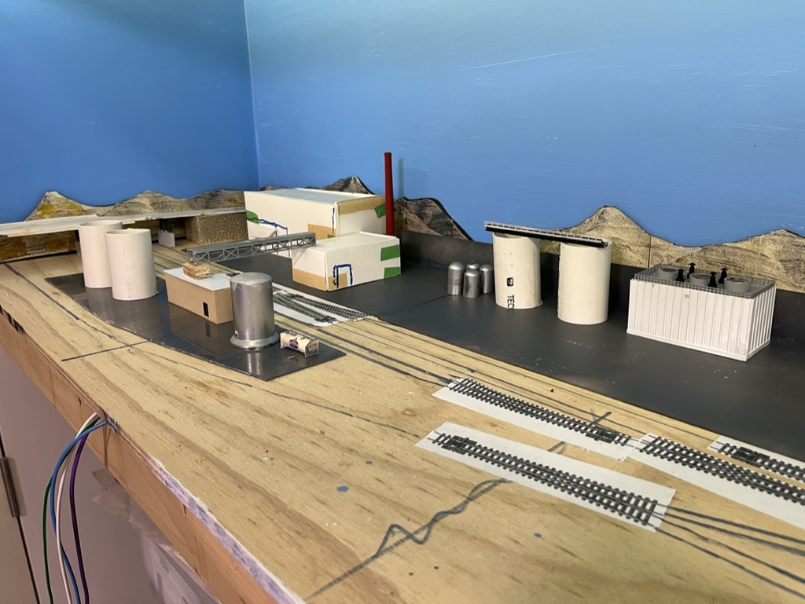

I also discovered whilst searching the spare parts bins that I had many building sidings that would suit the plant theme.
Enthusiasm took over and I built several “sheds”. One of the signature sheds is the power plant. Using the photos I was able to see what they looked like and proceeded to scratch build it. Here is the first attempt and I will detail it with workers and lettering further on. Photos are valuable in showing up details the ageing human eye does not pick up. The grill on the centre vent needs repair.
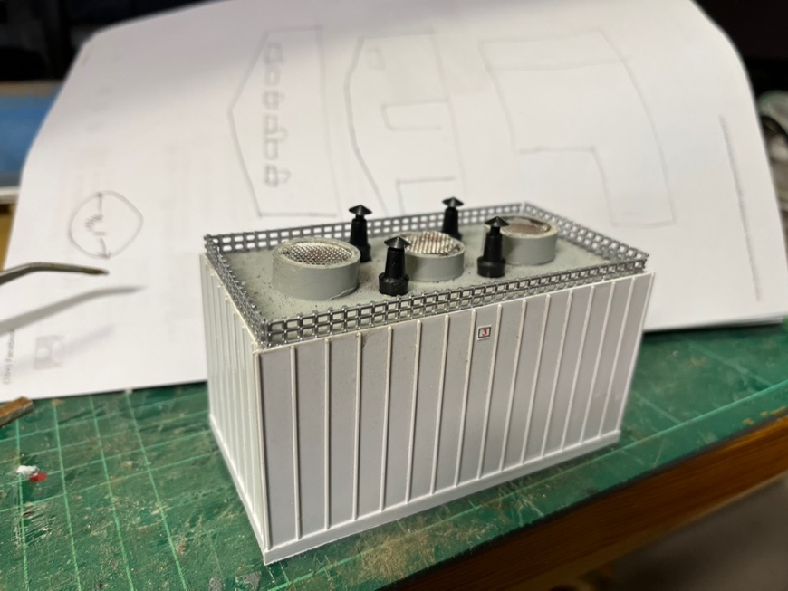
It is 3 weeks before I leave for the N Scale Convention in Nashville and then collect my Grain Silos. So, I am building various buildings using my spare parts bin.
Did you notice that modern ethanol plants are usually finished in light colours? There is a dusting from the grain, but most of the base buildings are a white, or off-white colour. The silos are silver. The piping is silver, and as most ethanol plants are in the mid-west the ground is dryer.
Here are a couple of buildings I have scratch built that will fit into the plant. This one is using Evergreen siding and some basic details.
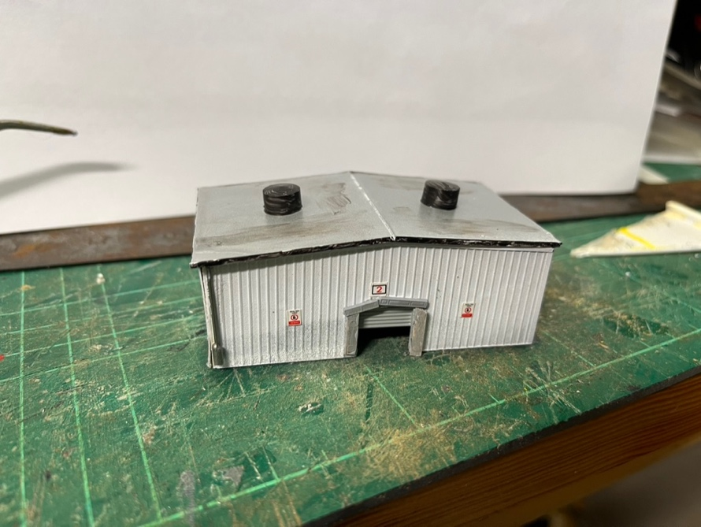
Here is another building using siding and an aluminium roof. I have added mini LEDs and will weather the building to show some rust and age eventually.
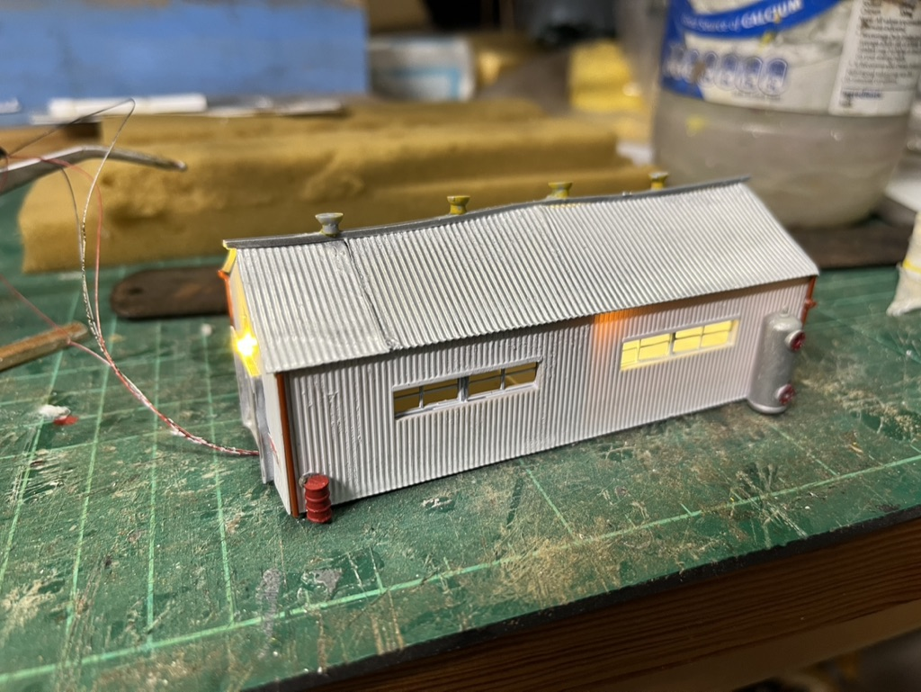
Note the barrel and Gas cylinder from the spare parts bin. There is an internal divider in the building so only one half internally is lit. The internal divider adds structural strength to minimise warping, although the roof looks like it has aged already.

Here is another building from scraps. It was an additional truck building as part of a wheat silo kit.
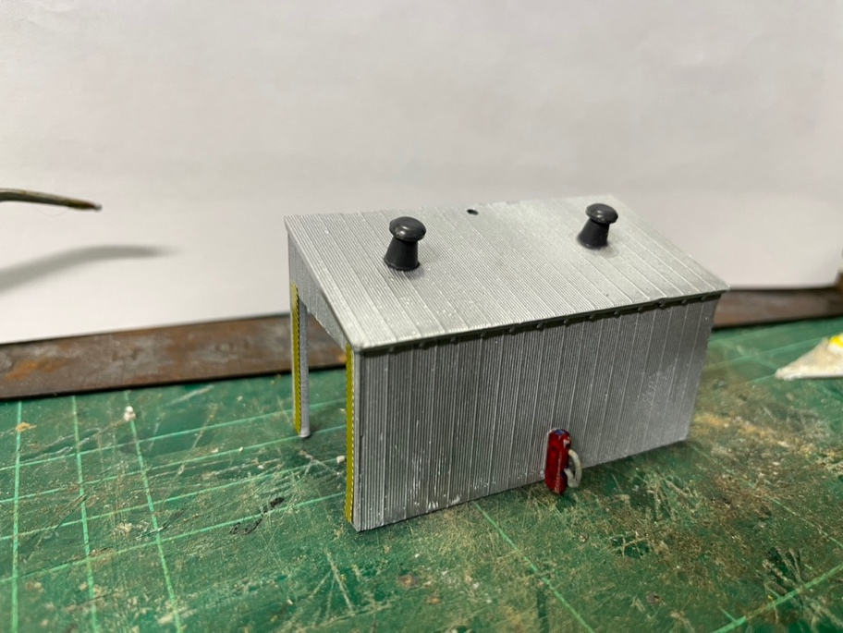
The end of the “module” will be part hidden by a road overpass. I have decided to also scratch build this and have started on the supports and road base.
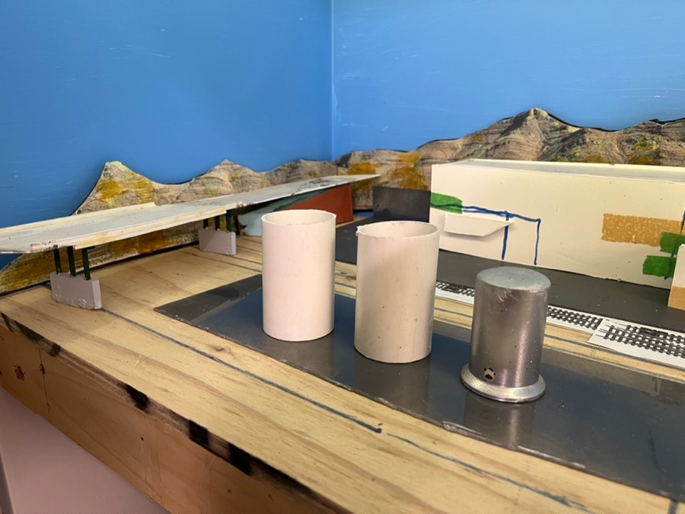

Below I glued the cork roadbed in place.

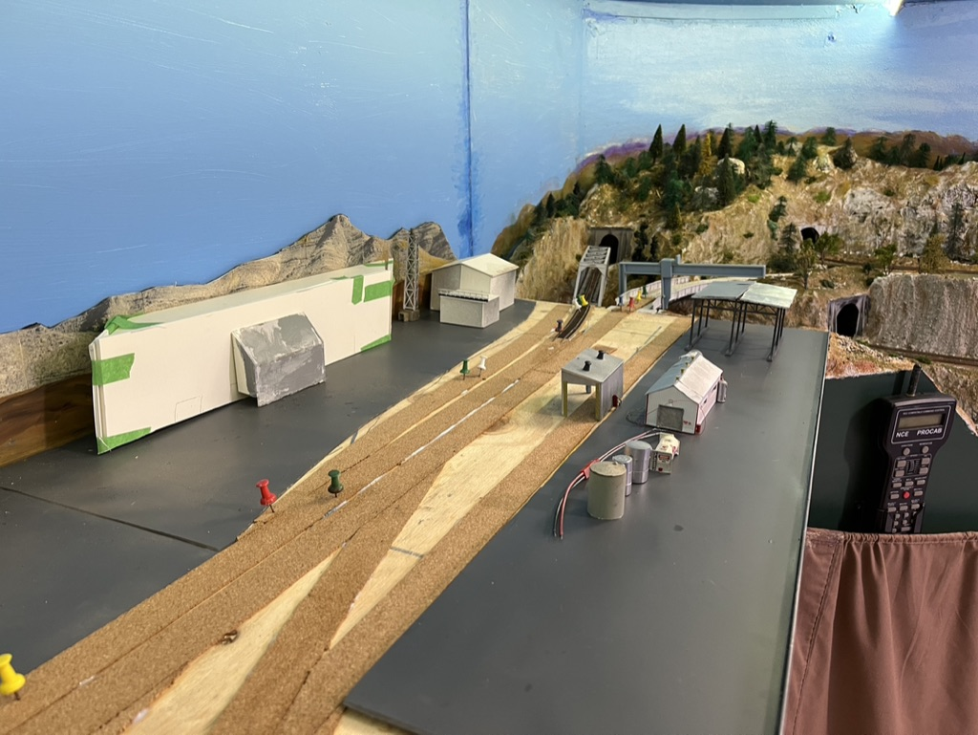

Once the glue for the cork roadbed had dried I sanded the edges and sealed it with a grey paint. I also sealed the rest of the plywood with an earth colour paint.
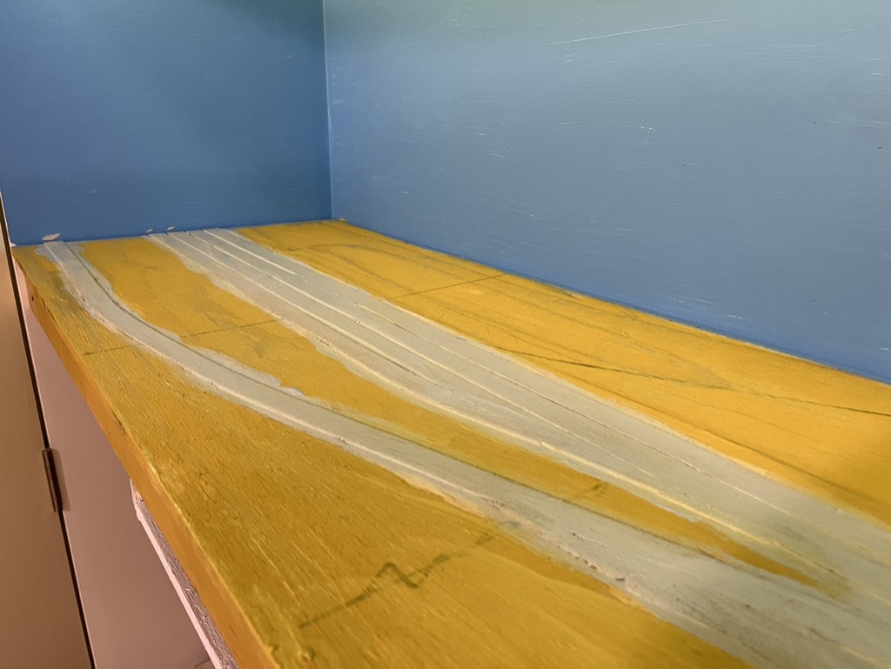
Here is another view of the cork roadbed finished and waiting for tracks.
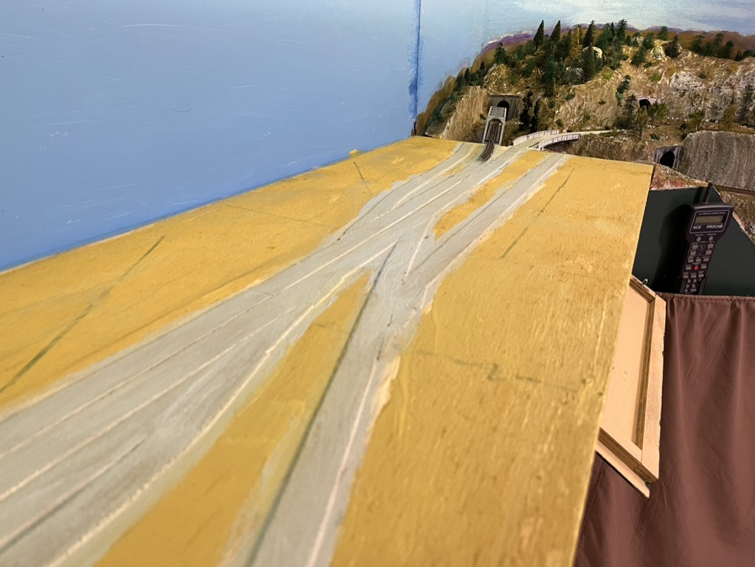
Here is the slide out drawer and pull down door to house the various controls. As I plan the wiring, and the section is modular I realise several of the terminal blocks and “Frogjuicers” will need to be attached to the base.
Part of our hobby that takes considerable time is the planning. Do I put all the relays on the slide out shelf or attach them to the baseboard?

I took the opportunity at this stage to invite some of my NMRA members to visit the layout, operate, and also to be critical of my current project. I will share their views and ideas in the next episode.
Whilst waiting for the next update here are some photos of the layout that is more advanced. Here is a pulp mill on the peninsular where the mainline drops or raises at 1.5% between levels.

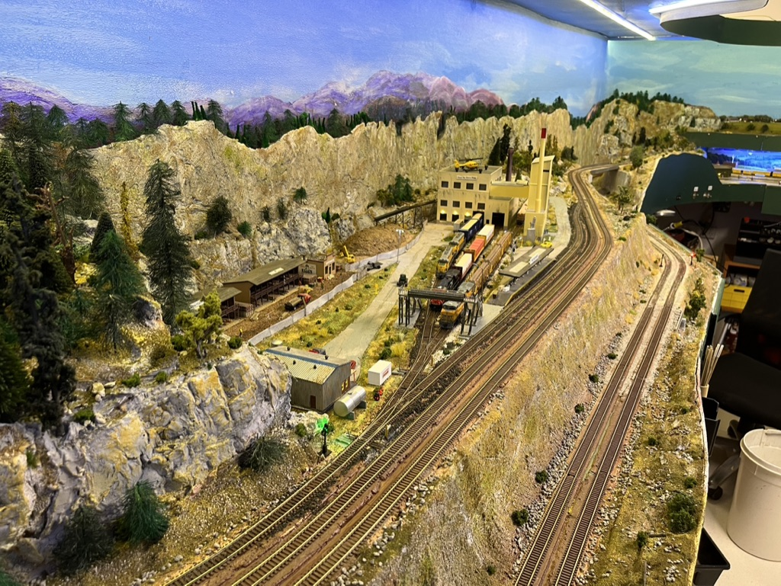

Here is another scene of an industrial area.

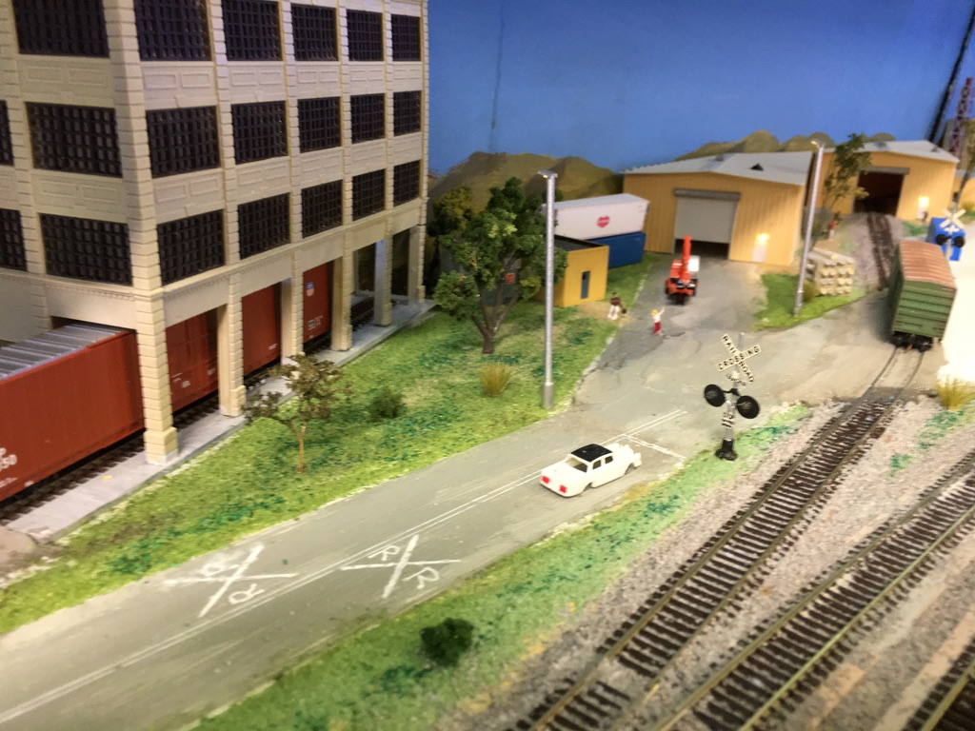

Further up the track is a container depot.
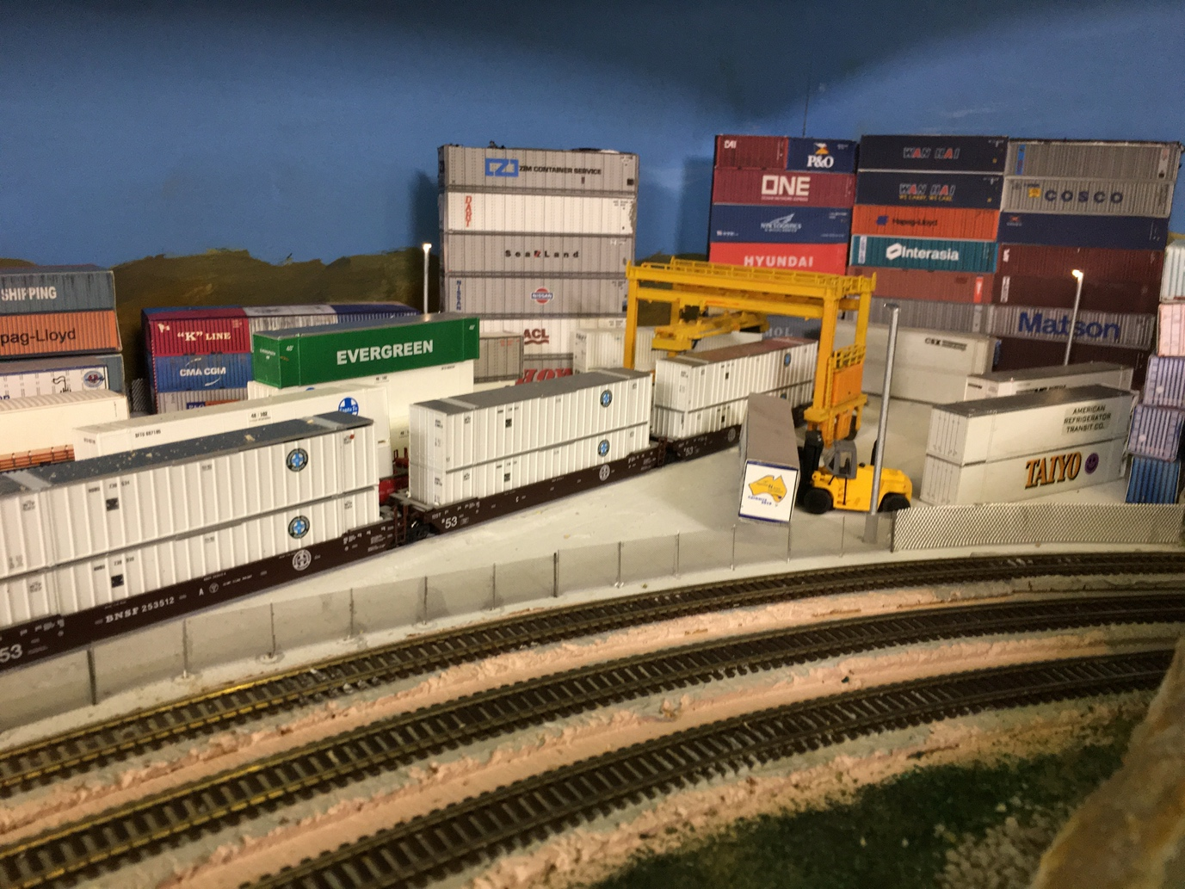

Now I am planning the track laying, switch controls, and signalling which I will cover in the next update.
Happy modelling.
You can see more of the layout on: www://jeffsrailroad.com

