Inspirational New Layout

Building a major layout is a big commitment. When you look at the time and expenses committed in hindsight it becomes a reality check. Sometimes we don’t realise we spent the best part of the last xxx years getting here. My current (now past) layout was started in 2013 and was not looking finished until 2018. That is 5 years of pretty dedicated work. The result, in my case was a good railroad. It ran well and operations worked OK. It was featured in a number of magazine articles internationally.

In 2019 I attended both the N Scale Convention in Chicago and the NMRA Convention in Salt Lake City. Despite a major commitment to a large layout that was operating very well, I decided to make a clean change and construct a new layout. Colleagues said I was crazy: “how will you find the time?.” “Your current layout is great”. “Will you have enough time to do it”? Etc”

Some background:
Eight years past my wife and I built a new house. Every new house has resulted in a new layout and there have been several in between. So, I can say I have experience starting a new layout. But, back to this house and layout. The architect could not comprehend why I needed a 6x6 meter room with no windows and dual power circuits etc. He continued to add it as a workshop and not part of the house. Finally, the house was built and the “train room” became the only room in the house with air conditioning. Of course, it was fully finished. It was a sealed room – ideal for a model railroad. My work schedules, which included significant overseas travel, limited the amount of construction but despite that the layout was steadily built.
As an NMRA member and a member of the Layout Design Special Interest Group (LDSIG), I utilised the consulting services to assist in the design of the layout. We hosted several operating sessions and I even managed to earn my Master Model Railroad award (MMR). During the 2013-18 period.
So, when I had several weeks in the USA at the 2019 conventions it inspired me to build a new layout incorporating all the good points of my previous experiences and layouts, plus utilise some of the inspirations I had picked up over the years.
Of course, I sat down and analysed whether I should change or continue to develop the current layout. The reasons for not building a new layout were:
- Current layout was operating well.
- There were still areas to super detail.
- A new layout would take a long time (years) to get to the current status.
- Cost:
- How to dismantle and what to do with the trash.
- Could I store all the components I needed to keep.
- I would not have a layout for many, many months
- Etc, etc.
Balancing the above were the challenges I saw:
- I could build as good an operating layout.
- The new layout would have neater wiring.
- I could replace hidden track.
- I could plan for signalling from day one.
- Wiring would be in drop down panels at the front of the layout making maintenance easier.
- I could change track and use “Fasttrack switches and more prototypical Atlas flex track.
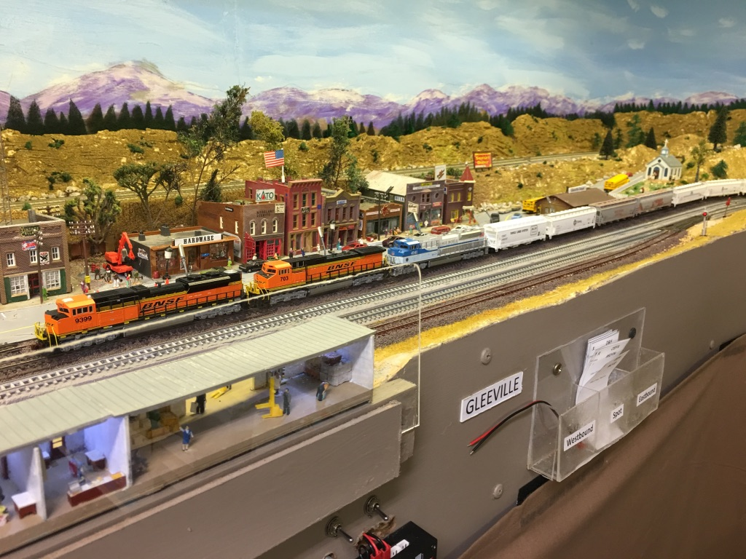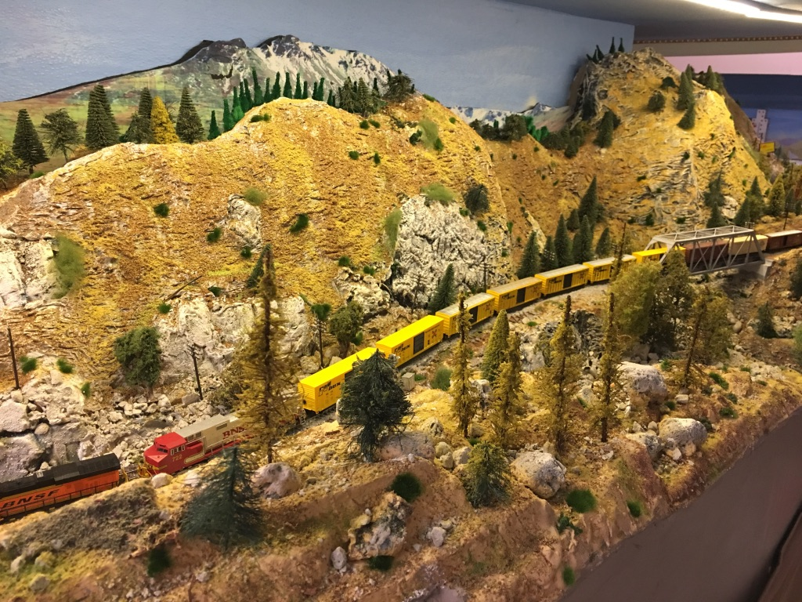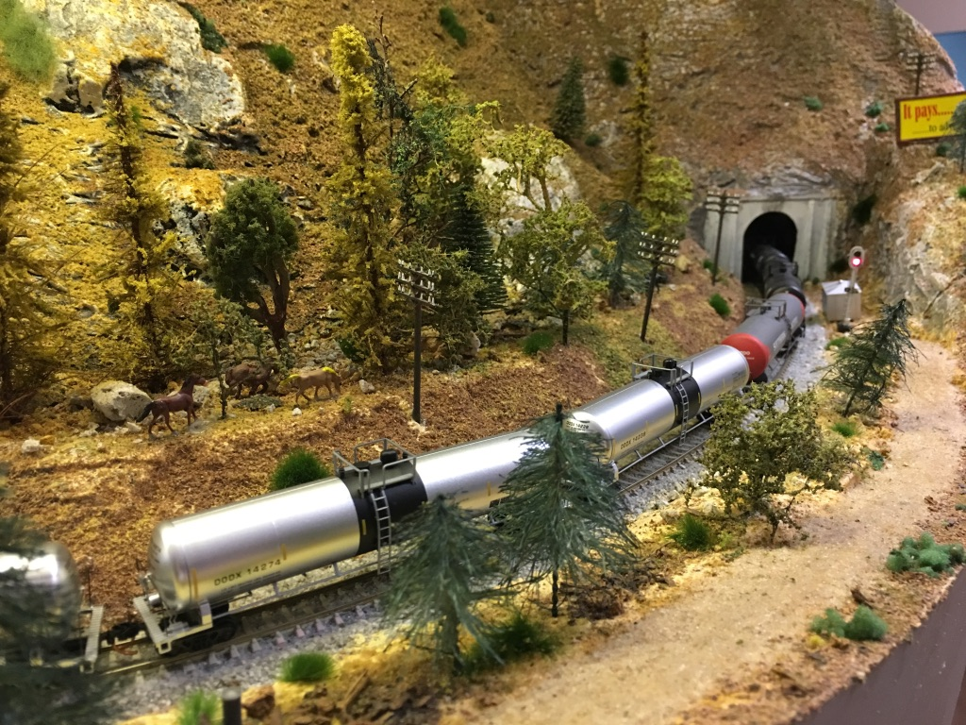

Of course, the challenge and opportunity won, and I proceeded to dismantle the current layout. Several trips to the local recycling facility and the train room was bare – except for the multiple boxes and cabinets housing my lifetime of collecting and building.

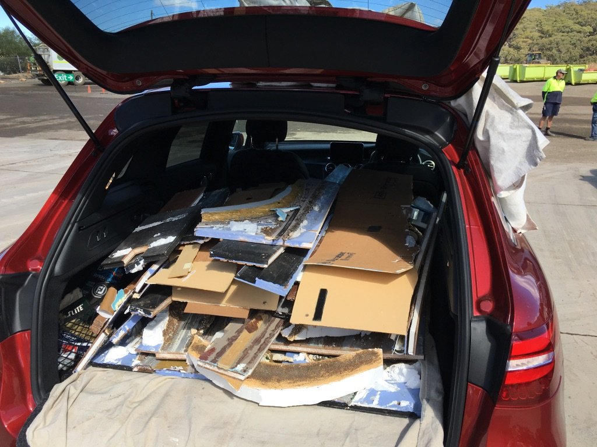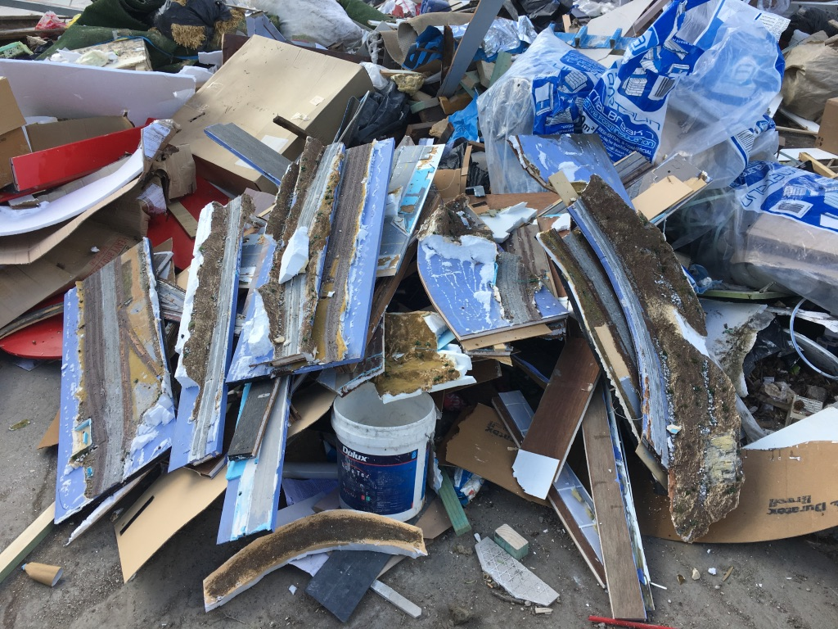
I created a list of “Druthers” that I would do with this new layout. The one area I was challenged was the brand of track and switches to use. In the past I had used Atlas Code 55 track and switches but had tended to focus on Peco code 55 track and switches. The Peco track and switches had always been reliable and my colleagues mostly encouraged me to stay with Peco. I had built “Fastracks” switches and liked their smooth operation. But did I have the time to build 80+ switches? Impulsively I ordered an initial pack of Fastracks switches and enough material to build 15 switches. I was still questioning that decision versus a full Peco one but here are my Druthers for the new layout:
- Walk in design – no lift bridge or duck under.
- Limited hidden track.
- No hidden staging.
- Wiring buses for all power.
- Wiring to the front of layout in drop down panels.
- “Neat” wiring. Use terminal blocks etc.
- Major use of T-Taps and Suitcase connectors.
- LED strip lighting in channels for both levels.
- Multi-level for part but no helix.
- Servos and DPDT slide switches for all switches. Tortoise for key switches.
- Blocks for signalling with BD20 detectors. May use IR detectors but prepare for alternatives. I notice Atlas has that option in their new signalling system.
- Maximum grade 1.5%.
- Level base for towns and industrial sidings.
- Switching leads for towns to switch off main.
- Major deck at 1.1Meters for better viewing of guests (I am tall, but guests and operators are often much shorter)
- Possible assembly of track on a bench in modules up to 2.4 meters in length.
- Use Cat 5 cable for Tortoise and SPDT switch leads to simplify wiring and make it neater.

One of the elements I did not plan was the demolition. I did want to preserve most of my previous work. The scenery could go but the trees should be saved if possible. Boy, there were nearly 1,000 trees!!!. All the buildings plus people and dioramas should be saved. Alas many did not come out well and were lost. The quantity of scenery, plaster, foam and plywood filled several containers and trips to the tip.

Eventually the layout room was empty except for the storage containers, plywood, frames and other goods previously stored under the layout. Some of the previous frames could be re-engineered and used again. The re-engineering involved changing the width, and in many cases, adding a drop down panel at the front of the frame. This “drop down” panel is to house the wiring and key controls.
Below are some initial photos of the lower deck frame and drop down panels for front of layout wiring.

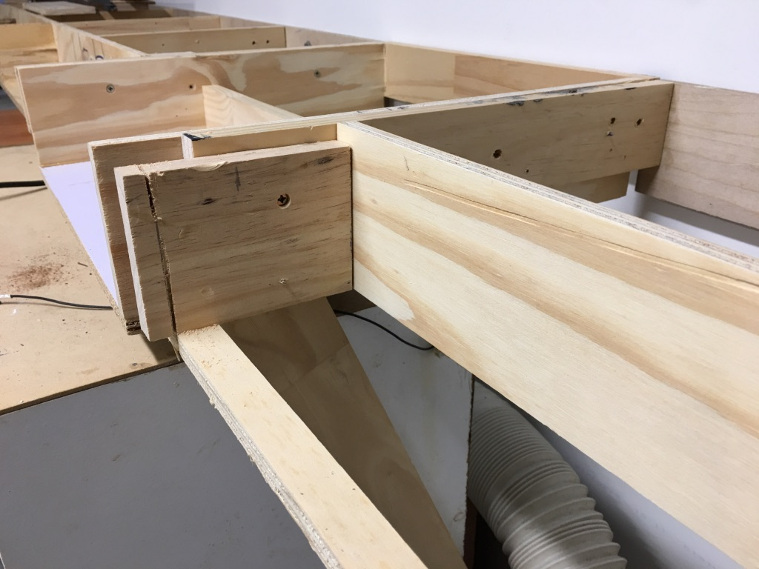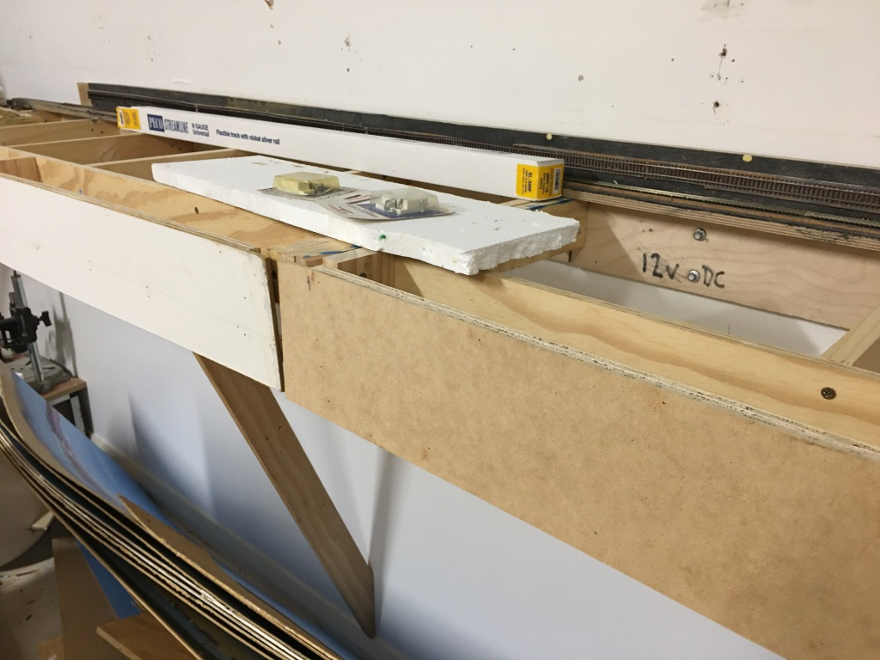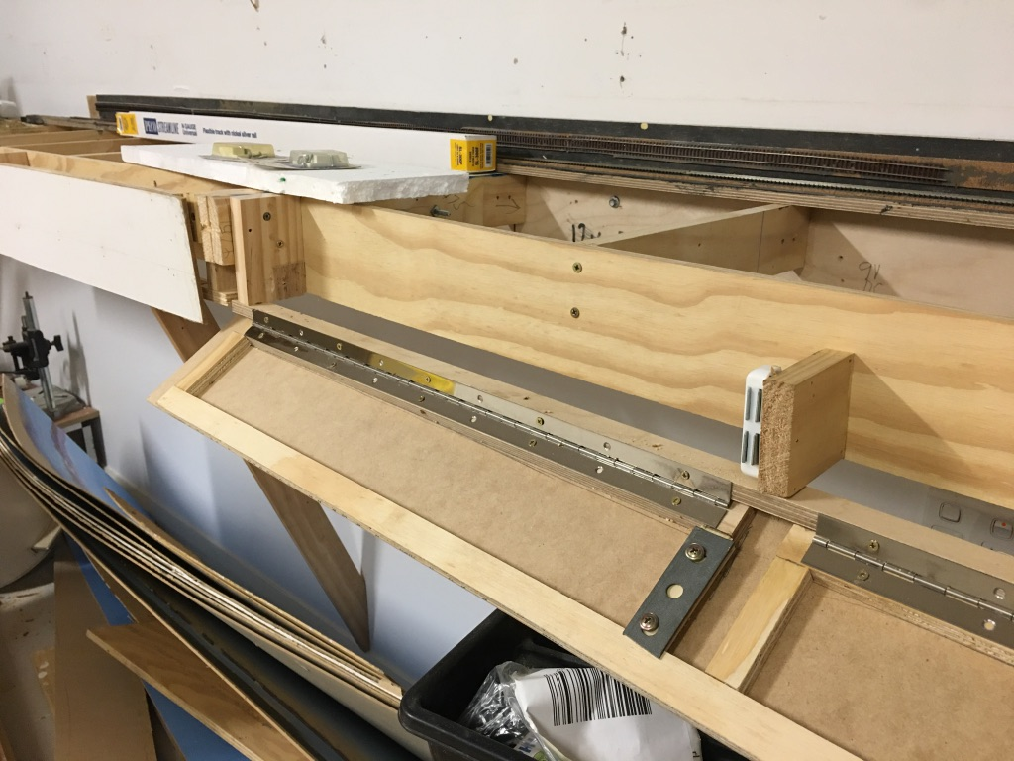

The new layout was to be multi-level. The lower level was to be on a frame suspended from the walls plus a peninsular. The peninsular will have a double turn to elevate the track to a shelf upper level.
I decided on a height of 116cm for the lower level rising to 155cm at the upper level of the shelf layout.
There would be double track all the way and at the lower level and upper level there would be a return loop, ensuring continuous running.
One of the “druthers” was to build neat bus wiring. Below is the bus wiring for all the power circuits (12V DC, 5 V DC, 16V AC).
The bus runs around the entire layout so it can be accessed via terminal connectors where required.

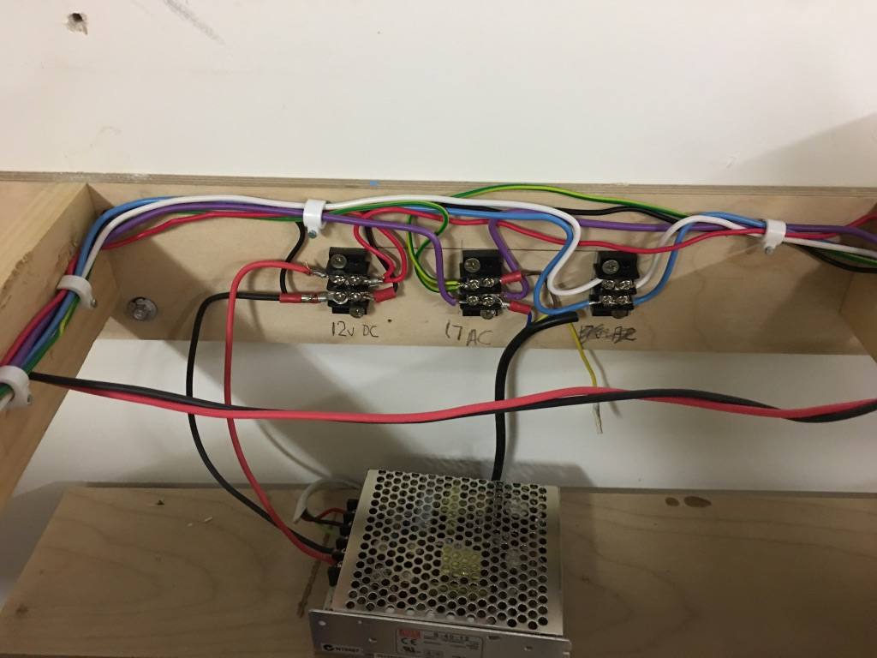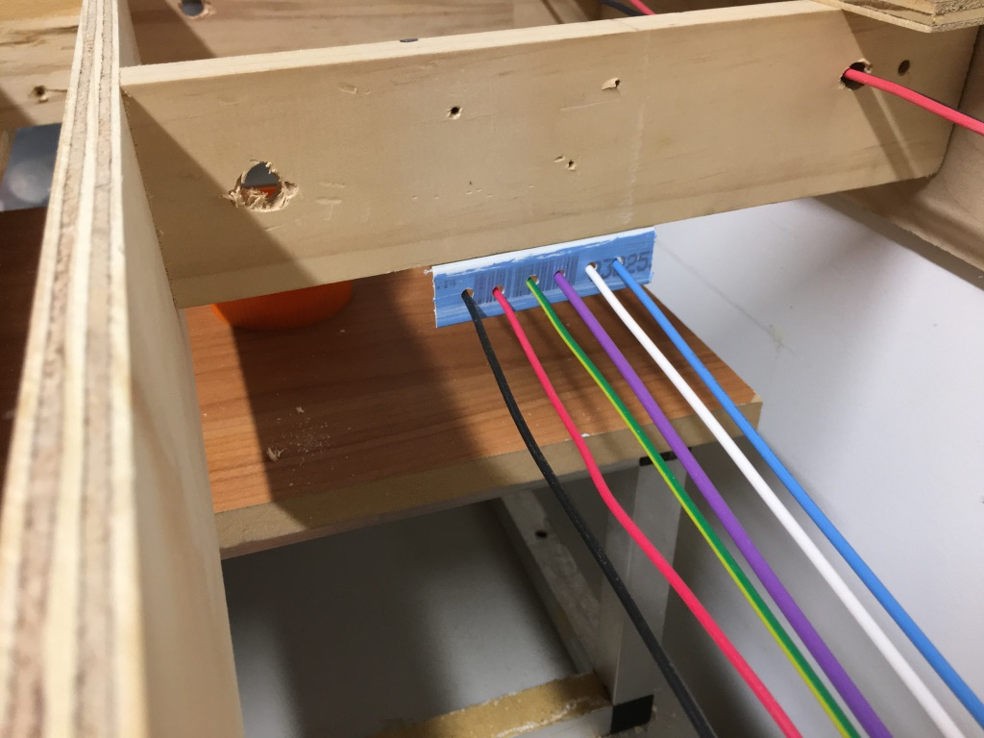

Another goal was to install LED lighting to all levels. Below is the lighting across one section of the new benchwork.
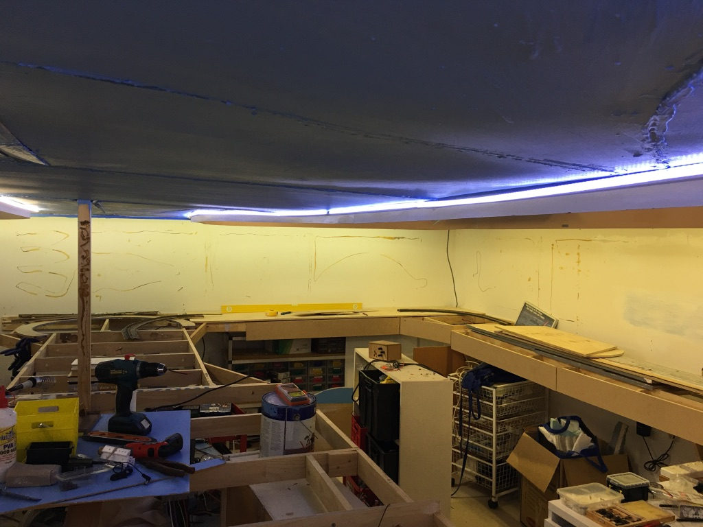

The upper level proved a challenge. Some of the questions were:
- How to get power and wires from the base to the upper benchwork
- How to hide the upper deck wires.
- How to install the LED strip lights.
- How to bring wiring to the front of the upper deck and install controls for servos and lighting.
Some of the answers happened after researching the needs.
The backdrop on the lower level would be out from the wall to hide the brackets. Therefore I could hide the wire leads behind that.
LED strip lighting could be stretched between the brackets. On top of the brackets I installed 12mm plywood to the width of the shelf. I used a router to cut slots in the plywood to accept the LED strips, and installed the LED strips under the baseboard.
Wiring at the front of the upper deck would be hidden in “Cable ducks” screwed to the shelf. This would be the same depth as the fascia installed on the upper deck.
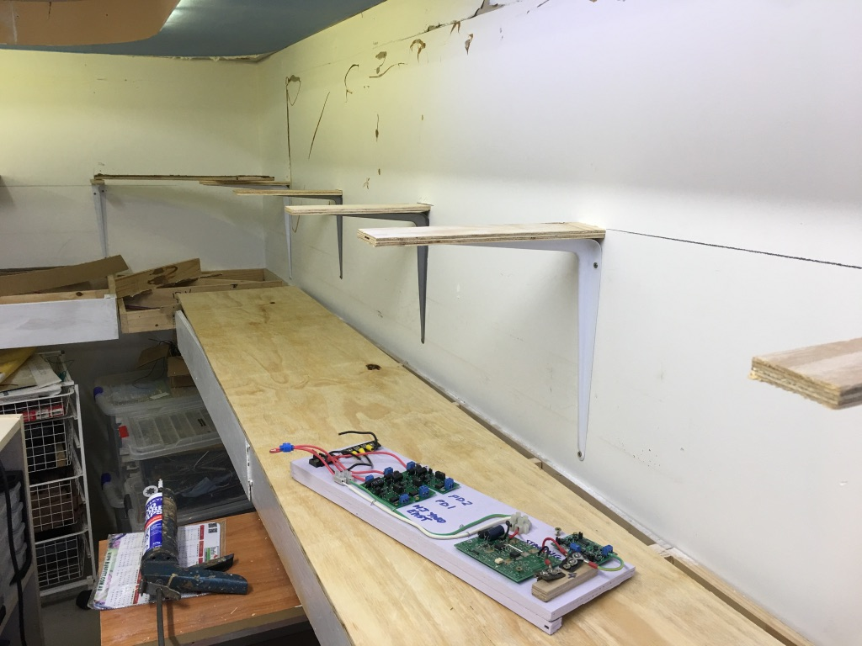
The peninsular was the area where the track would rise between the two levels. I did not want a hidden helix so managed to develop a two turn loop across the 4 meter peninsular. See photos below.

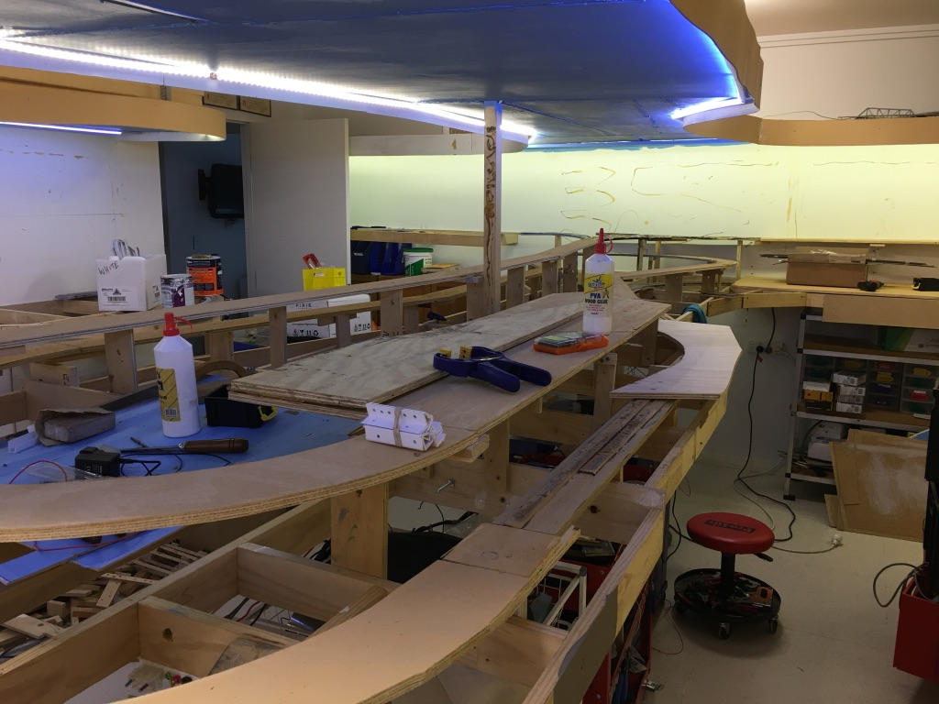

Well that was the plan and construction proved the plan could work. Boy, did I underestimate the time needed? Yes, I did, but work is progressing.
