New Layout: Update November 2019.

As in the previous post, my friends have continued to question my sanity to dismantle my previous working and almost fully sceniced layout.
The last month has seen the installation of the upper deck. The upper deck will need to be completed as track will have to start there. We have to start on the upper deck because drilling and other modifications on the upper deck will cause “bits” to drop to the lower deck. So we need to complete a majority of the construction on the upper deck. This is a limitation if you have more than one level on your layout. The upper deck is supported by brackets. Each bracket has 12mm plywood supports on the bracket. The benchwork is 12mm plywood. It varies in width from nearly 40cm to 20cm.
Each of the wooden supports screwed onto the brackets is routered to accept the LED strips. LED strip lighting runs the entire length of the upper deck.
All of the 12mm plywood is painted on both sides to seal it and also to create a clear uniform colour.
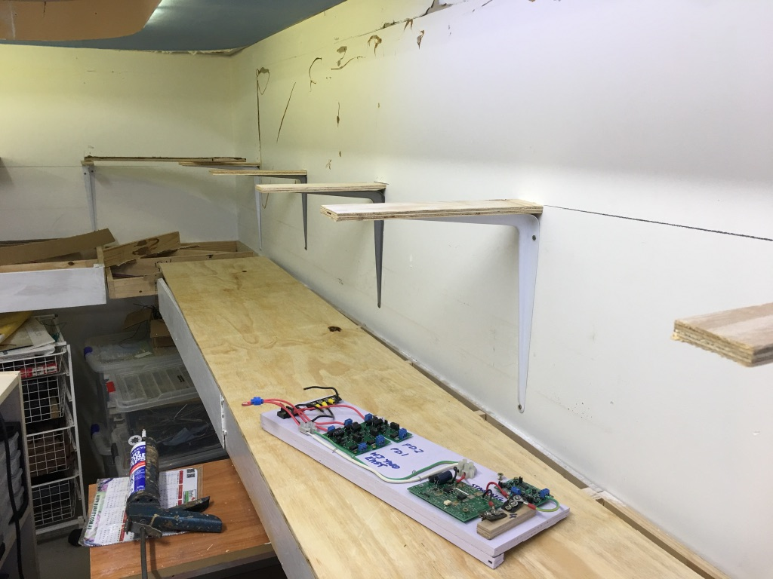
Figure 1 : Brackets with 12mm plywood extensions routered to accept LED strips between the metal bracket and wooden base on top.

Under the upper benchwork at the front I ran a power bus for each of the two power districts. The first 2 wires are the blue and white from the main bus. The next wires are the Main rear and Main front, plus one passing siding. These blocks are wired separately for signalling. The wires are labelled for identification. (see next 2 photos). The 70mm fascia will hide these wires.

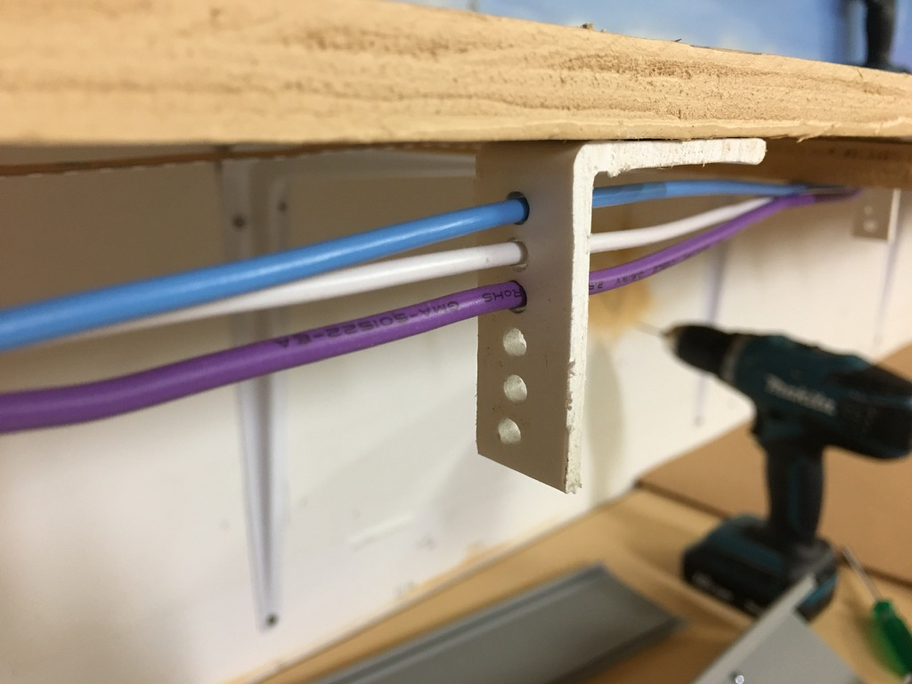

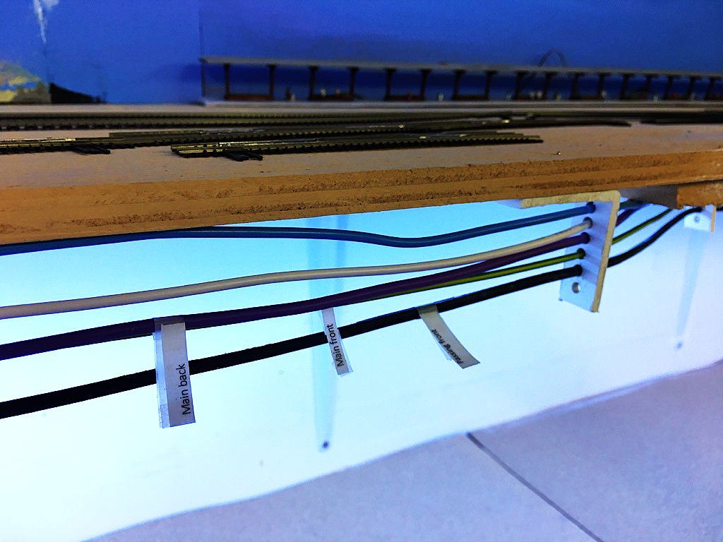

Below are the brackets I made up to support the bus wires. The section is 50mm angle which I cut 20mm wide. The 50mm angle comes in 3meter strips and costs less than $10. From a hardware store. It is used for building walls with gyprock (sheet rock).
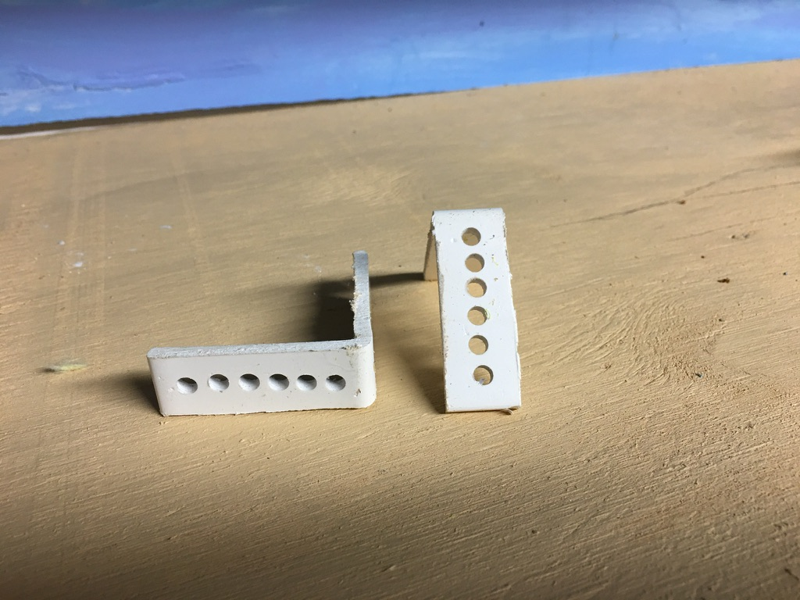

All the wiring is to the front of the layout. On the main level we use drop down doors as described before. On the upper shelf I used cable ducts with a sliding cover as seen below. These ducts will house most of the terminal boards, Frog juicers, block detectors, Servo boards etc. Eventually the cable duct covers will be painted the same colour as the fascia.
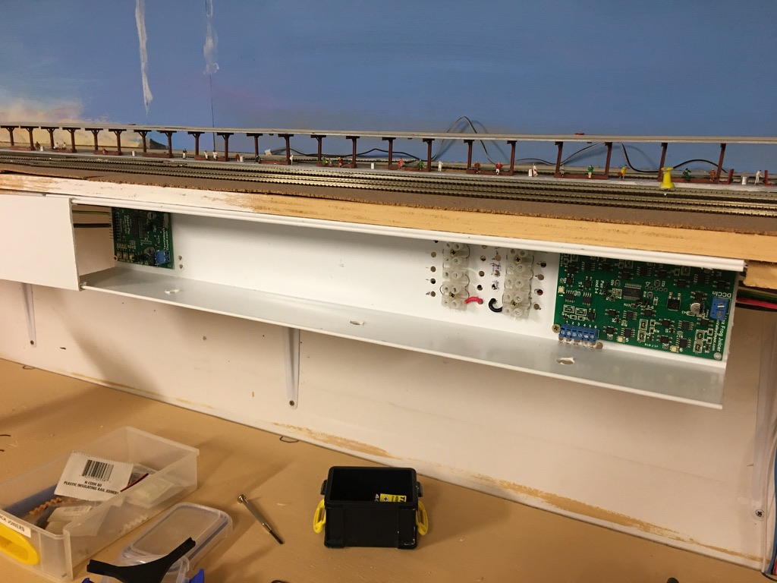

The area where the track will be laid has a base of 1.5mm cork sheet. This 1.5mm cork base will be cut to hide the wire feeders from the tracks so there is minimal wire under the upper shelf.
Below is the cork laid and some initial track positioned to test positions for switches etc. I had to move track around so that switches did not occur right over the brackets and not allow the servos to be installed under them.
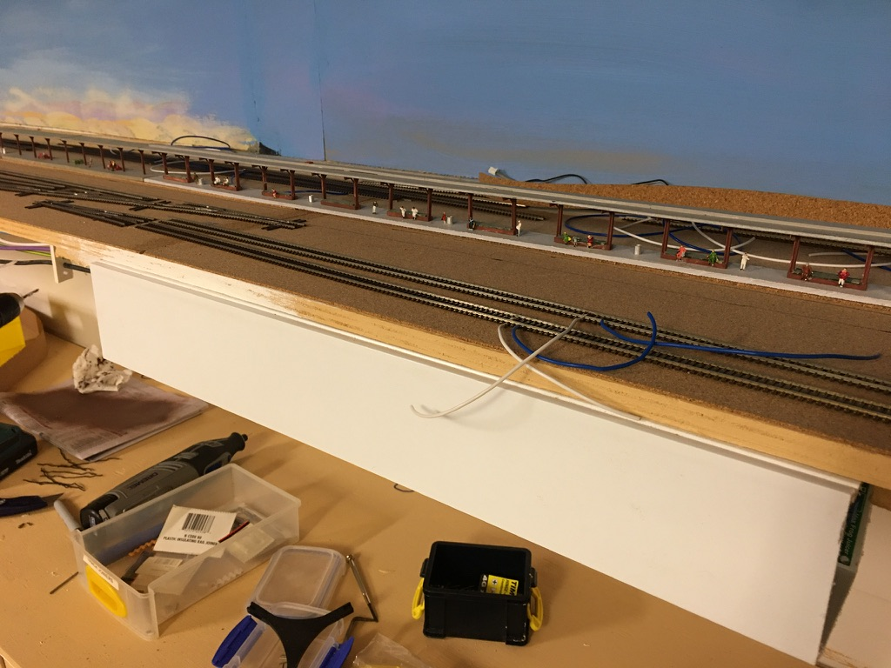

The track is pre wired with blue and white feeders.
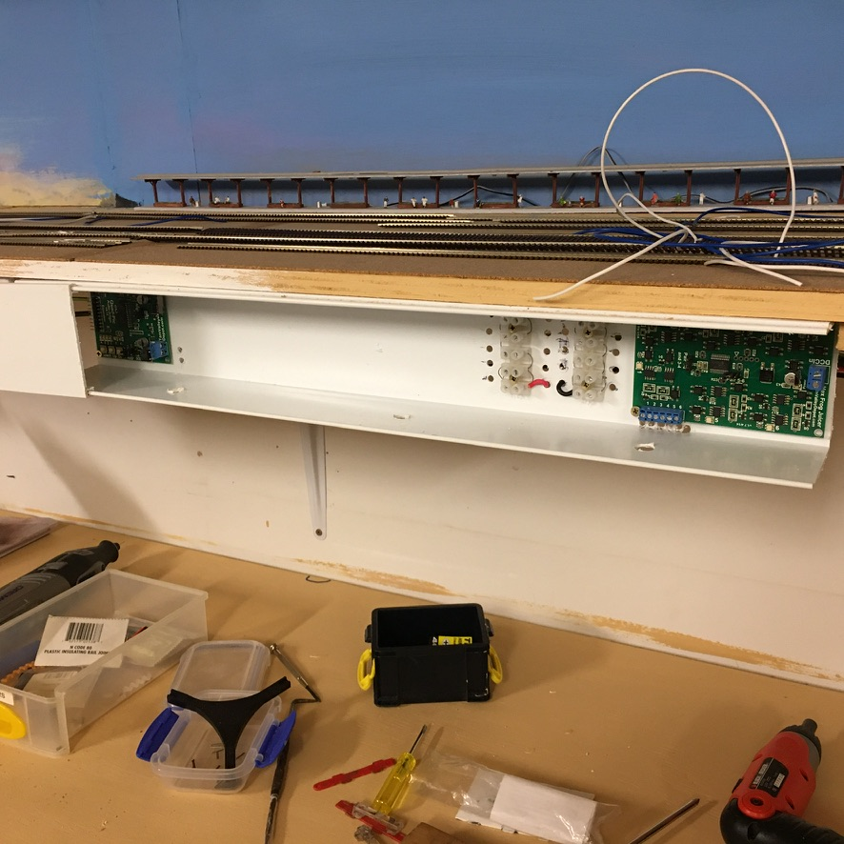

Once the position of the track was determined, I drew the switch positions on the cork base and proceeded to lay the cork roadbed. The cork roadbed is 3mm cork 20mm wide. This is glued down and will be sanded once dry and painted to seal it.
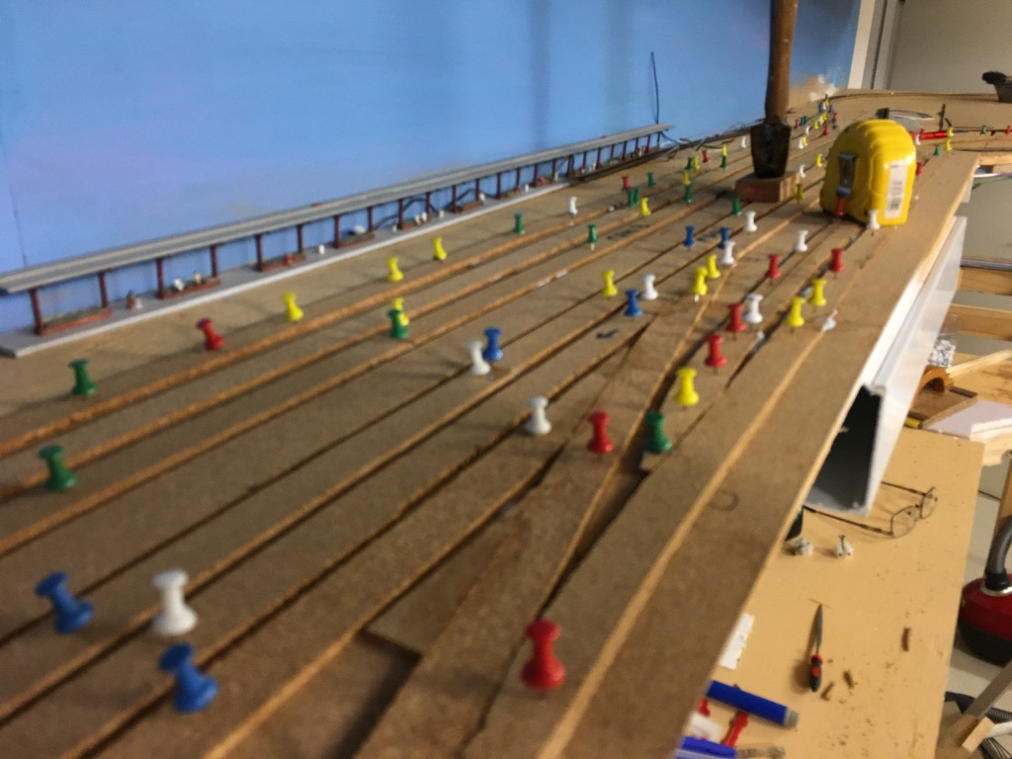

As well as “suitcase connectors” I will be using T-Tap connectors for the track feeders into the track bus. The advantage of these is the connection has a snap on connection that can be disconnected easily.
Below is an example of the T-Tap connector.
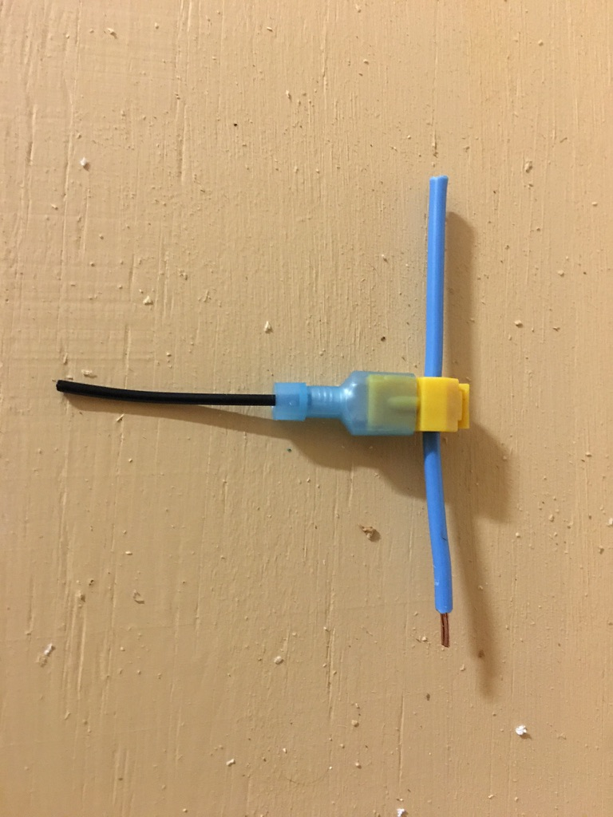

Well progress is continuing, but will I have something running for my Grandson who arrives a day after Christmas this year?

