A Model Railroad is “NEVER” Finished.

Part 2 of 3 (or maybe more?)

By Jeff Lee, MMR

Last issue we covered the reasons for an update of the layout and the early construction to get the baseboard, and cork roadbed installed. Research had shown me I could improve my layout within the current space without (Major?) changes. If the new changes are on a solid base, the next phase of track laying and wiring can also go quickly and smoothly. I know this is basic “stuff” but after 50 years and dozens of layouts it still holds true. Don’t skimp on the base work or the rest will suffer.
Of course, in the first part we checked to make sure turnouts were not wrongly positioned over bench work risers. We also made sure our cork roadbed was properly spaced so the track we lay will be at the correct spacing. I use NMRA guidance for this. Several manufacturers like Peco have similar guidance and tools. Follow them and you will be rewarded.
We have a new plan and we want our new section to be the best we have ever had. Firstly, let’s prepare the turnouts and track. My choice is Peco code 55 with Electrofrog turnouts but most of the ideas and experiences apply to any track in any scale. My control system is DCC (NCE) so I need power districts and 2 wire bus cabling under the layout. If you have a small layout such as an 8x2 foot switching layout all power could come directly from the Command Station. In my case I have 8 power districts with 8 separate circuit breakers (NCE – EB1). From each power district, I run the bus wires for that section as a separate item. I also run an “on-off” switch, on the fascia, from each power district so that if a short occurs we can isolate that section, or turn off all sections and gradually turn on each to isolate that short. By turning all power districts off and then one by one turning them back on it is easy to see what is causing the short. My message here is to plan the wiring before laying the track and future jobs like signalling (if you do it) are much easier.
The Bus Cable I use is multi strand 20-amp household power wire. You can buy this in Big Box stores or your local electrical outlet in 100-yard lengths. If you have a large layout that will usually be more than enough. I have enough to do another layout if that every happens, or to help friends out. Strip the insulation and you have three colours (black, red, green, usually). By purchasing an additional 2 colours I can make every Bus Wire for a power district a unique combination of colours. (e.g. red/black, red/white, red/blue, white/blue etc.).
I run the bus wire under the layout and support it with cheap plastic angle, plasterers’ builders use. It comes in 3-meter (8 feet) lengths for a few dollars. Here the bus wires for this section are red and green. (Fig 1) Below is also a mistake I made. I painted the plywood to seal it on both sides, but used a dark, almost black colour underneath. White is preferable as it makes under the layout much lighter and it is easier to find wires etc. Of course, you don’t have to seal the plywood base but for the small cost and time I find it worthwhile.
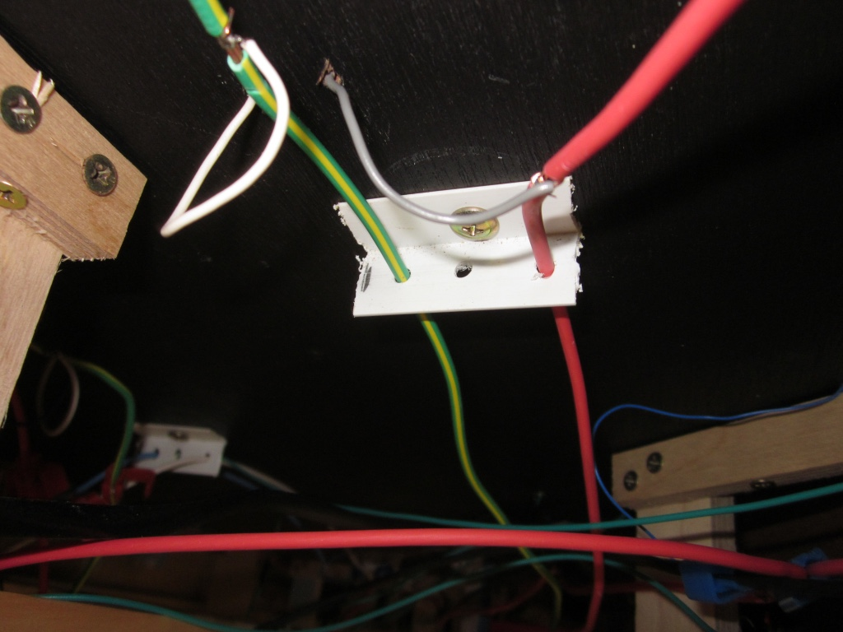Figure 1 Support for Bus Wires under layout

The first priority in laying track is to start with the more complicated areas and work out from there. This will usually be a section with multiple switches close together. With many switches, it is possible to use them as they come from the packet, but for long term reliability I prefer to add some wires to the stock rails and the frog to ensure continuity of power.
With Peco Elecrofrog turnouts (N Scale code 55 are a little different from HO scale but the process is similar) - see Fig 2. I isolate the frog by cutting the two rails leading to the frog about 20mm away with a jeweller’s saw. Once cut, I insert a small piece of 0.25mm plastic in the cut and super glue it in place. This ensures the rails do not touch later due to movement or expansion. In the photo below, you can see the cut and plastic filler in place. Once painted this will be almost invisible.
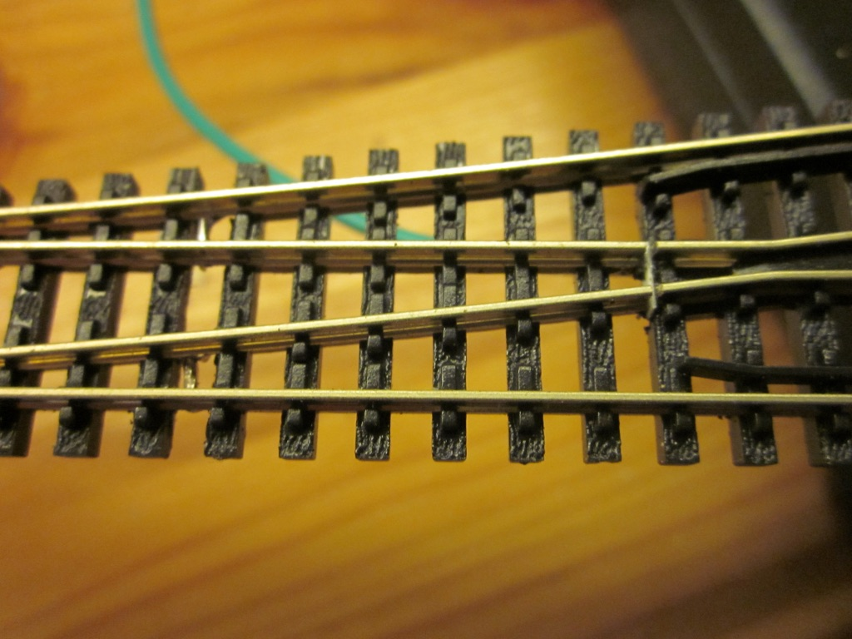Fig 2 Isolating the frog
The next step is to turn the switch over and attach three wires. One (green) to the frog, and the power wires to the outside stock rails. In the photo below, (Fig 3) you can see the frog wire attached. The stock rails will have feeder wires attached next to ensure continuous power across the rails, and not rely solely on electrical touch. I use a colour code for the feeder wires. This helps when connecting the feeder wires to the bus wire under the layout. In my case the feeders are white and either blue or grey. The darker colour goes to the “rear” bus. So before connecting the feeder wires to the switch you need to determine which direction it will be installed so you have consistent wiring standards.
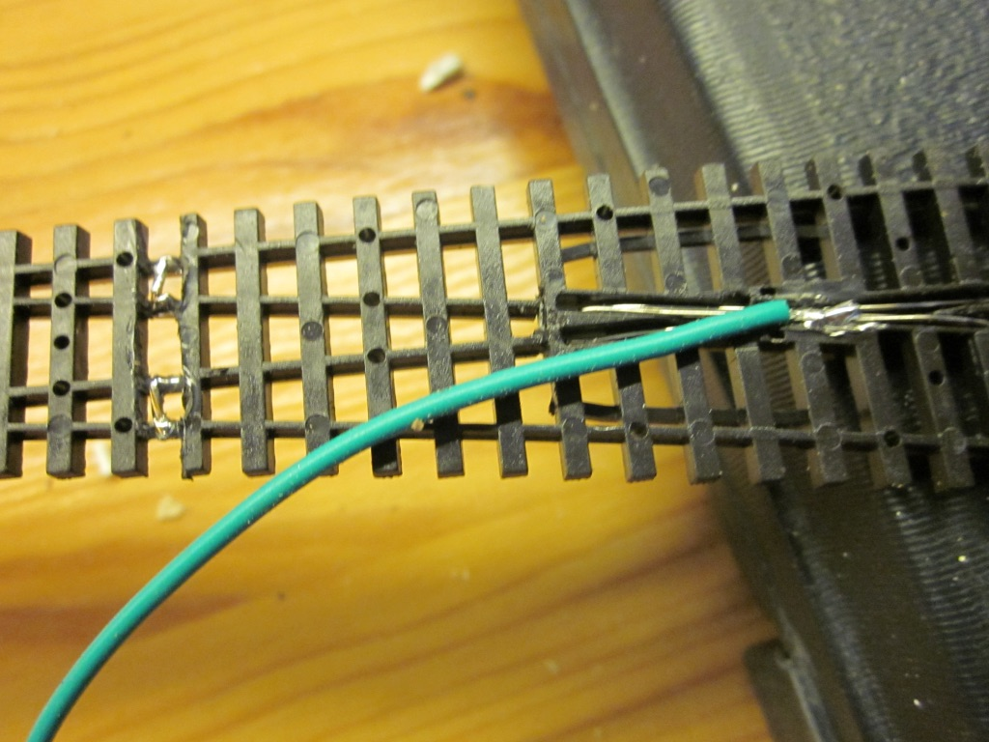Figure 3: Frog rail wired and stock rails connected.
When we have the switches wired we can join banks of switches together. With Electrofrog switches the rails leading from the frog to the diverging tracks need to have insulated joiners. The other metal joiners between switches get soldered together.. This way you can handle the switch group as one. You may be OK not soldering joiners if every rail has a feeder pair, but soldering a bank of switches makes their installation easier.
The next step is to lay the first bank of switches on the roadbed and mark the position of the feeder wires with a sharpie or pencil. Remove the switches and drill the 1/8-inch (3mm) holes for the feeder wires. Then test fit the switches by inserting the wire leads to make sure the switches sit flat. Sometimes you may have to dig out a little of the cork roadbed to ensure the switches sit flat.
Then go back to the plan. Before gluing the switches to the cork roadbed, double check your future operations plans for the new section. Take your time, it is worth it. How are you going to move the switches? Peco switches have a spring so they can be moved by hand and they snap across. You should use the outside throw bar to move the switch. Putting your finger between the rails to move the switch works but over time weakens the switch. The point rails are held by small tabs that could break. You can use a small plastic tube on a skewer stick that fits over the Peco “nob” on the throw bar. The skewer stick is a good uncoupling tool.
Think carefully about how you and your operators will move the switch points. I use a combination of manual throws, slide switches, servos and Tortoise slow motion machines. The tortoise or servo is used with difficult to reach switches. As my layout is basically a shelf layout most switches are accessible. In the majority of cases I use inexpensive slide switches to move the turnout (see below for construction and wiring). Whatever the control solution you need to now drill a hole for the servo or Tortoise control wire, or in the case of slide switches, cut the cork roadbed to allow the piano wire connection to connect. In N Scale Tortoise or Servo switch wires benefit from a hole about 5/16 inch right under the point where the wire connects to the throw bar. Once you have drilled this extra hole or cut the road bed it is time to install the first switches. I use grey caulk to hold down the track and switches. Mark the switch ends and apply caulk to the roadbed in all areas EXCEPT near the throw bars and spread the caulk with a spatula. You do not need any more than a thin “butter like” spread, or the caulk will ooze up between the ties and look ugly. Push the switches down into position, align them and make sure they are straight. I use a roller to press them down and then either pin them for 12 hours or use weights to hold them down if there is any hint of springing up.
Once the switches are in place we can move to the flexible track. Before rushing in go back to the plan and ask yourself some questions. Do I need blocks for signalling? In my case in this section the slide switches and Tortoise switch machines will control signals and the mainline signals will be controlled by infra-red sensors. (The new NMRA LCC standard will support both methods).Many modellers like block wiring but it does add to the wiring complexity:- I am still learning which is best.
Let’s begin laying the flexible track between the switches we have laid. A good rule is to have every section of track wired with a pair of feeder wires. Some folks use feeder wires attached to the rail joiners. I have not found this a great method as you still depend on the rail joiner to conduct electricity along the rails. Some folks drill a hole besides the rail and insert a wire and solder to the rail. This leaves a visible connection which is hard to hide. My preference is to solder feeders to the bottom of each rail. Provided you test the connection after soldering, I have found this method works very well. My experience is over 20 years and several layouts: both permanent and portable. In my opinion, this is the best method to wire the track. (Figure 4)
So here are some rules I have learned. Remove one tie. Make sure the feeder wires you connect to the track are long enough to reach the bus wires below. Tin both the wire ends and the rail after using flux to help the solder flow. If the wires and rail are tinned well you only need to apply a little heat to melt the solder. Then solder the feeders aligned as below. This ensures you can slip a “skinny” tie under the solder point and, from above, the connections are invisible. Keep to your rules for wiring. In my case the darker feeder goes to the back.
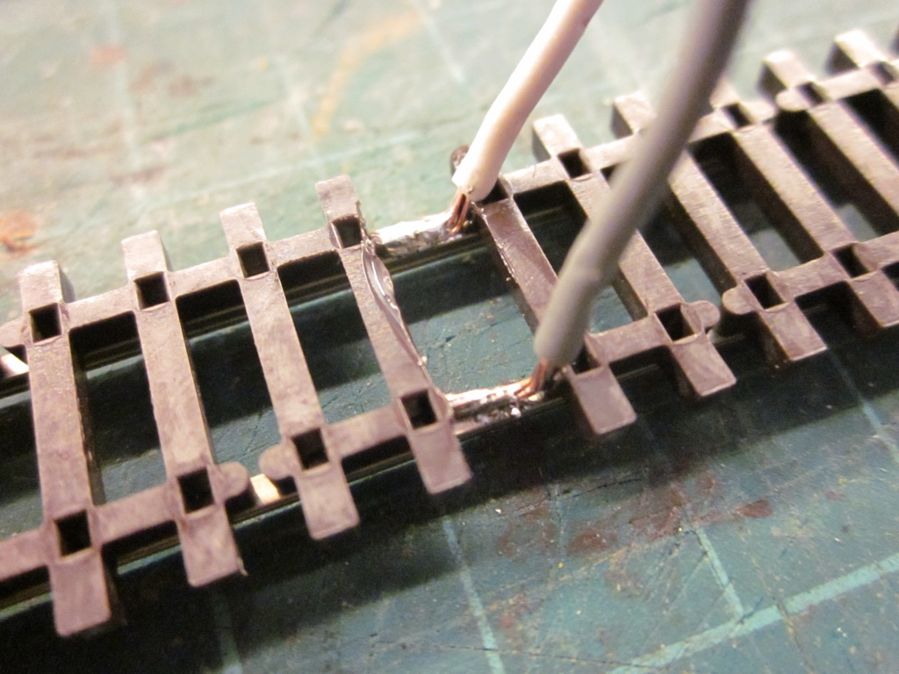Figure 4: Attaching feeders to track.
Now turn over the flex track and test fit it to the first location. If necessary use your Xuron rail cutter to square up the rails to fit into the joiners in the switch. File any rail ends after cutting. Mark the location of the feeder wires, remove the track and drill two 1/8-inch (3mm) holes for the feeder wires. Mark the end of the flexible track section, so you know how far to add caulk.

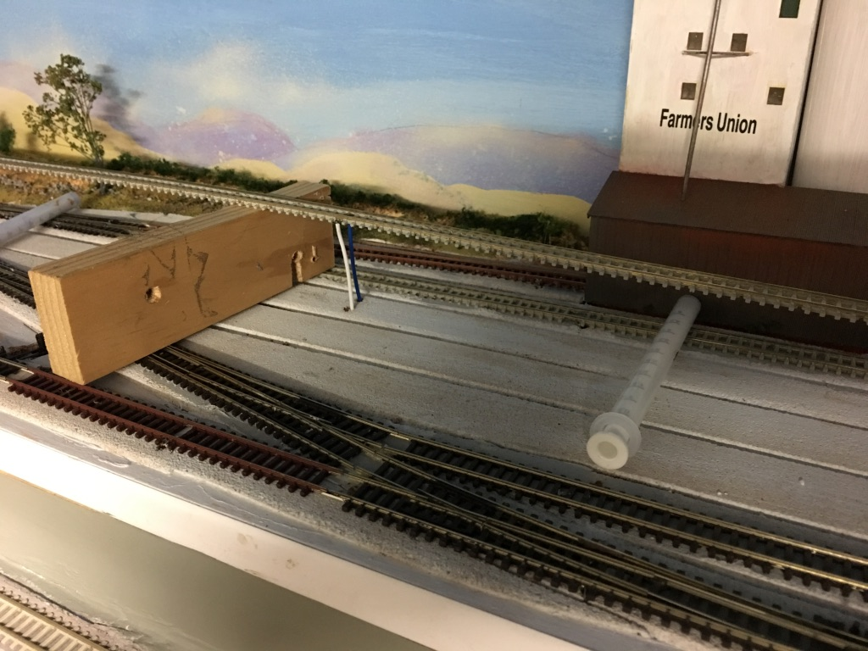Figure 5: Track ready for gluing down

Now we are ready to lay the track.
Here is a check list of items to have handy to ensure the track is well laid.
- Pins to align and hold track.
- A straight edge – I use a 1.5-meter (4-5 feet) aluminium bar 8mm wide which I bought for a few dollars from the local aluminium fabricator, but any straight edge that works for you will do. The 8mm bar fits into N Scale track. Some shelving vertical metal supports also work and are the exact fit for N Scale track, ensuring you get straight track laid straight.
- On curves, you can use “track setters” for the respective curve radius. With multiple curved tracks I make a template for the inside track from thin plywood and then use the track spacers to ensure the additional curved tracks are “parallel”. I do make a short easement at the beginning and end of the curve. My minimum radius is 18-20 inches. If you don’t have that luxury (of larger radius) you may need to use a track setter to ensure the track radius is even.
- Caulk and caulk gun. I use grey caulk but if you have a heavy industry area you may prefer a brown colour.
- A roller to press the track into the caulk. Michaels or similar craft stores sell them.
- A spatula to spread the caulk.
- Towel or paper napkin to wipe away excess.
- Spare rail joiners – they sometimes “disappear” from the rails.
- Drill to drill holes for the feeder wires. A 3mm drill bit is ideal.
- A vacuum to get rid of shavings before caulking.
- A track spacer for parallel track spacing. Peco sells them or you can make your own to ensure consistent spacing. Note the distance between tracks on curves may need to be more than on straight sections to prevent overhanging cars from hitting each other on parallel tracks. On parallel straight tracks, I use the distance the Peco switches demand which aligns with the Peco track spacer. The NMRA publishes standards for track separation.
Below is a roller in action on the staging tracks. Note the track spacer made from 2mm plastic. Slide the spacer along as you roll the track into the caulk and on straight sections you may not need any weights or pins, or very few to hold the track until set.
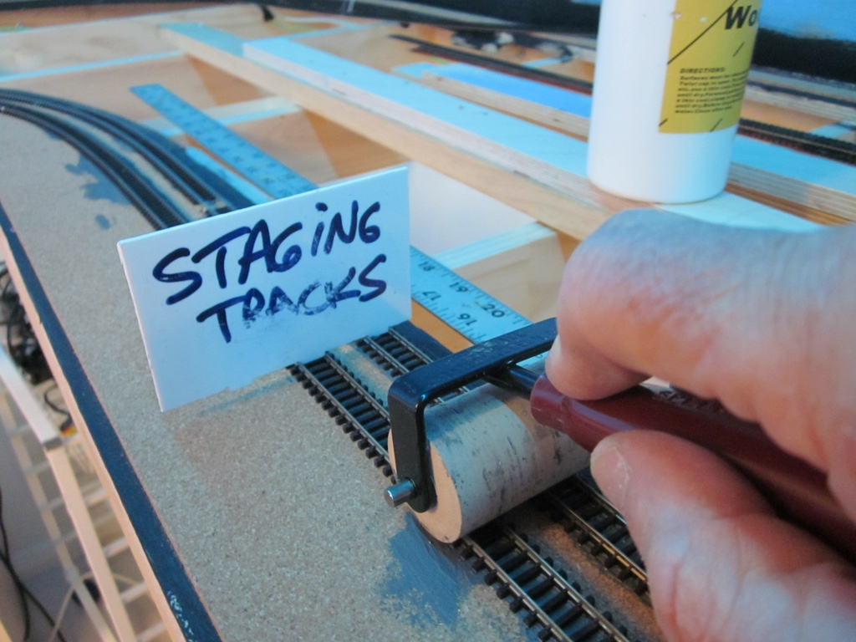Fig 6. Pressing track into the caulk.
On curved sections where one length of flex track is not sufficient for the curve I solder two sections of flexible track together before curving. Then solder the feeder wires and curve the track to the desired radius. Cut the ends to join to the previous track, add rail joiners and position your track to mark the hole locations for the feeders. Drill the feeder holes, vacuum and get ready to lay the curved section. If it is single track you may be able to curve by eye matching the roadbed previously laid. If it is parallel track I make a template for the first track. This template has a slight easement at each end to “ease” the track from straight to curved. As below (Fig 7) you will need a lot of pins and weights to hold the curved track in position. Experience says to leave it for at least 12 hours to set before laying the other parallel tracks.
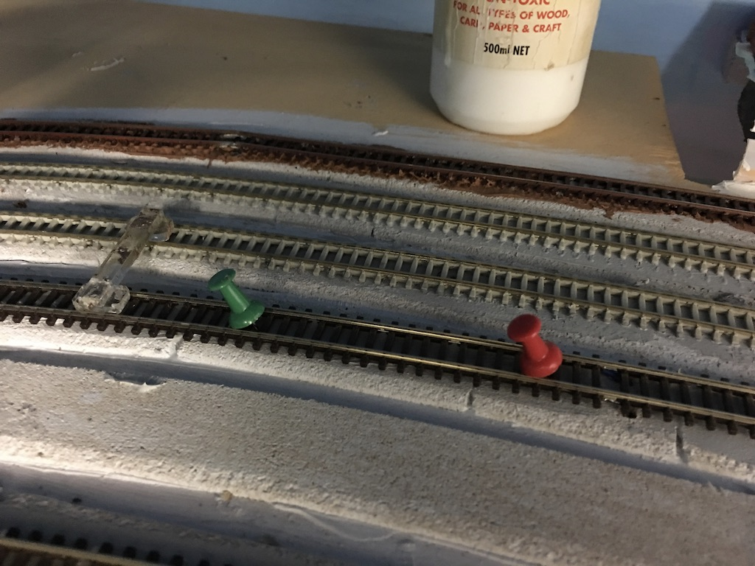Fig 7: Pinning and spacing parallel tracks.

DPDT Slide switches for turnout control.
Where possible my turnouts are controlled with double pole, double throw (DPDT) slide switches. These units cost less than $1 and as well as powering and switching the frog polarity, they can also light signals to show direction of the switch. If you have panels you can use them to show track direction on the panel. Here is the unit as bought and wired. I drill two 1mm (#80 drill) holes in the DPDT lever after removing the aluminium cover (which is a great scenery “rubbish bin”). Drill one hole through the lever near the base for the throw rod and another in the top to add a switch stand. I use a 2mm (5/64inch) thick plastic base around the DPDT slide switch as shown to cover the gap in the hole cut for the switch.
Below you can see one installed (left) (Fig 9) and on the right a new DPDT switch and one wired ready to install. Note the use of Cat5 cable to make wiring neater.
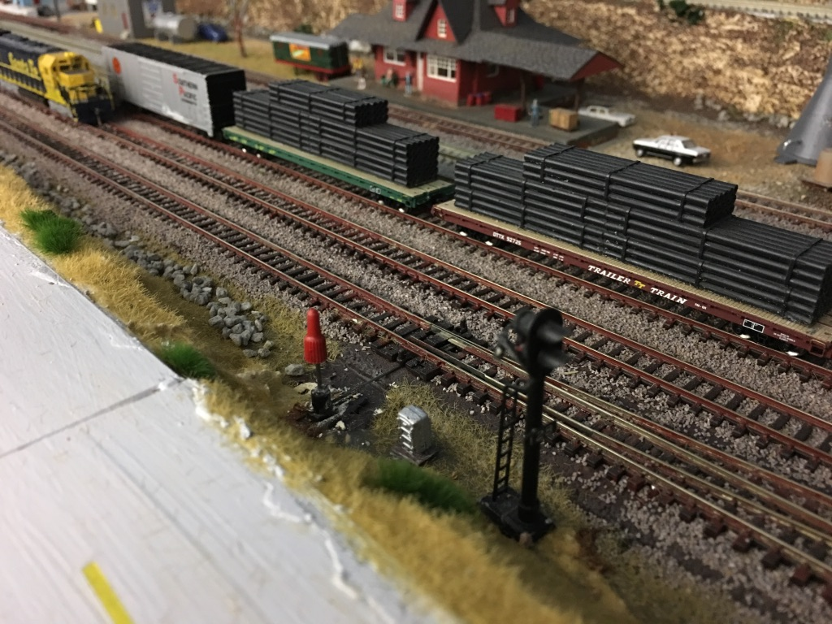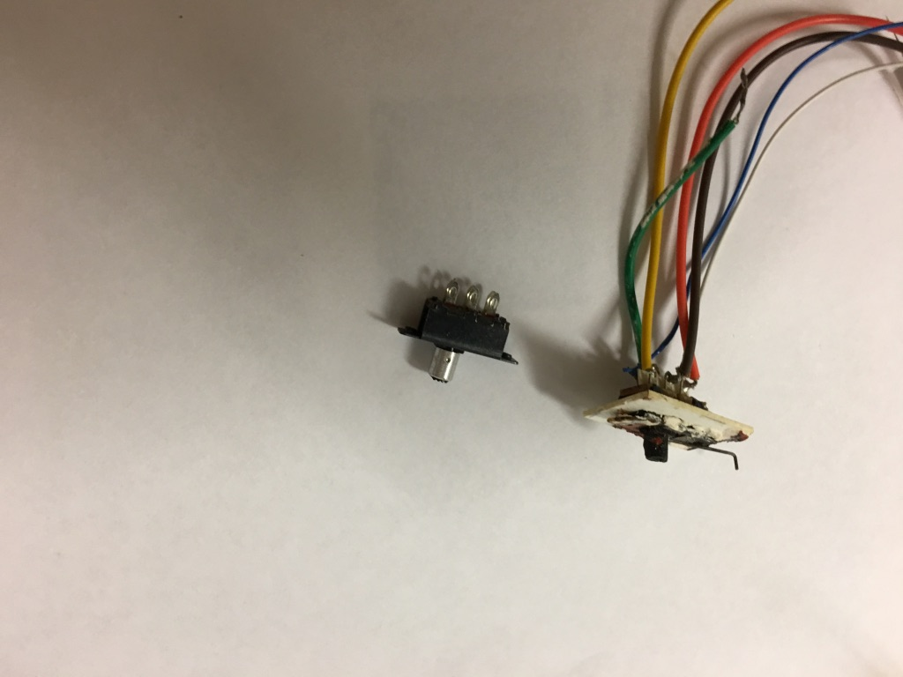
Fig 9. Switch stand installed. Fig. 8: DPPT switches before and after wiring

Wiring to the bus: Connecting it all up:
This is the quick and easy part if you have been consistent with the wiring colours. There are two popular methods to connect the feeder wires to the bus. One is to strip the bus wire and twist the bare (stripped end) feeder around the bare bus wire and solder. Another is to use suitcase connectors. I find the latter easier and neater, but the choice is yours. Soldering is cheaper.
Before any connections are made, get yourself an electrical buzzer and 9-volt battery (see picture). Disconnect the bus wires from the command station and/or circuit breaker as this will create a closed circuit. Attach the buzzer to the tracks where you will start the wiring connections. Check the buzzer is working by shorting a section of track. Start connecting the feeder wires as per your colour code. If the buzzer sounds you have a short which is probably either an insulated rail joiner missing, or the feeder wires are reversed. A tricky area is often the DPDT switch wiring to the bus. The green wire (centre pole) goes to the frog. The bus wires can connect now. Test that you have connected the track wires from the DPDT switch correctly by running a locomotive through the switch slowly. This will test if the frog is powered and the wires are the correct polarity. If the locomotive stalls or appears to short reverse the track wires from the switch to the bus.
If all looks good, connect up the circuit breaker and we are ready to run trains. Slowly running a train over the whole section will check the wiring and any track work that may cause problems. Sometimes a dab of caulk remains on the track or has squeezed up between the ties and could potentially cause a rough ride or derailment.

Lift Bridge track work:

One of my compromises was to install a lift bridge to make a “better” mainline and reduce return loops. The track work here is similar to the other track work except at the bridge joints. This section of track needs to be 100% bullet proof. I remove four ties at each end of the track on the bridge and replace with “American Tie and sleeper”. These ties are soldered to the rails to provide stability to the track near the bridge openings. After laying the track and once the caulk has had at least a day to set it is time to cut the joints for the bridge. A combination of the caulk and soldered rail on each side of the joint will hold the rail in place. Using a fine and new razor saw start by cutting the cork roadbed, then cut the rails vertically along the bridge joints.(see Fig 11) Once everything is cut the bridge can be raised and the rails filed to remove any burrs. You may have to file the rails with a slight angle to ensure smooth operation. There are many videos around on lift bridges, so be cautious of easy solutions. My advice is to ensure you have:
- Very stable/strong foundations that will not move.
- A solid lift bridge; build a frame of ¾ inch quality plywood etc.
- Top quality hinges.
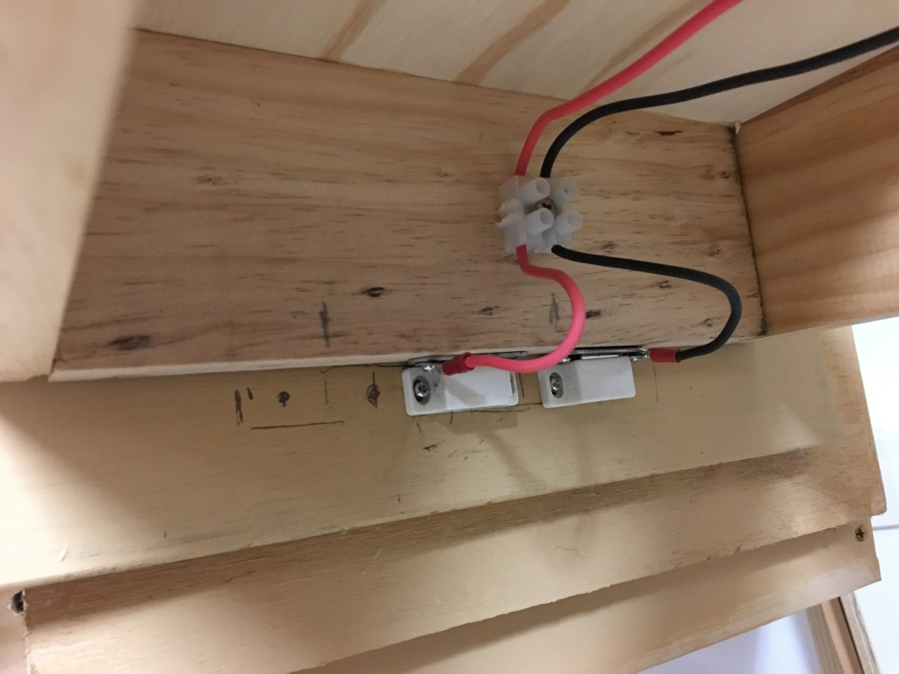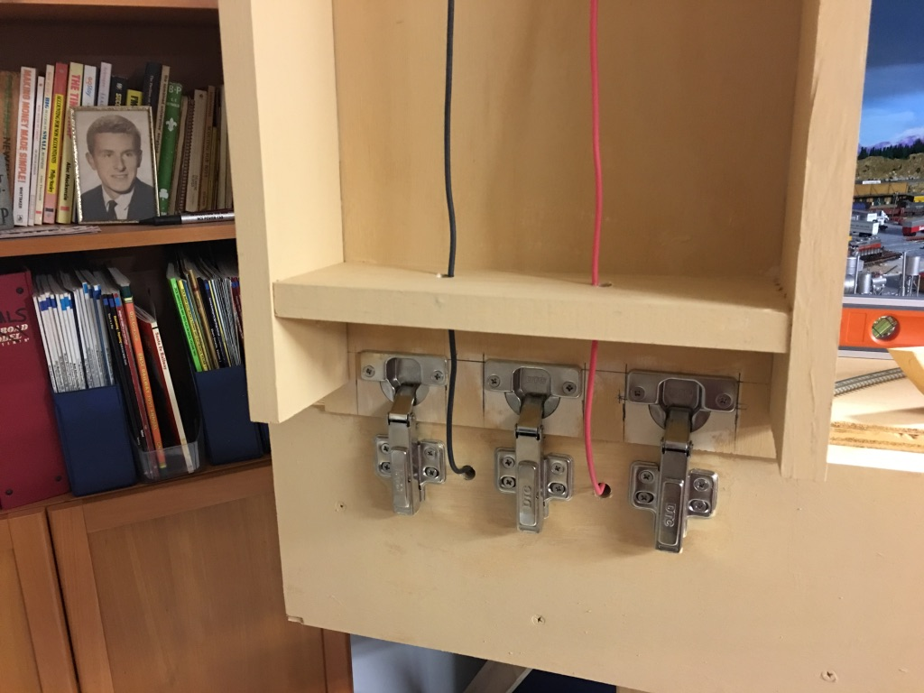
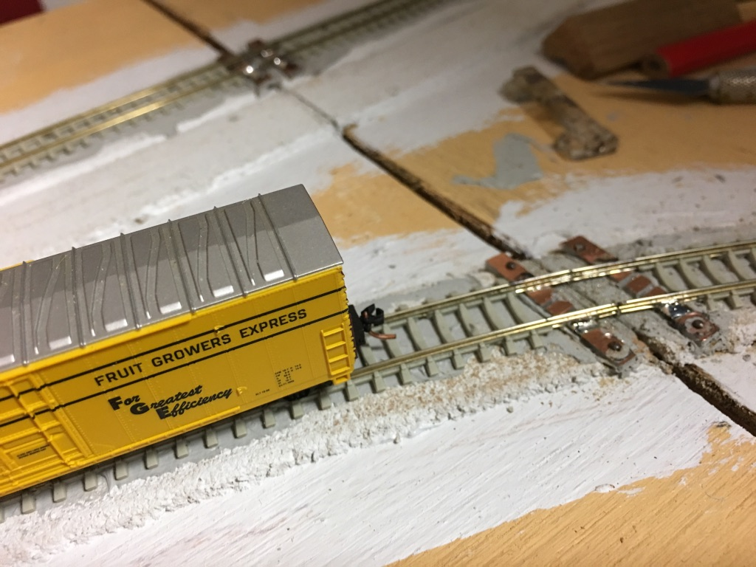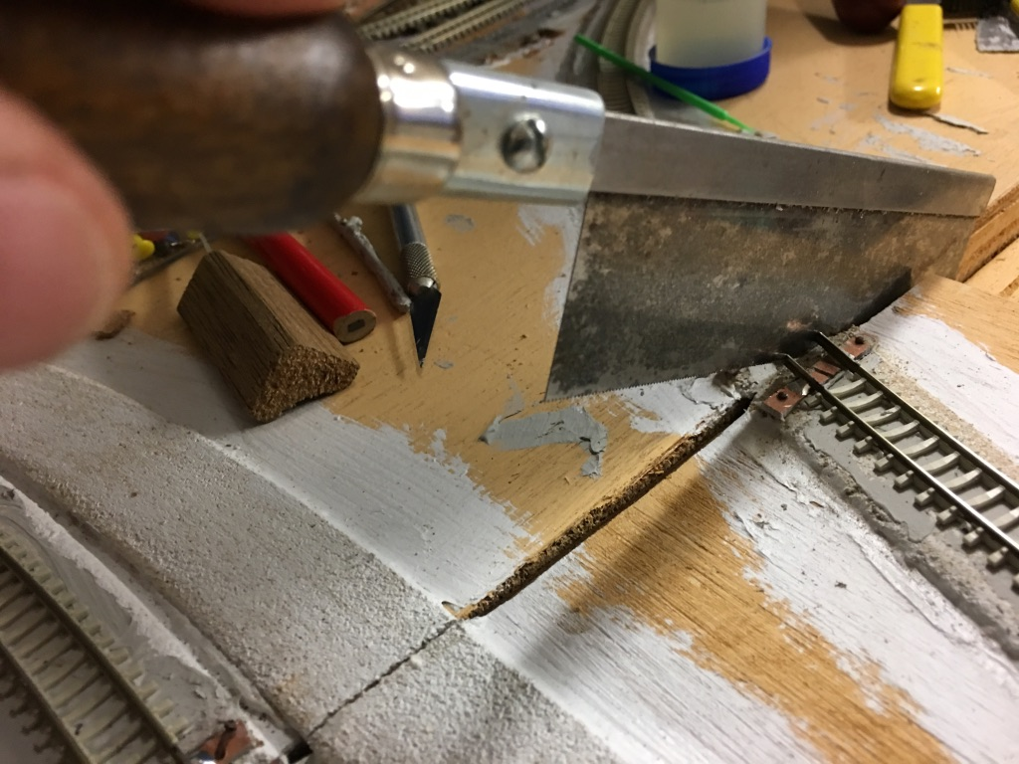Fig 11: Cutting the rails and cork roadbed
Wiring requires a connection that only works for safety reasons, when the bridge is down. A simple magnetic latch on the base of the bridge works as the bus connector. Or you can have a manual connection via a 2-pin plug. I also created track blocks on each side of the bridge about 40 cm. (18 inches) long so I could isolate those blocks when the bridge was raised. Signals will be installed on the mainline at these block gaps to warn operators.
Now the final test of all the work to date.
A good vacuum of the new area is essential before running any trains. Those bits of solder, caulk and even spare track connectors stay around. Once the new work is clean I started to test run with just one locomotive running over all the new track work. This showed up some glue and caulk that had stuck on the rails. It also showed a Tortoise lever wire that was too high and stopped the locomotive. After a few more checks it was time for full freight and passenger trains to run. It was great to see a long 30 car train successfully run across the new section and lift bridge.

Now everything is in place and here is the first train. My Kato SP 4449 plus a full consist of 18 carriages! Next on my schedule is to complete the basic scenery and install the mainline signals. The city buildings will be lit and lighting controlled by both Arduino circuits, and Woodland Scenics “Just Plug” controllers. But for now, I can operate and slowly add my scenery and details.

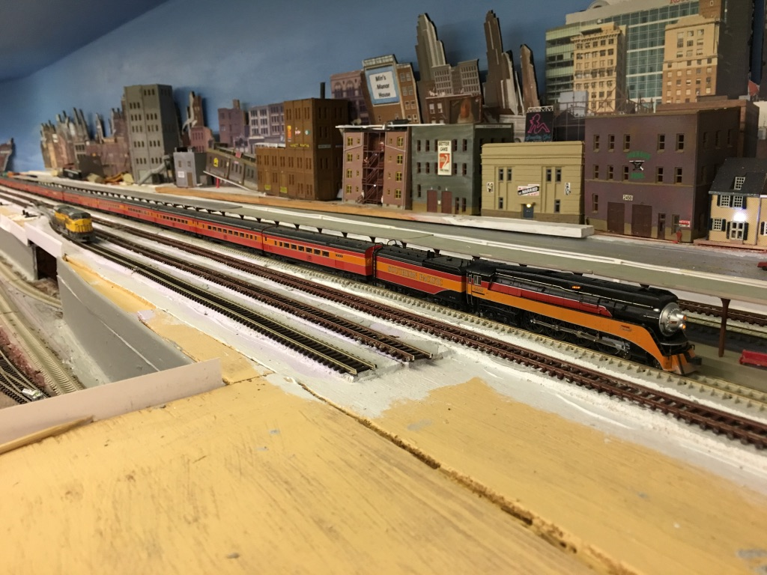

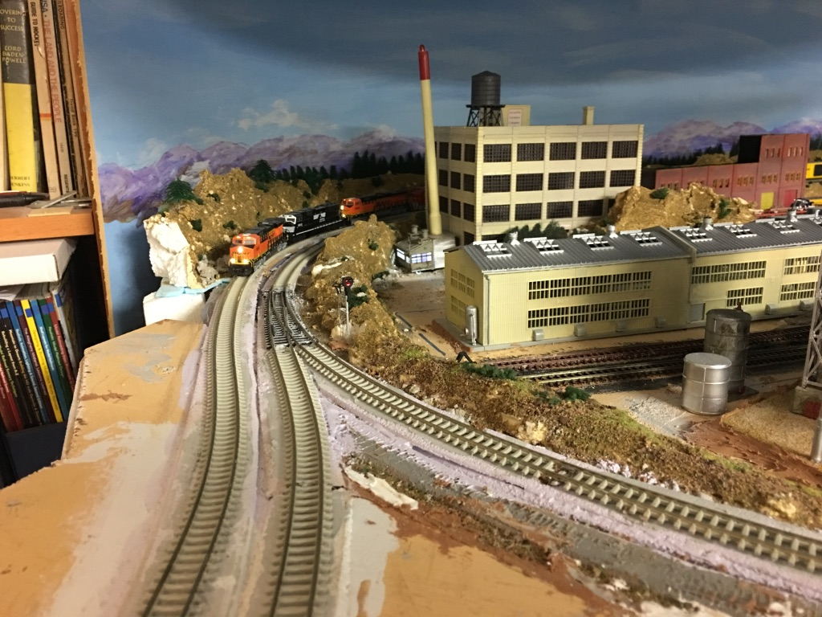
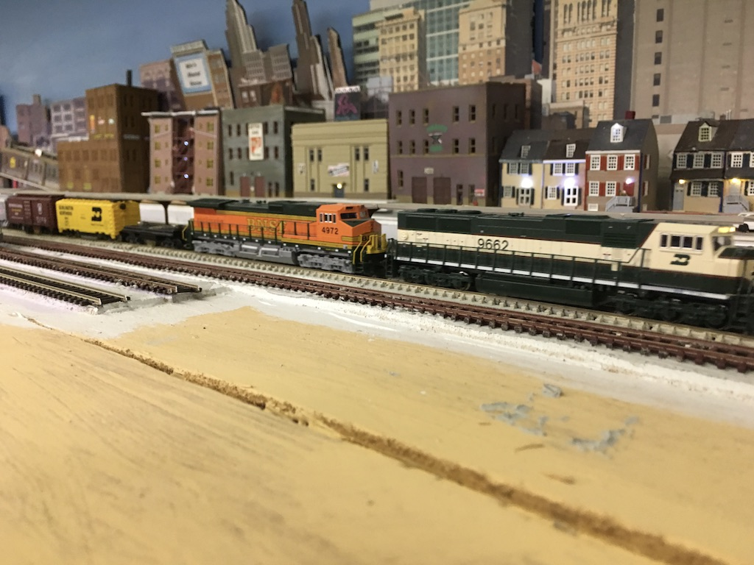
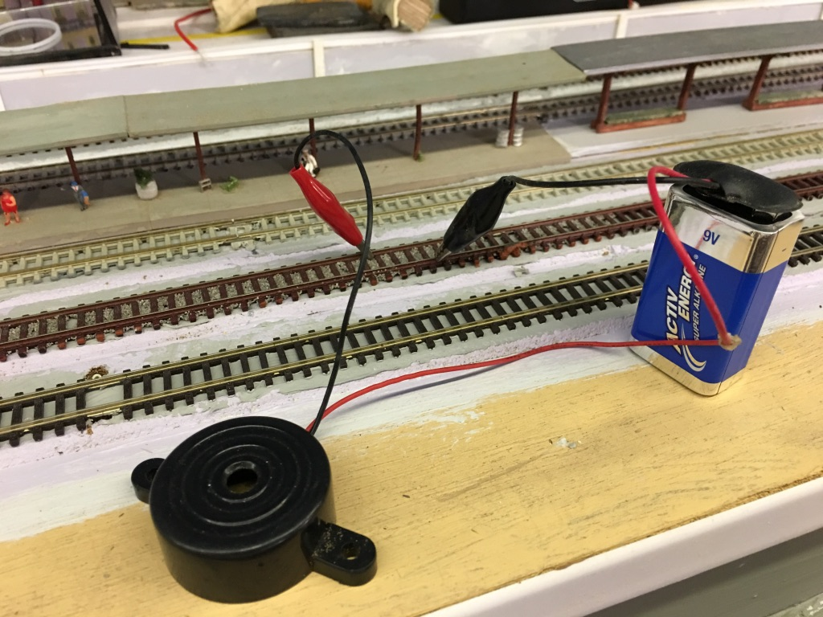
Fig 12: Tester for wiring installation.

