C**lubHollywooF.com (407)701-9011**

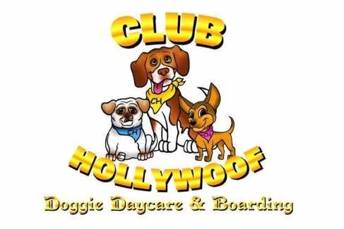

Spa Services & Packages

Full “Masterpiece” Groom:

*Includes Serenity Bath, Blow Dry,*

*Nail Trim, Ear Cleaning, Full Cut*

*including trimming of the face, paw*

*pads and sanitary area.*

*Finish with Essential Oil Mist !*

Small Dog: Starts at $20

Md Dog: Starts at $30

Lg Dog: Starts at $40

XLg Dog: Starts at $50

Kitty - Cat Packages:

*Price based on cats coat. Special Appointment Required !*

Bath: Starts at $45

Grooming: Starts at $55

Full Cut: Starts at $65

Size Chart:

Small Dog 20 lbs & Under

Medium Dog 21 lbs – 40 lbs

Large Dog 41 lbs – 70 lbs

XLarge Dog 70 lbs & Up

**NOTE:** *Prices May Var*y based upon the type and condition of the coat. Additional Charges may be necessary *for de-matting, undercoat removal, behavioral issues, extensive breed specific styling or double coated breeds. See associate for pricing.*

Mini “Masterpiece: Groom:

*Includes Serenity Bath, Blow*

*Dry, Nail Trim, Ear Cleaning,*

*And trimming of the face,*

*Paw pads, and sanitary area.*

*Finish with Essential Oil Mist !*

Small Dog: Starts at $30

Md Dog: Starts at $40

Lg Dog: Starts at $50

XLg Dog: Starts at $60

Play Packages:

*Hair Coloring by Area !*

1 Area: $5

2 Areas: $9

3 Areas: $12

Body: $45 & Under

Serenity Bath:

*Includes relaxing bath, blow dry, brush out, nail trim, ear cleaning.*

*Finish with Esential Oil Mist !*

Small Dog: Starts at $40

Md Dog: Starts at $50

Lg Dog: Starts at $60

XLg Dog: Starts at $70

ADD – ONS & Additional Services:

Anal Glands: $6

Teeth Brushing: $8

Nail Clipping: $8

Nail Grinding: $12

De-Matting: $15

( Per 20 mins)

Flea & Tick

Treatment: $10

De-Shedding: $16