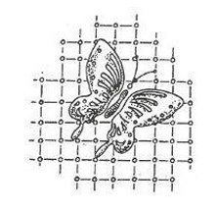Fenton Art Glass Collectors of America, Inc.
PO Box 384 • Williamstown, WV 26187 • (304) 375-6196 • fagcainc@cascable.net
Annual Membership Form – Dues Renew Annually on February 1
Name: _________________________________________
Address: _________________________________________ check if new address
_________________________________________
City: __________________________ State: ______ Zip: _____________ Phone:( ____) ______________ Business Name _______________________________
(if dealer)
Email Address: ________________________________________________________

MEMBERSHIP TYPE | QTY | EACH | TOTAL
Individual Full FAGCA Membership |  | $ 40.00
Associate FAGCA Membership |  | $ 5.00
Child Membership (under 12) |  | FREE | N/A
Replacement Membership Card  (no longer issued annually) |  | $ 5.00
 | TOTAL AMOUNT ENCLOSED

Full individual membership includes a subscription to Butterfly Net, the official newsletter of FAGCA, as well as full voting rights. Associate memberships are for additional members within the same household (associates have full voting rights, but do not receive a separate copy of the newsletter). Membership for children under 12 is free. Please list associate/child member names below (and please provide birthdates for children).

___________________________ _ __________________________

___________________________ _ __________________________

Please mail this form, along with check or money order, to: Fenton Art Glass Collectors of America, Inc.
P.O. Box 384
Williamstown, WV 26187

To renew online, go to fagcainc.org and scroll down to Join or Renew Now. There will be a 4% convenience added to credit card transactions.

