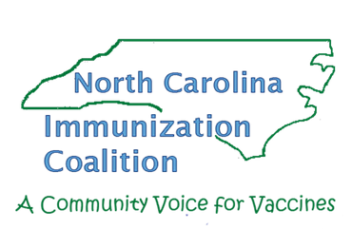
NCIC Quarterly Meeting Minutes
February 9, 2021

12:00 pm Opening and NCIC Update
Lindsay Capozziello, PharmD, Chair

12:05 pm Joint COVID-19 “Node” of the Community Care of North Carolina and NC AHEC
Chris Weathington, Director, Practice Support, NC AHEC
- Keeping Kids Well Campaign Update
  - COVID-19 has led to a measurable decrease in pediatric preventative care across all populations. Disparities in rates across populations seen historically persist, especially with Latinx and Black children.
  - Under-utilization of well-child visits are missed opportunities to identify physical, developmental, and behavioral concerns – many of which can be managed or treated.
  - Missed vaccinations can eventually lead to potential community outbreaks of preventable disease during a busy COVID-19 and influenza season. We don’t want another pandemic on top of a pandemic.
  - Need for AHEC and CCNC to help practices reduce care alerts or overdue well child checks to pre-COVID19 levels via 1:1 practice support assistance, webinars, media communications, printed resources, etc.
  - CCNC care management has been reaching out to parents and families with tailored messaging to Latinx and African-American families.
  - Local Health Departments are deploying care managers with active outreach to children in care management who are missing immunizations and well visits.
- COVID-19 vaccine administration assistance
  - AHEC and CCNC have partnered to also provide practice support assistance with COVID-19 vaccine administration. Practice support coaches are also able to assist with questions, clinical workflow guidance, and collaborate with the CVMS helpdesk to resolve issues.
  - AHEC and CCNC have a co-branded website with resources at Coronavirus (COVID-19) Information | Community Care of North Carolina (communitycarenc.org).
12:20 pm HPV Task Force Update
Scott Coleman, Member, HPV Task Force
- HPV task force intends to apply for Merck grant in collaboration with NC Oral Health Collaborative. Project will focus on making online training related to HPV vaccination available for dentists.
12:30 pm Immunization Branch Update
Scott Coleman, Communications Specialist
- North Carolina DHHS launched a new flu vaccination campaign for 2020-21 to encourage flu vaccination and educate North Carolinians about the health risks associated with flu- “The flu vaccine. Get it. Got it. Good.” Available at flu.ncdhhs.gov/materials. Results from campaign will be available shortly.
- Updated meningococcal (MCV4) booster requirement also included on new 12th grade N.C. Back to School Requirements fact sheet, as well. All updated grade-specific fact sheets, in English and Spanish, available at: https://www.immunize.nc.gov/family/nc_immnz_requirements.htm
- COVID-19 Communications Toolkit.
  - You can help people in your community find their spot and take their shot!
  - Resources are available at: https://covid19.ncdhhs.gov/vaccines/covid-19-vaccine-communications-toolkit

12:40 pm The NC|Mutual CPESN Network Role in Community Immunizations and COVID-19 Activities
Christine Heath, PharmD, interim NC Mutual CPESN Network Facilitator
- Community Pharmacy Enhanced Service Network (CPESN)’s goal is to reach as many patients in the community as possible.
- Currently, there are 282 CPESN Pharmacies in North Carolina. 209 CPESN Pharmacies in North Carolina selected CPESN USA as their Federal Pharmacy Partner to receive FPP allocation of the COVID-19 vaccine.
  - When taking the Social Vulnerability Index (SVI) into consideration, North Carolina has 143 CPESN Pharmacies or 68% of the CPESN Pharmacies that are above the 50th percentile of the SVI.
  - CPESN Pharmacies in North Carolina are ready and awaiting vaccine to be a solution in providing vaccines to those most vulnerable populations.
- More information and COVID-19 vaccine resources, learnings, and best practices are available at https://www.covidbestpractices.com/vaccines
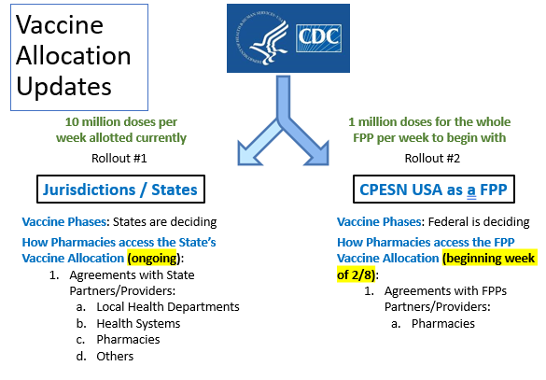
1:15 pm COVID-19 Vaccine Development
Tim Mullenix, PharmD, Vaccines Medical Director, Pfizer
- Pfizer’s mRNA COVID-19 vaccine is currently authorized for emergency use but is not yet approved by the FDA. Pivotal phase 2/3 clinical trial is currently ongoing, and Pfizer anticipates filing for FDA approval at the end of March or beginning of April 2021
- Pfizer has fully enrolled 12-15-year-old patient group in ongoing trial and plans to conduct additional clinical trials in children and pregnant women in future
- Vaccination is important to achieve herd immunity to COVID-19. A significant threshold of herd immunity to SARS-COV-2 will be required to disrupt sustained viral transmission; this may be achieved through natural infection or mass vaccination. Natural immunity comes with the cost of significant morbidity and mortality. Assuming a uniform herd immunity threshold of 67% (R₀=3) and an infection fatality rate of 0.6%, the absolute number of expected COVID-19 deaths across the globe would exceed 30 million people without vaccine intervention.
- Multiple potential vaccine platforms for COVID-19 vaccines, including inactivated, live-attenuated, protein-based, viral-vectored, DNA, and RNA.
- Spike protein is surface-exposed and mediates entry into host cells; therefore, it represents an attractive target for antibody-mediated neutralization and was the focus of vaccine design
- Pandemic vaccine development requires a fundamental shift in clinical development and innovative regulatory processes, allowing for faster authorization/approval of vaccines. Novel vaccine technologies also allow for acceleration of vaccine development
1:55 pm Closing
Lindsay Capozziello, PharmD, Chair
- Please Save the Dates for Upcoming NCIC Quarterly Meetings:
  - May 11, 2021
  - August 10, 2021
  - November 9, 2021
2:00 pm Adjourn

