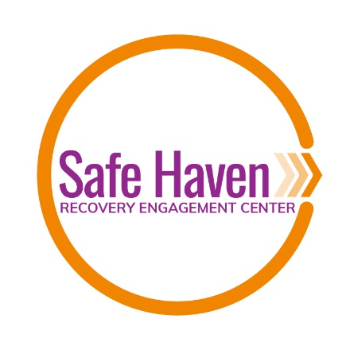
Code of Ethics

Ethics Statement
Safe Haven Recovery Engagement Center is designed to strengthen recovery from alcohol or substance use disorder, foster an environment where natural leadership can emerge, and bring people together within the recovery community to create positive change and overcome the stigma of substance use.
OUR CORE VALUES: Safety, Respect, Compassion, Acceptance
SAFETY
- We believe that all related to the Safe Haven Engagement Center are seeking to enhance their recovery and wellness.
- We will seek to resolve conflicts with others and not create disturbances by way of the use of profanity, gossip, fighting, choosing sides, outbursts of anger, or harming others.
- We will respect every member’s personal boundaries – physical, social, and emotional.
- We will honor each other’s confidentiality and right to privacy.
- We will not bring drugs and/or alcohol on the premises of Safe Haven or attend any Safe Haven activity or meeting under the influence of drugs and/or alcohol.
- We will not use relationships made here for personal gain.
- When we have concerns for the safety of others, ourselves, or the integrity of the center, we will seek staff guidance.
RESPECT
- We will strive to treat everyone with dignity and respect, and as a valued individual.
- We will show appreciation to our fellow recovery community members.
- We will allow others to make their own decisions and choices in regards to their own lives.
- We will be ready and willing to speak with anyone we may have inadvertently upset, and we will use listening skills in our communication.
- We will be role models within the community, always remembering we are representatives of Safe Haven.
- We will make every effort to be considerate of each other regarding a tolerable noise level when working, and to honor other’s wishes for solitude whenever possible.
- We will not take another’s belongings or any property of Safe Haven without first seeking permission.
- We will work together as a group, maintaining the concept at all times of peer-run programs, remembering we are not counselors, therapists, or professionals in this capacity, although some members may be in their professional lives.
COMPASSION
- For many, relapse is part of recovery, and we will welcome back those who are struggling.
- We will treat each member of the recovery community with care and compassion, as we wish to be treated.
- We will work hard to represent all members of the community, especially those who feel they have no voice.
- We will take extra care with new people who walk through our door and try to make certain they feel welcomed and comfortable.
- When a member of the recovery community needs to talk, we will do our best to listen with full awareness, without criticism or judgement, and when a member has the need for clinical work with a professional, we will do our best to refer that person to the appropriate support within the community.

ACCEPTANCE
- “Recovery by any means” is our standard, declining to be associated with any one model or approach.
- We will strive to meet each person “where they’re at” in regards to recovery, way of life, emotional stability, and health.
- We will seek to recognize our own biases and prejudices and attempt not to place them on others.
- We will honor each other’s culture, race, life experience, belief system, class, age, sexual orientation, gender, and appearance.
- We will do our best to acknowledge and validate the achievements and feelings of others.

