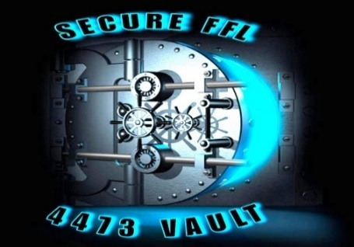
SECURE FFL, LLC.
(904) 882-7000
INFO@SECUREFFL.COM
FOR IMMEDIATE PRESS RELEASE
RELEASE DATE
AUGUST 30, 2024

THE RISKS OF STORING 4473 DOCUMENTS IN THE CLOUD

In today’s world, most FFL Dealers realize the value of storing data electronically. They also realize the importance of being able to easily access and utilize that stored data. What they may not realize is that where the data is being stored can determine what data can be accessed and by whom it may be accessed.

More and more firearm software technology companies are pushing FFL Dealers to store their important data in offsite Cloud sources. They would like you to believe it is cheaper, more convenient, and more secure. The facts of the matter are Cloud storage of documents such as 4473s comes with additional fees with third party providers, less ability to search relevant data stored in rigid PDF copies, most importantly opening up the opportunity for your data, and the data of your customer to be more readily available by law enforcement. Imagine customers finding out their purchase data is accessible in the Cloud Storage through mass acquisition.

In reality, 4473 data stored in the Cloud can be accessed through a broad profile driven SUBPOENA. Law Enforcement Agencies can obtain an abundant amount of Cloud stored data from an FFL Dealer with such a SUBPOENA versus a WARRANT which has to be case specific when stored on premise in a store. SECURE FFL reminds us, when the government wants to access information stored on a computer, federal and state laws usually require a case specific WARRANT, issued by a judge who has found probable cause that the data will lead to evidence of wrongdoing. However, a much lower standard than probable cause occurs with an ordinary SUBPOENA.” In “Policing and the Cloud”, by Christopher Slogobin, Director of Criminal Justice Program at Vanderbilt Law School, points out the precautions with storage of important data in a third-party cloud CLOUD storage.

SECURE FFL offers the best solution to these concerns with the SECURE 4473 and searchable Vault Database. Since these applications are stored on premises, access to the data is limited to a case specific WARRANT search. Furthermore, the Vault Database used in conjunction with the SECURE 4473 enables the store administrator to access and search 16 filters and 16 categories in addition to Firearm, Gauge, Model, Serial Number, Purchaser, etc. This allows for precision searches that are faster and less intrusive whether it be during a routine ATF audit or a case specific search. Your database is not safe from subpoena inspection in CLOUD storage, SECURE VAULT stores the database in-house and is only accessed through a CASE SPECIFIC warrant. Don’t depend on our competitor’s reassurance, check with your attorney and call us for a demo on protecting your database with our in-house storage.

Contact SECURE FFL directly to learn more TODAY!

