Papillion-LaVista Girls Spring Softball Camp 2019913210
Wednesday March 27th For girls entering grades 7th, 8th and 9th

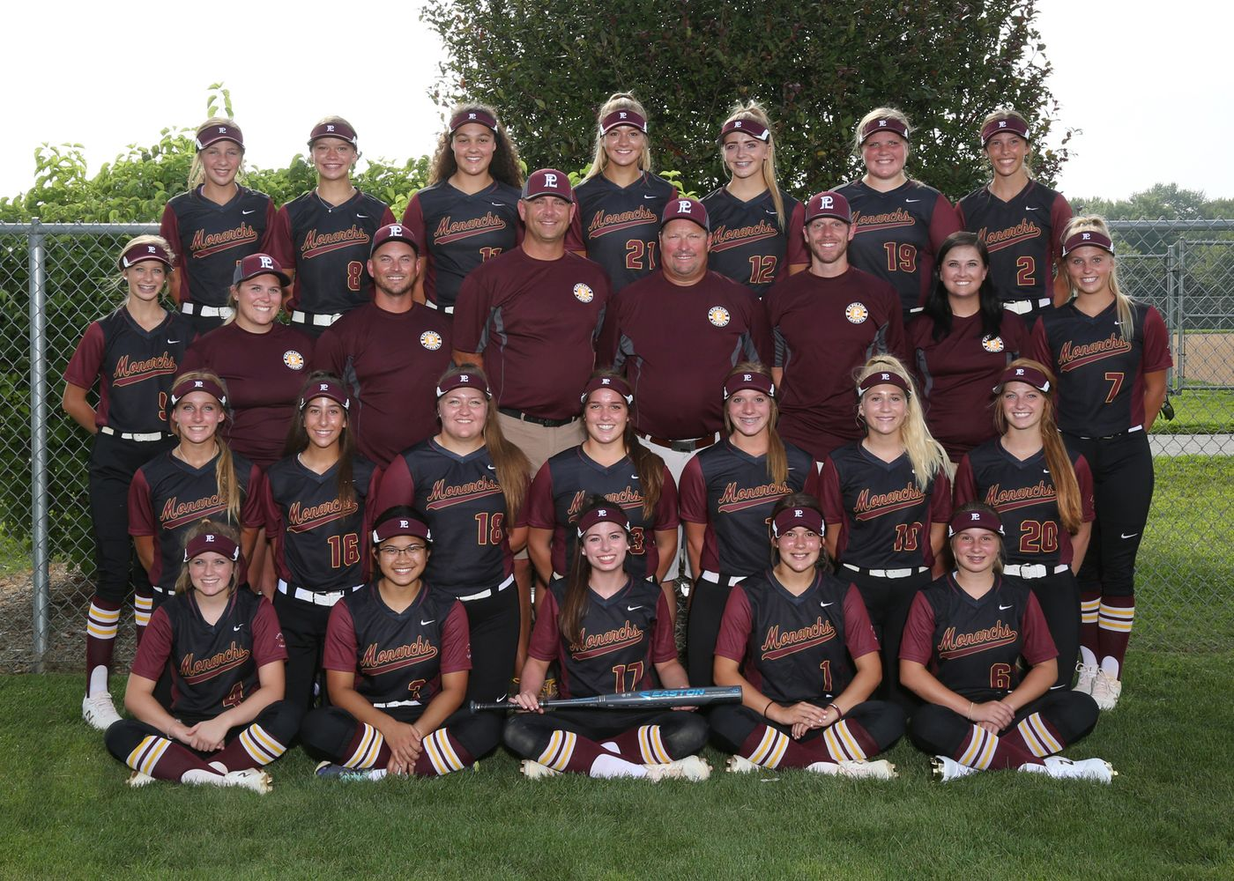
State Champions: 1995, 1996, 1997, 1998, 1999, 2000, 2001, 2002, 2003, 2004, 2006, 2007, 2010, 2017
State Runner Up: 2005, 2008, 2013, 2015, 2016, 2018
State 3rd Place: 2011, 2012, 2014
State Qualifier: 1993, 1994, 1995, 1996, 1997, 1998, 1999, 2000, 2001, 2002, 2003, 2004, 2005, 2006, 2007,
2008, 2009, 2010,2011, 2012, 2013, 2014, 2015, 2016, 2017, 2018
Metro Conference Champions: 1997, 1998, 1999, 2000, 2001, 2003, 2004, 2008, 2009, 2013, 2015, 2017, 2018
14 Time State Champion!!
State Qualifier 26 out of 26 years!!!

Fundamentals Great Instruction Hard Work Discipline
When: Wednesday, March 27th
Where: LaVista City Park- 78th and Josephine
Times: 6:00-8:00 PM for girls going into grades 7th, 8th, and 9th – (Fall 2019)
Cost: $10. Pay day of the clinic. If inclement weather, we will look for a new date. Please send e-mail to Toddpetersen0853@gmail.com or text to 402-880-1926 to reserve a spot.

Dear Parent: I’d like to invite your daughter to a softball camp for an opportunity to meet the Papillion LaVista Softball coaching staff as well as receive some great instruction. Monarch Softball tradition is like none other and we want you to be a part of it.

If you would like to participate in our Spring Camp, please e-mail me so I have a count of the number of girls participating.
GO MONARCHS!!!

Coach Petersen
Papillion-LaVista H.S. Head Softball Coach
(402) 880-1926
toddpetersen0853@gmail.com
www.papiosoftball.com

