**Papillion-LaVista Girls Spring Softball Camp – 2021**

Thursday, April 8th For Girls Entering Grades 7-9 (Fall 2021)

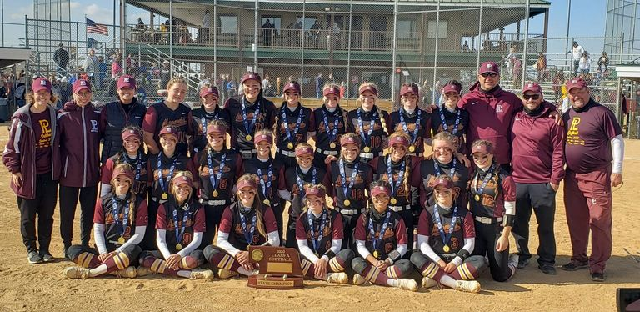

**State Champions: 1995, 1996, 1997, 1998, 1999, 2000, 2001, 2002, 2003, 2004, 2006, 2007, 2010,**

**2017, 2019, 2020**

**State: Runner Up: 2005, 2008, 2013, 2015, 2016, 2018**

**State 3rd Place: 2011, 2012, 2014**

**State Qualifier 28 Consecutive Years: 1993–2020**

**Metro Conference Champions: 1997, 1998, 1999, 2000, 2001, 2003, 2004, 2008, 2009, 2013, 2015, 2017, 2018,**

**2019, 2020**

**16 Time State Champion!**

**Fundamentals Great Instruction Hard Work Discipline**

**When: Thursday, April 8th**

**Where: LaVista City Park- 78th and Josephine**

**Times: 6:00-8:00 PM for girls going into grades 7th, 8th, and 9th – (Fall 2021)**

**Cost: $20. Pay day of the clinic or Venmo me at @Todd-Petersen-5. Rainout date will be April**

**15th. Please send e-mail to thunder@ufanebraska.com or text to 402-880-1926 to reserve a**

**spot.**

**Dear Parent: I’d like to invite your daughter to If you would like to participate in our Spring**

**a softball camp for an opportunity to meet the Camp, please e- mail or text me so that I**

**Papillion LaVista Softball coaching staff as have a count of the number of girls**

**well as receive some great instruction. participating.**

**Monarch Softball tradition is like none other**

**and we want you to be a part of it. Coach Todd Petersen**

**Head Softball Coach**

**402-880-1926**

[**thunder@ufanebraska.com**](mailto:thunder@ufanebraska.com)

[**www.papiosoftball.com**](http://www.papiosoftball.com)

**Twitter: @papiosoftball**

**Facebook: Monarch Softball**