**Papillion-LaVista Girls Spring Softball Camp 2022**

**Tuesday April 12th For girls entering grades 6th, 7th, 8th and 9th**

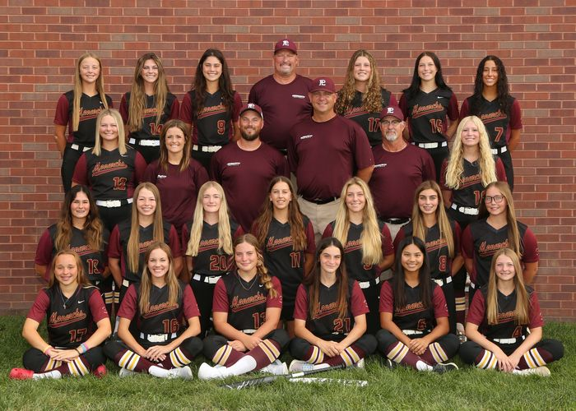

**State Champions: 1995, 1996, 1997, 1998, 1999, 2000, 2001, 2002, 2003, 2004, 2006, 2007, 2010, 2017,**

**2019, 2020**

**State Runner Up: 2005, 2008, 2013, 2015, 2016, 2018**

**State 3rd Place: 2011, 2012, 2014**

**State Qualifier: 1993, 1994, 1995, 1996, 1997, 1998, 1999, 2000, 2001, 2002, 2003, 2004, 2005, 2006, 2007,**

**2008, 2009, 2010,2011, 2012, 2013, 2014, 2015, 2016, 2017, 2018, 2019, 2020, 2021**

**Metro Conference Champions: 1997, 1998, 1999, 2000, 2001, 2003, 2004, 2008, 2009, 2013, 2015, 2017, 2018,**

**2019, 2020**

**16 Time State Champion!!**

**State Qualifier 29 out of 29 years!!!**

**Fundamentals Great Instruction Hard Work Discipline**

**When: Thursday, April 7th**

**Where: LaVista City Park- 78th and Josephine**

**Times: 6:00-8:00 PM for girls going into grades 6th, 7th, 8th, and 9th – (Fall 2022)**

**Cost: $20. Pay day of the clinic or Venmo me at @Todd-Petersen-5 . Rainout date will be April 14th. Please send e-mail to thunder@ufanebraska.com or text to 402-880-1926 to reserve a spot.**

**Dear Parent: I’d like to invite your daughter to a softball camp for an opportunity to meet the Papillion LaVista Softball coaching staff as well as receive some great instruction. Monarch Softball tradition is like none other and we want you to be a part of it.**

**If you would like to participate in our Spring Camp, please e-mail me or text so I have a count of the number of girls participating.**

**Coach Petersen**

**Head Softball Coach**

**(402) 880-1926**

**thunder@ufanebraska.com**

**www.papiosoftball.com**

**@papiosoftbal**