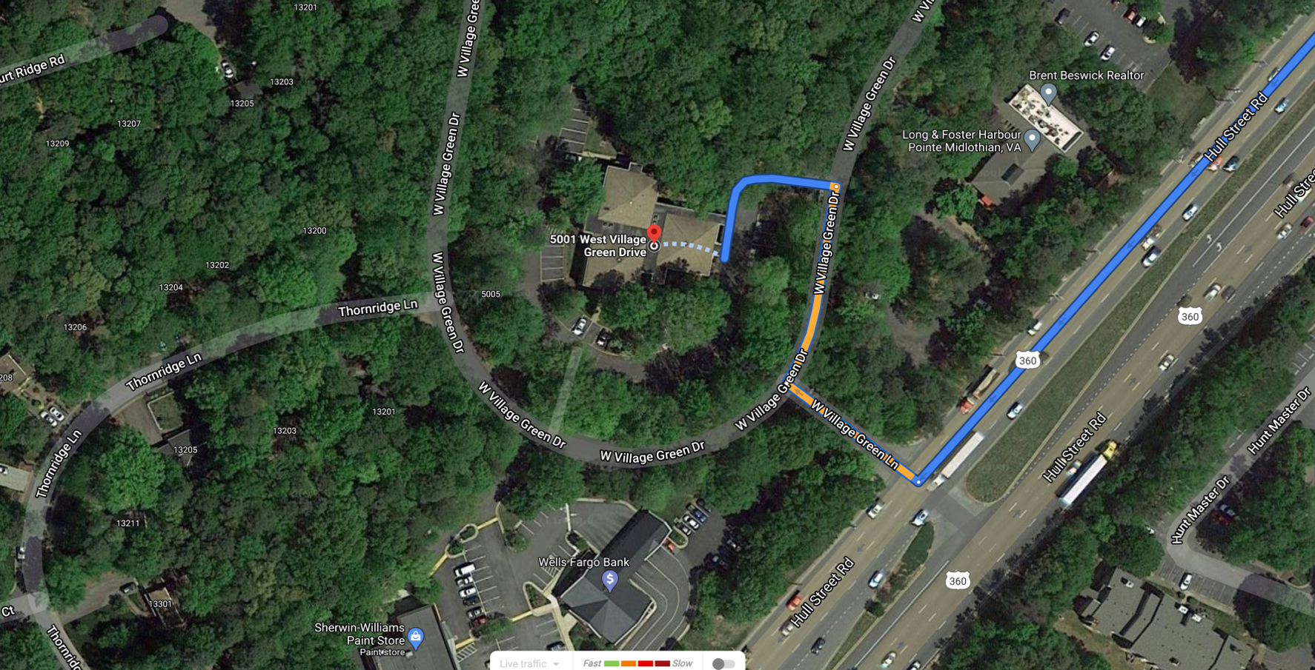

- Exit off interstate 288 onto US 360/Hull Street West Toward Amelia
- Turn Right onto W. Village Green Ln (If you pass Wells Fargo, you have gone too far.)
- Turn Right onto W. Village Green Dr.
- Turn left to follow the W. Village Drive to around to the back of the office building.
First door on the right
- Suite 109 is the first door on the right.

