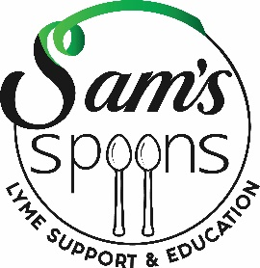

3rd Annual ‘Tick Talk: A Conversation About Lyme’

April 30th Dickinson College, Carlisle

11am-4pm, 6-10pm

Sponsorship Levels:

Diamond--$5,000

Your company name/logo will be represented throughout the event on:

* Brief speaking opportunity to kick off event
* Printed materials, including logo on attendee “goody bag,” plus inclusion of product
* Acknowledgement on Sam’s Spoons social media
* Signage at event
* Vendor table space
* Company representative invite to private cocktail on April 29th

Emerald--$2,500

Your company name/logo will be represented throughout the event on:

* Printed materials, plus inclusion of product in “goody bags”
* Acknowledgement on Sam’s Spoons social media
* Signage at event
* Vendor table
* Company representative invite to private cocktail on April 29th

Opal--$1,000

Your company name/logo will be represented throughout the event on:

* Printed materials, plus inclusion of product in “goody bags”
* Acknowledgement on Sam’s Spoons social media
* Signage at event
* Vendor table space

Pearl--$500

Your company name/logo will be represented throughout the event on:

* Printed materials, plus inclusion of product in “goody bags”
* Acknowledgement on Sam’s Spoons social media
* Signage at event

Patron--$250

Your company name/logo will be represented throughout the event on:

* Printed materials
* Signage at event

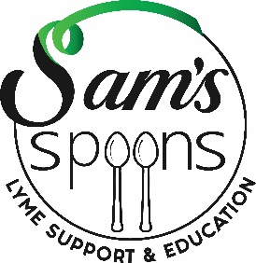

3rd Annual ‘Tick Talk: A Conversation About Lyme’

30th Dickinson College, Carlisle

Due Date for Sponsorships: April 1, 2019

YES!! We WILL support Tick Talk 2019!! Please send this form via mail or scan and send to email listed below. Thank you!!

____Diamond Sponsor $5,000

____Emerald Sponsor $2,500

____Opal Sponsor $1,000

____Pearl Sponsor $500

____Patron Sponsor $250

Name: ___________________________Company: ____________________________

Address: _____________________________________________________________

City: _________________________State: _________________Zip Code: _________

Email: _________________________________ Phone: ________________________

I would like to pay my sponsorship by:

__Check (Sam’s Spoons Foundation, send to 2455 Hume Lane, Enola, PA 17025)

__Credit Card at Sam’s Spoons Foundation donation page

[www.SamsSpoons.org](http://www.SamsSpoons.org)

A donation letter with tax id will be sent to the above address.

Questions?? Email us at Info@SamsSpoons.org