Bronze Stag Beetle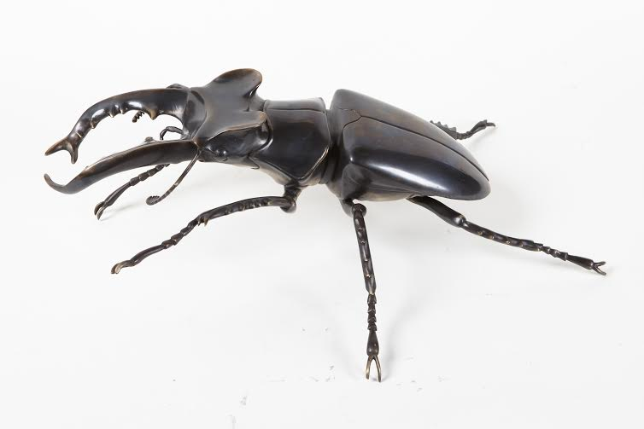
Looks:
Ringo the stag beetle has “antlers” that aren’t antlers at all! They are part of his mouth that sticks out far enough that he can push other stag beetles around.

Lady Friend:
Even though Ringo’s jaws are better in a shoving match, his girlfriend, Lucy has jaws with a special task too. She doesn’t have the long antlers; instead she has short jaws made for cutting out tunnels in logs where she can lay eggs.

Favorite Food:
The giant jaws might make Ringo look frightening, but he’s no hunter. He hardly needs to eat anything at all, but when he does feel hungry, he likes to drink the sweet sap of trees.

Fun Fact:
Ringo once was a larva that looked like a little brown worm! He spent almost two years as a larva, eating as much as he could because the more nutrients he got as a larva, the bigger he would be as a beetle! Ringo didn’t have his shiny body, long legs and strong antlers until he made a cocoon from dirt and emerged from it!
Giant African Millipede
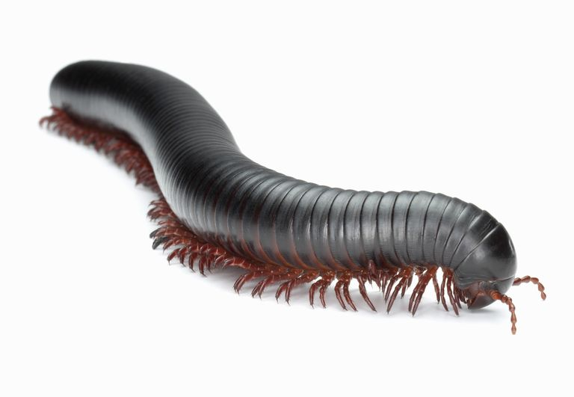
Ginger Spice
Favorite Food:
Old mushy plants are always on the menu for Ginger Spice. Her jaws don’t have to be strong to chew up rotting plants, so they are too weak to bite a person, and she wouldn’t want to anyway.

Roommates:
Ginger Spice lives with the other Spice Girls in a big bin of moist dirt with old leaves it in. It’s no celebrity mansion, but that’s what giant African millipedes love! Ginger Spice and her friends make a lot of the dirt themselves, just like they would in Africa.

Sensitive Soul:
Sometimes we give Ginger Spice something new to smell or something new to feel, like a fuzzy cloth to walk on. Ginger Spice can smell and taste with her whole body! Wouldn’t it be weird to taste with your feet?

Baby Spice:
When Ginger Spice hatched from her egg, she only had three sets of legs. We’ve lost track of how many she has now, but it’s between 200 and 300! Even with all those legs though, she moves pretty slowly, and she’ll never win any races because it takes her so long to lace up all 300 pairs of shoes!

Greatest Accomplishment:
Ringo
Photo credit Marin Pierce, Beetle Mania
Photo credit: Thoughtco.com

Chilean Rose Tarantula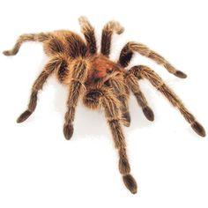
Out of Sight:
You probably knew that tarantulas like Coraline have eight legs, but did you know she has eight eyes too? Even with all eight peepers, Coraline can hardly see; mostly she gets around using her senses of touch, taste, and smell.

Favorite Food:
Coraline doesn’t need to eat three meals a day like a person does. If she has breakfast on Monday, she doesn’t need lunch until Thursday! Cora has fangs with venom that she uses to kill other bugs for her meals. Crickets are her favorite food.

Doctor Cora:
People don’t have to be afraid of tarantula venom; we’re way too big to eat! Some of Coraline’s relatives have venom that is really useful because scientists have figured out how to use it in heart medicine and to relieve pain. Paging Doctor Cora…

Favorite Hobby:
When she’s not quietly enjoying the darkness of her burrow, Cora spins webs of silk. She has little spinnerets on her behind that poke out when she feels like spinning. She makes her webs in and around her burrow on the ground.
Tobacco Hornworm

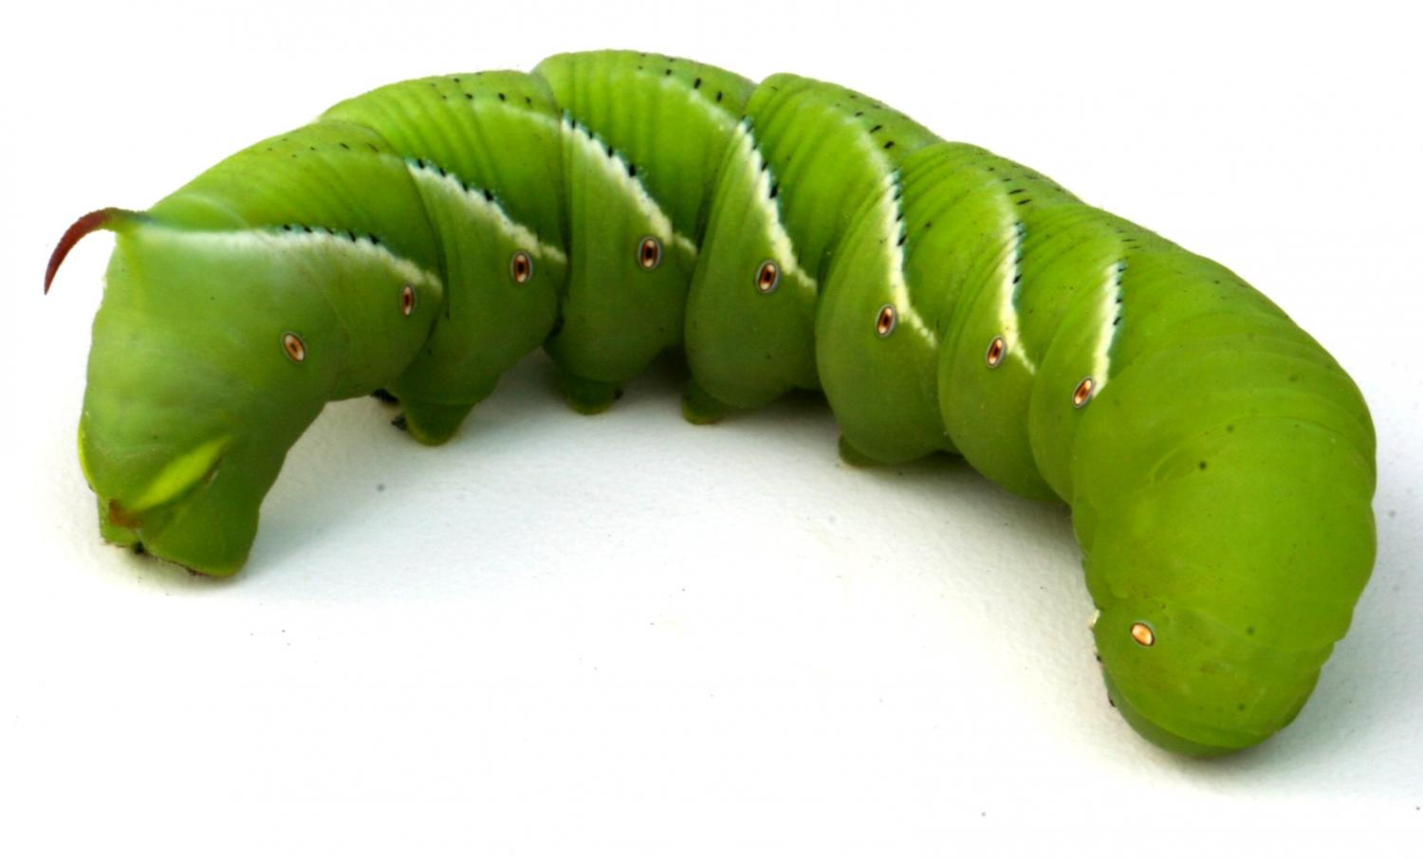
Marvin
Morphin’ Marvin:
Marvin the hornworm isn’t a worm at all. He’s a type of caterpillar, so someday he will spin a cocoon and emerge as a lovely moth! When he is a moth, Marvin will help plants grow by spreading pollen.

Worry Worm:
There’s a lot out in the wide world for a hornworm caterpillar like Marvin to watch out for. Birds, frogs, and even spiders and wasps might want to make Marvin into a tasty treat.

Smells Like Safety:
Tobacco plants are a hornworm’s favorite food, but they have a poison chemical in the leaves. The more tobacco Marvin ate, the more chemicals would build up in his body and the worse he would smell! Spiders would catch a whiff of the chemical and leave him alone. Peeee-eeew! Here at the zoo we don’t feed Marvin tobacco, so don’t worry, you don’t have to plug your nose.

Pointy Puzzle:
The red spike on Marvin’s back has puzzled scientists. They’re not sure what he uses it for, but it’s not as spikey as it looks. If you touch it, his “horn” feels squishy and won’t poke you at all.
Coraline
Photo credit: petco.com
Photo credit: phys.org

Jungle Nymph

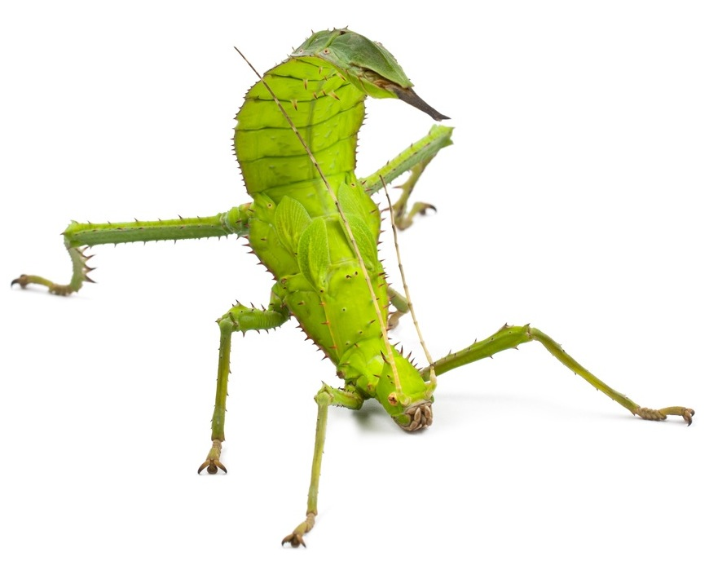
Leaf Me Alone:
Even though Angeleafa is over 6 inches long, she can be really tough to spot! Her bright green body looks just like a leaf. Most of the day Angeleafa sits still among the leaves of a tree, hoping not to be noticed.

Rockin’ Walkin’:
When Angeleafa has somewhere to go, she sways back and forth, which doesn’t seem like the best way to get anywhere, but the rocking motion makes Angeleafa seem like she’s just blowing in the wind. It’s a good way to be sure birds and snakes don’t try to eat her for lunch.

Sunny Disposition:
While she’s doing her best impersonation of a leaf, Angeleafa might also be snacking. Jungle nymphs chew holes into the foliage of the rainforest canopy, which allows sunlight to reach the forest floor.

Sight for Night:
Many bugs have very poor eyesight, but Angeleafa’s vision is very keen, even when there’s not much light. Angeleafa’s night vision will improve until it is ten times better than it was when she was a baby!
Angeleafa
Photo credit: petinfoclub.com
References:
Giant African Millipede:
Giant African Train Millipede Care. (20 April 2015) The Herpetological Society of Ireland. Retrieved 26 March 2017 from https://thehsi.org/2015/04/20/giant-african-train-millipede-care/,
Giant African Millipede: (Archispirostreptus gigas). Retrieved 26 March 2017 from http://www.pdza.org/files/library/cae9b85635dea840_o.pdf
Giant African Millipede (Archispirostreptus gigas). Point Defiance Zoo & Aquarium Animal Fact Sheet. Retrieved 4 April 2017 from http://www.pdza.org/giant-african-millipede/
Bronze Stag Beetle:
Goyens, J., Dirckx, J., & Aerts, P. (2015). Costly sexual dimorphism in Cyclommatus metallifer stag beetles. Functional Ecology, 29(1), 35-43.
http://onlinelibrary.wiley.com/doi/10.1111/1365-2435.12294/full
Goyens, J., Van Wassenbergh, S., Dirckx, J., & Aerts, P. Combining micro CT and CFD to reveal the aerodynamics of flying stag beetles.
http://bruker-microct.com/company/UM2014/030_Jana_Goyens.pdf
Chilean Rose-hair Tarantula:
Clement, H., Odell, G., Zamudio, F. Z., Redaelli, E., Wanke, E., Alagón, A., & Possani, L. D. (2007). Isolation and characterization of a novel toxin from the venom of the spider Grammostola rosea that blocks sodium channels. Toxicon: official journal of the International Society on Toxinology, 50(1), 65.
Rose-hair Tarantula: (Grammostola rosea). Point Defiance Zoo & Aquarium Animal Fact Sheet. Retrieved 9 April 2017 from http://www.pdza.org/rose-hair-tarantula/
Tobacco Hornworm:
Featured Creatures: Entomology and Nematology. University of Florida. Retrieved 9 April 2017 from http://entomology.ifas.ufl.edu/creatures/field/hornworm.htm
Schwen, D., & Commons, W. The bad-breath defense Caterpillars that munch tobacco fend off predatory spiders by exhaling nicotine. Science News for Students. Retrieved 10 April 2017 from https://www.sciencenewsforstudents.org/article/bad-breath-defense
Jungle Nymph:
GBIF Secretariat: GBIF Backbone Taxonomy. doi:10.15468/39omei
Accessed via http://www.gbif.org/species/5050613 on 2017-04-11
Phasmids. Encyclopedia of Life. Retrieved 9 April 2017 from http://eol.org/pages/645/overview
Jungle Nymph (Heteropteryx dilatata) PDZA fact sheet

