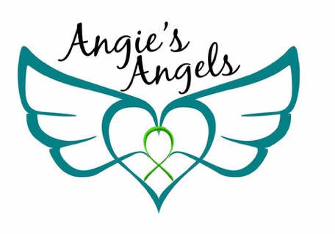

Angela Dallaire Bruce Memorial Scholarship

Application

515 S. Main St Eaton Rapids, Mi 48827 adbscholarship@gmail.com ♦ adbscholarship.org

Applicant Information
Name:
Date of birth: | Phone:
Current address:
City: | State: | ZIP Code:

Parent or Guardian Information
Name
Address if different:
Phone: | E-mail:

School Information
Name:
Address:
City: | State: | ZIP Code: | Phone:
Last Grade Completed:

Please check which music camp you would like to attend Vocal Music Instrumental Music

If you are interested in Instrumental Music (Band) Camp:
- Do you own your own instrument? Yes No
- Which instrument do you play? ___________________
- How many years have you played your instrument? ______________________

Will you have transportation to the camp? Yes No

Please answer one of the following essay questions. Your response must be 200 to 300 written words or 3 to 5 minutes in video. You may answer on paper and submit it with your application, or you may record a video and email it to adbscholarship@gmail.com:

1. What does music mean to you?

2. Why would you like to go to music camp?

3. What are your goals and plans for your future?

A letter of recommendation from a music teacher is strongly recommended but not required.

Student / Applicant Signature: ______________________ Date: _______________

Parent or Guardian Signature: _____________________ Date: _______________

For the principal or school counselor only
⎯⎯⎯⎯⎯⎯⎯⎯⎯⎯⎯⎯⎯⎯⎯⎯⎯⎯⎯⎯⎯⎯⎯⎯⎯⎯⎯⎯⎯⎯⎯⎯⎯⎯⎯⎯⎯⎯⎯⎯⎯⎯

Do you certify that the student applicant meets any of the following criteria (please check all that apply)
Student qualifies for the free and reduced lunch program
Student has an IEP/504 plan
Student is in the ESL program
Other reason the student is considered “at risk”

If you selected other, please briefly describe why below:

Name: _______________________ Position: ________________________

Signature: _____________________ Date: __________________________

