**Angie’s Angels 2nd Annual Legacy Ride & Run** 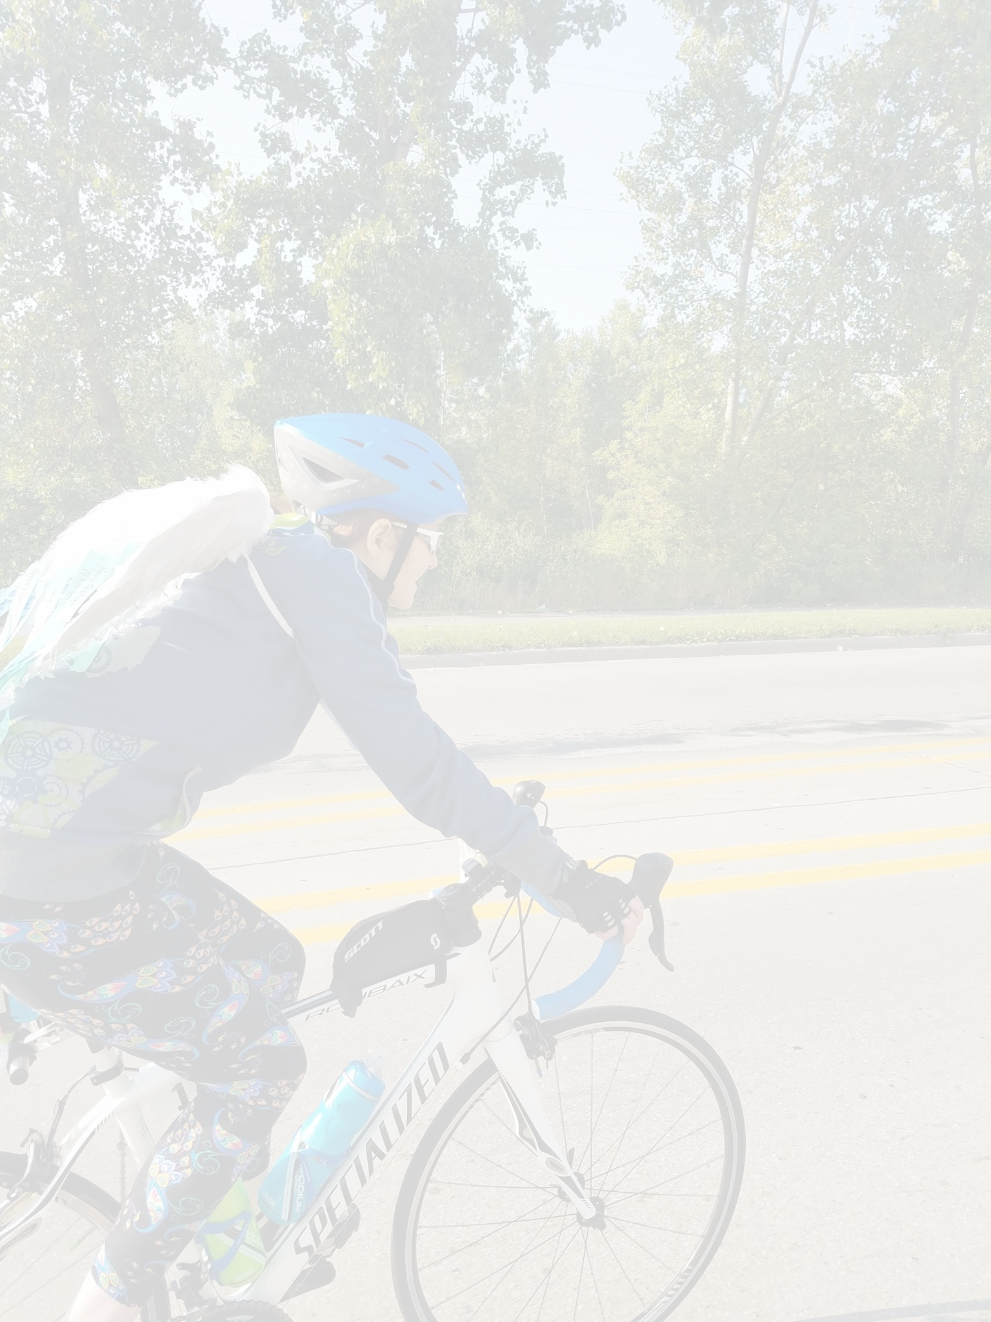

**Sunday, October 13th, 2019**

[**www.adbscholarship.org**](http://adbscholarship.org)

**Early Registration by August 13th, 2019 at 11:59 PM EDT: $25.00 for ride OR run/walk**

**Children 12 and under $10.00**

**$40 for ride AND run/walk**

**Late Registration after August 13th, 2019 at 11:59 PM EDT: $35.00 for ride OR run/walk**

**$50 for ride AND run/walk**

**NO REFUNDS Late Registration Closes On 10-13-19 8:00 PM EDT**

**REGISTRATION FEE** payable through PayPal to adbscholarship@gmail.com or check made payable as stated below. Registration is not complete until payment is received.

**REGISTRATION INCLUDES:** Rest stops with fresh baked cookies and other food items, maps and cue sheets, SAG support and T-Shirts guaranteed when registration completed prior to September 15, 2019 at 11:59 PM EDT.

**LIMITED SUPPLY** of T-Shirts the day of the ride - $15.00

**ROUTES INCLUDE** but are not limited to road rides of three loops of 15, 30, and 70 miles and any combination or repetition thereof, with light traffic and rolling hills.

**ADB Scholarship Association reserves the unconditional right to modify the routes and itinerary, without prior notice, due to weather, flooding, road conditions, or other unpredictable situations.**

**Registration and Start Location:** Brewer Park, 399 84th Street, Byron Center, MI 49315.

**Registration Opens** at 7 AM EDT(70+ milers encouraged to begin by 9:15 AM EDT) all rest stops close at 4:00 PM EDT, SAG ends for all riders at 4:30 PM EDT.

**5k Run/Walk Begins** at 8 AM EDT

**ALL riders** **and runners/walkers** must register or check in at registration to receive a number which must be displayed at all times during event.

**NO Headphones, all riders must obey the rules of the road. HELMETS REQUIRED for all riders.**

League of American Bicyclists (LAB) RELEASE and waiver of liability, assumption of risk, and indemnity “agreement". In consideration of being permitted to participate in any way in the Angela Dallaire Bruce (ADB) Scholarship Association sponsored bicycling and/or running/walking activity, I, for myself, my personal representatives, assigns, heirs, and next of kin:

1. **ACKNOWLEDGE**, agree, and represent that I understand the nature of bicycling and/or running/walking activities and that I am qualified, in good health. and in proper physical condition to participate in such activity. I further acknowledge that the activity will be conducted over public roads and facilities open to the public during the activity and upon which the hazards of traveling are to be expected, including but not limited to dogs, wildlife, traffic, or other road conditions. I further agree and warrant that if at any time I believe conditions to be unsafe, I will immediately discontinue further participation in the activity.
2. **FULLY UNDERSTAND that:** (a) BICYCLING and/or RUNNING/WALKING ACTIVITIES INVOLVE RISKS AND DANGERS OF SERIOUS BODILY INJURY,

INCLUDING PERMANENT DISABILITY, PARALYSIS, AND DEATH (“RISKS"); (b) these risks and dangers may be caused by my own actions or inactions, the actions or inactions of others participating in the activity, the conditions in which the activity takes place, or THE NEGLIGENCE OF THE “RELEASEES" NAMED BELOW; (c) there may be OTHER RISKS AND SOCIAL AND ECONOMIC LOSSES either not known to me or not readily foreseeable at this time; and I FULLY ACCEPT AND ASSUME ALL SUCH RISKS AND RESPONSIBILITY FOR LOSSES, COSTS, AND DAMAGES I incur as a result of my participation in the activity.

**3. HEREBY RELEASE, DISCHARGE, AND COVENANT NOT TO SUE** ADB Scholarship Association, League of American bicyclists, their respective administrators, directors, members, agents, officers, volunteers, and employees, other participants, any sponsors, advertisers, and if applicable, owners and Lessors of premises on which the activity takes place, (each considered one of the “Releasees" herein) FROM ALL LIABILITY, CLAIMS, DEMANDS, LOSSES, OR DAMAGES ON MY ACCOUNT CAUSED ALLEGED TO BE CAUSED IN WHOLE OR IN PART BY THE NEGLIGENCE OF THE RELEASEES OR OTHERWISE, INCLUDING NEGLIGENT RESCUE OPERATIONS. AND, I FURTHER AGREE that if, despite this release and waiver of liability, assumption of risk, and indemnity agreement I, or anyone on my behalf, makes a claim against any of the Releasees, I WILL INDEMNIFY, SAVE, AND HOLD HARMLESS EACH OF THE RELEASEES from any litigation expenses, attorney fees, loss, liability, damage, or cost which any may incur as a result of such claim.

**4**. **I grant ADB Scholarship Association** the right to take photographs of me and my family in connection with this event and agree that ADB Scholarship Association may use photographs with or without names for any lawful purpose (e.g. publicity, illustration, web, or Facebook content). I understand that ADB Scholarship Association does not sell or share demographic information to any other parties for any reason.

**5**. **I agree to cooperate to** **“Share the Road”** and agree not to ride more than two abreast. I agree to follow all Michigan rules of the road, which apply to both cars and bicycles.

**6**. **I AM 18 YEARS OF AGE OR OLDER.** **I HAVE READ THIS AGREEMENT**, FULLY UNDERSTAND ITS TERMS, UNDERSTAND THAT I HAVE GIVEN UP SUBSTANTIAL RIGHTS BY SIGNING IT AND HAVE SIGNED IT FREELY AND VOLUNTARILY WITHOUT INDUCEMENT OR ASSURANCE OF ANY NATURE AND INTEND IT TO BE A COMPLETE AND UNCONDITIONAL RELEASE OF ALL LIABILITY TO THE GREATEST EXTENT ALLOWED BY LAW. I AGREE THAT IF ANY PORTION OF THIS AGREEMENT IS HELD TO BE INVALID, THE BALANCE, NOT WITHSTANDING, SHALL CONTINUE IN FULL FORCE AND EFFECT.

**Signature Required**:  **____________________________________________________ ▢ I HAVE READ THIS RELEASE**

**SIGNATURE OF PARTICIPANT** **OR signature of parent/guardian** of children participating under 18. (If rider and/or runner/walker is under the age of 18, they must be accompanied by an adult during the ride.) (WE DO NOT SHARE OR SELL YOUR DEMOGRAPHIC INFORMATION)

For more detailed information or to **register online**, please visit [www.adbscholarsip.org](http://www.adbscholarsip.org)

**ALL riders and runners/walkers** must register or check in at registration to receive a number which must be displayed at all times during event.

**(one rider and/or runner/walker per form this includes minors or tandem riders – form may be photocopied or downloaded from our web page.)**

**SELECT T-SHIRT SIZE (optional pre-registration by 8-13-2019) S / M / L / XL / XXL / XXXL**

_______________________________ ____ **Registration Fees Please make checks payable to:**

name age Through After ADB Scholarship Association

_____________________________________ **8/13/19**       **8/13/19** 515 S Main St

address (Adult each)   $25.00     $35.00 Eaton Rapids, MI 48827

_____________________________ _______ (12 & Under) $10.00 $35.00

city/state zip (Adult both) $40.00 $35.00 **For internal use only**

_____________________________________ Participant Number___________

email Please Indicate the number of shirts Check number_______________

_____________________________________________ 1 shirt is included in the registration fee Cash ______________________

phone extra shirts are $15. Day of Amt._________________

____________________________________ Short Sleeve _____________ Date_______________________

emergency contact name Processed by ___________________

____________________________________ Computer entered by _________

emergency contact phone number

ADB Scholarship Association Bicycle Ride Pledge Sheet

Participant Name: ________________________ Phone #:  (      )      ‐               E‐Mail:   __________________

**ADB Scholarship Association is a registered 501(c)(3) nonprofit. All donations are tax deductible.**

Sponsor’s Name E‐Mail/Phone   $ Amount Pledged Collected?

(PER MILE OR FLAT DONATION?)

______________________________________________________________________ Yes     No

______________________________________________________________________ Yes     No

______________________________________________________________________ Yes     No

______________________________________________________________________ Yes     No

______________________________________________________________________ Yes     No

______________________________________________________________________ Yes     No

______________________________________________________________________ Yes     No

______________________________________________________________________ Yes     No

______________________________________________________________________ Yes     No

______________________________________________________________________ Yes     No

______________________________________________________________________ Yes     No

______________________________________________________________________ Yes     No

______________________________________________________________________ Yes     No

______________________________________________________________________ Yes     No

______________________________________________________________________ Yes     No

______________________________________________________________________ Yes     No

______________________________________________________________________ Yes     No

______________________________________________________________________ Yes     No

______________________________________________________________________ Yes     No

______________________________________________________________________ Yes     No

______________________________________________________________________ Yes     No

______________________________________________________________________ Yes     No

______________________________________________________________________ Yes     No

______________________________________________________________________ Yes     No

Total Collected:  ________________________

Make all checks payable to ADB Scholarship Association