Epicenter Church OC 10/11/26

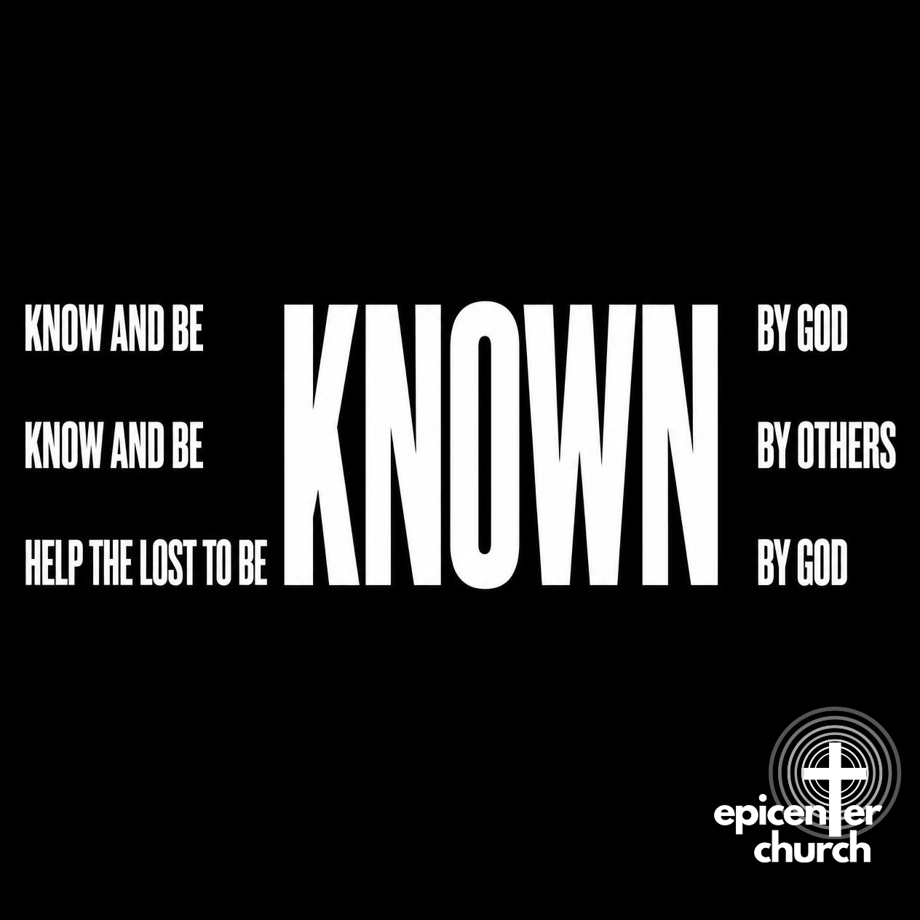

For more check out epicenteroc.org

Vision: We are a home for people who are making Jesus the epicenter of their lives.

Epicenter is an intentionally relational and impactful family of Jesus-loving and people-loving Christians committed to listening to God and to each other, helping each other heal and be free of sin’s bondage, knowing and being known by each other, being equipped with God’s Word to become who God designed us to be, and impacting others through love and good deeds to know Christ.

Mission: To help others make Jesus the epicenter of their lives

Repair broken lives
Prepare believers for spiritual maturity and leadership
Share love to people everywhere through prayer, caring for others, and sharing the gospel

Values: 1 Life-giving Listening, 2 Healing Freedom, 3 Intentional Community, 4 Huge Spiritual Growth, 5 Impactful and Courageous Mission

Values
1. Life-Giving Listening
We believe that we will become the people God made us to be when we listen to Him and help each other listen to Him. We are committed to listening to what is happening in each others’ lives so that we can be comforted and exhorted to be who God made us to be
2. Healing Freedom
We believe that God loves to set captives free from the pain of our pasts and the bondage of our sin. We help each other heal with compassion that encourages and words of truth that removes lies.
3. Intentional Community
We gather as a welcoming group in a safe environment to worship and connect, believing that this is the best way for us to experience God and experience fruitful relationships.
4. Significant Spiritual Growth
We grow through the faithful preaching and teaching of God's Word and by creating spaces for prayer and sharing to change lives. We provide not just content, but our lives and shepherding as well to shape people’s hearts.
5. Courageous Mission
We endeavor to change people’s lives with courage and boldness. We provide an opportunity for each member to serve and give to be a blessing with their spiritual gifts

Prayer for Epicenter During Life Groups and Bible Studies:
-that we would try to speak as much life into others as possible

Giving: Thank you! Your donations enable us to shepherd God's people and reach those who don't know Him yet! You will now be able to contribute in advance of official approval of the 501(c)(3) application for tax credit.

Our expected annual operating budget is $35,830
Annual expenses:
$18,688 Facility rentals
$1,230 Insurance and Licensing
$1,670 Website, online services
$11,692 Sunday Gathering and Outreach resources
$2,550 Children's ministry expenses

You can give cash, make a check to
“Epicenter Church OC” or:

1. Zelle to our email
epicenteroc@gmail.com

2. Online Breeze Giving (higher fees for credit cards)
https://epicenterchurchoc.breezechms.com/give/online

3. Text Breeze Giving: Text an amount to (616) 730-8308

LITurgy



Song: Great is Thy Faithfulness

[Verse 1]
Great is Thy faithfulness, O God my Father,
There is no shadow of turning with Thee;
Thou changest not, Thy compassions, they fail not;
As Thou has been Thou forever will be.

[Refrain]
Great is Thy faithfulness!
Great is Thy faithfulness!
Morning by morning new mercies I see
All I have needed Thy hand hath provided,
Great is Thy faithfulness!
Lord unto me!

[Verse 2]
Summer and winter, and springtime and harvest,
Sun, moon, and stars in their courses above,
Join with all nature in manifold witness
To Thy great faithfulness, mercy, and love.

[Verse 3]
Pardon for sin and a peace that endureth,
Thy own dear presence to cheer and to guide;
Strength for today and bright hope for tomorrow,
Blessings all mine, with ten thousand beside.

CCLI Song # 18723
Thomas Obediah Chisholm | William Marion Runyan
© Words: Public Domain; Music: Public Domain
For use solely with the SongSelect® Terms of Use. All rights reserved. www.ccli.com
CCLI License # 21814908
Individual Prayer: What words have been spoken to you that have encouraged you the most? Are there any discouraging words over your life that still have power?

Song: When I Lock Eyes With You/Your Love Is Extravagant

[Verse]
So when I lock eyes with You
I see my reflection
When I lock eyes with You
I feel Your affection
I love to get lost in You
Cause You’re my obsession
[Chorus]
And all I want is You
And all I need is You
And all I see is You
[Bridge]
So come in like a fire
Come in like a flood
I don’t care what it looks like
I’m so in love
Your love is extravagant Your love is intimate

CCLI Song # 7126778
Brandon Lake | Elyssa Figueroa | Jonathan Jay | Tony Wood
© 2020 Brandon Lake Music; Heritage Worship Music Publishing; Maverick City Publishing; Maverick City Publishing Worldwide; Elyssa Marie Music; UR Creative; Curb Congregation Songs; Tony Wood Songs; Let There Be Songs; Bethel Music Publishing
For use solely with the SongSelect® Terms of Use. All rights reserved. www.ccli.com
CCLI License # 21814908

Song: Fall Like Rain/All I Need Is You

[Verse 1]
God, I live to worship You
All my life I offer You
Simple melodies of sacrifice

[Verse 2]
Open hands and open heart
You’re the only one I want
Your presence is my treasure, my delight

[Chorus]
Fall like rain
Holy Spirit, fall like rain
Holy Spirit, have Your way
Let Your glory fall down
Let Your glory fall down

[Verse 3]
One thing I ask, one thing I seek
So much more than anything
To dwell within Your house for all my days

[Verse 4]
Knowing You is everything
I let go of lesser things
You alone are worthy of my praise
So stir in me a passion for Your Name

[Chorus]
Fall like rain
Holy Spirit, fall like rain
Holy Spirit, havе Your way
Let Your glory fall down
Let Your glory fall down

[Bridge]
May I never lose the wonder of Your presence
May I always stand in awe of who You are
Oh the beauty and the gift of Your friendship
Is unlike anything I’ve ever known

[Chorus]
All I need is You
All I need is You Lord
Is You Lord
All I need is You
All I need is You Lord
Is You Lord
All I need is You
All I need is You Lord
Is You Lord
All I need is You
All I need is You Lord
Is You Lord

CCLI Song # 7214412
Beau Maddox | Bede Benjamin-Korporaal | Brett Younker | Zahriya Zachary
© 2024 Zahriya Zachary; Beau Maddox Designee; Capitol CMG Paragon; People Of The Rising; SHOUT MP Carrington; sixsteps Music; Songs By Bede; UR Creative; worshiptogether.com songs; Bethel Music Publishing
For use solely with the SongSelect® Terms of Use. All rights reserved. www.ccli.com
CCLI License # 21814908

Group Prayer: Get into groups of 3-4. Let’s pray that our church would continue to be sources of encouragement with our words.

If you would like to share and receive prayer: In what area(s) of your life would you like to be more encouraged about?

LITURGY (Hunter)

ANNOUNCEMENTS (Danny):

WELCOME: Need a Bible? We have one for you, keep it! It’s our gift to you for joining us today

Haves and Needs: Have something to offer for free? Have a need? Fill out this form!
https://docs.google.com/forms/d/1meuVO3Ca-NsmLkBNIcbPrBRUQuAgHSpeo18PiKxu2fg/edit

COMMUNITY
-Pick up Lunch after church
-Irvine Life Group Tuesday 7:00PM
-Orange Life Group Wednesday 7:30PM
-Tustin Worship Weekend Nov 6 7-9PM, Nov 7 7-9PM, Nov 8 7-9PM
-Saturday 6PM 11/14 Men's and Women's Ministries
-Sundays 10AM Gathering at Galaxy Arts

Prayer (?)

Sermon (David)

Exhortation (Elisha): Prayer, Care, and Share

Communion (Marvin): If you haven’t been baptized as a believer yet we ask you do this first before regularly taking communion

Benediction (Griffin)

Life Group

1) Keep the conversations confidential!
2) Listen with empathy and compassion. Don’t give advice unless requested and continue to be gentle with someone who is sharing vulnerably.
3) Share and pray freely but be considerate of others’ time and opportunities to share and pray. Also let’s hold off on sharing about crimes committed that haven’t been prosecuted yet as well as intention to harm oneself or others.
4) Continue to speak well of each other in the church, also being mindful to preserve unity by not using language that divides based on age, culture, gender, etc.
5) If you have a personal story that is similar to someone, be careful as you’re sharing to not minimize the other person’s experience or to correct them.

Prayer for Epicenter During Life Groups and Bible Studies:
-that we would try to speak as much life into others as possible

This Week’s Meditation Verse: Ephesians 4:29
²⁹ No foul language should come from your mouth, but only what is good for building up someone in need,^{[a]} so that it gives grace to those who hear.

