International Conference on Advanced Materials and Manufacturing for Sustainability, ICAMMS-2026
VNIT Nagpur
12-14 March 2026

Paper Title: International Conference on Advanced Materials and Manufacturing for Sustainability, ICAMMS-2026
Authors: Gaurav Tiwari*, T V K Gupta, Trushar B Gohil, Ravikumar Dumpala
Department of Mechanical Engineering, Visvesvaraya National Institute of Technology, Nagpur – 440010
*Corresponding Author: Dr. Gaurav Tiwari, Email: gauravtiwari@mec.vnit.ac.in

Abstract (< 200 words) (Times New Roman,Font size:10, BOLD): Authors are requested to type their Abstract for the International Conference on Advanced Materials and Manufacturing for Sustainability, ICAMMS-2026 organized by the Department of Mechanical Engineering, VNIT Nagpur during 12-14 March 2026. This conference is planned in fully offline mode. Authors are requested to type their Abstract for the International Conference on Advanced Materials and Manufacturing for Sustainability, ICAMMS-2026 organized by the Department of Mechanical Engineering, VNIT Nagpur during 12-14 March 2026. This conference is planned in fully offline mode. Authors are requested to type their Abstract for the International Conference on Advanced Materials and Manufacturing for Sustainability, ICAMMS-2026 organized by the Department of Mechanical Engineering, VNIT Nagpur during 12-14 March 2026. This conference is planned in fully offline mode. Authors are requested to type their Abstract for the International Conference on Advanced Materials and Manufacturing for Sustainability, ICAMMS-2026 organized by the Department of Mechanical Engineering, VNIT Nagpur during 12-14 March 2026. This conference is planned in fully offline mode. Authors are requested to type their Abstract for the International Conference on Advanced Materials and Manufacturing for Sustainability, ICAMMS-2026 organized by the Department of Mechanical Engineering, VNIT Nagpur during 12-14 March 2026. This conference is planned in fully offline mode. (Times New Roman, Font size:10).
Keywords (Maximum 5): Conference, Advanced, Materials, Manufacturing, Sustainability
Introduction (< 500 words): Authors can write the introduction of the article within 500 words in this paragraph for the the International Conference on Advanced Materials and Manufacturing, ICAMMS-2026 organized by the Department of Mechanical Engineering, VNIT Nagpur during 12-14 March 2026. Authors can write the introduction of the article within 500 words in this paragraph for the International Conference on Advanced Materials and Manufacturing, ICAMMS-2026 organized by the Department of Mechanical Engineering, VNIT Nagpur during 12-14 March 2026. Authors can write the introduction of the article within 500 words in this paragraph for the International Conference on Advanced Materials and Manufacturing, ICAMMS-2026 organized by the Department of Mechanical Engineering, VNIT Nagpur during 12-14 March 2026. Authors can write the introduction of the article within 500 words in this paragraph for the International Conference on Advanced Materials and Manufacturing, ICAMMS-2026 organized by the Department of Mechanical Engineering, VNIT Nagpur during 12-14 March 2026. Authors can write the introduction of the article within 500 words in this paragraph for the International Conference on Advanced Materials and Manufacturing, ICAMMS-2026 organized by the Department of Mechanical Engineering, VNIT Nagpur during 12-14 March 2026.
Table 1: Table Column Head
Table Head | Table Column Head
Table Head | Table column subhead | Subhead | Subhead
copy | More table copyª

Use either SI (MKS) or CGS as primary units. (SI units are encouraged.) English units may be used as secondary units (in parentheses). An exception would be the use of English units as identifiers in trade, such as “3.5-inch disk drive”. Avoid combining SI and CGS units, such as current in amperes and magnetic field in oersteds. This often leads to confusion because equations do not balance dimensionally. If you must use mixed units, clearly state the units for each quantity that you use in an equation. Do not mix complete spellings and abbreviations of units: “Wb/m²” or “webers per square meter”, not “webers/m²”. Spell out units when they appear in text: “. . . a few henries”, not “. . . a few H”. Use a zero before decimal points: “0.25”, not “.25”. Use “cm3”, not “cc”. There is no period after the “et” in the Latin abbreviation “et al.”. The abbreviation “i.e.” means “that is”, and the abbreviation “e.g.” means “for example”.
Authors can write the introduction of the article within 500 words in this paragraph for the International Conference on Advanced Materials and Manufacturing, ICAMMS-2026 organized by the Department of Mechanical Engineering, VNIT Nagpur during 12-14 March 2026. Authors can write the introduction of the article within 500 words in this paragraph for the the International Conference on Advanced Materials and Manufacturing, ICAMMS-2026 organized by the Department of Mechanical Engineering, VNIT Nagpur during 12-14 March 2026. Authors can write the introduction of the article within 500 words in this paragraph for the International Conference on Advanced Materials and Manufacturing, ICAMMS-2026 at VNIT Nagpur during 12-14 March 2026 in offline mode.
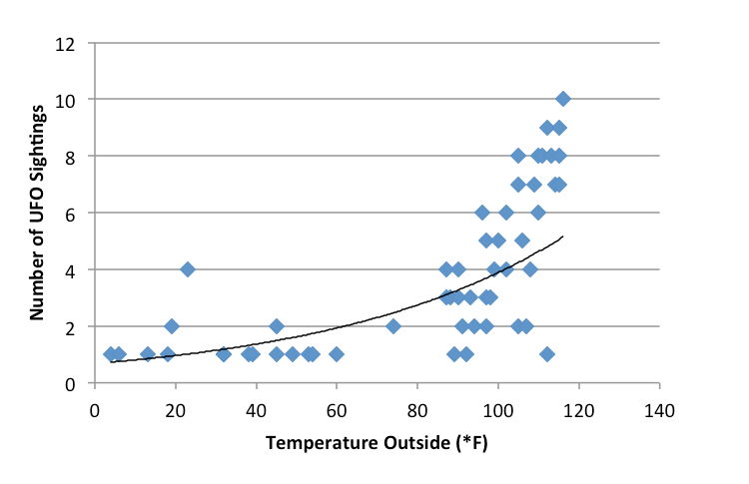
Figure 1: Number of UFO
Results and Discussion: Authors can briefly enumerate the results and discuss the results of the work carried in this research. Please note that all the presented and selected manuscripts will be published in reputed Special Issues of various International Journals (SCI/SCIE/Scopus indexed) and rest of the manuscripts will be published in Scopus indexed conference proceedings by Springer. Authors can briefly enumerate the results and discuss the results of the work carried in this research. Please note that all the presented and selected manuscripts will be published in reputed Special Issues of various International Journals (SCI/SCIE/Scopus indexed) and rest of the manuscripts will be published in Scopus indexed conference proceedings by Springer. Authors can briefly enumerate the results and discuss the results of the work carried in this research. Please note that all the presented and selected manuscripts will be published in reputed Special Issues of various International Journals (SCI/SCIE/Scopus indexed) and rest of the manuscripts will be published in Scopus indexed conference proceedings by Springer. Authors can briefly enumerate the results and discuss the results of the work carried in this research. Please note that all the presented and selected manuscripts will be published in reputed Special Issues of various International Journals (SCI/SCIE/Scopus indexed) and rest of the manuscripts will be published in Scopus indexed conference proceedings by Springer.
References (Maximum 5):
[1] P.D. Wood, H.E. Evans, C.B. Ponton, Investigation into the wear behaviour of Stellite 6 during rotation as an unlubricated bearing at 600◦C, Tribol. Int. 44 (12) (2011) 589–1597, https://doi.org/10.1016/j.triboint.2011.02.011.
[2] D. Bartkowski, A. Mlynarczak, A. Piasecki, B. Dudziak, M. Goscianski, A. Bartkowska, Microstructure, microhardness and corrosion resistance of Stellite-6 coatings reinforced with WC particles using laser cladding, Opt. Laser Technol. 68 (2015) 191–201, https://doi.org/10.1016/j.optlastec.2014.12.005.
[3] R. Singh, S.K. Damodar Kumar, S.K. MishraTiwari, Laser cladding of Stellite 6 on stainless steel to enhance solid particle erosion and cavitation resistance, Surf. Coat. Technol. 251 (2014) 87–97, https://doi.org/10.1016/j. surfcoat.2014.04.008.
[4] R. Liu, J. Yao, Q. Zhang, M.X. Yao, R. Collier, Effects of molybdenum content on the wear/erosion and corrosion performance of low-carbon Stellite alloys, Mater. Design 78 (2015) 95–106, https://doi.org/10.1016/j.matdes.2015.04.030.
[5] Jeshvaghani, R. Arabi, M. Shamanian, M. Jaberzadeh, Enhancement of wear resistance of ductile iron surface alloyed by stellite 6, Mater. Design 32 (4) (2011) 2028–2033, https://doi.org/10.1016/j.matdes.2010.11.060.

