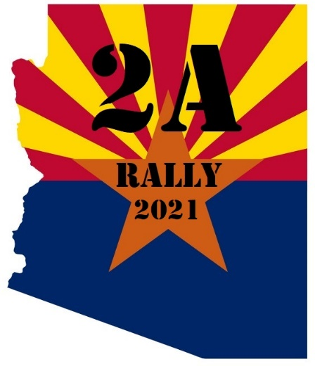
Dear Vendor,
Most accidents at events involve canopies. It is your responsibility to minimize the risk.
YOU ARE NOT ALLOWERD TO DRIVE ANY STAKES INTO THE GROUND
The below information is a guideline for you to use when setting up for the event.
Canopy Weight Guidelines
Phoenix, AZ has unpredictable weather, and often strong, gusty winds. While participants use canopies to shield themselves from the rain and sun, our region's winds can turn your canopies into deadly missiles with one unexpected gust.
All participants must have their own weights, with a minimum of 40 pounds, per tent leg. Gallon water jugs and single bricks are not safe. A gallon of water weighs only 8 pounds and a single brick is worthless, weighing in at 3 pounds. PVC pipe filled with concrete or tent weight sandbags are safe ways to weigh down your tents.
Setup and breakdown periods are when canopies consistently prove to be most vulnerable to the wind. You must be sure to completely secure your canopy as soon as you set it up and take down your canopy as soon as you remove your weights at the end of the day.
DO NOT let yourself be interrupted by ANYTHING in the middle of this process, as a half-secured canopy is as dangerous, if not more dangerous, than an unsecured canopy.
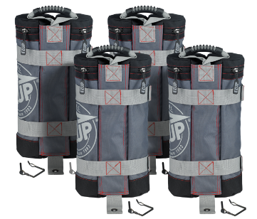
WHAT IS APPROVED
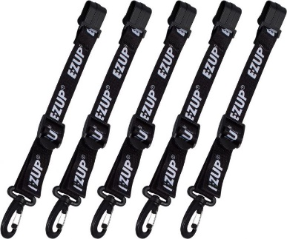
PVC Pipe Filled with Concrete (40-50 pounds per leg) or EZ - Up Sandbags or Similar (40 pounds per leg)
The PVC pipe filled with cement hangs on the inside of the canopy pole, and it has rounded edges. Pipe must be secured to roof and to canopy leg separately.
Use tie-down straps that allow you to adjust the height for your weights. This keeps the weight tension tight. Only use approved tie down straps to secure the weights to the canopy.
WHAT IS NOT APPROVED
• One-gallon water jugs weighing 8 pounds each are far short of the required 40 lbs. per leg.
• Larger water jugs that do not have handles molded as part of the body.
• Concrete blocks – cannot be secured adequately to canopy legs and do not weigh enough.
• Coolers, bags of ice, water jugs from which water or product is removed.
• Loose weightlifting plates – cannot be secured to legs properly.
• Dumbbells – cannot be secured properly to canopy legs.
• Merchandise Racks – do not weigh enough when product is removed.
• Stakes in the ground.

HOW TO SECURE WEIGHTS
Weights must be secured to canopy roof and to canopy leg separately with the following methods:
• Nylon ratchet straps
• High quality rope – light-duty cord is not allowed.
• Factory-supplied pins (weight bags come with these). Note: Bungees and rubber straps are not allowed!
** If you have any questions or are unsure if your weights will work, please contact Tom at 602.575.1357

Thanks for your participation in in our event this year.
2ndAmendmentRallyAZ.com

