How the Orthotech can play a vital role in Serial Casting for Achilles Tendon Repair with FHL Transfer.
By Sylvie Henley, OTC
Fletcher Allen Health Care
Orthopaedic Technologist, Certified
The Achilles tendon repair with Flexor Hallicus Longus (FHL) transfer is a surgical procedure that can be done to repair a ruptured Ach
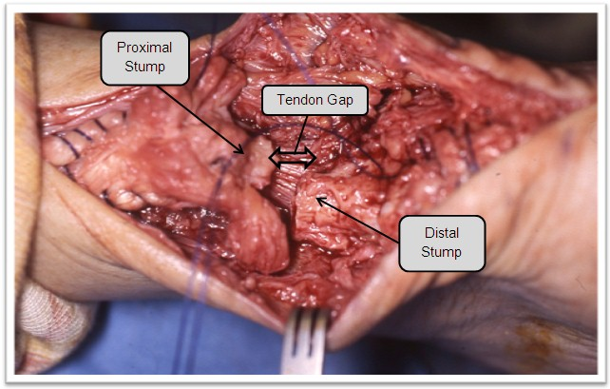
illes tendon that has a gap too large (>1-3cm) for a traditional repair. The goal is to build a bridge between the proximal and distal stumps of the Achilles tendon. Often times this is the case with chronic ruptures or re-ruptures of the Achilles tendon. This can be determined through a thorough physical evaluation, the Thompson Test, and an MRI.
There are many factors which may cause the ends of the Achilles tendon to become too far apart to put back together with a traditional repair. In addition to traditional tendon retraction, it may be that the condition was undiagnosed for a period of time, or was misdiagnosed. The patient may also have failed conservative management or suffered a re-injury. There may have been complications to an initial repair like an infection or a re-rupture. No matter how the condition came to be, the result is a large gap that needs to be bridged. The FHL tendon and muscle serves that necessary purpose to assist in bridging this gap. The first intra-operative image demonstrates a gap between the proximal and distal stumps of the Achilles tendon that is too great to bridge through a traditional repair.
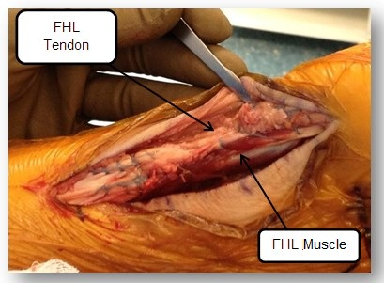
The second intra-operative picture demonstrates a completed repair with use of the FHL tendon and muscle to bridge the gap.
Many times the result of a repair like this is a very tight Achilles that is not in the neutral position immediately following surgery. This is often seen clinically at the first or second post-operative appointment when it is time to remove the splint and apply a cast. In cases such as these, the Orthotech will find it useful to do serial castings at intentional intervals designed to bring the patient closer to neutral at each casting. Changing these casts every two weeks works well to allow for pain and swelling to subside and also does not put undue pressure on patients whom travel a long distances to get there.
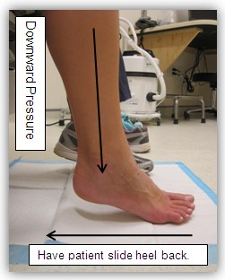
One step which may not have been previously considered is having the patient stretch in-between cast changes. This is performed by placing a Chux disposable pad down on the floor and having the patient slowly move their heel backwards under their knee. They should be instructed to attempt to get their foot as flat as possible on the floor. The patient can use their hands to put gentle downward pressure on their knee if the weight of their limb is not sufficient enough on its own. Have the patient do this stretching while they’re waiting for the doctor to come in and see them and while the cast cart is being set up after they have been evaluated by the physician. Around the post-operative six week mark, a patient’s pain may be reduced enough that they might be able to try and stand with a walker to further help stretch out the Achilles tendon. The walker helps keep them balanced safely and can off load the affected lower extremity while stretching.
Next, it is also recommended to use a cast stand for the cast application. This can be more successful than placing the patient’s foot on the Orthotech’s knee. With a cast stand the patient can maintain a downward force the entire time the cast is being applied. This is opposed to picking up and putting down the foot on the knee numerous times while the initial part of the cast is being built. Some range of motion (ROM) might be lost with each pick up and put down of their foot.
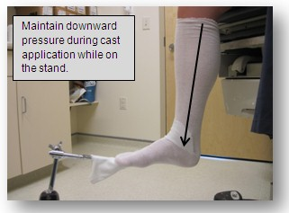
There are cast stands that are so versatile and adjustable they can easily accommodate a tight Achilles by simply changing the angle and height of the foot plate. The first few casts are the toughest. The patient is in pain, their ROM is minimal, and many are nervous about re-injuring the Achilles tendon. It may be that improved ROM may be achieved by changing the cast every two weeks. The first six weeks are non-weight-bearing in a short leg cast followed by six weeks of weight-bearing in a short leg walking cast. Ideal position may not yet be obtained at the post-operative six week mark. Patients are eager to improve and are generally willing to come in again to attain that ideal position so they can walk again without the use of crutches. It turns out to be several cast changes, but it is well worth it in the end. Patients are generally very happy to be a part of the team and a part of their own recovery. Good luck with adding the stretching piece in. I am confident it will really help yield good results for your patients.
Sylvie Henley OTC

