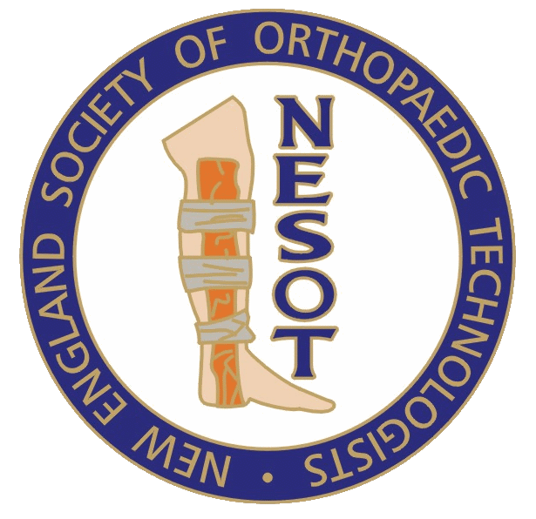 | Sid Rubinstein Award
In recognition for the hard work that our members put into proving their competency on a national level, The New England Society of Orthopaedic Technologists (NESOT) established a Sid Rubinstein Award for one NESOT member and one NESOT student member who passed that year’s National Board for Certification of Orthopaedic Technologists (NBCOT) exam. The award is reimbursement for the exam fee to the individual or the candidate’s employer (excluding late fees).
Please send completed form to NESOT President

Application for Exam Award: (please type or print)

Name: DOB:
Address:
Phone:
Employer:
Address:
Phone/Cell: Email:
Years Worked:
Student- School: Yr of Graduation:
Years employed as an OT: Consecutive years member of NESOT:
Place of Exam: Exam Date:

Award Rules and Regulations:

- Must be a NESOT member in good standings for one year.
- First time taking and passing NBCOT exam.
- Must be residing or working in NESOT states (ME, NH, VT, MA, CT, RI).
  - Students must have attended and graduated from a National Association of Orthopaedic Technologists (NAOT) recognized New England Orthopaedic Technologists Program.
- Application must be filed within three months of notification of passing NBCOT exam.
- A copy of the NBCOT exam grades must be attached to this application.
- A Letter of Employer Recommendation must be attached to the application.
  - Students need Letter of Recommendation from Program Director.
  - Students applying for the Sid Rubinstein Award must submit a copy of their Certificate of Completion.
- Award selection will be decided by the Executive Board and will be presented at the next fall meeting. Applicants must be in attendance at the meeting to receive the award. The employer/ school will be notified of the award presentation. In the event of multiple applicants in both categories, one award in each category will be granted to the highest passing NBCOT exam grade. NBCOT exam application will determine whether he/she is either a student or member.
- Applications must be received by September 15st of each year.
Send all information for review to:
Ken Penn
22 Cranwell Drive, Manchester, NH 03109

