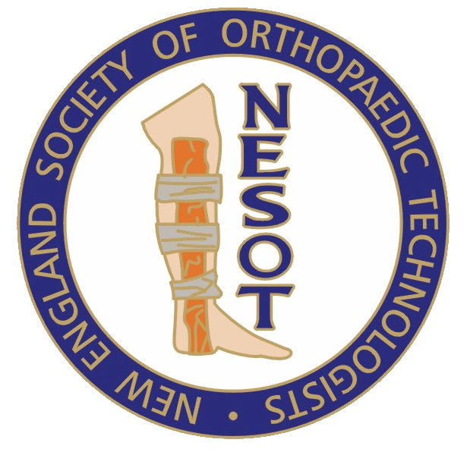 President-Kenny Penn

*New England Society of Orthopaedic Technologists*

*Est. 1983*

Vice President –Heather Smith

Treasurer – Pamela Bartlett

**NESOT Spring Meeting 2018**

**Basic/Intermediate Program**

**April 21st 2018**

**Boston Childrens Hospital, Waltham Mass.**

**Advanced Level:**

Participants will be able to review anatomy, understand mechanism of injuries, and understand surgical options vs. conservative options for treatment through lectures and videos given by Board Certified Orthopaedic Surgeons.

**Geared Toward:**

Orthopaedic Technologists, Athletic Trainers, Medical Assistants, Nurses, Orthotic Fitters, Radiology Techs

**Course Outline:**

7:30-8:00 Registration and Vendor Set up

8:00-8:30 Registration and Vendor Viewing

8:30-9:00 Welcome (opening statements)

9:00-10:00 Dr. Matthew Milewski- ‘Comprehensive lecture on Orthopaedic Knee injuries’

10:00-11:00 Dr. Clifford Voigt- Comprehensive lecture on Pediatric wrist injuries and treatment

11:00-12:30 Dr. Bryan Houseman, DO- Comprehensive lecture on Orthopaedic Trauma injuries and treatment.

12:30-1:30 Lunch and Vendor Viewing

1:30-2:30 Kelly Dixon OT-C- Comprehensive lecture/Demonstration on use of Bladder Extrophy Paper and use in Orthopaedics

2:30-3:30 Billy Maxwell OT-C- Comprehensive lecture on Cast saw injuries in Orthopaedic

Setting.

3:30-4:00 NESOT Business Meeting

4:00-4:30 Closing Statement and Distribution of Certificates

**\*\*NOTE TIMES AND LECTURERS ARE SUBJECT TO CHANGE\*\***

**Format & Schedule**

1 day program with lecture, videos, hand on application and various product demonstrations from multiple Orthopaedic Vendors. Saturday 7:15am-5:00pm (continental breakfast and lunch included).

**Faculty**

Lectures given by Board Certified Orthopaedic Surgeons and/or Physician Assistants, Orthopaedic Technicians (OT-C) are nationally certified Orthopaedic Technologists

**Register/Payment**

A printed registration form can be mailed to NESOT and is located on NESOT website (nesot.com). Payment and registration can also be completed via PayPal (link on NESOT website).

Hotel Accommodations: Courtyard Marriot Waltham Massachusetts

**Continuing Education (CEU’s) for the following credentials**

NBCOT- 6 CEU’s ASRT-TBD

ABC-TBD