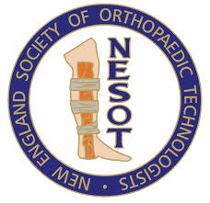
HOTELS
The first two are closest
- Courtyard by Marriott
70 Constitution Ave
Concord, NH 03301
603-225-0303
- Holiday Inn Downtown
172 North Main Street
Concord, NH 03301
603-224-9534
- Comfort Inn
71 Hall Street
Concord, NH 03301
- Best Western
97 Hall Street
Concord, NH 03301
- Residence inn by Marriott
91 Hall Street
Concord, NH 03301

