Camps

All future Princesses of Dance are invited to:

Tap, Tumble and Tiaras Princess Camp 3-5 yrs.
These future little dance princesses will receive the “Royal” treatment at Dance Expressions Summer Dance Camp!
Our morning begins with creative movement songs and routines using wands and wearing tiaras. Then it’s on to pre-ballet where we will use assorted props that twinkle and glow!
During snack time a princess story will be read to continue the theme of wonder and enchantment.
Dancers will also be asked to bring their favorite princess costumes to wear over their leotards for the princess-themed craft segment.
We will end with exhilarating tumbling, tap dance basics and fun and games for developing gross motor skills! We invite you to our Royal Castle of Dance!

Dance and Groove 5-7 yrs.
This program will explore the different genres of dance we offer such as Ballet, Tap, Jazz, Hip Hop and Acro. If your dancer has lots of energy then this is where it’s at. Each day will be different with crafts, activities, games and more. Dancers are asked to bring a snack and drink to recharge their “dance batteries” each day.

Summer Dance Sampler 7 – 10 yrs.
This program is intensely fun for the aspiring dancer. If your dancer wants to keep dancing in the summer then this is the perfect camp for him/her! They will train in Ballet, Jazz, Hip Hop, Lyrical, and Tap with an emphasis on stretch and flexibility, strength and conditioning, Acro and so much more!! A great way to see what form of dance your dancer loves for fall calsses

Teacher Bios
Laurene Aldorisio, Owner/Instructor
· A.S. in Dance from Dean College
· B.A. Degree in Dance from Roger Williams University
· Attended the Philadelphia University of Arts as a Ballet major, where she received training with famous ballet professionals of the Philadelphia Ballet.
· Studied tap with the well-known LaVaugn Robinson, who taught Gregory Hines.
· Trained in Modern Dance at Jacob's Pillow with Milton Myers and Judith Jamison, both of the famous Alvin Ailey Dance company.
· Active member of Dance Masters of America,
New England, the most prestigious dance organization in the country.

Teacher Bios (Cont.)

Laurene Aldorisio (Cont.)
· Certified by Dance Teachers Club of Boston for completing Dance Education Training to teach dance.
· Continuing Education in all forms of dance to stay fresh and current in the dance industry by attending national and regional conventions, workshops and dance performances.
· Every year she continues to train with the most renowned and sought after choreographers and instructors in the world who have made incredible impacts in the dance industry such as; Mia Michaels, Tyce Diorio, Chris Judd, Brian Friedman, Desmond Richardson, Gil Duldulao, Brook Lipton and Dave Scott.
· Trained and attended several master classes at the Dance Complex, Jeanette Neil and the Broadway Dance Center in NYC.

Jocelyn Cronin
Miss Jocelyn (Jaycee) was born and raised in Holden, MA. She started her dance training at the age 3 at Diane Kelley Dance Studio in West Boylston and her gymnastics training at Sterling Academy of Gymnastics. She has competed and performed in several dance/gymnastics competitions at both a regional and national level. She also attended several workshops and master classes at the Broadway Dance Center in NYC and also many dance competition conventions. She has worked with many choreographers including Jermaine Brown, Wade Robson, Katy Spreadbury, and many more.
After she graduated high school, Miss Jocelyn received her 1st. year teacher training certificate through Dance Masters of America in Buffallo, NY and has taught at several studios around the area sharing her love of dance and gymnastics for 10 years.
Miss Jocelyn places a strong emphasis on safety and conditioning/flexibility in her Acro classes, while keeping them fun! Her favorite styles of dance are Acro and Contemporary. Her acro classes consist of many different elements of dance/tumbling including; conditioning, flexibility, technique/dance training, individual skills, along with partner/group lifts and stunts. Students will gain flexibility, control, strength, tumbling skills, and also teamwork in a safe and fun environment.

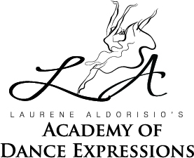

Feel the Beat in the Heat
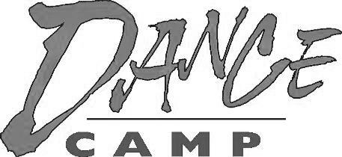
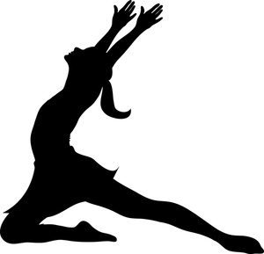

Fun Dance Games
Crafts Snacks

- Tap Tumble and Tiaras
- Dance and Groove
- Summer Dance Sampler
- Summer Dance Intensive
- Private/Semi-Private
Lessons

(508) 836-3608
laurenedanceexpressions@gmail.com
Summer Dance Camps
Minimum of 5 dancers to hold camp
Tap, Tumble and Tiaras
Princess Camp
Ages 3-5 Monday – Thursday 9am–12pm
August 1st-4th
- Wear leotard and tights
- Bring your favorite
princess costume!
Mon: Ariel Tues: Cinderella
Wed: Belle Thurs: Elsa

Dance and Groove
Ages 5 - 7 Monday – Thursday 9am-12pm
August 15th – 18th
- Wear leotard
- Black dance shorts

Summer Dancer Sampler
Ages 7 - 10 Monday – Thursday 9am-1pm
July 18th – 21st
- Wear leotard and black dance shorts
- Hair in a bun

Private & Semi-Private Lessons
We are now offering private or semi-private lessons this summer
- 45 min & 1 hour lessons
- Inquire for pricing and details
- Email with interest

2022 Summer Dance Camp

- Each program is Monday – Thursday.
- The cost is $185 or $200/child/program.
See chart at right.
- A minimum of 5 dancers is required to hold a program. If the minimum is not met one week prior to the first day, it will be cancelled.
- Please pack a snack and drink for your dancer each day.
- A craft activity will be provided on the last day of each camp.
- Tap, Tumble and Tiara Princess Camp - dress in the theme of that day’s princess over your leotard and tights.

Ballet, Pointe, Tap, Jazz, Modern,
Hip-Hop, Lyrical, Contemporary, Acro
& Musical Theater Jazz

Preschool through Adult
For the serious or recreational dancer
400 Union St, Suite 103
Westborough, MA 01581
(508) 836-3608

e-mail: laurenedanceexpressions@gmail.com
web: www.laurenedanceexpressions.com

Registration Form

Registration Deadline: June 2022

Sign up for: |  |  | Time |  | Price
❒ | Tap, Tumble and Tiaras  Princess Camp  Aug 1-4, 2022  Monday -Thursday  Ages 3-5 |  | 9:00-  12:00 |  | $185
❒ | Dance and Groove  August 15-18, 2022  Monday –Thursday  Ages 5-7 |  | 9:00-  12:00 |  | $185
❒ | Summer  Dance Sampler  July 18-21, 2022  Monday- Thursday  Ages 7-10 |  | 9:00-  1:00 |  | $200
❒ | Dance Company  Summer Intensive  Ages 11+  * July 11-14 * Aug 22-25  * July 25-28  * Aug 8-11 *$200/week |  | 9:00-  1:00 |  | $800
Name
Address
Phone
E-mail
Method of Payment
❒ |  | Check Ck#:
❒ |  | Cash

