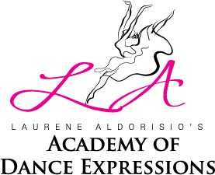

COVID-19 SCREENING CHECKLIST FOR DANCERS
NAME ___________________________________________ DATE __________ TIME __________
PURPOSE: Based on the US Center for Disease Control guidelines, service providers are encouraged to screen all clients for signs of respiratory illness accompanied by fever on a daily basis.
INSTRUCTIONS: All dancers entering Laurene Aldorisio’s Academy of Dance Expressions must be asked the following questions below:

By checking this box, I pledge to provide only correct and truthful information when completing the screening.
1. Do you have any of the following respiratory symptoms?
a. New or worsening cough _____ Yes _____ No
b. New or worsening shortness of breath _____ Yes _____ No
2. Have you had a fever of 100.4⁰F or greater within the last 14 days? _____ Yes _____ No
3. Are you feeling feverish? _____ Yes _____ No
4. Are you having chills? _____ Yes _____ No
5. Have you been in a facility or home with confirmed COVID-19 (by lab test)
within 14 days? _____ Yes _____ No
6. Have you been with persons with confirmed COVID-19 (by lab test)
within the last 14 days? _____ Yes _____ No
If you answered “NO” to all questions, you will be allowed entry into the studio.
By signing the form below, I am acknowledging the potential risk to contract the COVID-19 disease during classes that I voluntarily agreed to attend. I further agree and, hereby release, Laurene Aldorisio’s Academy of Dance Expressions and its employees from any and all liability associated with my potential risk to contract COVID-19.

DANCER’S FULL NAME (PLEASE PRINT): ___________________________________________________

DANCER/PARENT SIGNATURE (IF UNDER 18): ______________________________________________
DATE: ____________

_______________________________ DATE: __________
LAURENE ALDORISIO

