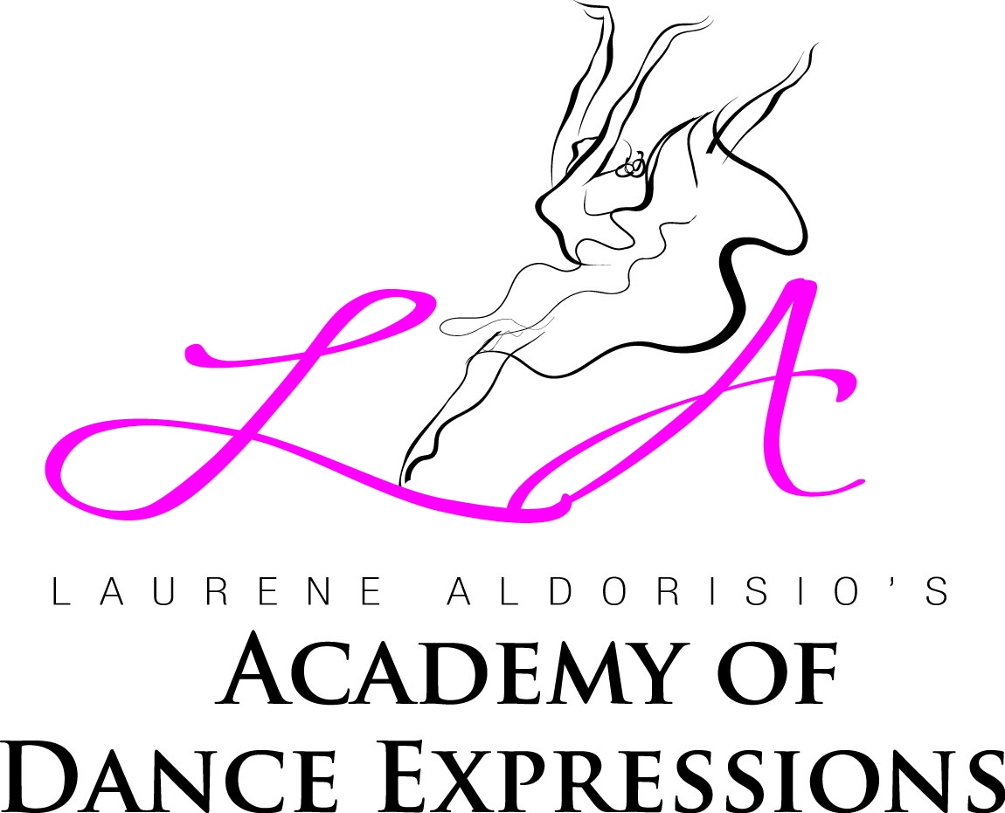
LAURENE ALDORISIO’S ACADEMY OF DANCE EXPRESSIONS
Ballet * Pointe * Jazz * Modern * Contemporary *
Lyrical * Tap * Hip Hop * Acro

Dance Expressions Dance Attire Policy

*** ALL STUDENTS MUST WEAR HAIR IN A HIGH BUN
Combo Classes | Leotard | Tights | Shoes Needed |  | Shoes Brand & Style
Mommy & Me, Dance & Play, Pre Ballet/Tap, Kinderdance, | Black | Girls: Pink Footed  Boys: Black Sweatpant | Ballet, Tap |  | Girls’ Ballet: Capezio “Daisy” Ballet  Pink Leather, Style #205c or Bloch 205  Girls’ Tap: Capezio “Mary Jane”  Tap shoe/Black (Not Patent Leather) Style#3800c  Jazz (All): Capezio “Slip-On” Jazz Shoe/Black  Style # EJ2C (Child); Style #EJ2 (Adult)  Hip Hop (All): All Black sneaker For example: Converse,  Nike Roshe, Addidas, Puma  Boys’ Ballet: Capezio Ballet /Black  Style #205c  Boys’ Tap: Capezio Tic-Tac-Toe  Lace-up tap shoes/black
Dance Expressions | Black | Girls: Pink Footed  Boys: Black Sweatpant | Ballet, Tap, Jazz
Ballet/Jazz/Tap | Black | Pink Footed  Boys: Black Sweatpant | Ballet, Tap, Jazz
Beg. Hip Hop | Black | Girls:Black leggings or sweapant/Boys: Black Sweatpant | Hip Hop sneaker
***ABSOLUTELY No skirts or attached skirts to leotards are to be worn in class.
Subject/Class | Leotard | Tights |  | Shoes
Ballet (Ages 2-10) | Black | Pink Footed/Convertible  Boys: White t-shirt, black footed tights |  | Capezio “Daisy” Ballet Pink Leather, Style 205c OR Bloch 205  Boys: same in Black
Ballet (Ages 11+) | Black | Pink Footed/Convertible |  | Capezio Hanami Light Pink Style #2037W  Company Member Requirement
Jazz (All) | Black | Black/Convertible |  | Capezio “Slip-On” Jazz Shoe/Black  Style # EJ2C (Child); Style #EJ2 (Adult)
Tap (Ages 2-10) | Black | Black Footed/  Convertible |  | Capezio “Mary Jane” Tap Shoe/Black  Style #3800C (Not Patent Leather)
Tap (Ages 11+) | Black | Black Foot/Convertible |  | Capezio Cadence  Style #CG19
Modern | Black | Black/Convertible |  | Capezio Footundeez
Hip Hop (All) | Black | Black Leggings or sweatpant Boys: Black Sweatpant |  | All Black sneaker  For example: Converse, Nike Roshe, Puma, Addidas
Acro | Black | Black Shorts |  | Barefoot
Flexibility/Strength/Condition | Black | Black Shorts |  | Barefoot
Contemporary/Lyrical | Black | Black/Convertible |  | Hanami Half Soles Style: H064W

All dancers are required to have the appropriate shoes no later than October 1st
(508) 836-3608 * laurenedanceexpressions@gmail.com

