Distance Running Energy Systems

All human movement needs ATP (Adenosine Triphosphate) for muscle contraction. ATP could be considered our gasoline, and it is created through various methods in our body. Racing and training for the distance events contested in high school necessitates utilizing the following energy systems:

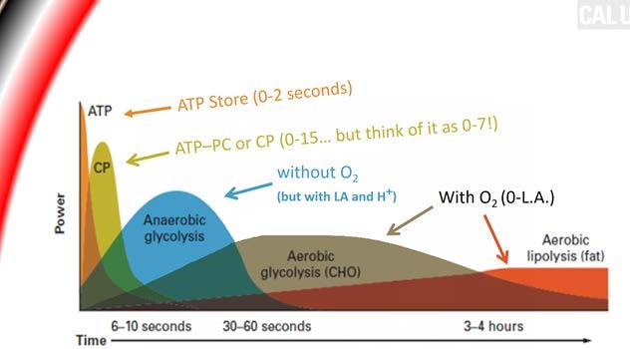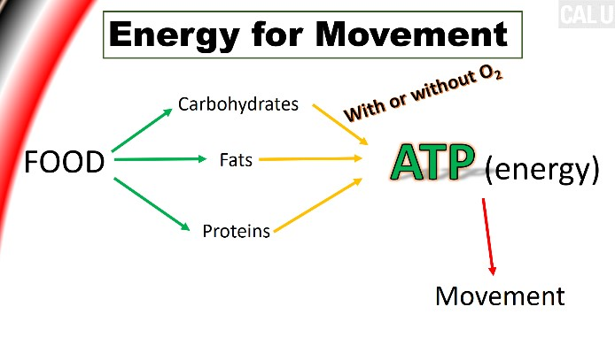
1.

Anaerobic Alactic (ATP-PC and ATP Store)
2.

Anaerobic Glycolysis (Lactic Acid)
3.

Aerobic Glycolysis

The ATP-PC system is powerful but only lasts for a few seconds. It is the system you use when running at full speed (maximum velocity). You use it at the start of many races, and sometimes throughout.
The Lactic Acid system is next in terms of power production. It can last over a minute, but has a byproduct of lactic acid, and more importantly, hydrogen ions (H⁺). The accumulation of H⁺ leads to a reduction of power output and as a result, reduction of speed.
Finally, the last, and most important energy system involved with all high school distance running is the Aerobic glycolytic system. This system can last a few hours depending on the intensity. As a result, the vast majority of your athletes training should be aerobically based.

*above from a presentation by Coach Daniel Caulfield at 2019 Ohio Track Clinic

