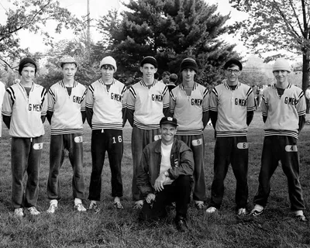  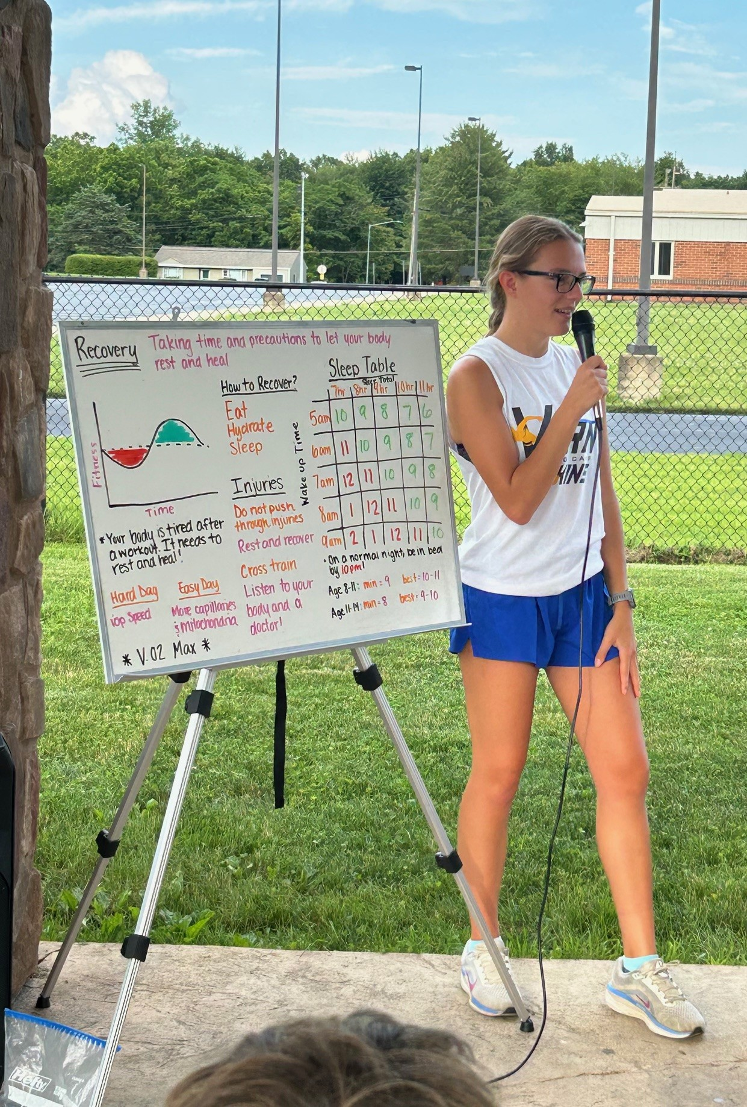  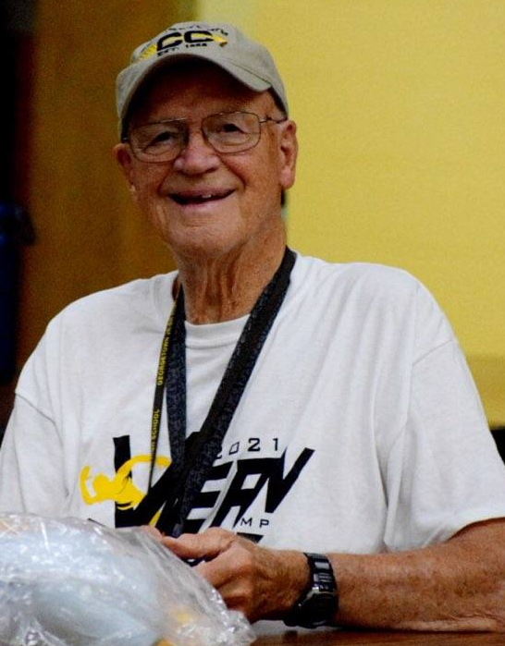  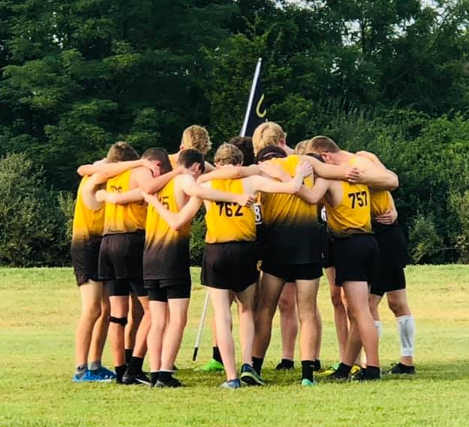  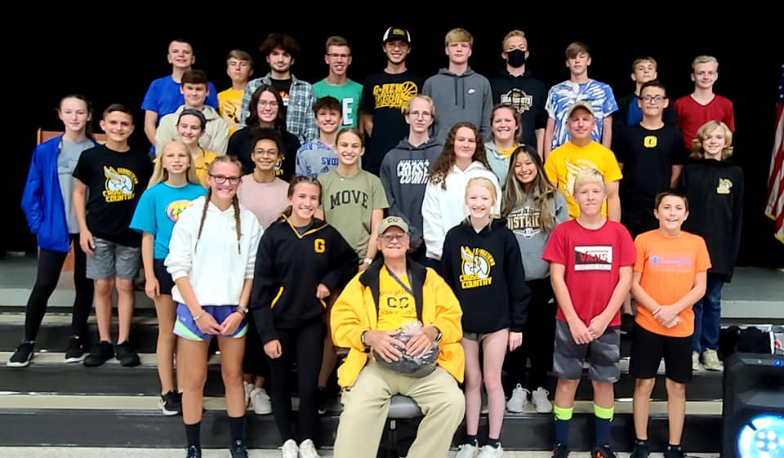  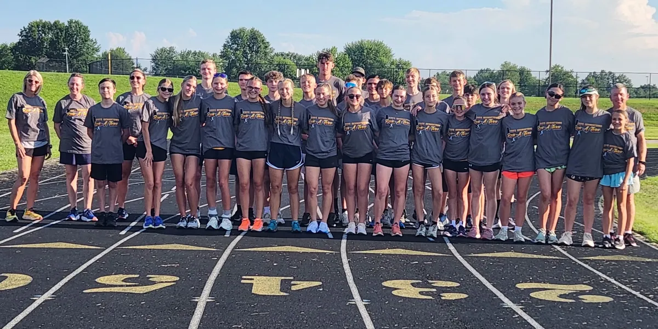  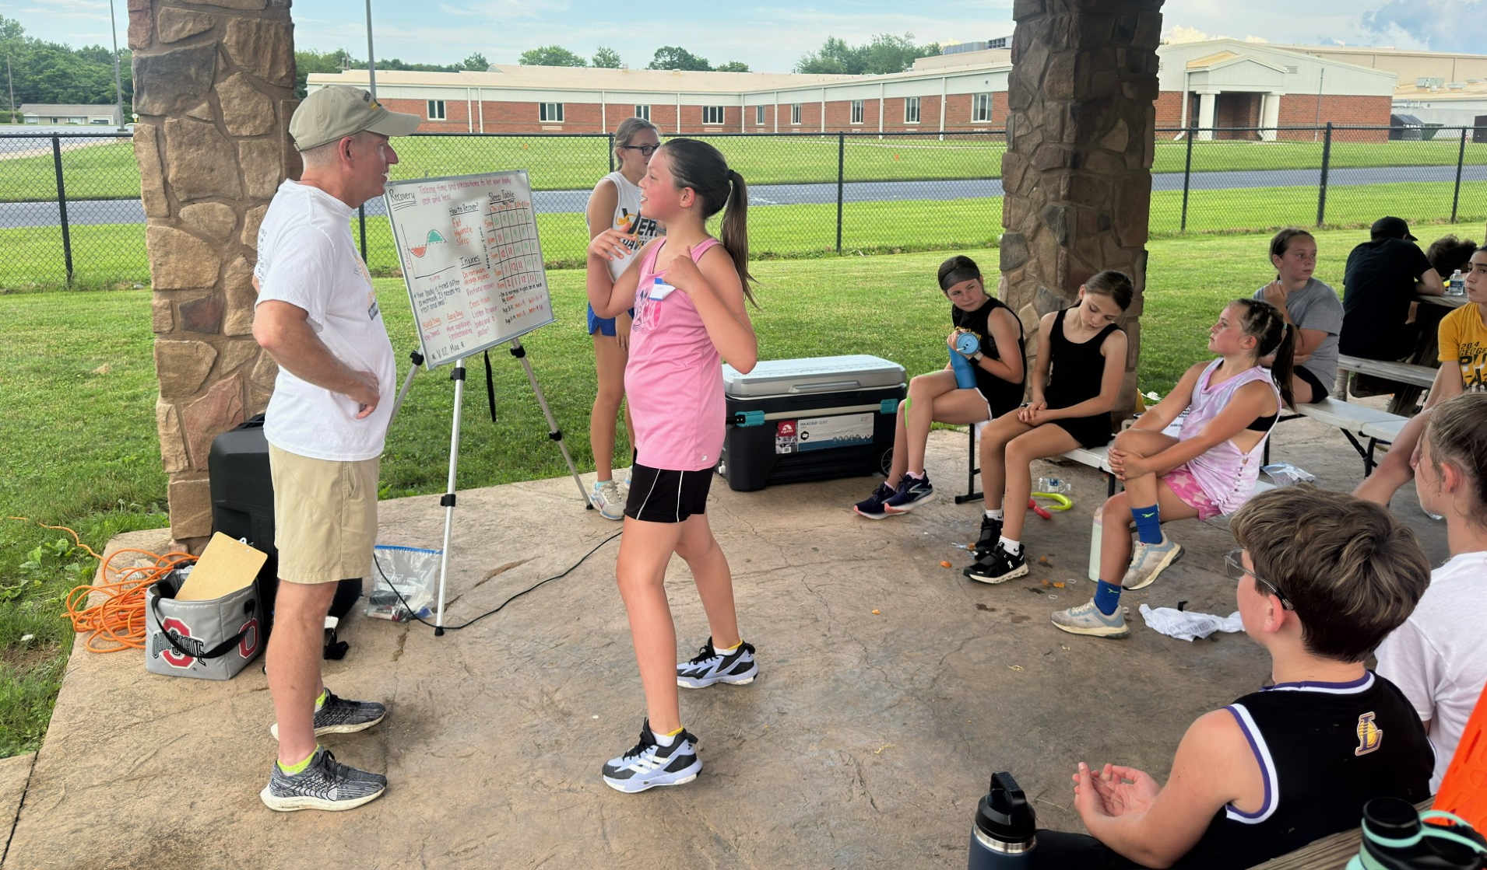  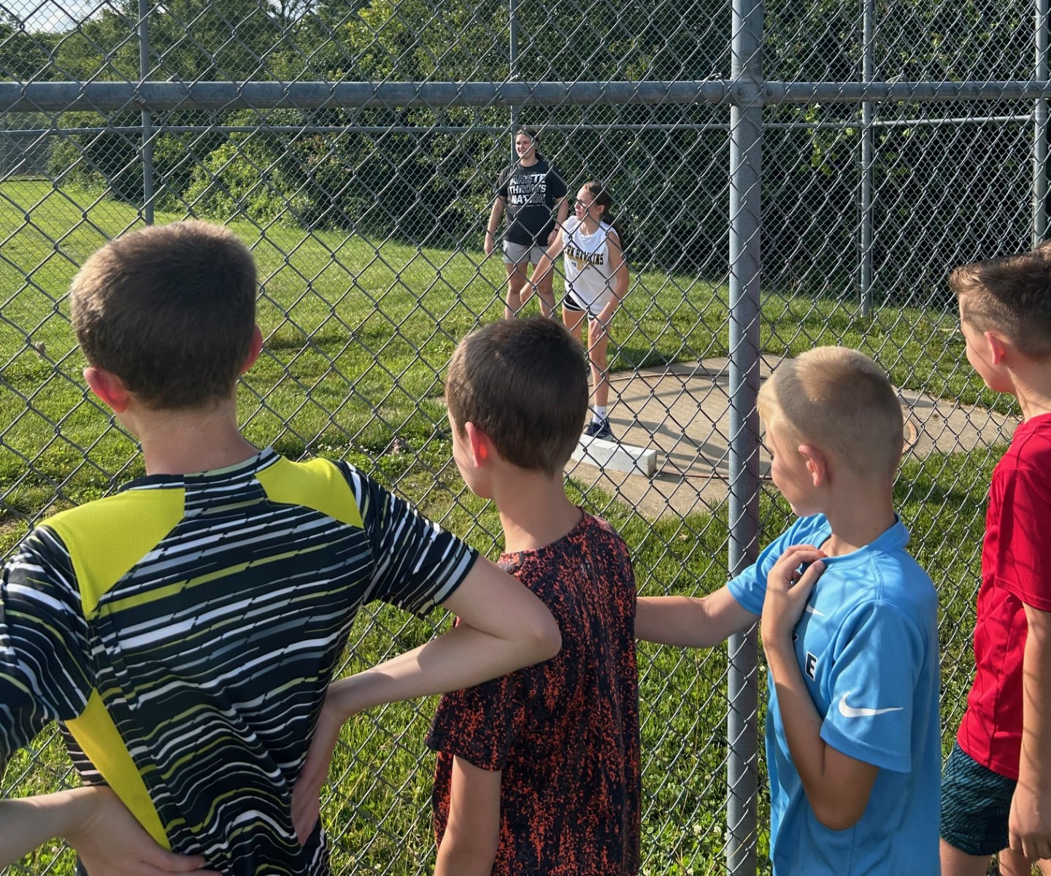    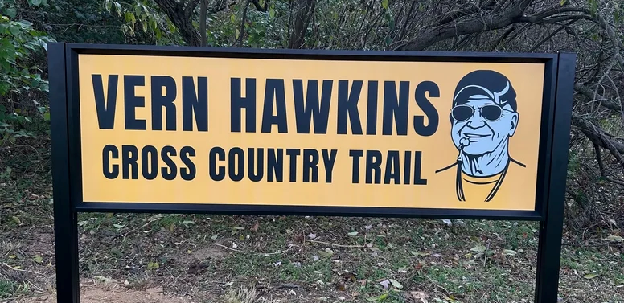 | _________________  _________________ | Molly Ellis  130 Bennington Ct.  Georgetown, OH 45121 | 2026  Vern Hawkins Youth Summer Running Camp  - June 22nd – June 25th  - 6:00PM – 8:00PM  - Georgetown High School Track  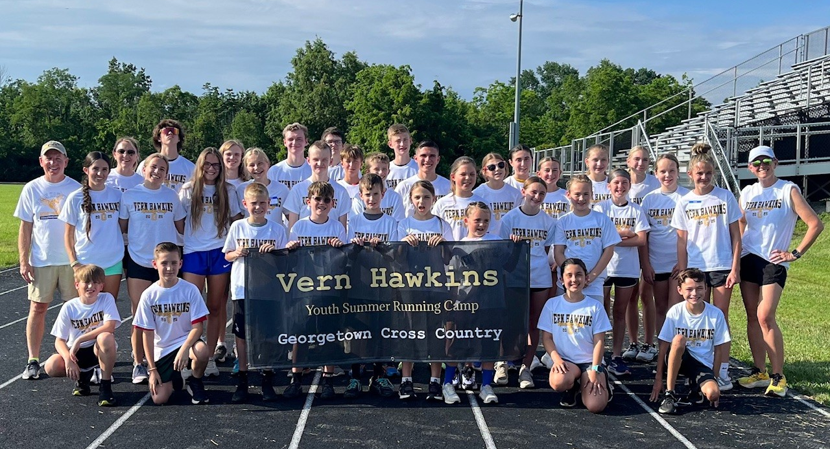  - Open to boys and girls entering 4th through 7th grade  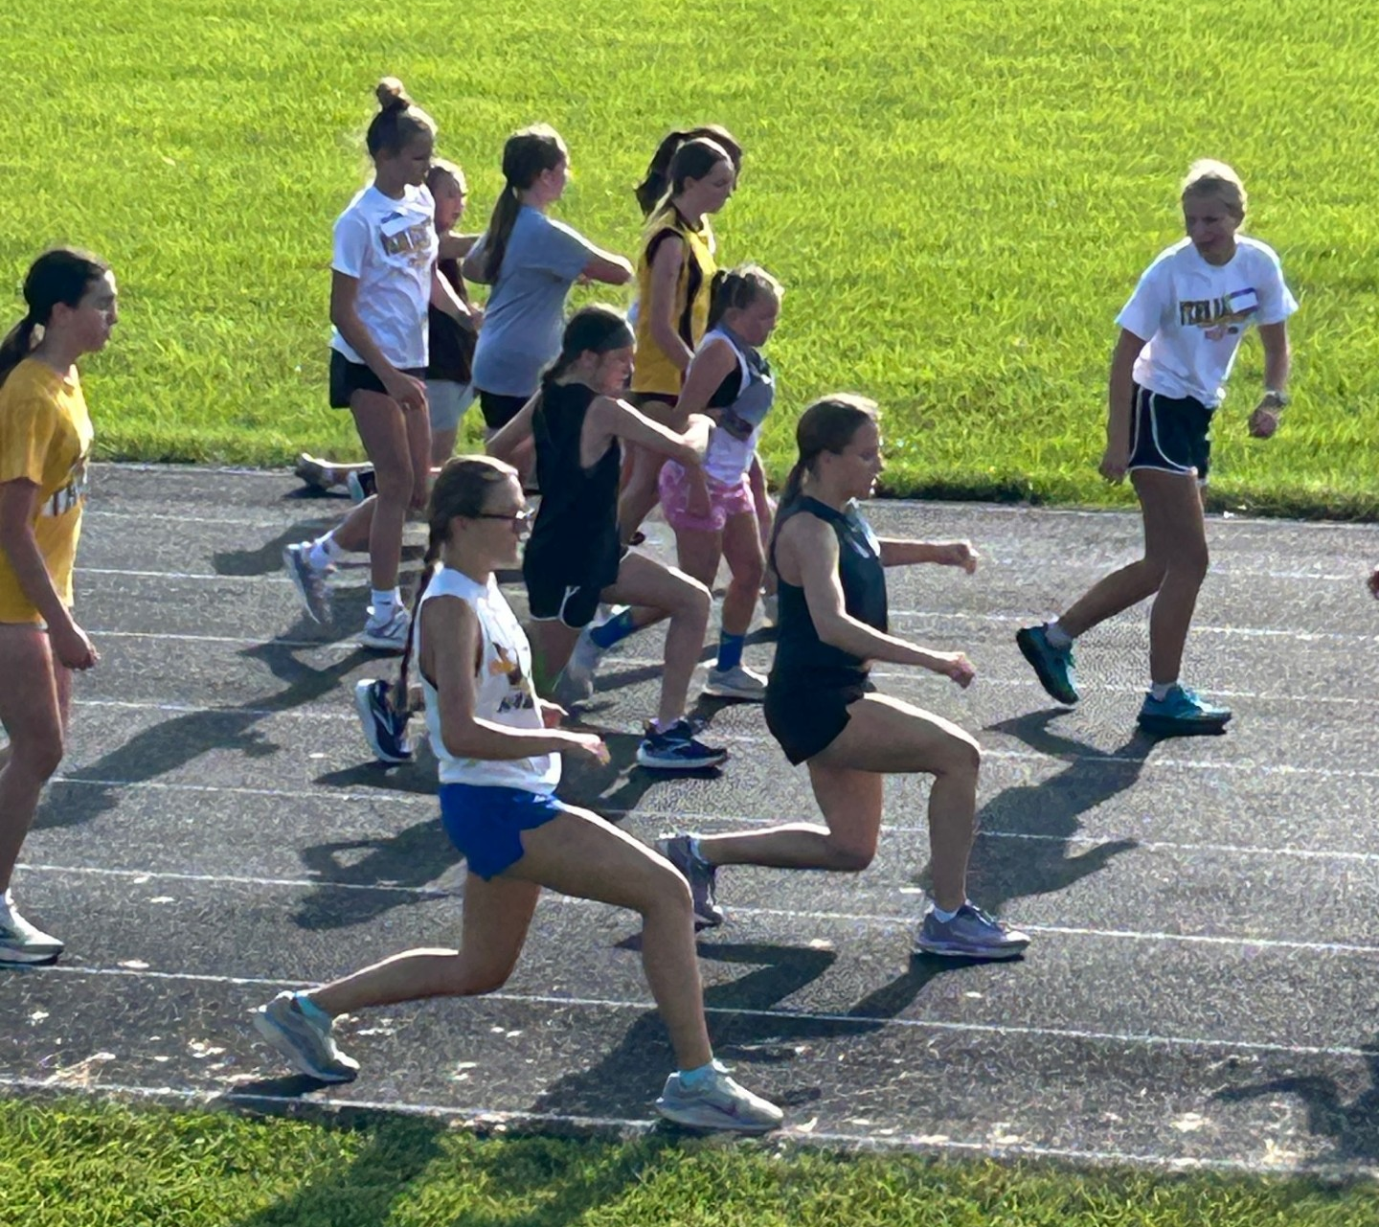  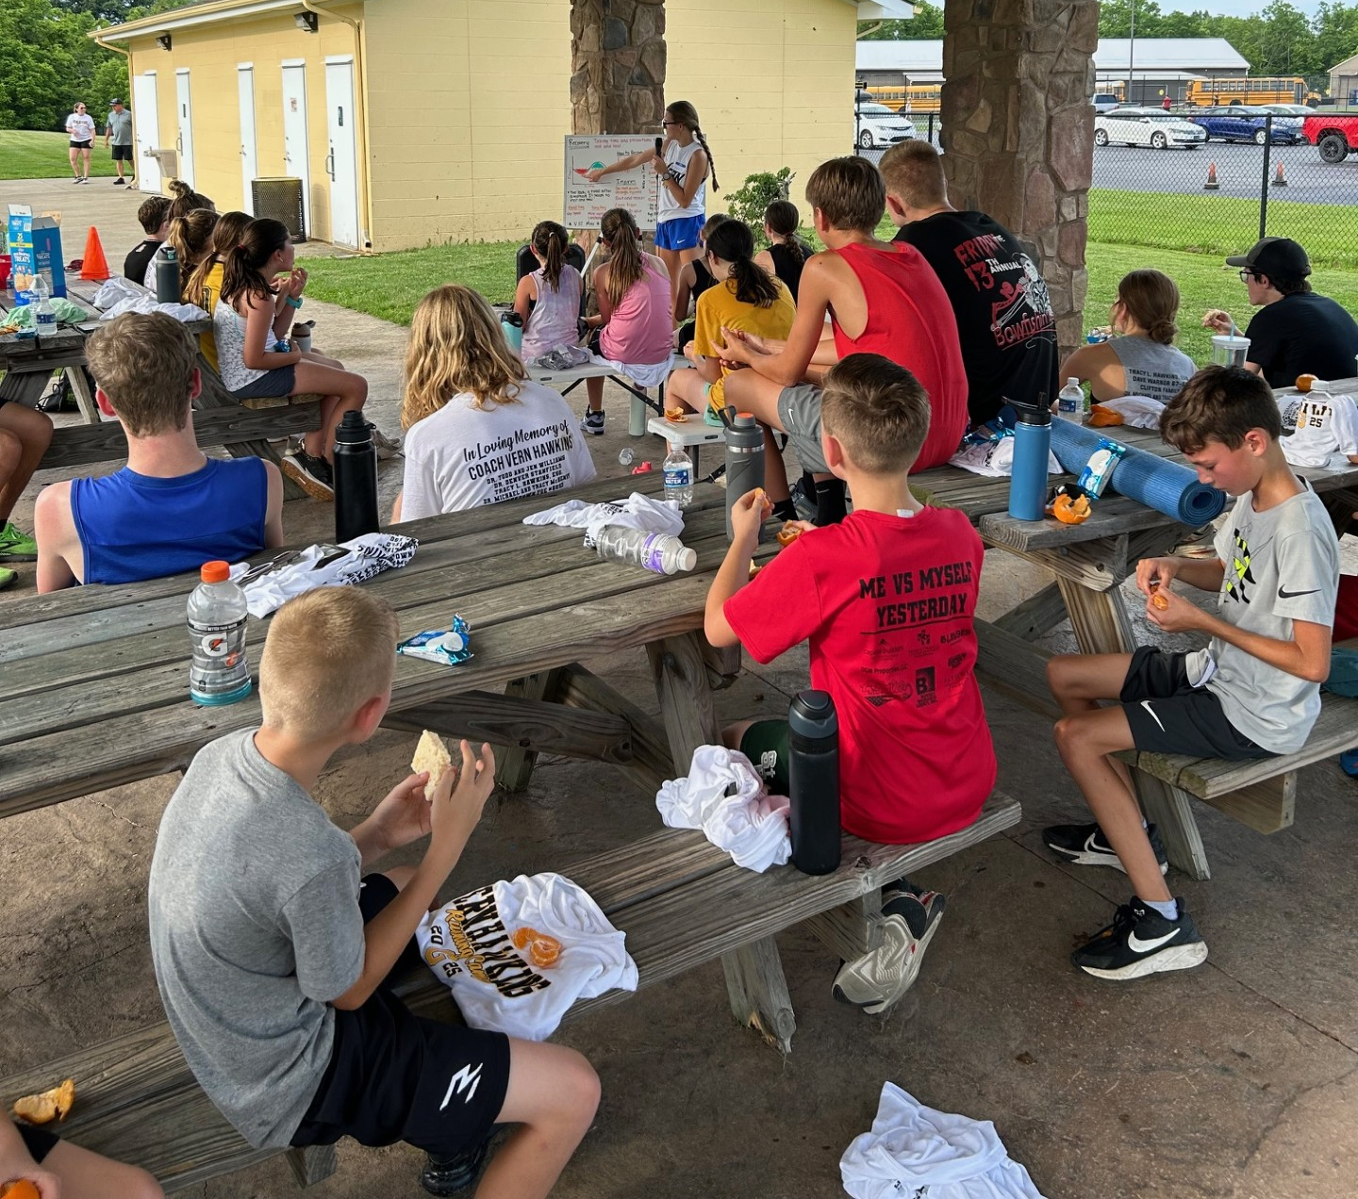    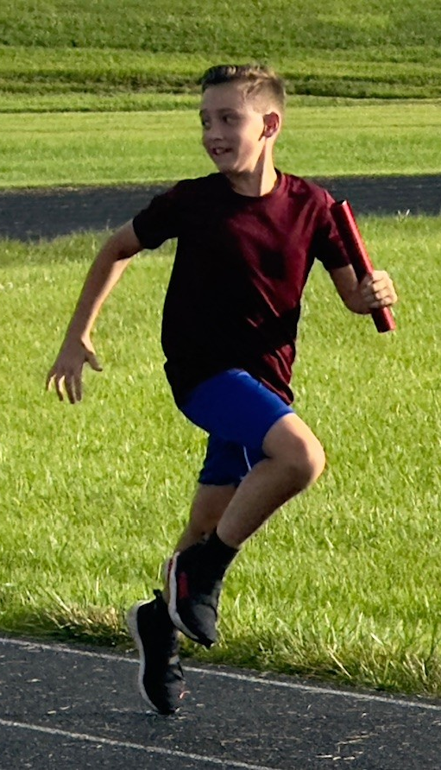  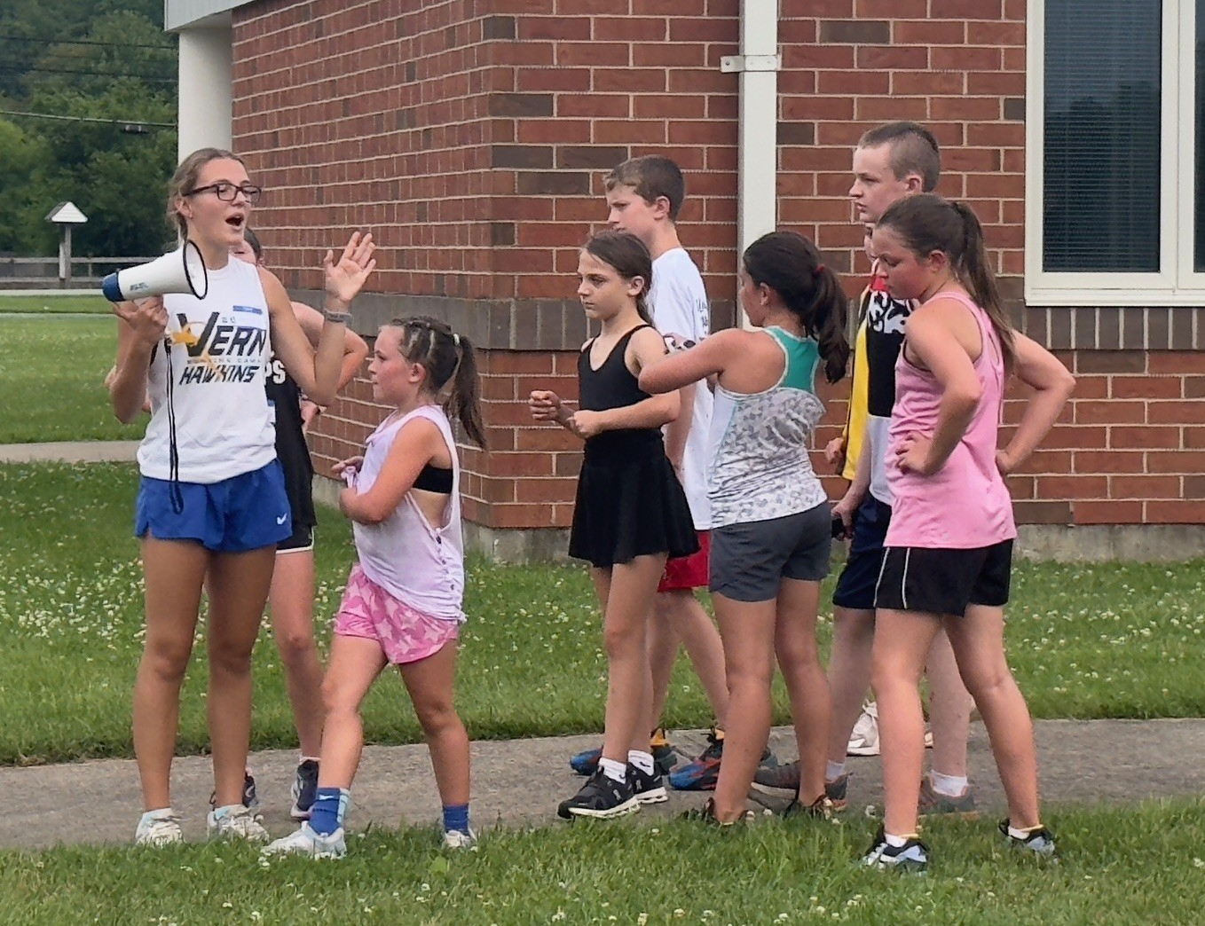

  Campers will learn about:  - Proper running form  - Stretching  - Nutrition  - Basic training fundamentals  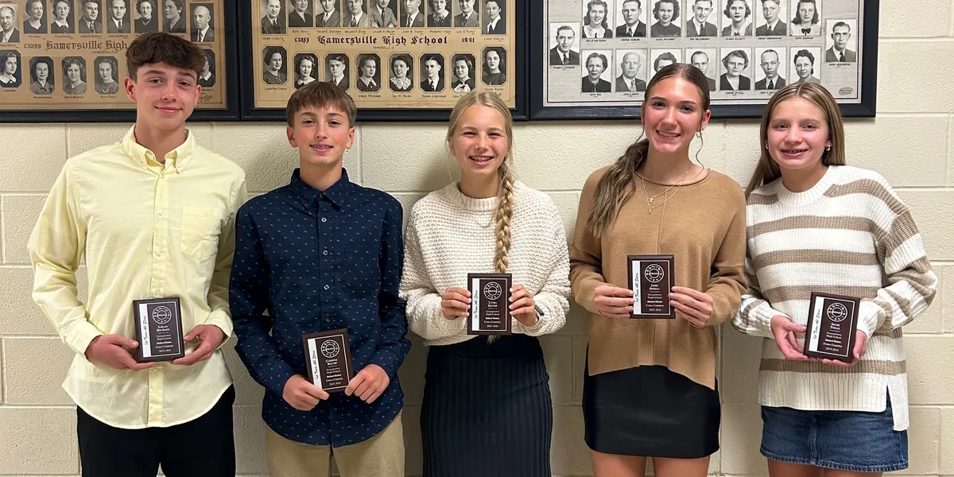  Training provided by the Georgetown Cross Country staff and special guest speakers.  For more information    go to Gtowncc.com | Cost of Camp  Camp fees will be $40 per camper.  Please enroll by May 20th to guarantee correct T-shirt size.  Checks payable to Georgetown Athletic Boosters.  Student Name ___________________  Parent/Guardian Name _______________________________  Incoming Grade Level _____________  Phone # _______________________  Email _________________________  Emergency Contact Phone #  ______________________________  Significant Health Problems  ______________________________  Allergies _______________________ | Please Circle T-shirt Size  Youth S M L XL  Adult XS S M L XL  2XL Other ______  Wavier of Claims  I, as a parent or guardian, hereby give my permission for __________________ to attend the “Vern Hawkins Youth Summer Running Camp” and acknowledge the fact that he/she is physically able to participate in all camp activities. I hereby authorize Camp Staff to act according to their best judgement in any emergency requiring medical attention and I waive and release Camp Staff and Georgetown Exempted Village Schools from any and all liability for injuries or illness incurred while he/she is at camp. I hereby state that the camp is not responsible for the recurrence of any pre-existing injury or illness. I indemnify and hold harmless the Camp Staff from any claims for personal injury or illness he/she may sustain during camp. I acknowledge that I will be responsible for any cost (through family medical insurance or otherwise) incurred due to illness or injury. I hereby waive any claim I might have against the Camp Staff or Georgetown Exempted Village Schools and/or individuals of the Camp Staff or Georgetown Exempted Village Schools.  Parent /Guardian Signature Date  __________________ _________  Camper Signature Date  __________________ _________

