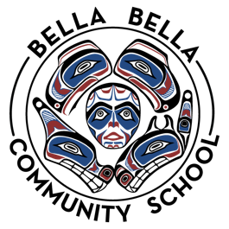
Career Life Connections
Teacher: Ashley Gosse + [contact info]
Grade Level: 12
Duration: Full Year
Credit Value: 4 credits [Grade 8 or 9 - delete this row]
Google Classroom Access Code:
Curriculum Link: https://curriculum.gov.bc.ca/curriculum/career-education/all/courses

Welcome Message
Congratulations! Career Life Connections (CLC) leads you the student to graduation and beyond!…+

Curriculum:

Big Ideas & Learning Standards
[Specific examples from the curriculum that you want to highlight]

Teaching & Learning Strategies
[specific to this class; designed to maximize student success] i.e. clear learning goals, example of what success looks like, multiple ways of presenting material (verbal, visual, multimedia…) …

Assessment
[specific to this class; designed to maximize student success]

Covid Safety
Stay home if you are sick
Use the high school doors when entering and leaving the school
Wash / sanitize your hands upon entry to school & each class
Wear your mask in the hallways
Stay in your learning group
Consume only your own food or drinks
Cough into your elbow
Personal items are for you only
Disinfect your desk and chair at the end of class

Optional: Routines, Rules…
[specific to this class]

