NYSED Parent Dashboard Communications Toolkit
The Parent Dashboard will go live on Thursday, October 29, 2020 on NYSED’s public data website. When the Parent Dashboard goes live, the link will be: https://data.nysed.gov/parents/
After the Parent Dashboard is made available to the public on October 29, please complete the actions listed below using the tools provided in this document. We ask that you complete the following steps by Monday, November 30, 2020:
- Place a link to the Parent Dashboard on your school and district websites. The Parent Dashboard logo and link can be added to your website in one of two ways:
  - Download the Parent Dashboard logo and link it to https://data.nysed.gov/parents/ from your website.
  - Use the following embed code:
<a href="https://data.nysed.gov/parents/"><img src="http://www.nysed.gov/common/nysed/files/parent-dashboard-logo.png" alt="NYSED Parent Dashboard" width="250" height="100" border="0" /></a>
Please Note: Each school, district, and BOCES has its own profile on the Parent Dashboard. After the Parent Dashboard goes live on October 29, you can find the unique profile for your school, district, or BOCES using the search box as shown in the screen shot below. If preferred, your unique profile link can replace the link to the Parent Dashboard home page in the Parent Dashboard letter and social media posts.
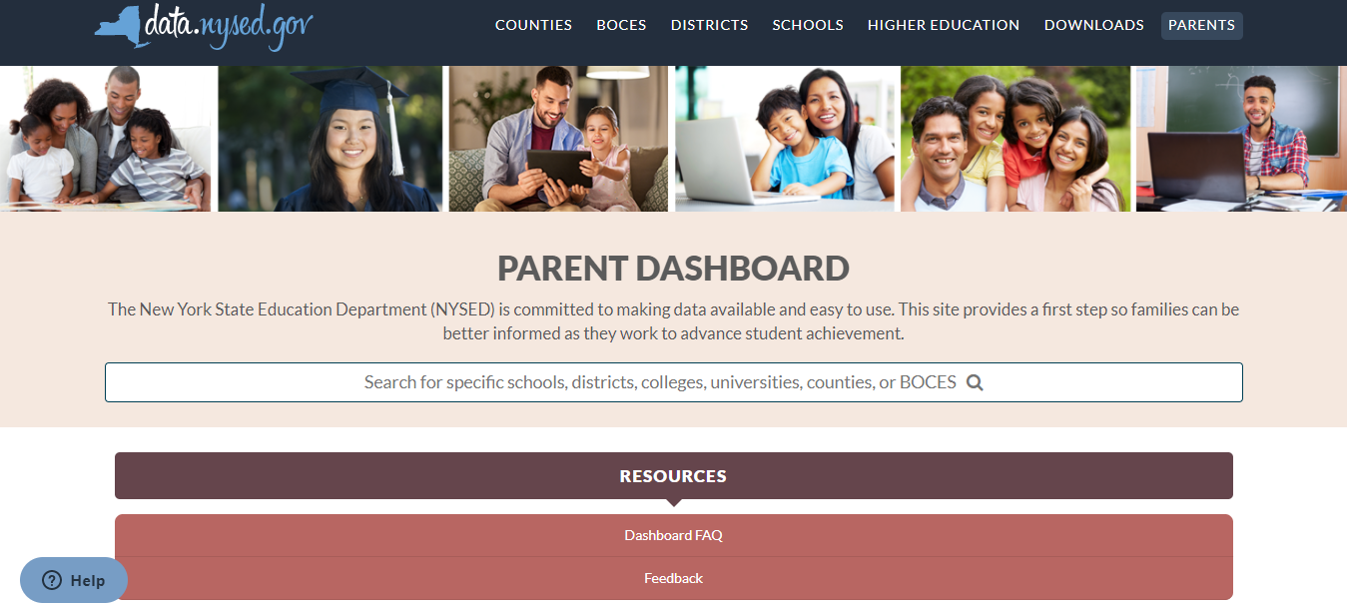
- Send the Parent Dashboard Letter (Attachment 1) to students’ parents and guardians. The letter provides information about the Parent Dashboard and includes an online feedback survey available in 17 languages. The letter is meant to be a template that you can customize to fit your needs. The letter can be sent by mail, email, or another communication method.
- Use the pre-written posts and graphics (Attachment 2) on your school and district social media channels. Please use the social media posts to help raise awareness and gather feedback about the Parent Dashboard over the next year. Graphics are available for Facebook, Twitter, and Instagram.
Attachment 1: Parent Dashboard Letter
This letter is intended as a communication from school leaders to parents and guardians.
Please Note: The link to the Parent Dashboard will be a working link after 11AM Thursday, October 29
Dear Parents,
The New York State Education Department (NYSED) has developed a Parent Dashboard to increase transparency and make information about school performance and other school-level data easier for parents and the public to access. The Parent Dashboard is part of New York’s Every Student Succeeds Act (ESSA) plan, which emphasizes equity in education for all students and expands measures of school accountability and student success. This new dashboard will provide parents with information about their child’s school. The Parent Dashboard is now available in addition to the New York State School Report Card on NYSED’s public data site. The Parent Dashboard offers information on all public schools including charter schools.
In 2019, NYSED gathered feedback from parents and stakeholders to guide the work of developing the Parent Dashboard. The data elements that parents ranked highest on the survey are available on the Parent Dashboard.
NYSED is now gathering additional feedback from parents and stakeholders to guide further enhancements to the Parent Dashboard. We invite parents and other stakeholders to explore the Parent Dashboard and then provide feedback via an online feedback survey available in 17 languages. NYSED will use this feedback to identify the data that is most useful to parents and the public and to make improvements to the website.
If you have any questions or would like more information, please visit the Parent Dashboard, which includes frequently asked questions and contact information.
Thank you for your feedback and for your continued commitment to your child’s education.

Attachment 2: Social Media Posts and Graphics
Social Media Posts
- The New York State Education Department developed a Parent Dashboard to increase transparency and make school-level data easier for parents and the public to access. Find information about your child’s school and provide feedback: https://data.nysed.gov/parents/
- The New York State Education Department Parent Dashboard provides a gateway to school-level data for parents and the general public. Feedback from parents and stakeholders will guide enhancements to the Parent Dashboard. View the dashboard and provide feedback: https://data.nysed.gov/parents/
- The New York State Education Department designed the Parent Dashboard to be an informative and user-friendly way for parents and the public to access information about New York State schools. Check out the Parent Dashboard here: https://data.nysed.gov/parents/
- Tell the New York State Education Department what school-level data is most important to you in two steps:
1) Take a look at the new Parent Dashboard: https://data.nysed.gov/parents/
2) Complete the 5-minute Parent Dashboard survey: https://surveyhero.com/c/b438754c
- The New York State Education Department is gathering feedback from parents and stakeholders to guide enhancements to its Parent Dashboard. Please complete this 5-minute survey and help make the Parent Dashboard as useful as possible: https://surveyhero.com/c/b438754c
- The New York State Education Department is inviting parents and other stakeholders to explore its new Parent Dashboard and provide feedback via an online survey. The feedback will be used to make improvements to the website. Learn more here: https://data.nysed.gov/parents/
Graphics
- Facebook
  - Facebook Image 1
  - Facebook Image 2
  - Facebook Image 3
  - Facebook Image 4
  - Facebook Image 5
- Twitter
  - Twitter Image 1
  - Twitter Image 2
  - Twitter Image 3
  - Twitter Image 4
  - Twitter Image 5
- Instagram
  - Instagram Image 1
  - Instagram Image 2
  - Instagram Image 3
  - Instagram Image 4
  - Instagram Image 5

