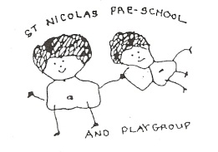
St. Nicolas Pre-school & Playgroup
(Registered Charity No. 284755)
Boxhill Walk, Abingdon OX14 1HB
______________________________________________________________________
PRE-SCHOOL APPLICATION FORM
NAME OF CHILD:
DATE OF BIRTH: GENDER: Male/Female
NAME OF PARENT/GUARDIAN: | NAME OF PARENT/GUARDIAN:
Does this person have legal responsibility? Y / N | Does this person have legal responsibility? Y / N
ADDRESS:  POST CODE: | ADDRESS:  POST CODE:
TELEPHONE NO’s HOME: WORK:
Email address(s):
Please share any relevant information about your child (Special Educational Needs, Cultural)?
Do you have a 2 year assessment on your child? Y / N
Please tick as appropriate: YES NO

- Child(ren) currently at St Nicolas Pre-School/Playgroup?             
- Child(ren) currently at St Nicolas School?             
If yes, please confirm the following:
- Name of child(ren) currently at School:....................................................................
and
- Class and Teacher:.....................................................................................................

I/We enclose a voluntary contribution of £3.00 to cover administration costs (in cash or cheque made payable to St. Nicolas Pre-School and Playgroup).
I/We will notify the Pre-School and Playgroup of any changes.

SIGNED: ......................................................... . DATE: .......................................

Please return your completed form and voluntary contribution addressed to ‘Waiting List Secretary’ at the above address. You will receive confirmation of your application form having been received. Thank you.

Waiting List Secretary – stnicpreschool.waitinglist@gmail.com

