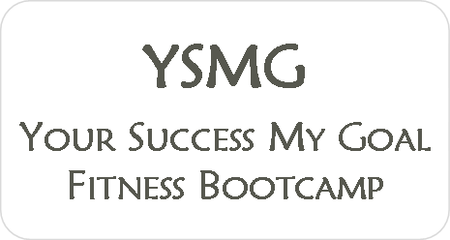

Waiver/Informed Consent

Each participant in the Your Success My Goal Boot Camp or Jeff Laynes person training program should realize that there are substantial risks, hazards, and danger inherent in Personal Training and involves an inherent risk of physical injury and the undersigned assumes all such risks. Because physical exercise can be strenuous and subject to risk of serious injury (including but not limited to musculoskeletal injury, spinal injuries, abnormal blood pressure responses, and rare instances heart attack or death), it is urged that you obtain physical examination from a doctor before using any exercise equipment or participating in any exercise activity. If you do not obtain physical examination from a doctor prior to starting Boot Camp/personal training, you certify that you refuse to see a doctor and are in good health.

You agree that by participating in physical exercise or training activities, you do so entirely at your own risk. Any recommendation for changes in diet including the use of food supplements, weight reduction and/or body building enhancement products are your responsibility and you should consult a physician prior to undergoing any dietary or food supplement changes. You agree that you are voluntarily participating in these activities and use of these facilities and premises and assume all risks of injury, illness, or death.

By signing this document, you assume all risk for you health and well-being and hold harmless of any responsibility, the instructor, facility or any persons involved with this program and testing procedures. You should stop exercise immediately if you feel fatigued or unwell. You understand that questions about exercise procedures and recommendations are encouraged and welcomed, but you acknowledge that the instructor is not a physician and is not trained in any way to provide medical diagnosis or any other type of medical advice.

Waiver/Informed Consent

This waiver and release of liability includes, without limitations, all injuries which may occur as a result of; a) your use of all amenities and equipment at Your Success My Goal Boot Camp and your participation in any activity, class, program, personal training, supervision, or instruction; b) the sudden and unforeseen malfunctioning of any equipment; c) our instruction, training, supervision, or dietary recommendations and; d) your slipping and/or falling while at Your Success My Goal Boot Camp, at any of its locations, including adjacent sidewalks and parking areas.
By signing this release, you acknowledge that you understand its content and that this release cannot be modified orally.

You acknowledge that you have carefully read this “waiver and release” and fully understand that it is release of liability. You expressly agree to release and discharge the trainer/instructor from any and all claims or causes of action and you agree to voluntarily give up or waive any right that you may otherwise have to bring a legal action against Your Success My Goal Boot Camp for personal injury or property damage.

_________________________________________
Signature

_________________________________________
Date

