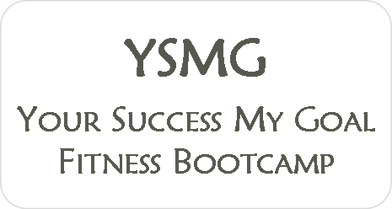

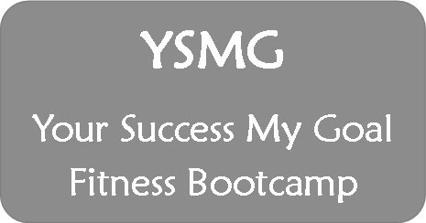

Enrollment Form

Please fill out this form and email to Jeff at jlaynes@aol.com

Contact Information

First Name Last Name

Address City State Zip

Email Telephone Mobile

Emergency Contact Name Telephone Relationship

Personal Information
This information will help customize the fitness session to ensure each participant will more likely achieve success.

Gender Male Female Age Height Estimated weight

Approximate fitness level
Beginner (Just starting or reestablishing your fitness routine)

Intermediate (Currently exercising one-two days weekly)

Advanced (Currently exercising three or more days weekly)

Professional (Advanced athlete training for a specific sport)

Fitness Information
Camp—please write your preferred first day of Boot Camp. Each Camp lasts 30-sessions, and can start on Monday, Wednesday, or Friday. Start date:

Camp Time—please select your Boot Camp time. Participants must attend only the Camp time for which they have signed-up.

6:00-7:00 am 6:30-7:30 pm

