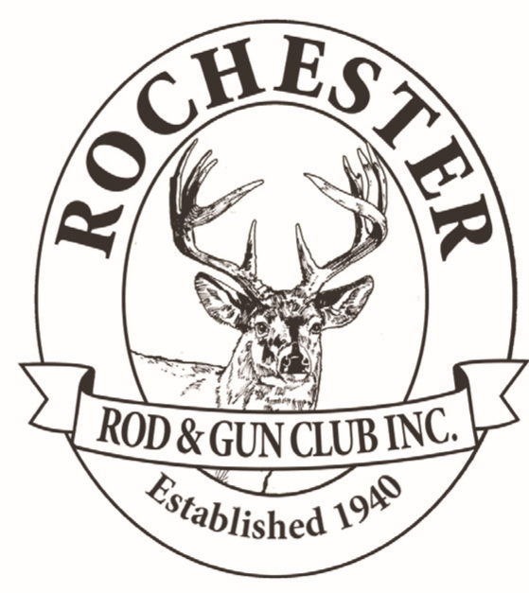
Rochester Rod and Gun...
APPLICATION FOR MEMBERSHIP
Rochester Rod & Gun Club reserves the right to deny any application not accepted by board members
Date:____________________________
Name: _____________________________________________SHIRT SIZE___________________
Street Address: * ________________________________________________________________
City/Township: * ________________________________________________________________
Telephone(Day): ________________________________________________________________
Telephone(Cell): _________________________________________________________________
NRA# and Expiration Date: _________________________________________________________
Email: * ________________________________________________________________________
( * ) Required field
Hunting Interests
Check all that apply... Target Shooting Long Range Small Game Fishing
Willing to work on Club Projects?
Check all Appropriate....
Building & Grounds Maintenance Range Improve
Fund raising (such as grant writing) Club Events Photography
Computer web site creation and monthly maintenance
Other specialty you may have?
_________________________________________________________________________
_________________________________________________________________________
Type of membership desired: Individual Family
If family—name or names of family members desiring membership__________________________________
If family--specify shirts are $20.00 Specify Male or Female. Size of shirt: ____________
I hereby request membership in the Rochester Rod & Gun Club, and have two sponsors ( page 2 ) I am aware that Rod and Gun is a “working club” and various requirements ( listed on page 2 ) are expected.
Signature of Applicant:

2
I hereby recommend this applicant for membership in Rochester Rod & Gun Club.
Two sponsors are needed for Applicant’s first year.
_{Sponsor:}
Sponsor:

Membership fees: (1st year) = $200.00 Associate (family member) = ($10.00 ea. per year)

All members must adhere to the rules and regulations of the club. As amended 12-8-11
To maintain good member status, all members, regardless of age must:
a. Maintain active membership in the NRA
b. Attend four (4) meetings per club year *
c. Work one of our two fundraisers …
(Wild Game Dinner or 20 Gun Raffle…or pay $50.00 instead)
d. In addition, members under the age of 65 must participate in two club work parties
* *one meeting (Item B) can be purchased for $25.00 and one work party (Item D) can be purchased for $25.00
Any member, who through unsportsmanlike action proves himself to be undesirable as a member, is subject to having their membership suspended or revoked from the club without any refund of membership fees, and must surrender his membership upon request of the Executive Board.
Members must refrain from hunting in the immediate vicinity of all buildings, livestock, or in any orchard or other areas designated by the landowner.
Members shall adhere to all rules and regulations of the Clubs Shooting Range, as printed and posted.
Members must have the permission of the landowner when hunting upon their land. Written permission is preferred by most landowner members as well as Ohio Division of Wildlife Officials. Always let landowner members know when you will be on their land, as well as providing a description of the vehicle you will be using.
I have read the above conditions of membership, and agree to abide by them as a condition of continuing membership in the Club.
(member signature) X
Mail forms back to:

Les Jemiola
Membership Chairman
37423 Sugar Ridge
N. Ridgeville, OH 44039

email: websmoen1970@gmail.com

Form10042020

