Thank you for your purchase!

Reaper Traction Bars stands behind our products. We will make things right unless there has been obvious negelect or improper installation or use of this product not as intended.

**INSTRUCTIONS:**

**Rear bracket installation.**

1. Place the plate on the front of the axle you can also face them down to change the angle of the bar.
2. 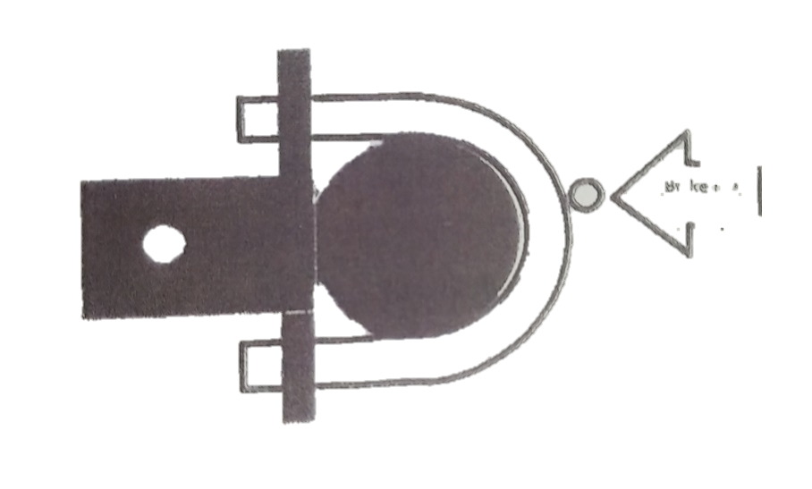Then install the U-bolts with the nuts and washers provided, be sure not to smash the brake line on the axle tube.   
   Torque the U-bolts to (60 FtLB) or until tight.

**BRAKE LINE**

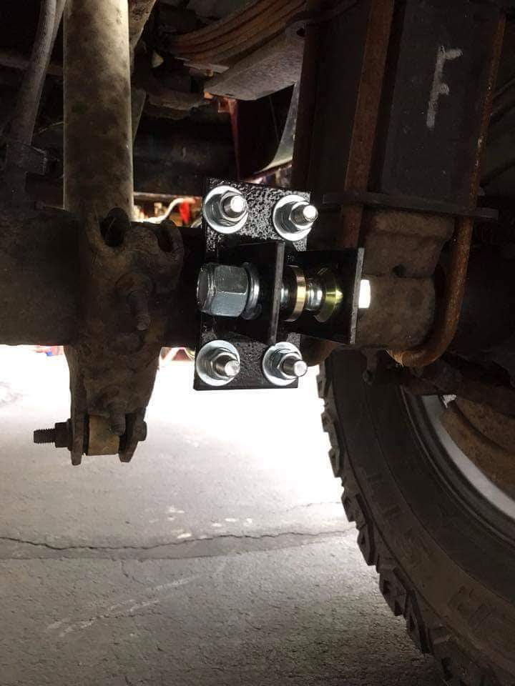

**Front bracket and** **Bar Installation:**

1. Install the traction bar to the back bracket with the provided nuts and bolts, the gold spacers cone towards the rod end torque to 220 FtLb or torque until tight.
2. Then install the front bracket onto the bar and hold it up to the frame. Make sure the rod ends are screwed all the way in.

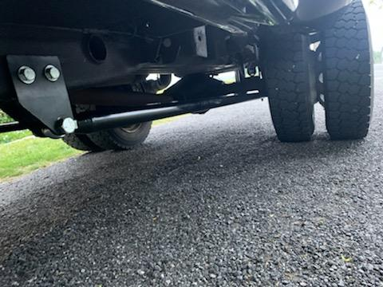

1. Take your half inch drill bit and mark the frame. Place the traction bar with the bracket down to drill the hole.
2. Install the bracket and bar with the bolts provided, tighten the ½” bolts to 55 FtLb or until tight, and the ¾” bolts to 200 FtLb or until tight
3. Lastly, tighten the bar until it is snug, once snug not tight tighten 1/2 turn then tighten the nuts on to the bars to 220 FtLb or until EXTRA tight.

Occasionally check bars and brackets for loose bolts or any other issues.

**Warning**: This is a high performance part. User assumes all risk when installing this product. Product is intended for off-road use only. We will not be held responsible for any damages that can or may occur to your vehicle while this part is installed on your vehicle.