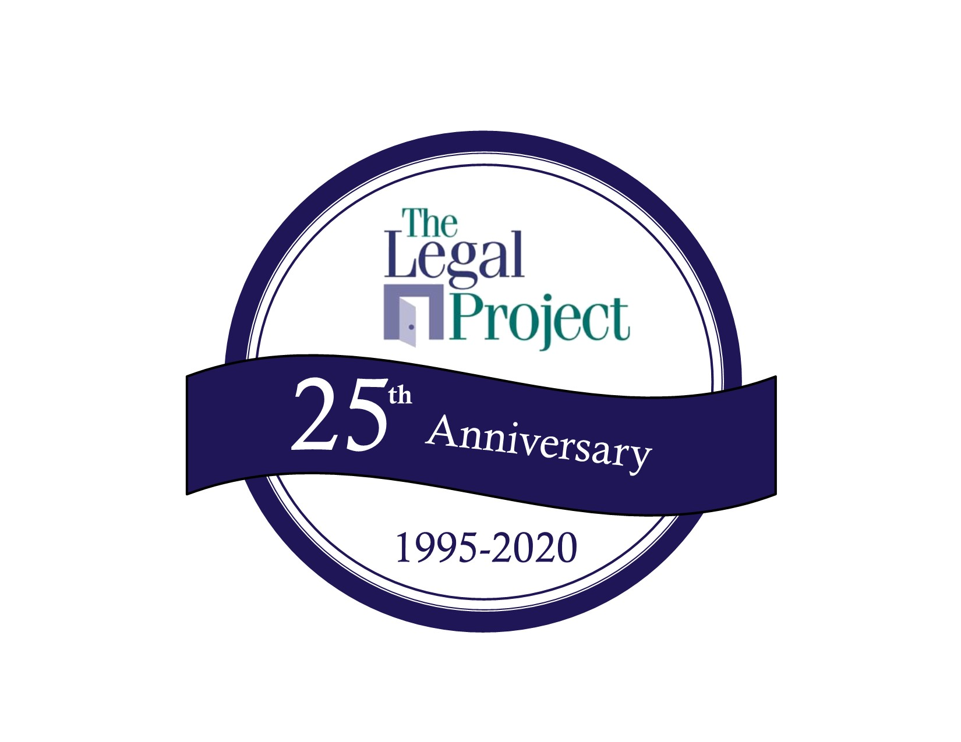
The Legal Project’s 25th Pro Bono Awards Breakfast “Have Breakfast with a Champion” Thursday, April 30, 2020 8:00-10:30 a.m.

The Legal Project’s 25th Pro Bono Awards Breakfast Honorary Committee

Yes, I would be pleased to serve on The Legal Project’s Honorary Committee. Please list my name as follows: ____________________________________________________________________________________________________________________

Enclosed is my donation of $100 (please make check payable to The Legal Project)

I have paid securely online at www.legalproject.org.

Name:____________________________________________________ Telephone: __________________________________ Email: ____________________________________________________________________________________________________________

No, I regret that I am unable to serve, but enclosed is a donation in support of your work.

To secure your place on the Honorary Committee and ensure that your name is listed on the invitation, please mail this form on or before March 15, 2020 to The Legal Project, ATTN: Margie Sheehan, Director of Fund Development, email to msheehan@legalproject.org or fax to (518) 435-1773. Thank you for your support!

