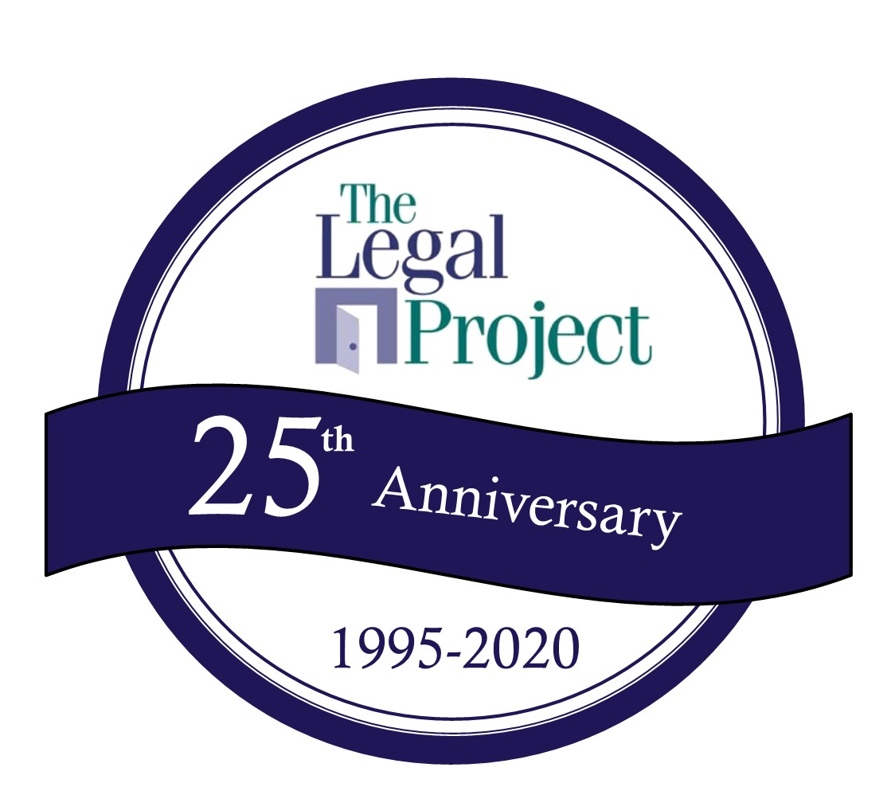
25th Pro Bono Awards Breakfast “Have Breakfast with a Champion”

Thursday, April 30, 2020 8:00-10:30 a.m. The Century House, 997 New Loudon Rd, Latham, NY
Yes! We are proud to support the work and mission of The Legal Project as a Sponsor. Enclosed please find:

A check made payable to The Legal Project.
This pledge form. Please invoice us.
This pledge form. We have made payment by credit card (MC, VISA or AMEX) on The Legal Project’s secure website at www.legalproject.org.
We are interested in paying on an installment basis (for contributions of $1500 or more).
Company/Business Name: _____________________________________________________________________________________
Contact Name: __________________________________________________________________________________________________ Email:_____________________________________________________________________________________________________________
Please add my/our name(s) as a Sponsor in the following category:

Sunrise Presenting Sponsor RESERVED All Rise! Coffee Sponsor $1,500

Waffle Bar Sponsor $5,000 Wake Up To Equal Protection! Sponsor $750

Hungry for Justice! Sponsor $2,500 Pro Bono Champion Sponsor $400

To ensure your participation as a Sponsor on the printed invitation, please submit this form on or before March 15, 2020 to The Legal Project, ATTN: Margie Sheehan, Director of Fund Development, email to msheehan@legalproject.org or fax to (518) 435-1773. We will contact you regarding fulfillment of your Sponsorship benefits. Thank you for your support!

