The Soldiers’ Plot Cemetery Restoration Project 2025-2026

In 2024, the DeWitt County Genealogical Society received a query regarding one of the men buried at the Soldier’s Plot at Woodlawn Cemetery in Clinton, a grouping of 80 Civil War Union veterans’ graves. While performing the research, it was noted that the tombstones located there were becoming increasingly deteriorated. Some were broken, some were leaning, some were sunken and some were missing altogether. Almost all of the tombstones there are military issue, engraved with a name along with company and regiment of service. They do not bear the birth and death dates of the decedent like civilian stones ordinarily do, which makes identification of the individuals very challenging. Furthermore, many of these men were barely past boyhood and did not leave an historical footprint to trace. As a result, they were underrepresented on the City of Clinton’s online GIS map of the cemetery and on the website Find-A-Grave. The Society resolved to rectify that deficit and spent close to a year researching and identifying each fallen soldier. All but one of the 80 men buried here were identified and added online. This resulted in two binders containing short biographies on file at the DeWitt County Genealogical Society library.

The problem of deteriorating tombstones remained. In 2009, a project spearheaded by Joey Long, now director of the DeWitt County Museum, recorded the tombstone inscriptions and displayed them on a memorial sign beside the Soldiers’ Plot. The U. S. Army originally marked soldiers’ graves with wooden markers, but with so many casualties during the Civil War, they switched to more durable stone for their national cemeteries. In 1879, they authorized the use of this style of grave marker in public cemeteries, and that’s when many of these stones were ordered. By 2009, they were already 130 years old, and by 2025, at close to 150 years old, they could barely be read. The sign itself was beginning to show its age, so a decision was made to update it as well. As for the tombstones, the plan was to preserve rather than replace, except ones that were completely missing or beyond repair.

The restoration journey began with obtaining permission from the City of Clinton, which required a liability waiver. Then an appeal to the public was made on the local radio station and in the local newspaper, resulting in some generous donations. On June 21, 2025, local volunteers took a class in historical cemetery restoration hosted by the Illinois Department of Natural Resources and R.I.P., Ltd. restoration specialists. It consisted of a classroom session in the morning, then hands-on training at the cemetery in the afternoon. We learned the techniques and products used for historic tombstone repair as well as how to document each procedure.

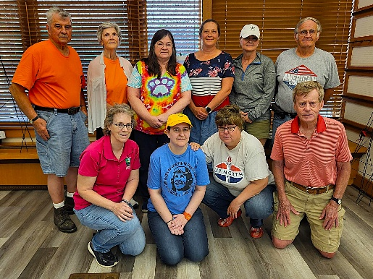
L-R, back row: John and Geni Heider with R.I.P., Ltd., volunteers Terri Lemmel, Leslie Hunt, Daisy Dowell, JD Larkin

L-R, front row: Dawn Cobb, IDNR archaeologist, volunteers Katrina Held, Joy Holmes, Jered Hooker

Work began slowly, with just five core volunteers becoming familiar with implementing the approved procedures. Excessive heat limited work sessions to about three hours with an average of two or three stones completed per session. The team soon learned that when the spade hits the dirt, there’s no way to predict what will be uncovered. In a standard restoration (as pictured), a stone is loosened and lifted out of the ground, the dirt and sod being set aside on a tarp. Measurements are taken and preparations are made to reset the stone with one third of its length underground. The hole is then dug to the proper depth and coarse gravel (road pack) is tamped down in the bottom for support and drainage. The stone is then lowered back into the hole, taking care that it is sitting level and in line with the other stones in that row. More gravel is placed around the bottom, then dirt is added, tamping everything down layer by layer. Finally, the sod is replaced as neatly as possible, and the stone is cleaned, initially with ammonia water, then with the special biological cleaner D2. Several applications of D2 over time are needed to lighten the staining without scrubbing.
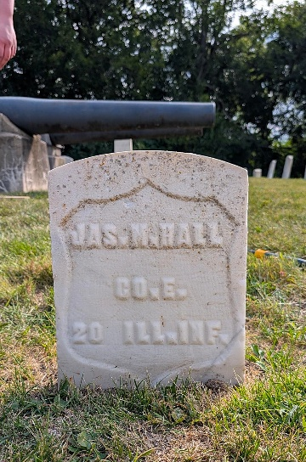
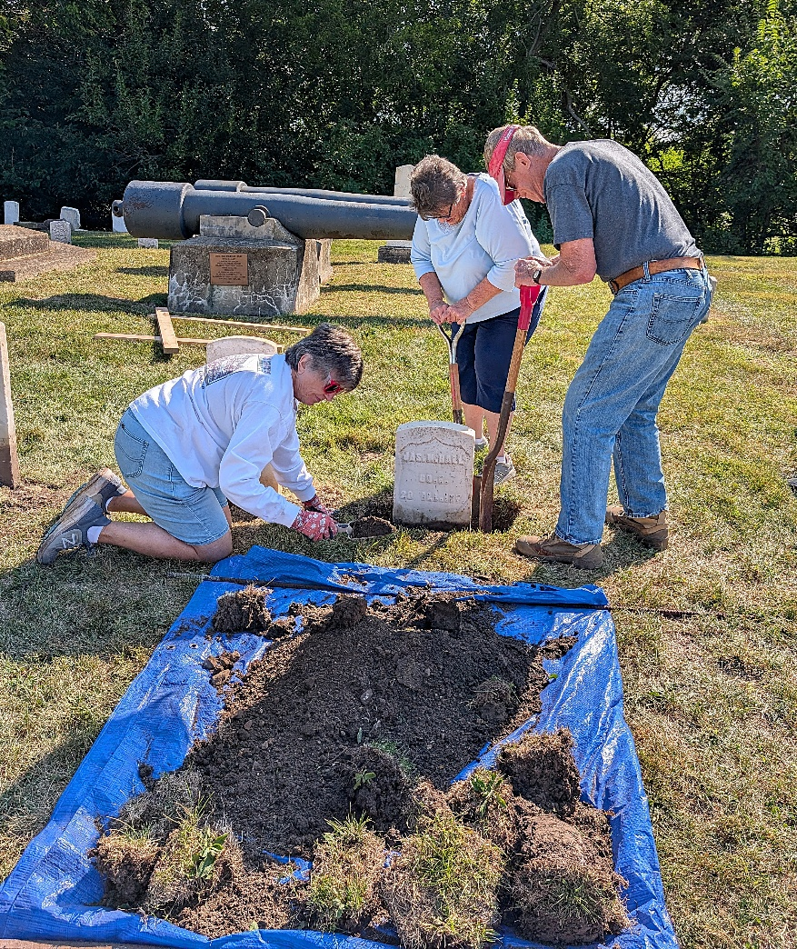

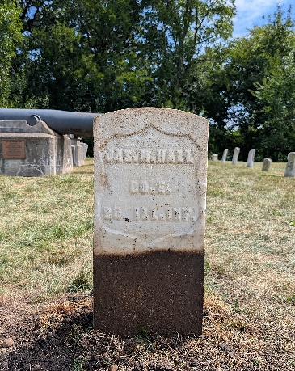
One stone that was removed from the ground was attached to a concrete block just below the sod, therefore it had to be reset at the same level for the block to be covered.

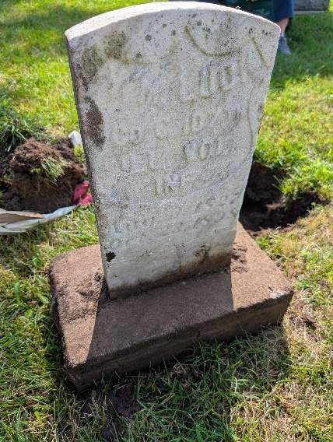
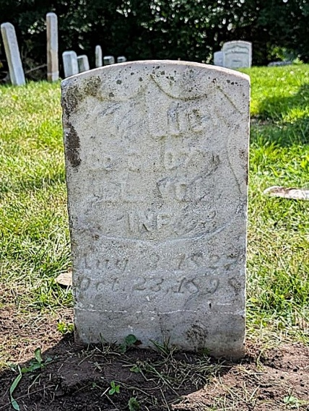
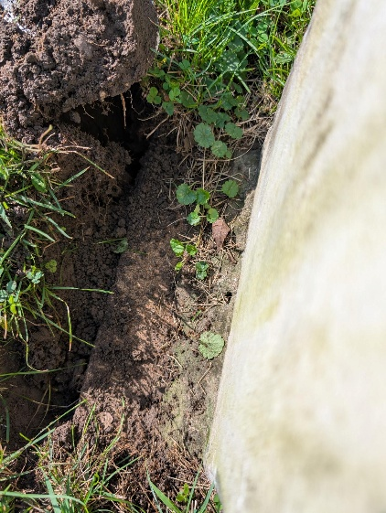

A few Stones were broken but repairable, using a specialized mortar.

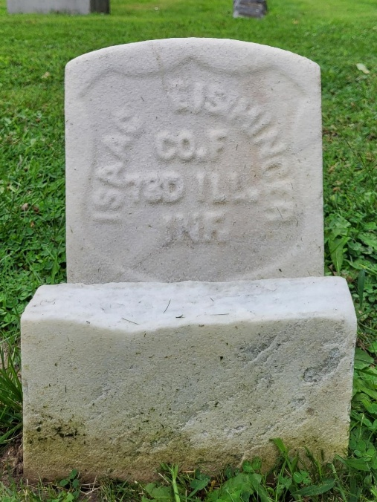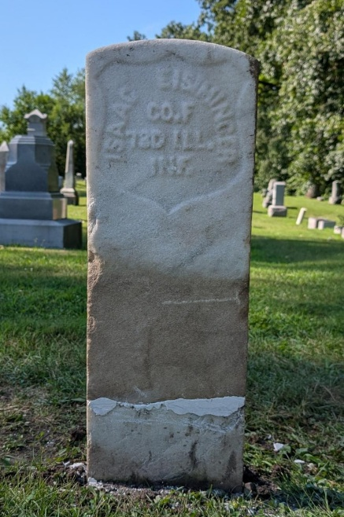

A few stones we found were broken off underground, such as this one. At first glance, it looks like a simple restoration just needing to be straightened. When the first layer of sod and soil were removed, the bottom portion was exposed slightly in front of the top part about six inches below the surface. Once the top part was set aside, measurements were taken and the bottom portion was leveled and put into position for the top to be adhered. The two pieces were held together with clamps until the mortar set, then the soil and sod were replaced.

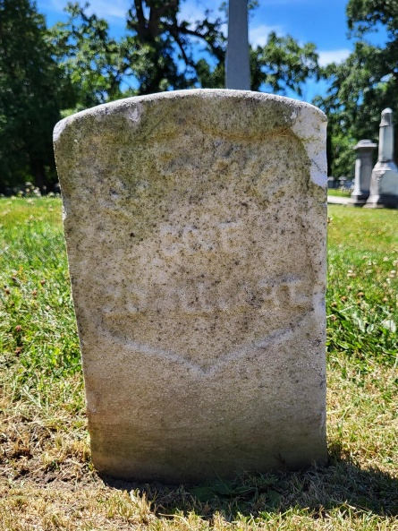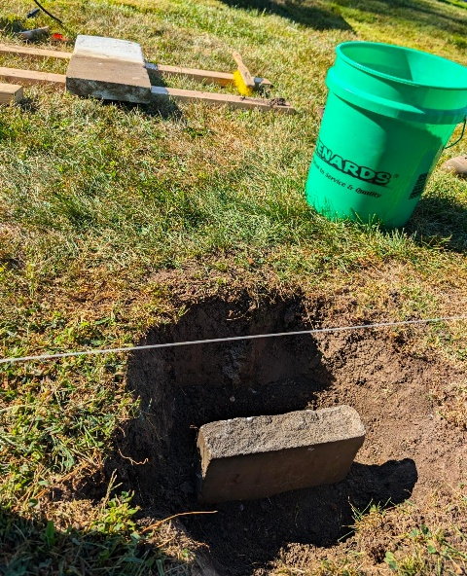

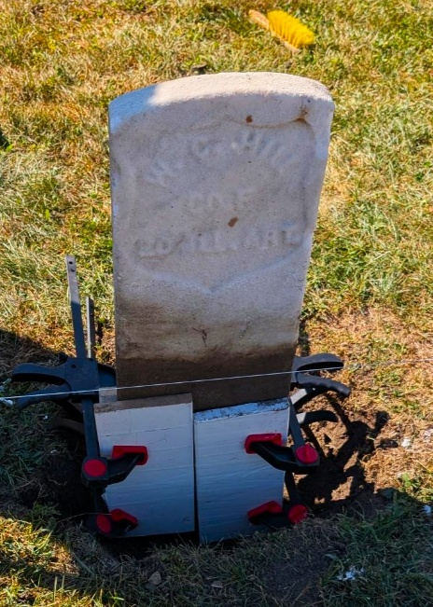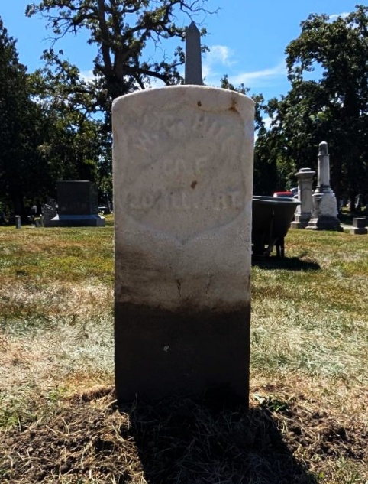

Another stone that had broken off underground could not be repaired because the break was jagged and appeared to have pieces missing. If the two edges do not fit together like puzzle pieces, then they can’t be mended. That particular stone had to be reset “as is” only straight.

Sometime during the 50-plus year history of the DeWitt County Genealogical Society, some old photo negatives were donated, two of which were obviously the Soldiers’ Plot. When placed on the microfilm reader, the names on the tombstones were clear as day! This provided us with invaluable information as to the burial location of a few soldiers whose tombstones had gone missing. By looking at the monuments in the negatives, we deduced the photos had to have been taken sometime after 1898 (when the Spanish War monument was erected) and before 1917/18 (when the cannonballs under the cannons were donated to the iron drive during WWI). Mark Woods of Woods Studio in Clinton made prints for us, and he pointed out that the old inter-urban tracks can be seen in one shot. They were laid around 1903, so that narrows the time frame even further.

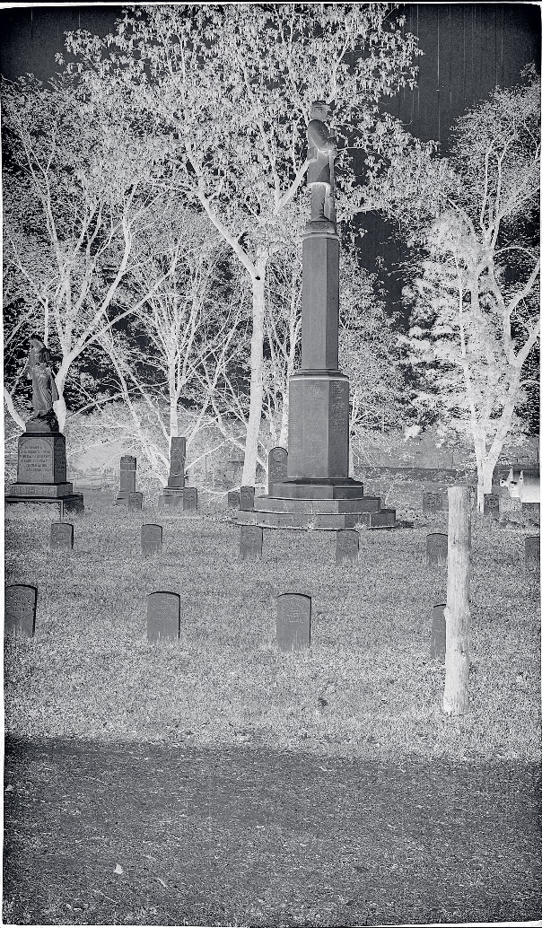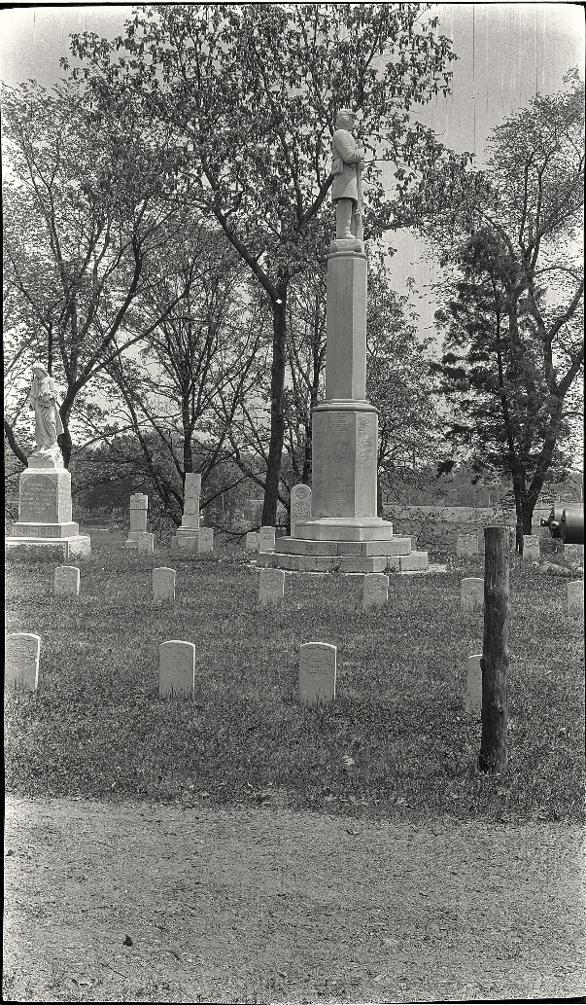

View from west to east.

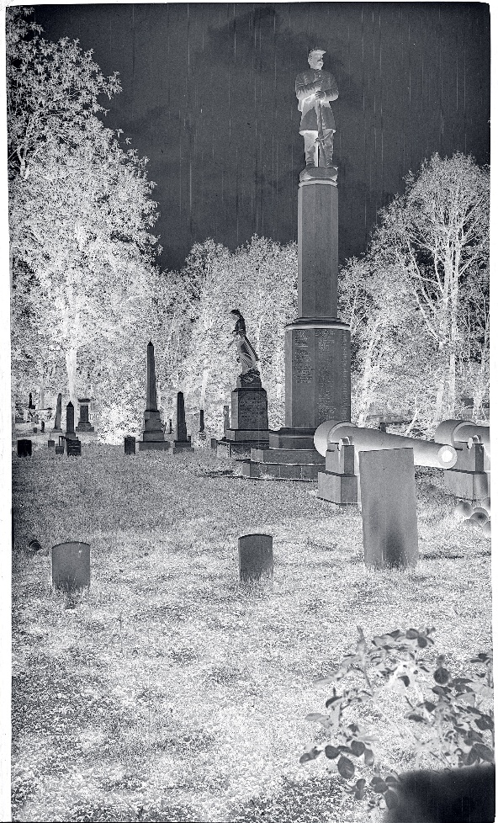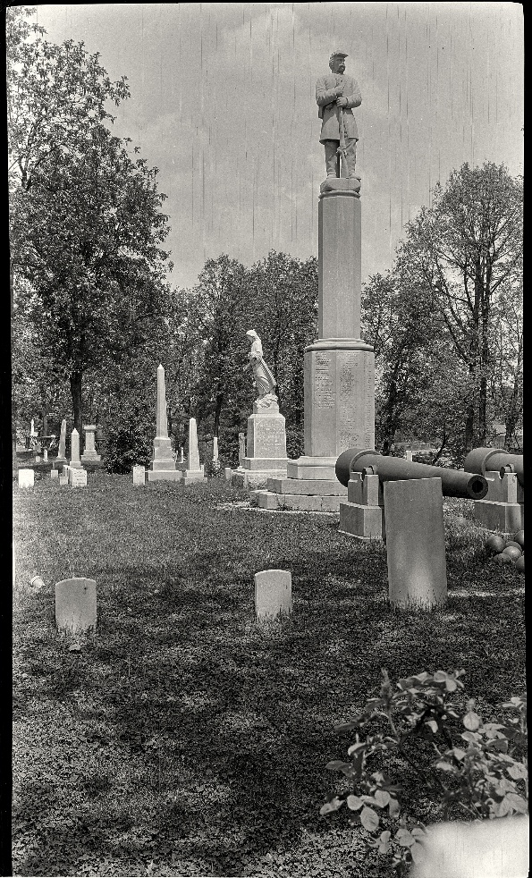

View from south to north.

Sometime after these pictures were taken, something happened here, probably a tree falling, which obliterated some of the tombstones between the tall soldier monument and the Spanish War monument. The young woman still has her outstretched hand strewing flowers upon the graves of the fallen. That hand has been missing for many years and may have been severed during the same event that ruined the gravestones. When the first sign was erected here in 2009, we knew there were at least three soldiers buried here who had no tombstones marking their graves. One of them was J. A. (Joshua) Carter, and his descendants stepped forward and got a replacement stone from the Veterans Administration to mark his spot. His original stone can be seen in this closeup with a white check mark. To the left is the stone for Asa Cain (green check mark) and another (blue check mark) that only shows the top edge peeking up behind the Spanish War monument. We know from old cemetery records that J. A. Carter, Asa Cain and Reuben Ogborn were buried beside each other in that row. Behind those are civilian (family) stones erected for William Proud (pink), Joseph Moore (red) and John Cuppy (yellow). All three men were Union veterans, but their families chose private sector monuments. These were also badly damaged, probably by a falling tree, probably at that same time, though remnants of them remain. Some well-meaning group in the following decades took it upon themselves to obtain military stones for Proud, Moore and Cuppy and installed them in the vacant area where we can now see Carter, Cain and Ogborn are interred.

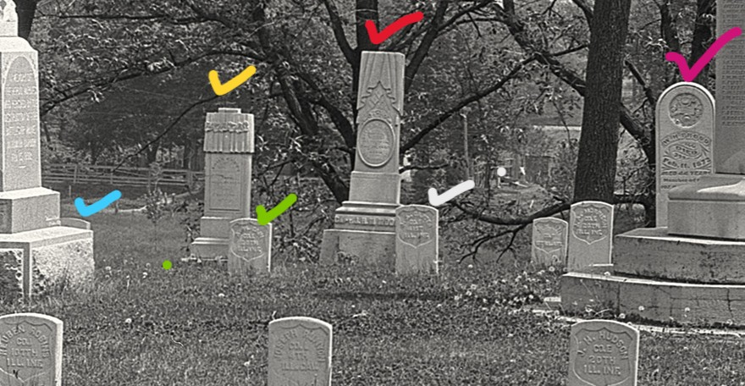

With the assistance of Clinton City Clerk Kamren Wilford and Clinton Water Department’s Kyle Morris and his crew, we were able to get replacement headstones from the Veterans Administration. First, we had to prepare the place for them, which meant removing the Proud and Cuppy stones. (After much consideration, we decided to leave the Moore military stone in place. There was plenty of room for the replacement stones, and the Moore stone is in good condition and in alignment with the rest of the row. Birth and death dates were added, but the death date is wrong – it says 1896 instead of 1869 – so that still needs to be corrected.) We kept the military stones for Cuppy and Proud to be reset beside the remains of their family stones.

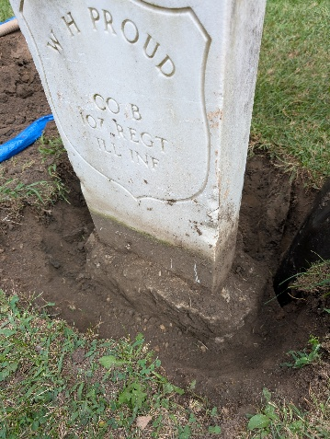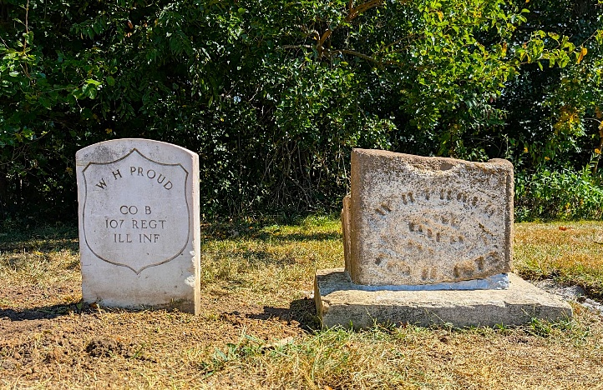

John Cuppy’s stone was removed without incident, but William Proud’s stone was set in what seemed like a ton of concrete! (These newer headstones weigh an average of 230 pounds without concrete attached.) The first rule of historic gravestone preservation is like the medical oath to do no harm. These stones should never be set in concrete, and we didn’t even try to remove it. We finally got it out of the ground, but we were not able to reset it as high as we would have liked due to the concrete. His family stone, while a beautiful one in its day, was a tall, thin tablet style set in a keyhole base. Over the years, it became broken into several pieces, none of which fit back together (apparently some went missing). The part with his name and date of death was still there and legible, so we arranged the pieces on top of the base to keep them from being swallowed up by the earth (which is what happens fairly rapidly when a stone is flat on the ground).
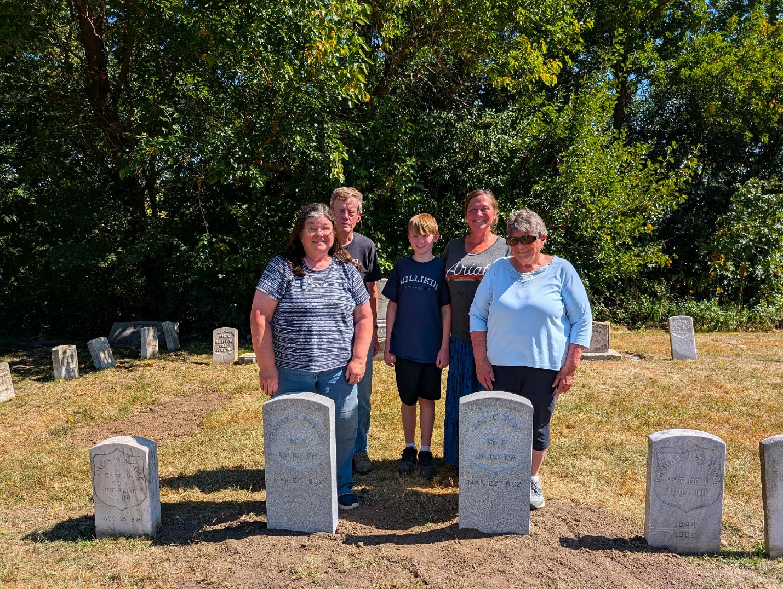

Cain and Ogborn replacement headstones in place.

In the south row, another stone was missing. It had also been a tall, thin tablet style that probably got broken several times over the years. One remaining piece with most of the soldier’s name on it (Nathaniel Day) was at the cemetery’s maintenance shed. Per protocol, we buried the remaining piece behind the replacement stone. The negative view shows the original tombstone from behind (red check mark).

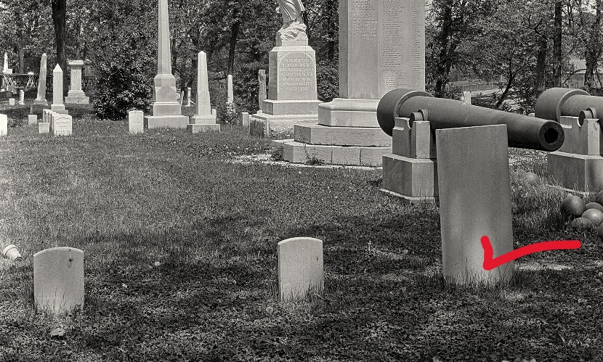
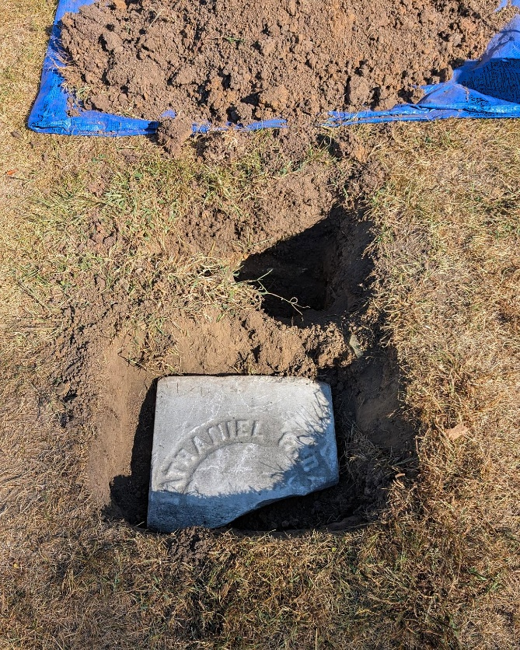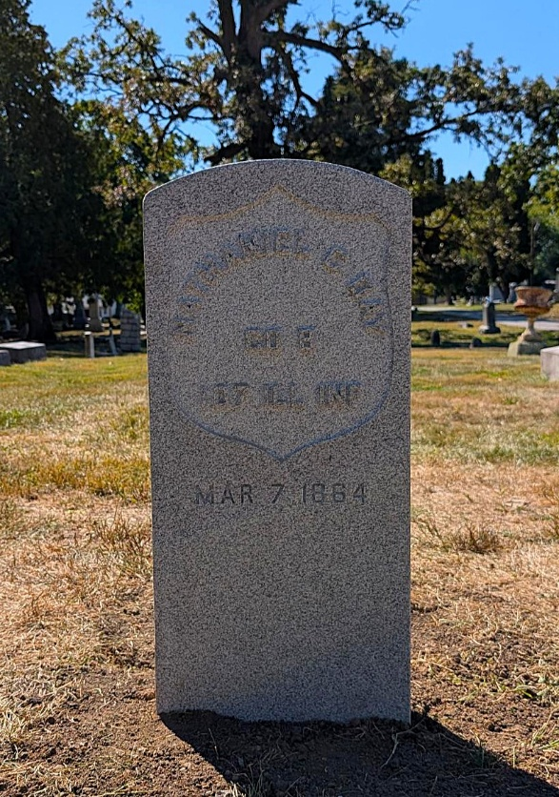

Work will be completed in the spring of 2026, and a dedication ceremony is scheduled for May 16 with a reception following in the Carriage Barn at the DeWitt County Museum.

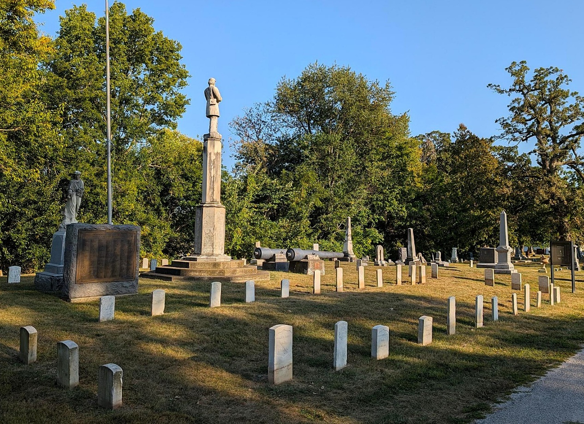
Core volunteers: Joann Manley, Jered Hooker, Leslie Hunt, Cheryl Lehman Terri Lemmel

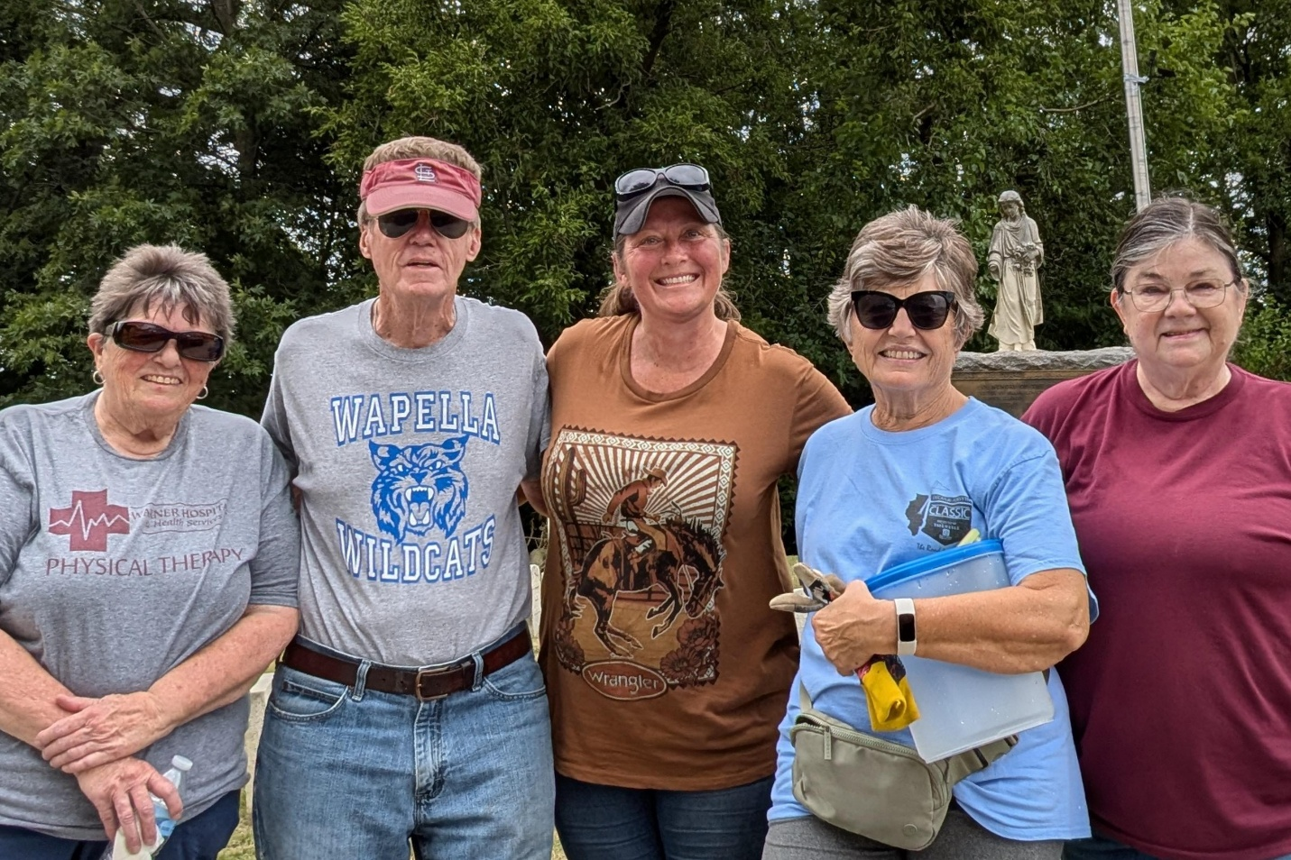

Extra helpers: Rosemary Brady-Craven, Edith Brady-Lunny, Matt Cooper, Josie Foffel, Brock Hardwick, Brody Hunt, Randy Kuker, JD Larkin, Calvin Lunny, Helen Michelassi, Layne Miller, Kylee Moore, Blake Rasor

Monetery donations: Phillip and Ann Rybolt, Mike and Susan West (in memory of Dr. Rolla Richards, 20th IL Regiment Surgeon and LTC Evan Richards, KIA at Raymond MS), AmVets Post 14, Joann Manley, DeWitt Lodge 84 AF & AM, DeWitt Clinton Chapter NSDAR, Lorraine Schmidt, Bob Walters, Mary K. Berg, Friends of the Library, Sandy Blaesing, Joy Holmes & JD Larkin, Cindy Christensen, DeWitt County Home & Community, one anonymous.

Additional acknowledgements: Joey Long / C. H. Moore Homestead & DeWitt County Museum, Mark Woods / Woods Photography, Randy Rice / Calvert Funeral Homes, Clinton Chapel, DeWitt County Genealogical Society membership

