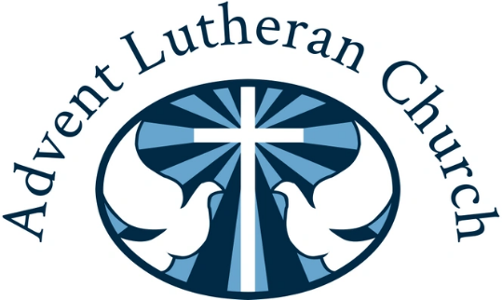

Winter Market 2023

**Saturday November 11**

9:00 a.m. ~ 2:00 p.m.

Route 202 in Rindge, North of Route 119

Gift Basket Raffle  Silent Auction  Bake Sale

Gingerbread Baking Contest  Vendors  Advent Café Take Out

**Exhibitor fee:** $20 (check payable to Advent Lutheran Church)

**Space provided:** 6’ table and 2 chairs

**Registration deadline:** Form and payment must be received by November 4

**Set-Up:** Doors will be open for exhibitor set-up at 7:30 a.m.

Advent reserves the right to limit duplication of exhibitors, thus helping to achieve a productive   
day for everyone. If you have any questions, call the church office at (603) 899-3095 or email nhlutherans@gmail.com

**************************** CLIP AND RETURN WITH PAYMENT **************************

Mail to: Advent Lutheran Church

ATTN: Winter Market Coordinator

P.O. Box 153

Rindge, NH 03461

Business Name _____________________________________ Owner ___________________________________

Address ______________________________________________________________________________________

Daytime phone____________________ Evening phone ____________________ Electrical Outlet (circle) YES NO

Email ________________________________________________________________________________________

Description of Items to be sold____________________________________________________________________