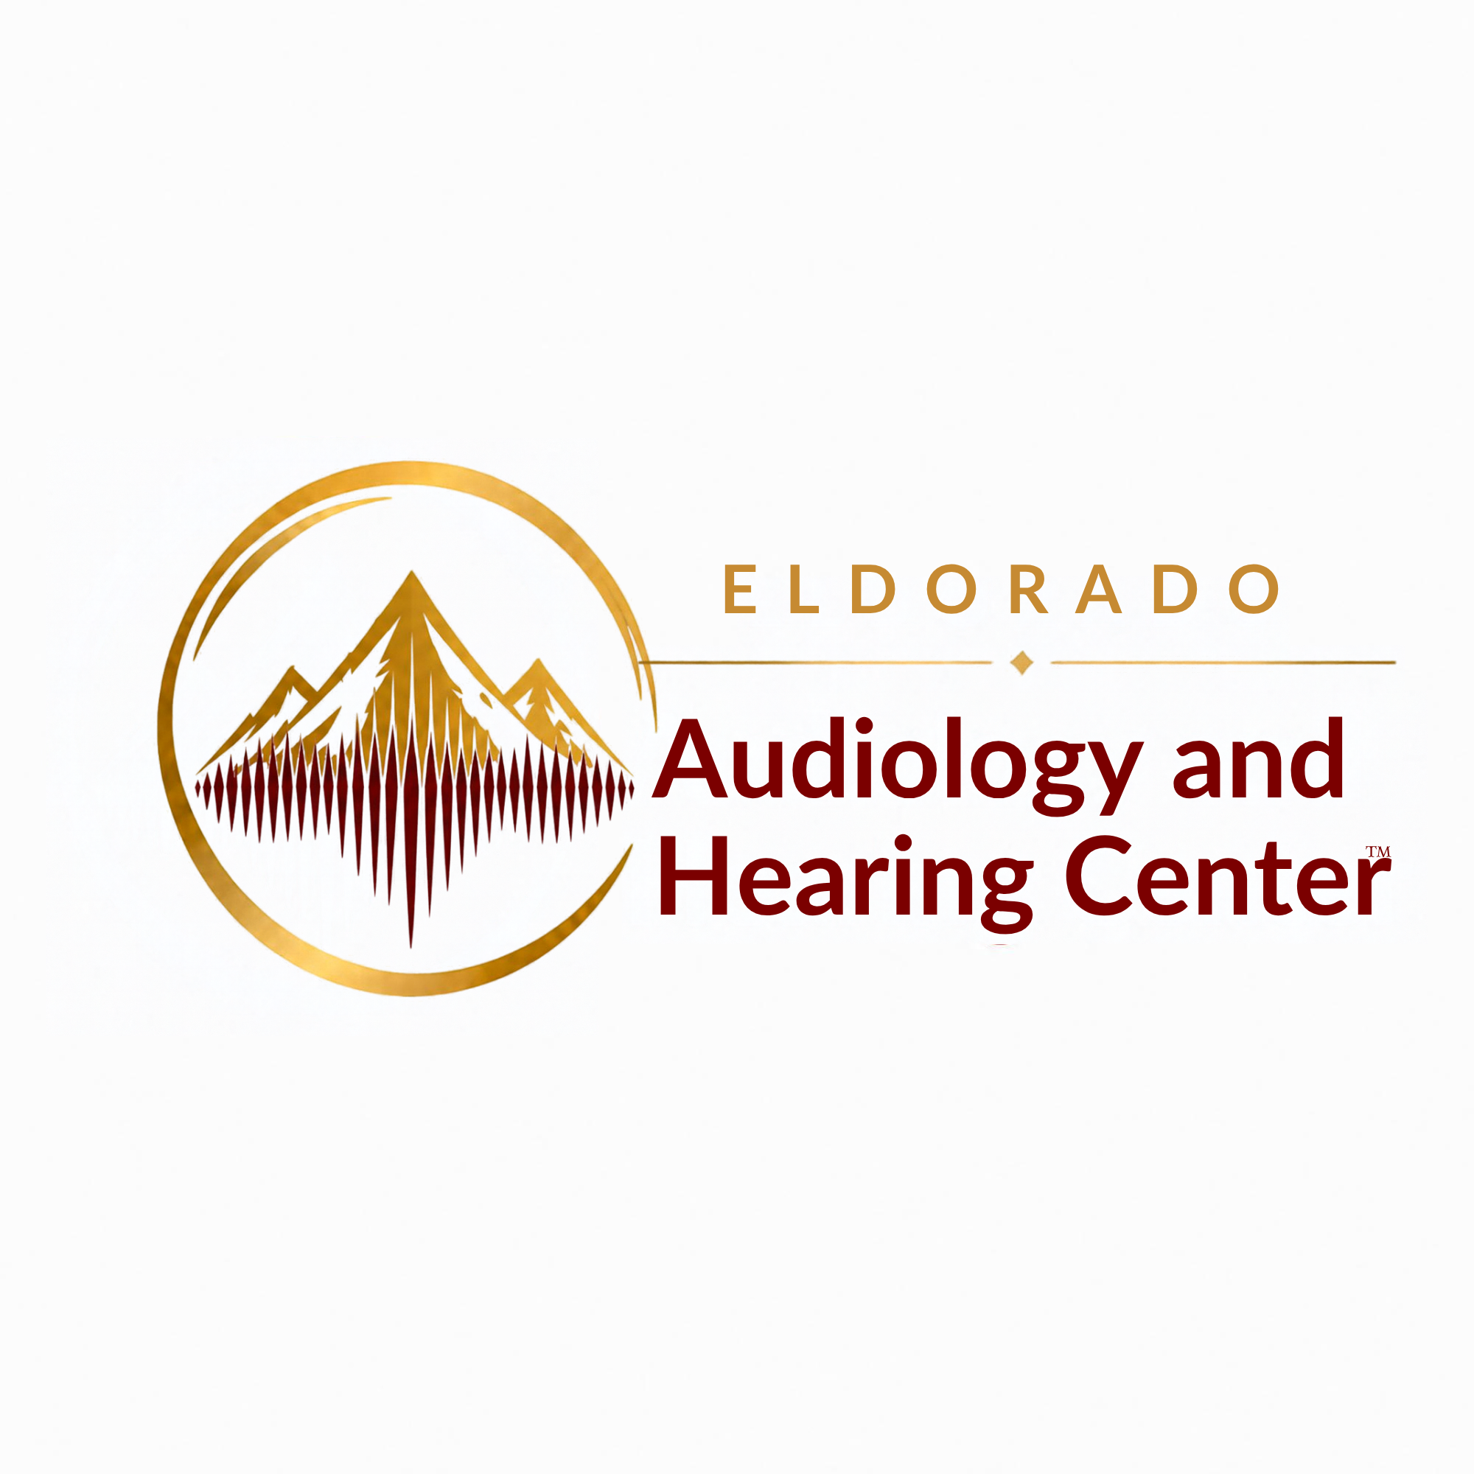 | FEDERAL CAPABILITIES STATEMENT  SBA-Certified Woman-Owned Small Business | New Mexico
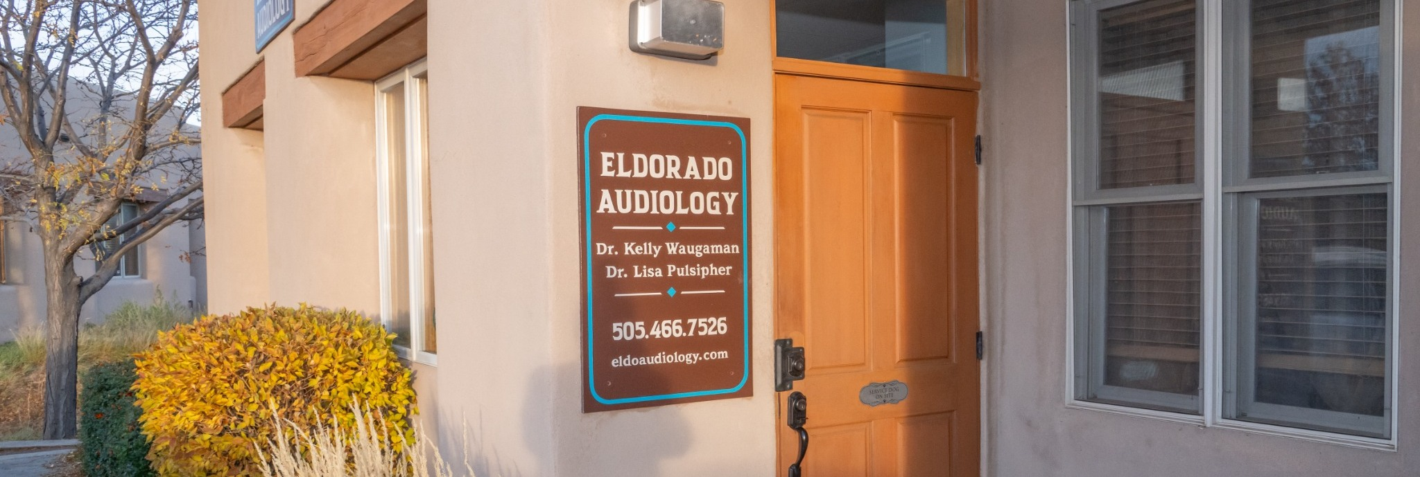
CLINICAL AUDIOLOGY • VETERAN SERVICES • HEARING TECHNOLOGY • HEALTHCARE CONSULTING
Eldorado Audiology and Hearing Center™ is an independent, audiologist-owned healthcare organization founded in 2013. We provide diagnostic audiology, vestibular and tinnitus services, hearing technology management, and specialized clinical support. Led by Dr. Kelly Waugaman, our organization combines doctoral-level clinical care with decades of healthcare experience and government contracting expertise.
CORE CLINICAL CAPABILITIES  • Diagnostic audiologic evaluations and testing  • Tinnitus evaluation and management  • Vestibular and balance assessment  • Auditory evoked potentials and otoacoustic emissions  • Retrocochlear assessment and referral coordination  • Hearing aid selection, fitting, programming, and repair  • Aural rehabilitation and longitudinal care  GOVERNMENT & SPECIALIZED SERVICES  • VA Community Care Network provider since 2014  • Experience conducting VA Compensation & Pension audiologic examinations  • Specialized and forensic audiologic assessment  • Clinical documentation, reporting, and referral coordination | ORGANIZATIONAL DIFFERENTIATORS  • Truly independent, audiologist-owned practice; no manufacturer affiliations  • Empathic Audiology® — a patient-provider care model emphasizing Care for Both  • Experienced in government contracting and veterans’ care  • Clinical, operational, and healthcare technology consulting expertise  FEDERAL REGISTRATION  Legal entity: Eldorado Audiology and Hearing Center, LLC  SBA certification: WOSB (certified May 13, 2025)  UEI: JVKFP5JADP95  CAGE: 9YAV0  Primary NAICS: 621340  SAM.gov: Active (per SBA public profile)
LEADERSHIP & CONTACT
Dr. Kelly Waugaman | Founder & CEO | Doctor of Audiology
5 Caliente Road, Suite 5, Santa Fe, NM 87508 • (505) 466-7526 • drkelly@eldoaudiology.com
eldoaudiology.com/government

