**SpeedSwivel FDC Adapter:**  **Revised “handout”, August 2024**

The use and care of a SpeedSwivel. For classroom or sales introductions.

PRINT YOUR DEPARTMENT NAME OR SALES REPRESENTATIVE NAME HERE.

**SUBJECT: The SpeedSwivel FDC adapter**

A SpeedSwivel provides firefighters with a tool and a solution for connecting fire hose to a fire department connection (FDC) when the brass swivels are missing or have been stolen.

1. **SPEEDSWIVEL TRAINING HANDOUT**

A. Defines the Speed Swivel.

1. Establishes the issuance of the SpeedSwivel.

1. Establishes guidelines for appropriate use, care, and storage of SpeedSwivel.

1. Effective Date _____/______/_____.

**11. POLICY**

It is the policy of the ________ Fire Department to provide the necessary tools to assist when operating safely at the scene of an incident. The SpeedSwivel provides firefighters with a solution for connecting fire hose to a fire department connection (FDC) when the brass swivels are missing or stolen. Fire fighters shall be responsible for the proper care and use of this hose adapter.

**111. DEFINITIONS**

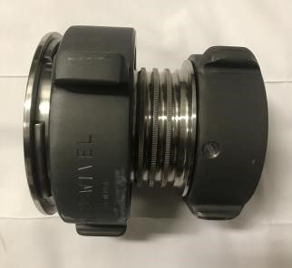

**SpeedSwivel:** A fitting that replaces a missing **FDC** female swivel by fitting over and tightening onto the ball bearing raceway.

Locking Collar

2 ½” female swivel connection

**Page 1 of 4**

**IV.** **OPERATIONAL USE OF THE SPEED SWIVEL**

The SpeedSwivel shall be used when the 2 ½” female swivel of an FDC has been stolen or is missing. When connecting to a vandalized FDC the member shall:

* + - 1. Ensure the barrel of the FDC is clear of debris and that there is no damage to the ball bearing raceway of the missing swivel.

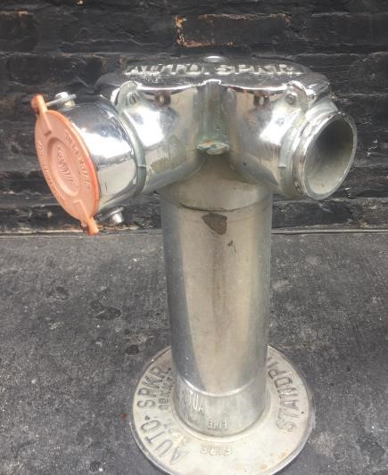

Female Swivel Bearing Raceway

* + - 1. Confirm the SpeedSwivel is in the open position by turning the Locking Collar counterclockwise until the four locking mechanisms have retracted back into the housing.

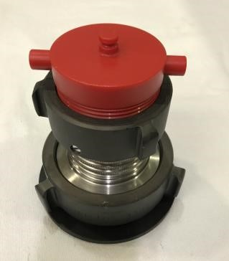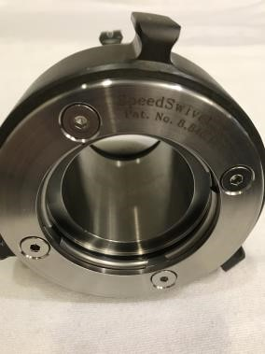

Locking

Collar

Locking

mechanisms

**Page 2 of 4**

* + - 1. Place the SpeedSwivel onto the intake port of the FDC with the 2 ½” female swivel connection of the Speed Swivel facing out.

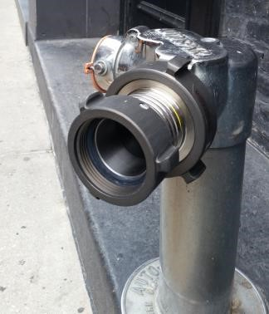

2

½” female swivel

connection

* + - 1. Turn the Locking Collar clockwise (or to the right) until it is hand tight.

Locking Collar

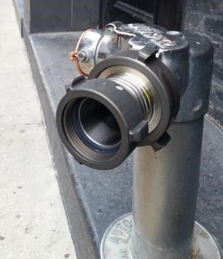

* + - 1. Attach the 2 ½” fire hose to the 2 ½” female coupling provided on the SpeedSwivel.

**NOTE:** Depending on the age and condition of the existing FDC, some leaking around the fitting is always possible. Check gaskets as needed.

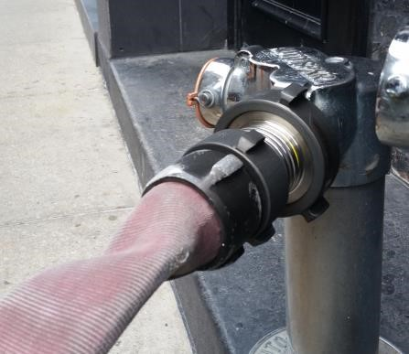

2

½” hose

2

½” female swivel

connection

**Page 3 of 4**

**Removing the Protective Cover**:

Spinning and/or pulling aggressively at the protective cover **will not** allow removal!

To remove the cover, grip the SpeedSwivel by the barrel section with the largest coupling facing up and smallest facing down.

Hold the barrel and spin the largest Coupling, (**three-five spins is enough**).

Dropping the coupling completely off the main body is only for cleaning.

The “Protective Cover” has a **ball-race** that duplicates/simulates the attachment of a SpeedSwivel to a vandalized FDC. The ball-race design duplicates the size-shape of the ball-race found on a vandalized FDC. The knowledge needed by a firefighter to remove & attach this dust cover will reinforce the knowledge needed to attach the SpeedSwivel to a “Vandalized FDC” in an emergency. This “Protective cover” is also a useful training prop.

The protective dust cover is recommended with every SpeedSwivel. The protective cover should **remain attached** when a device is stored in a truck compartment and not in use.

**Customer is responsible for care and maintenance Per NFPA 1962.**

Other considerations may include:

1. Fire fighters shall be responsible for the proper care and use of this hose adapter.
2. Upon receipt, the Speed Swivel shall be added to all appropriate truck inventories.
3. Any damage and/or signs of wear to the Speed Swivel shall be reported.
4. Check female threads for compatibility with your departments 2-1/2-inch male hose.
5. Refer to NFPA 1962 for care and maintenance of fire hose, nozzles, and adapters.
6. USA made, meets all NFPA requirements.

Contact: <Distributors, edit your contact here>.

SpeedSwivel FDC Adapters: U.S. Patent No. 8,840,149

**It’s Risky to be Without a SpeedSwivel FDC Adapter on Apparatus Inventory**

**Page 4 of 4**