La Sportiva Prodigio

Recommendation:
I’ll cut right to the chase, the La Sportiva Prodigio is a high-quality shoe at an acceptable weight and a reasonable price. In today’s running shoe market that’s a winning combination that should be given due consideration from those looking for a trail shoe that can excel at both short and long distances, smooth and technical terrain.

Fit:
Much of people’s frustration with the La Sportiva brand must center around their sizing and how it translates back to the US based Brannock metric we’ve become accustomed to; as the shoes themselves have always been of the highest quality; albeit usually a little over built for anything short of true mountain-oriented pursuits. My pair of Prodigio’s is a La Sportiva size 46, I make sure to call this out as a La Sportiva 46 is unlikely to align with another brand’s 46 since La Sportiva builds their shoes on European ½ sizes. La Sportiva’s size guide identifies a 46 as a 12.5; however, my size 46 insole measures 11 5/8”, which is the same as a size 11.5 Hoka Speedgoat 6 and fits me as such. For context when I put my feet on a Brannock device, my toe and arch length puts me in a size 11.5. When I step in the size 46 Prodigio it has a thumb’s width of space up and supports my arches accordingly. Most online guides will tell you to buy a ½ size up from your standard US size; however, that would put me in a 45.5 and that size resulted in a snugger fit up front in the toe box and not quite the level of support in my arches that I prefer; however, if you prefer a very precise fit over shorter distances and/or more technical terrain, then it may be the way to go. In summary, Sportiva sizing can be tough to figure out unless you are able to try the shoes on in person but hopefully this helps provide some context around the discrepancy that exists.

La Sportiva is also known as being a narrow fitting brand. While this may be true in comparison to some other brands, I have a normal “D” width foot in size 11.5 and feel no restrictions or general discomfort when using the shoe. In fact, I love the way this shoe hugs my foot in all the right places for a secure fit without feeling constricted in the toe box, allowing for ample toe splay and foot function. I would also add that the shape of the last used in this shoe allows for a nice straight big toe line, allowing for proper engagement and push off throughout the gait cycle. I also want to call out that I have taken this shoe up to 3 hours on buffed out rolling singletrack and experienced none of the upper discomfort around the ankle collar. However, when running repeatedly on off-camber steep trails I have felt some of the ankle collar discomfort on the lateral aspect of my left ankle. When I purchased this shoe at the La Sportiva store in Boulder (extremely helpful staff, good vibes, my kiddo walked away with a few free stickers for being patient while her dad tried on numerous shoes, highly recommend) I was told that the black and yellow colorway did not have the corrected upper that so many have complained about. I felt no pain in the store, am a sucker for the classic Sportiva color palate and decided to roll the dice. Hopefully the shoes continue to wear in and the upper discomfort on my left foot does not make itself more well known. Worst case it looks like that portion of the upper around the ankle could be trimmed down a bit to remove the issue altogether. I will note that I did try on one of the colorways that had the corrected upper and could not tell a difference in feel on my foot in store.

100 Mile Condition
To accurately show how things are holding up at the 100-mile mark, I am including photos of the shoes how they are today. They are not clean, and the photos are not touched up, simply straight off my feet for real-time photos.

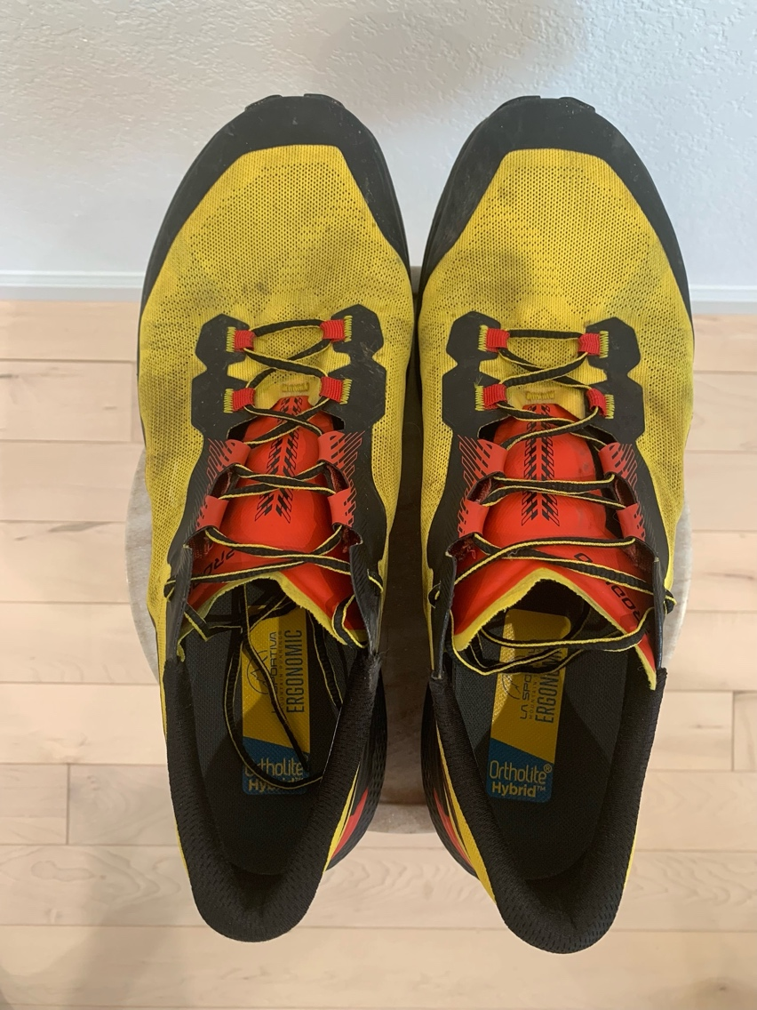
Top Down
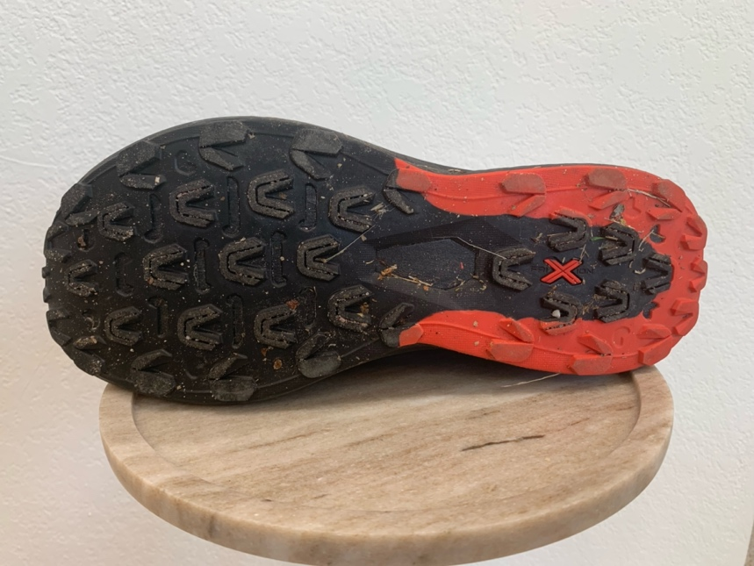
Sole
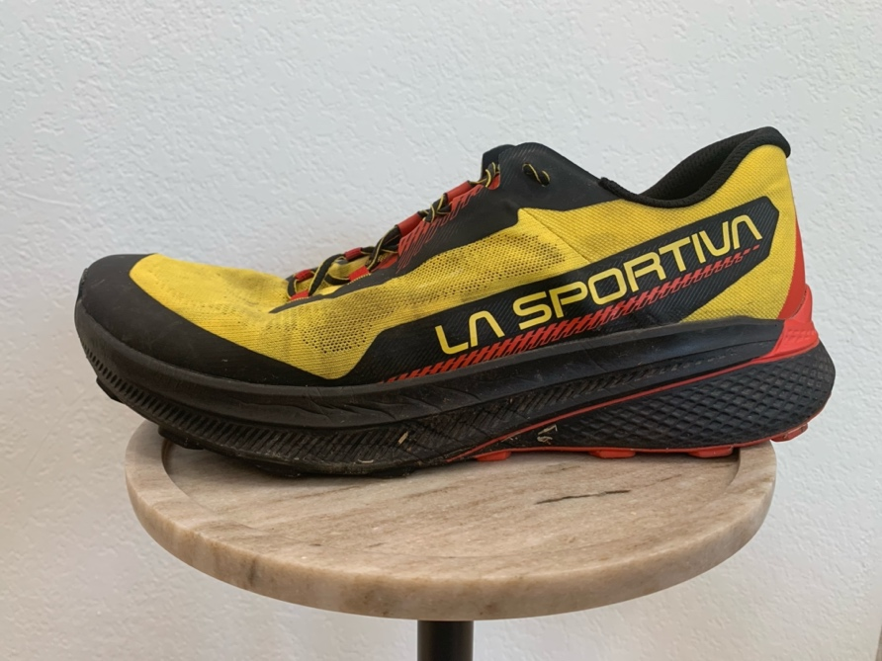
Lateral Side
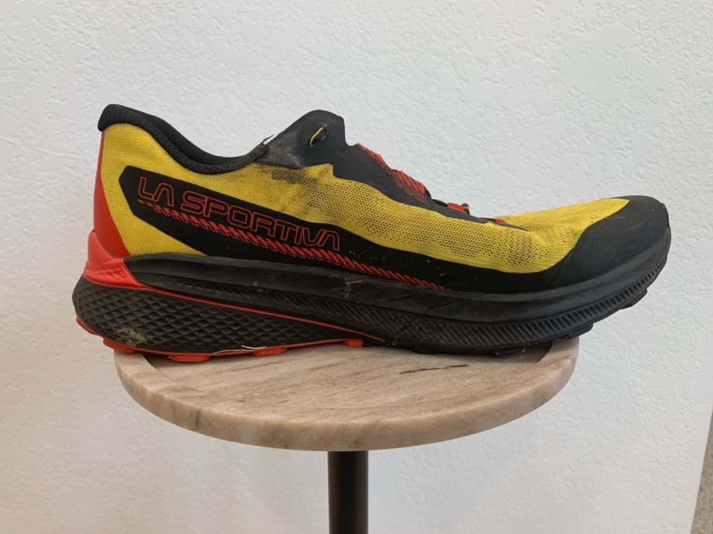
Medial Side
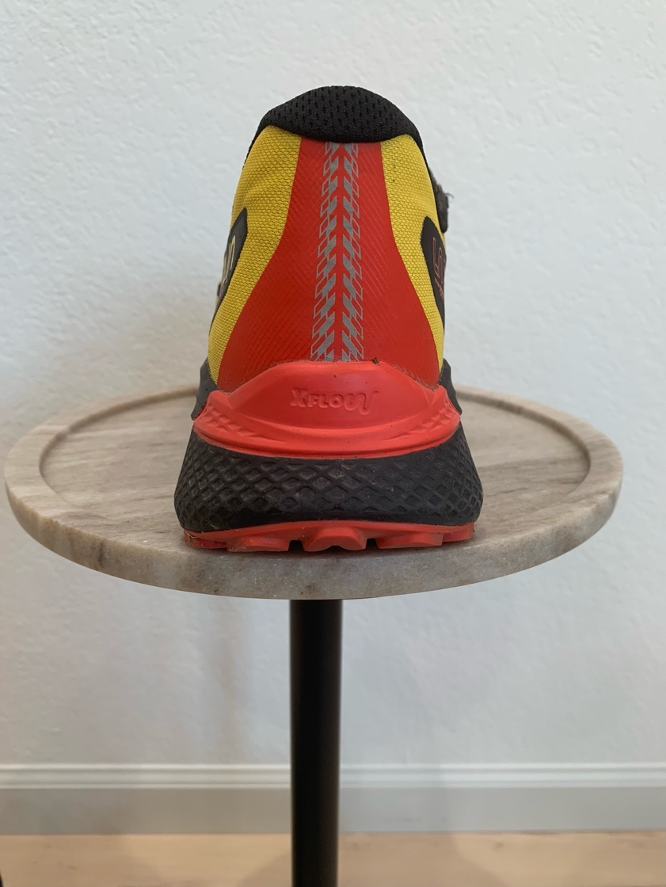
Rear

Function
My size 46 weighs in at 10.4 oz or 294.8 g, features a nitrogen infused insole and a FlowFilm insert in the sole which serves as a rock plate of sorts. So far, I have 100 miles in this shoe on varied terrain, including both outdoor and indoor.

I’ve taken it on semi technical trails (steep, off camber, some rocks, and roots), buffed out rolling singletrack, and even uphill repeats on the treadmill. In all instances, the shoe has lived up to expectations. In typical La Sportiva fashion the shoe feels best when things get a bit rougher and looser. The FlowFilm insert does its job as I have yet to feel any sharp zings from various sized rocks I’ve intentionally run over at speed. This shoe does not provide a big plush pillowy feel, that so many brands seem to be focused on, but instead provides a direct connected feel that I appreciate as it allows you to be more precise with your footing in more technical situations; however, even at the 3 hour mark my feet did not feel beat up or fatigued and the lighter weight and rocker profile allow for a quick pick up and turn over when moving along.

I will note that the shoe does seem to loosen a bit over time over extended durations, not to the extent that I bothered to stop and retie the shoe but if I was in for a full day on my feet, I would have. Experimenting with the classic runner’s heel lock, seemed to keep everything locked in. The heel counter is stiff and doesn’t seem to “suck” the foot down into the heel and could be contributing to the need for the runner’s lock. So far, the tread shoes no visible signs of wear, which is a win considering I’ve seen visible shavings come off other Sportiva models in the past when on the treadmill, even for sessions around the one-hour mark. The compound is listed as Frixion Red on the Sportiva site, which is considered a more durable compound and things appear to be in line with that statement. However, as indicated in the prior photos, they are plenty sticky enough to pick up lots of little rocks and debris and I have experienced no slipping to date.

It’s a bit early in overall mileage but as of right now, this shoe is my top choice in an upcoming 50K with around 9,000 ft of ascending and descending but may be a little too firm for a potential hundred miler at the end of June, time will tell as things continue to break in. It breathes well, inspires confidence in its overall fit and feel, and just rolls along nicely without feeling clunky or tippy.

