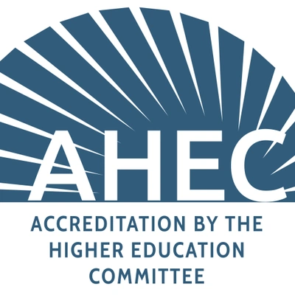

Application for Accreditation

*Submit your completed application and ALL course material, including the student syllabus, to your partner representative.

Program Details
Program Name: |  | Date:
Company Name:
Representative Name: |  | Partner ID:

Upon successful completion of the program, students will receive the following:
___ Certificate:

___ Certification:

Program & Scope
Purpose & Scope:

Criteria for Completion
Criteria:

Program Requirements: Operators
Instructor:

Subject Matter Expert:

Monitor:

Conductor:

1. Instructor: Employ or contract individuals to operate the program and document their students' competencies

2. Subject Matter Expert: Uses qualified subject-matter experts (SMEs) for the content and assessment design, delivery, and maintenance and documents their qualifications, competencies, and responsibilities of their roles

3. Monitor: Monitors, assesses, and assures the quality of all activities provided on behalf of the program following documented procedures

4. Conductor: Conducts yearly evaluations and supports the quality of the program and continues future improvement

Program Requirements: Policies
Instructor Qualifications:

SME’’s Qualifications:

Other Qualifications:

How will you develop and maintain the education/training:

Method used to deliver content:
What methods will be
used to conduct the assessment:

How can students
deliver feedback:

Defined Policies:

1. Defined policies and procedures for the following:

(a) qualifications required of all employees and volunteers involved in the development, delivery, and maintenance of the education and assessment
(b) procedures used to develop and maintain the education/training.
(c) methods used to deliver the education/training. - procedures used to develop and maintain (d) assessment(s).
(e) methods used to conduct an assessment(s); types of evaluation (s) and procedures used to evaluate or score participants.
(f) types of feedback provided to participants and documented quality

2. Has defined policies and procedures if a participant:

(a) misrepresents identity or eligibility status
(b) gives or receives unauthorized assistance on the assessment
(c) claims, states, or implies that the certificate is a professional certification
(d) engages in other violations of policies

Program Management Requirements
Proper Use of Certificate/Certification:

1. Has a process for conducting a needs analysis that is consistent with the program's purpose/scope
2. Education/training, intended learning outcomes, and assessment development are based on program purpose/scope
3. Education/training employs generally accepted instructional design methods relevant to the content, scope, and delivery method and developed by qualified individuals, including SMEs
4. Education/training is delivered using a method consistent with the purpose/scope of the program and delivered by qualified instructors (if applicable)
5. Content, design, and delivery of the education/training are reviewed periodically (at least annually) by qualified individuals, including SMEs
6. Has a process for evaluating and providing feedback on the performance of instructors/facilitators (if applicable)
7. Conducts summative assessment(s) to measure participants' accomplishment of the program's intended learning outcomes
8. Uses a generally accepted method for setting the passing standard that students must attain to be awarded a certificate
9. Uses rating scales, rubrics, or checklists to evaluate participant performance on subjective assessments (e.g., essays, portfolios, demonstrations) and documents procedures for training raters in the use of the scales, calibrating raters, evaluating the consistency of ratings, and resolving scoring differences (if applicable)
10. Prepares reports of assessment results summarizing the overall performance of the program and its participants
11. Informs certificate holders of the proper uses of the certificate/certification

Partner Acknowledgement

____ I understand that the program MUST meet the requirements outlined in this document

____ I understand that this application does not guarantee accreditation

___ I understand that AHEC reserves the right to revoke accreditation at any time

___ I understand that the program must maintain an overall score of 3.0 or higher on the student survey

___ I understand that an audit will be conducted if the program receives an overall score of 3.0 or below. The program will temporarily lose accreditation until an audit is completed. If the program fails the audit, the program will lose accreditation, and I will no longer qualify as a partner.

___ I understand that the application fee is NON-REFUNDABLE

Partner Printed Name: ___________________________________________________

Partner Signature: ________________________________________________________________

Email your completed application to your partner representative along with ALL program content, including the program syllabus.

FOR INTERNAL USE ONLY

Partner Representative:

Committee Member #1

Name:
Title:

Committee Member #2

Name:
Title:

Committee Member #3

Name:
Title:

Committee Member #4

Name:
Title:

Committee Member #5

Name:
Title:

Committee Member #6

Name:
Title:

Committee Member #7

Name:
Title:

Committee Member #8

Name:
Title:

Committee Decision:

Approve | Deny

Notes:

